SCHOOL OF COMPUTER SCIENCE AND ARTIFICIAL INTELLIGENCE |  |  |  |  | DEPARTMENT OF COMPUTER SCIENCE ENGINEERING
ProgramName:B. Tech |  |  |  | AssignmentType: Lab |  |  | AcademicYear:2025-2026
CourseCoordinatorName |  |  |  | Dr. Rishabh Mittal
Instructor(s)Name
  Mr. S Naresh Kumar
  Ms. B. Swathi
  Dr. Sasanko Shekhar Gantayat
  Mr. Md Sallauddin
  Dr. Mathivanan
  Mr. Y Srikanth
  Ms. N Shilpa
  Dr. Rishabh Mittal (Coordinator)
  Dr. R. Prashant Kumar
  Mr. Ankushavali MD
  Mr. B Viswanath
  Ms. Sujitha Reddy
  Ms. A. Anitha
  Ms. M.Madhuri
  Ms. Katherashala Swetha
  Ms. Velpulasumalatha
  Mr. Bingi Raju
CourseCode |  |  | 23CS002PC304 | CourseTitle |  | AI Assisted Coding
Year/Sem |  |  | III/II | Regulation |  | R23
DateandDay  of Assignment |  |  | Week5 - Tuesday | Time(s)
Duration |  |  | 2 Hours | Applicable to  Batches |  | 23CSBTB01 To 23CSBTB52
AssignmentNumber:10.1(Presentassignmentnumber)/24(Totalnumberofassignments)
 | Q.No. | Question |  |  |  |  |  | Expected Time  to complete
 | 1 | Lab 10 – Code Review and Quality: Using AI to Improve Code Quality and Readability  Lab Objectives  - Use AI for automated code review and quality enhancement.  - Identify and fix syntax, logical, performance, and security issues in Python code.  - Improve readability and maintainability through structured refactoring and comments.  - Apply prompt engineering for targeted improvements.  - Evaluate AI-generated suggestions against PEP 8 standards and software engineering best practices  Task Description -1(Error Detection and Correction)  Task:  Use AI to analyze a Python script and correct all syntax and logical errors.  Sample Input Code:  def calculate_total(nums)  sum = 0  for n in nums  sum += n  return total  Expected Output-1:  Corrected and executable Python code with brief explanations of the identified syntax and logic errors.  Task Description -2(Code Style Standardization)  Task:  Use AI to refactor Python code to comply with standard coding style guidelines.  Sample Input Code:  def findSum(a,b):return a+b  print(findSum(5,10))  Expected Output-2:  Well-structured, consistently formatted Python code following standard style conventions.  Task Description -3(Code Clarity Improvement)  Task:  Use AI to improve code readability without changing its functionality.  Sample Input Code:  def f(x,y):  return x-y*2  print(f(10,3))  Expected Output-3:  Python code rewritten with meaningful function and variable names, proper indentation, and improved clarity.  Task Description -4(Structural Refactoring)  Task:  Use AI to refactor repetitive code into reusable functions.  Sample Input Code:  print("Hello Ram")  print("Hello Sita")  print("Hello Ravi")  Expected Output-4:  Modular Python code using reusable functions to eliminate repetition.  Task Description -5(Efficiency Enhancement)  Task:  Use AI to optimize Python code for better performance.  Sample Input Code:  numbers = [ ]  for i in range(1, 500000):  numbers.append(i * i)  print(len(numbers))  Expected Output-5:  Optimized Python code that achieves the same result with improved performance.  Note: Report should be submitted a word document for all tasks in a single document with prompts, comments & code explanation, and output and if required, screenshots. |  |  |  |  |  | Week5 - Tuesday

Task 1: (Error Detection and Correction)

Prompt:

Analyze the following Python code and identify all syntax and logical errors. Provide corrected executable code along with brief explanations of each issue found.

Code:
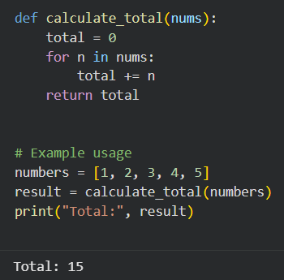

Sample Input/Output:

Explanation:
- The function definition was missing a colon (:), which causes a syntax error.
- The for loop statement also lacked a colon, making the loop invalid.
- The variable sum was used initially but total was returned, causing a logical NameError.
- The built-in function name sum was overridden, which is not recommended in Python.
- Indentation structure was unclear, which could lead to execution errors.
- The corrected version ensures consistent variable naming and proper syntax for execution.
Task 2 : (Code Style Standardization)

Prompt:
Refactor the following Python code to follow standard coding style guidelines (PEP 8). Improve formatting, indentation, naming conventions, and structure without changing functionality.

Code:
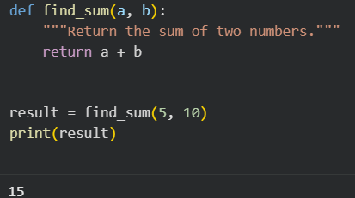

Sample Input/Output:

Explanation:
- The function name was changed from findSum to find_sum to follow snake_case naming convention as per PEP 8.
- Proper spacing was added between parameters (a, b) to improve readability.
- The one-line function was expanded into a properly indented multi-line structure.
- A docstring was added to improve code documentation and maintainability.
- The function call was stored in a variable (result) before printing for better structure.
- Overall formatting now follows Python’s standard coding style guidelines.
Task 3: (Code Clarity Improvement)

Prompt:
Improve the readability of the following Python code without changing its functionality use meaningful function and variable names, proper indentation, and clear structure.

Code:

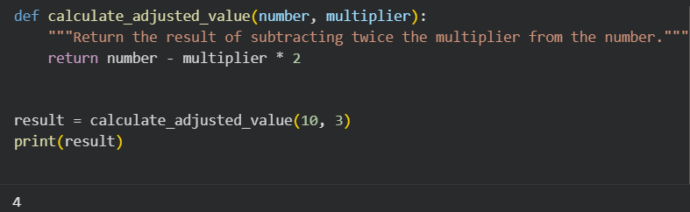
Sample Input/Output:

Explanation:
- The function name f was renamed to calculate_adjusted_value to clearly describe its purpose.
- Parameter names x and y were changed to number and multiplier for better understanding.
- Proper indentation was maintained to follow Python formatting standards.
- A docstring was added to explain what the function does.
- The function call result was stored in a variable (result) to improve clarity.
- The logic remains unchanged; only readability and structure were improved.
Task 4: (Structural Refactoring)

Prompt:

Refactor the following repetitive Python code into reusable functions.
Eliminate redundancy while maintaining the same output.

Code:
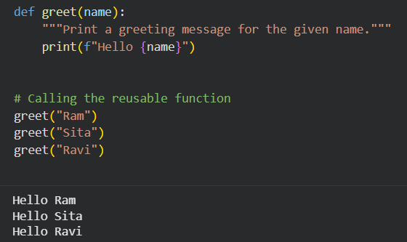

Sample Input/Output:

Explanation:
- The repeated print statements were refactored into a single reusable function named greet.
- A parameter name was introduced to allow dynamic greeting messages.
- This eliminates code repetition and improves maintainability.
- The function follows modular programming principles.
- A docstring was added for better documentation and readability.
- The output remains exactly the same as the original code.

Task 5: (Efficiency Enhancement)

Prompt:
Optimize the following Python code to improve performance without changing its output. Apply efficient Python techniques and maintain readability

Code:

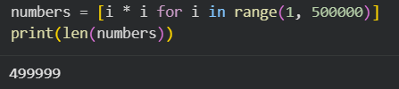

Sample Input/Output:

Explanation:
- The original code used a loop with append(), which is slower due to repeated list resizing operations.
- The optimized version uses a list comprehension, which is faster and more memory-efficient in Python.
- List comprehensions are internally optimized and execute quicker than manual loops.
- The functionality remains exactly the same generating squares from 1 to 499999.
- The length of the list is unchanged, ensuring identical output.
- The new version improves performance while keeping the code concise and readable.

