SCHOOL OF COMPUTER SCIENCE AND ARTIFICIAL INTELLIGENCE |  |  |  |  | DEPARTMENT OF COMPUTER SCIENCE ENGINEERING
ProgramName:B. Tech |  |  |  | Assignment Type: Lab |  |  | AcademicYear:2025-2026
Course Coordinator Name |  |  |  | Dr. Rishabh Mittal
Instructor(s) Name
  Mr. S Naresh Kumar
  Ms. B. Swathi
  Dr. Sasanko Shekhar Gantayat
  Mr. Md Sallauddin
  Dr. Mathivanan
  Mr. Y Srikanth
  Ms. N Shilpa
  Dr. Rishabh Mittal (Coordinator)
  Dr. R. Prashant Kumar
  Mr. Ankushavali MD
  Mr. B Viswanath
  Ms. Sujitha Reddy
  Ms. A. Anitha
  Ms. M.Madhuri
  Ms. Katherashala Swetha
  Ms. Velpulasumalatha
  Mr. Bingi Raju
CourseCode |  |  | 23CS002PC304 | CourseTitle |  | AI Assisted Coding
Year/Sem |  |  | III/II | Regulation |  | R23
DateandDay  of Assignment |  |  | Week6 - Tuesday | Time(s)
Duration |  |  | 2 Hours | Applicableto  Batches |  | 23CSBTB01 To 23CSBTB52
AssignmentNumber:12.1(Presentassignmentnumber)/24(Totalnumberofassignments)
 | Q.No. | Question |  |  |  |  |  | Expected Time  to complete
 | 1 | Lab 12: Algorithms with AI Assistance – Sorting, Searching, and Optimizing Algorithms  Lab Objectives:  - Apply AI-assisted programming to implement and optimize sorting and searching algorithms.  - Compare different algorithms in terms of efficiency and use cases.  - Understand how AI tools can suggest optimized code and complexity improvements.  Task Description -1 (Data Structures – Stack Implementation with AI Assistance)  - Task: Use AI assistance to generate a Python program that implements a Stack data structure.  Instructions:  Prompt AI to create a Stack class with the following methods:  - push(element)  - pop()  - peek()  - is_empty()  - Ensure proper error handling for stack underflow.  - Ask AI to include clear docstrings for each method.  Expected Output:  - A functional Python program implementing a Stack using a class.  - Properly documented methods with docstrings.  Task Description -2 (Algorithms – Linear vs Binary Search Analysis)  - Task: Use AI to implement and compare Linear Search and Binary Search algorithms in Python.  Instructions:  - Prompt AI to generate:  - linear_search(arr, target)  - binary_search(arr, target)  - Include docstrings explaining:  - Working principle  - Test both algorithms using different input sizes.  Expected Output:  - Python implementations of both search algorithms.  - AI-generated comments and complexity analysis.  - Test results showing correctness and comparison.  Task Description -3 (Test Driven Development – Simple Calculator Function)  - Task:  Apply Test Driven Development (TDD) using AI assistance to develop a calculator function.  Instructions:  - Prompt AI to first generate unit test cases for addition and subtraction.  - Run the tests and observe failures.  - Ask AI to implement the calculator functions to pass all tests.  - Re-run the tests to confirm success.  Expected Output:  - Separate test file and implementation file.  - Test cases executed before implementation.  - Final implementation passing all test cases.  Task Description -4 (Data Structures – Queue Implementation with AI Assistance)  - Task:  Use AI assistance to generate a Python program that implements a Queue data structure.  Instructions:  - Prompt AI to create a Queue class with the following methods:  - enqueue(element)  - dequeue()  - front()  - is_empty()  - Handle queue overflow and underflow conditions.  - Include appropriate docstrings for all methods.  Expected Output:  - A fully functional Queue implementation in Python.  - Proper error handling and documentation.  Task Description -5 (Algorithms – Bubble Sort vs Selection Sort)  - Task:  Use AI to implement Bubble Sort and Selection Sort algorithms and compare their behavior.  Instructions:  - Prompt AI to generate:  - bubble_sort(arr)  - selection_sort(arr)  - Include comments explaining each step.  - Add docstrings mentioning time and space complexity.  Expected Output:  - Correct Python implementations of both sorting algorithms.  - Complexity analysis in docstrings.  Note: Report should be submitted a word document for all tasks in a single document with prompts, comments & code explanation, and output and if required, screenshots. |  |  |  |  |  | Week6 - Tuesday

Task 1: (Data Structures – Stack Implementation with AI Assistance)

Prompt:
Generate a Python program that implements a Stack class with push, pop, peek, and is_empty methods including proper error handling for stack underflow. Include clear docstrings for each method and demonstrate usage with example operations.

Code:
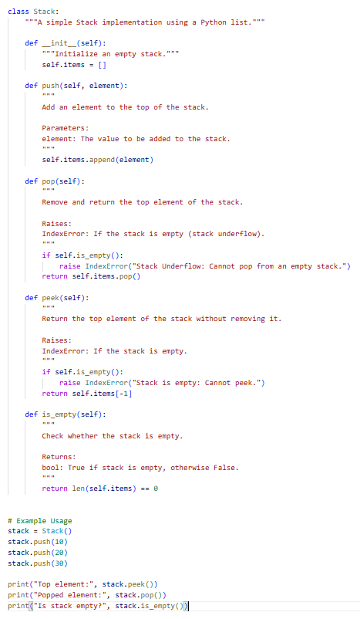

Smple Input/Output:

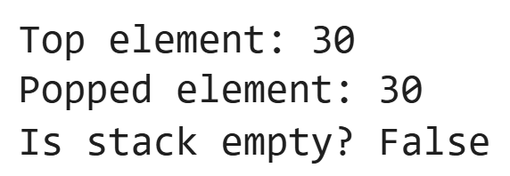

Explanation:
- A Stack class is created using a Python list as the underlying data structure.
- The __init__ method initializes an empty list to store stack elements.
- The push() method adds elements to the top of the stack using the append() function.
- The pop() method removes the top element and includes proper underflow error handling.
- The peek() method returns the top element without removing it and checks if the stack is empty.
- The is_empty() method returns a boolean value indicating whether the stack contains elements.
- Meaningful docstrings are provided for each method explaining purpose, parameters, return values, and exceptions.
- Example usage demonstrates stack operations and verifies correctness.

Task 2: (Algorithms – Linear vs Binary Search Analysis)

Prompt:
Generate Python implementations of linear_search(arr, target) and binary_search(arr, target) with proper docstrings explaining their working principles and time complexity. Include test cases with different input sizes and print results to compare correctness and behavior.

Code:

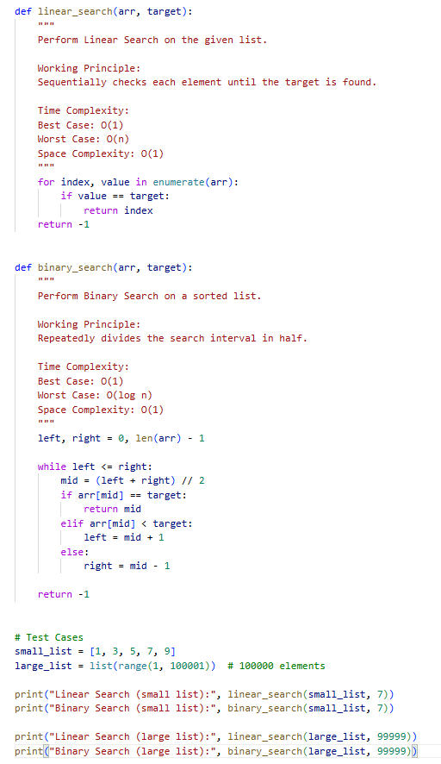

Smple Input/Output:
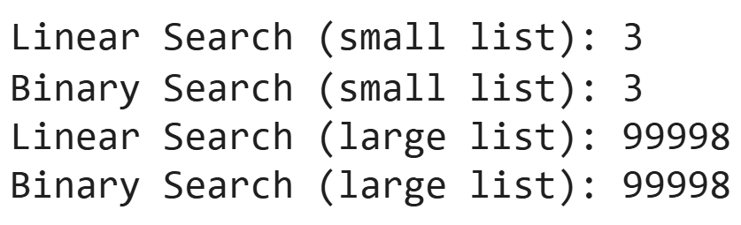

Explanation:
- Two search algorithms are implemented: Linear Search and Binary Search.
- Linear Search checks elements sequentially until the target is found or the list ends.
- Binary Search works only on sorted arrays and repeatedly divides the search space into halves.
- Linear Search has a worst-case time complexity of O(n), making it slower for large datasets.
- Binary Search has a worst-case complexity of O(log n), making it much faster for large sorted data.
- Both functions return the index of the target element or -1 if not found.
- Test cases are provided for both small and large input sizes to verify correctness.
- The comparison demonstrates how Binary Search performs more efficiently as input size increases.

Task 3: (Test Driven Development – Simple Calculator Function)

Prompt:
Generate Python unit test cases for addition and subtraction functions using unittest before implementing them. Then implement the calculator functions so that all tests pass successfully and demonstrate test execution.

Code:
def add(a, b):
"""
Return the sum of two numbers.
Time Complexity: O(1)
Space Complexity: O(1)
"""
return a + b

def subtract(a, b):
"""
Return the difference between two numbers.
Time Complexity: O(1)
Space Complexity: O(1)
"""
return a – b
import unittest
from calculator import add, subtract

class TestCalculator(unittest.TestCase):

def test_add(self):
self.assertEqual(add(5, 3), 8)
self.assertEqual(add(-1, 1), 0)

def test_subtract(self):
self.assertEqual(subtract(10, 4), 6)
self.assertEqual(subtract(0, 5), -5)

if __name__ == "__main__":
unittest.main()

Smple Input/Output:
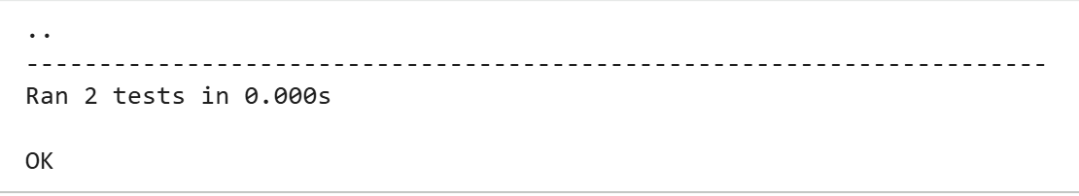

Explanation:
- Test Driven Development (TDD) begins by writing unit tests before implementation.
- The unittest framework is used to define structured test cases.
- Test cases check both positive and negative scenarios for addition and subtraction.
- Initially, tests fail because the implementation file does not exist.
- The calculator.py file is then created with add and subtract functions.
- After implementation, tests are executed again to verify correctness.
- Both functions pass all test cases, confirming successful development.
- This approach ensures reliability, reduces bugs, and promotes clean software design.

Task 4: (Data Structures – Queue Implementation with AI Assistance)

Prompt:
Generate a Python program that implements a Queue class with enqueue, dequeue, front, and is_empty methods including proper handling of overflow and underflow conditions. Include clear docstrings for each method and demonstrate the queue operations with example usage.

Code:
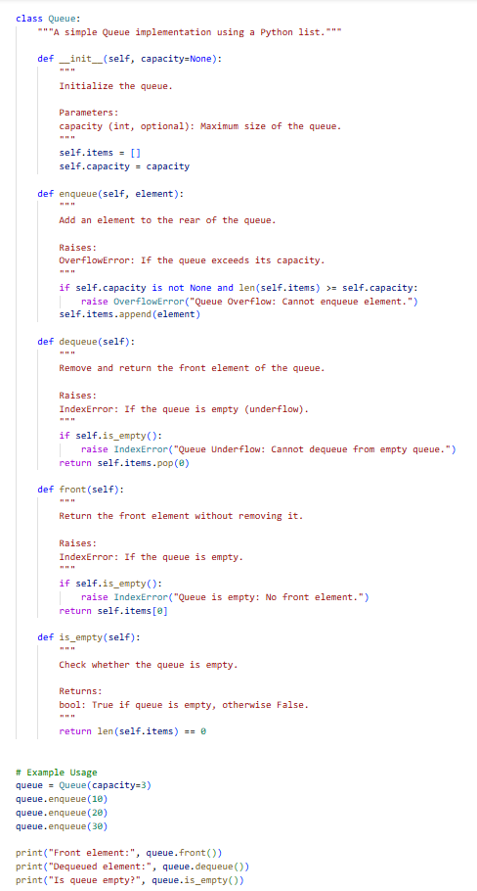
Smple Input/Output:
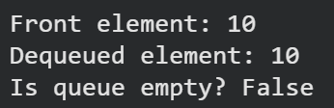

Explanation:
- A Queue class is implemented using a Python list to store elements.
- The enqueue() method adds elements to the rear of the queue and checks for overflow using the defined capacity.
- The dequeue() method removes elements from the front and handles underflow if the queue is empty.
- The front() method returns the first element without removing it.
- The is_empty() method checks whether the queue contains elements.
- Overflow is handled using OverflowError when capacity is exceeded.
- Underflow is handled using IndexError when attempting to remove from an empty queue.
- Example usage demonstrates correct functionality and validates queue behavior.

Task 5: (Algorithms – Bubble Sort vs Selection Sort)

Prompt:
Generate Python implementations of bubble_sort(arr) and selection_sort(arr) including step-by-step comments and docstrings mentioning time and space complexity. Demonstrate both algorithms with example input and compare their behavior.

Code:
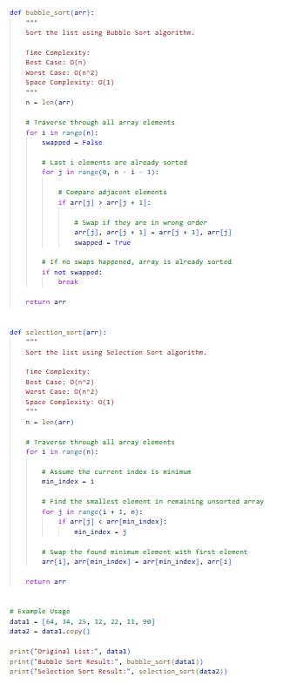
Smple Input/Output:
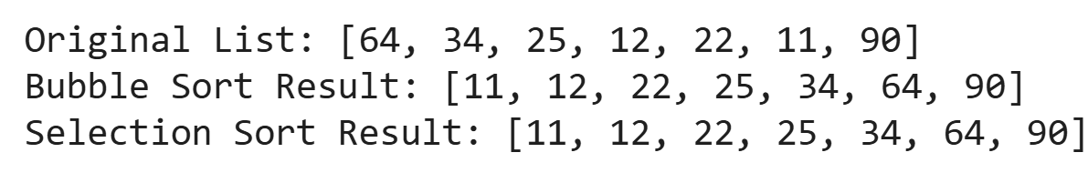

Explanation:
- Two sorting algorithms are implemented: Bubble Sort and Selection Sort.
- Bubble Sort repeatedly compares adjacent elements and swaps them if they are in the wrong order.
- It includes an optimization using a swapped flag to stop early if the list becomes sorted.
- Selection Sort repeatedly selects the minimum element from the unsorted portion and places it correctly.
- Bubble Sort has a best-case complexity of O(n) when the list is already sorted.
- Selection Sort has O(n²) time complexity in both best and worst cases.
- Both algorithms use O(1) extra space since sorting is done in-place.
- Example usage demonstrates correctness and allows comparison of behavior.

