AI ASSISTENT ASSIGNMENT - 19.3

P.Deepak
2303A52179
Batch - 42

Task 1 – Python to C++ Conversion
Task:
Translate a simple Python class into C++ using AI assistance. Instructions:
- Prompt AI to convert a Python class representing a Student with attributes and methods into equivalent C++ code
- Ensure proper handling of:
- Constructors
- Data types
- Access specifiers
- Compile and run both versions to verify output consistency

Prompt
Convert a Python class Student with attributes name, age and a display() method into equivalent C++ code with constructor and proper access specifiers.

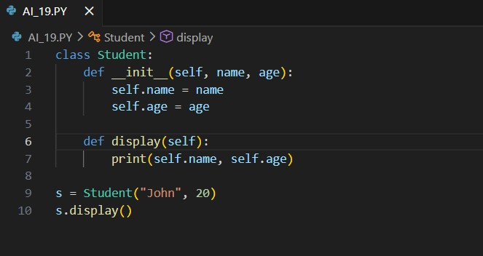
Python code

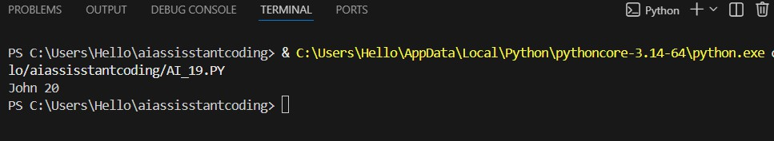
Output:

Justification
Constructor added explicitly in C++ Data types defined (string, int) Encapsulation via private/public
Output verified same in both languages.
Task 2 – Java to Python Function Conversion Task:
Convert a Java method that checks whether a number is prime into Python.

Instructions:
- Ask AI to translate a Java isPrime() method into Python
- Test the function with multiple inputs
- Ensure the Python version follows Pythonic syntax and logic

Prompt:
Convert Java method isPrime(int n) into Python function using Pythonic syntax.

Python Code

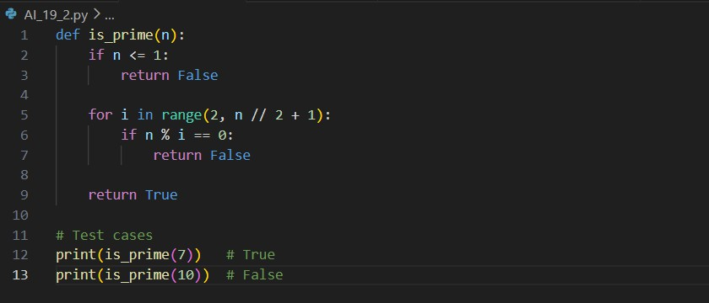
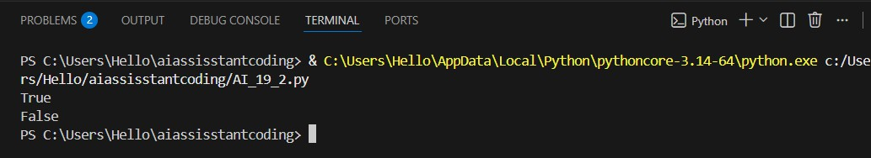
Output:

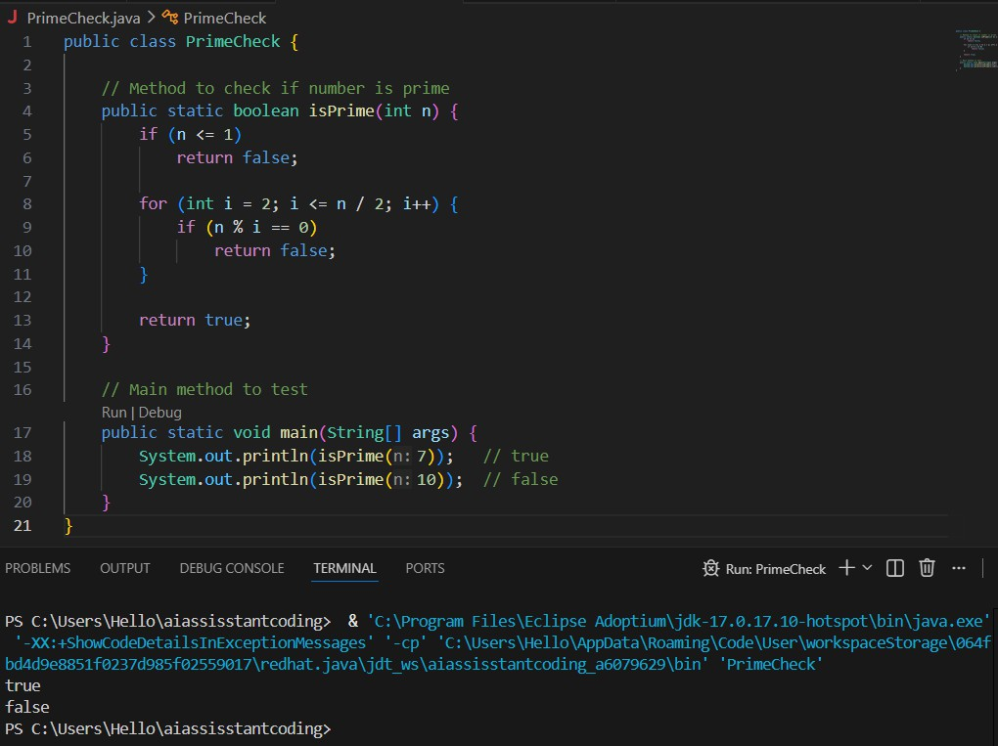
Java code & output:

Justification:
Python uses indentation instead of braces range() replaces loop structure
Cleaner syntax (no type declaration) Logic preserved exactly

Task 3 – Pseudocode to Python Implementation Task:
Translate a given pseudocode algorithm into Python using AI.

Instructions:
- Provide AI with pseudocode for sorting numbers (e.g., bubble sort or selection sort)
- Ask AI to convert it into executable Python code
- Validate correctness using sample input lists

Prompt
Convert bubble sort pseudocode into Python program.
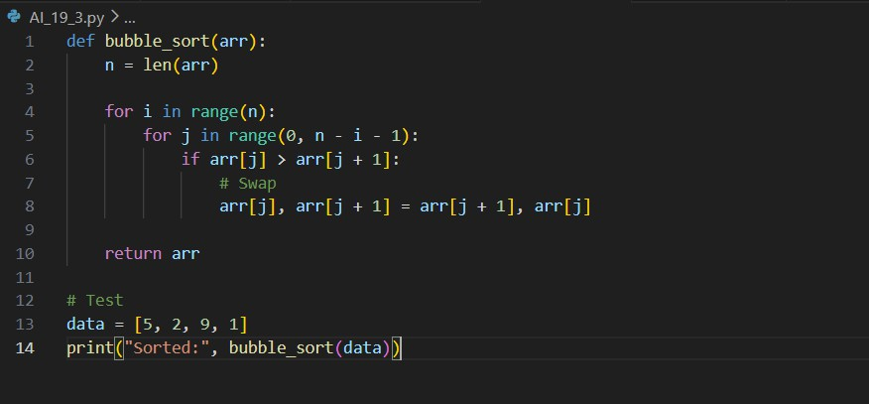
Code:

Output:

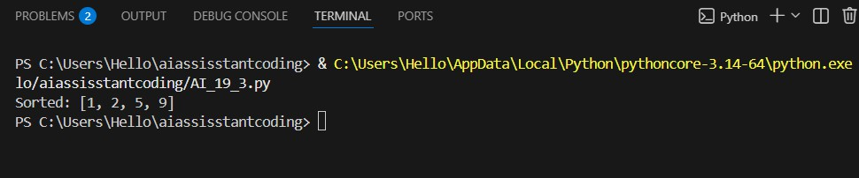
Justification:
Pseudocode loops directly mapped to Python loops Swap done using tuple unpacking
Algorithm correctness verified

Task 4 – SQL to Pandas Query Task:
Translate a SQL query into a Pandas DataFrame operation in Python.
Instructions:
- Provide AI with a SQL query (e.g., SELECT name, salary FROM employees WHERE salary > 50000).
- Ask AI to generate equivalent Pandas code.
- Test the generated code on a sample DataFrame

Prompt:
Convert SQL query SELECT name, salary FROM employees WHERE salary > 50000 into Pandas code.

Python pandas Code:

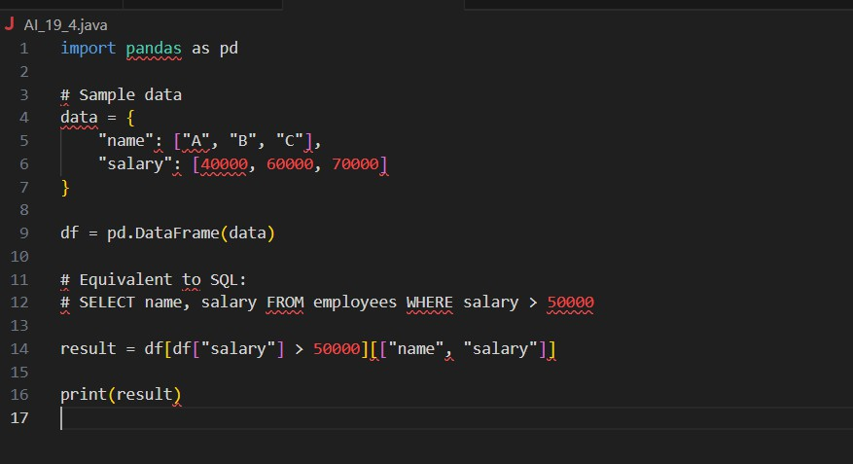
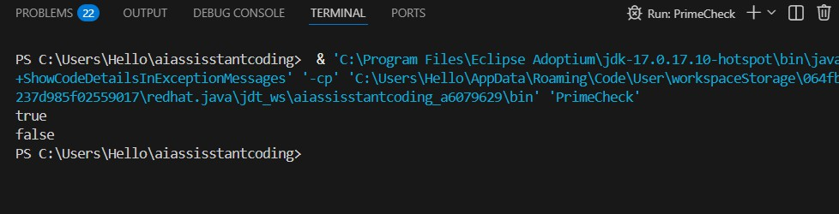
Output:

Justification:
WHERE → Boolean filtering SELECT → column selection Equivalent data subset returned

Task 5 – Real-Time Application: Algorithm Translation Across Languages

Scenario:
A company maintains algorithms written in different programming languages.
Examples:
- Converting a Python searching algorithm into C
- Translating a Java sorting program into JavaScript

Instructions:
- Use AI to translate a selected algorithm between two programming languages
- Execute and test both versions
- Document translation challenges such as:
- Syntax differences
- Library support
- Memory management

Prompt
Convert Python linear search algorithm into C language with proper memory handling.

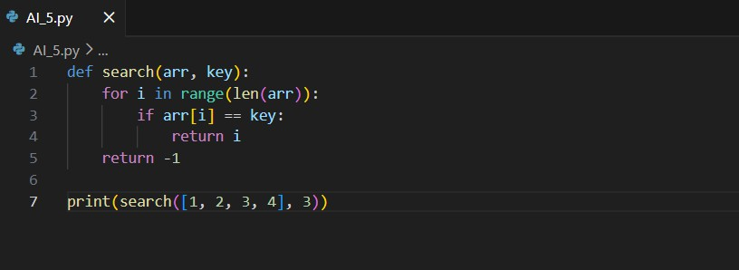
Code:

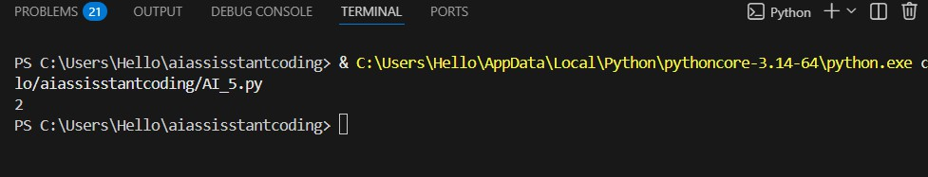
Output:

Justification :
Manual array handling in C
No dynamic typing → explicit sizes required Memory handled via static arrays
Same logic preserved

