ASSIGNMENT-1
2303A52192
TASK 0: Install & Configure GitHub Copilot (MANDATORY)
Step-by-Step
Open VS Code
Go to Extensions
Search GitHub Copilot
Click Install
Sign in using your GitHub account
Restart VS Code if asked
Screenshots to Take
Copilot extension page
GitHub sign-in success
Copilot enabled in VS Code
TASK 1: AI-Generated Logic (NO FUNCTIONS)
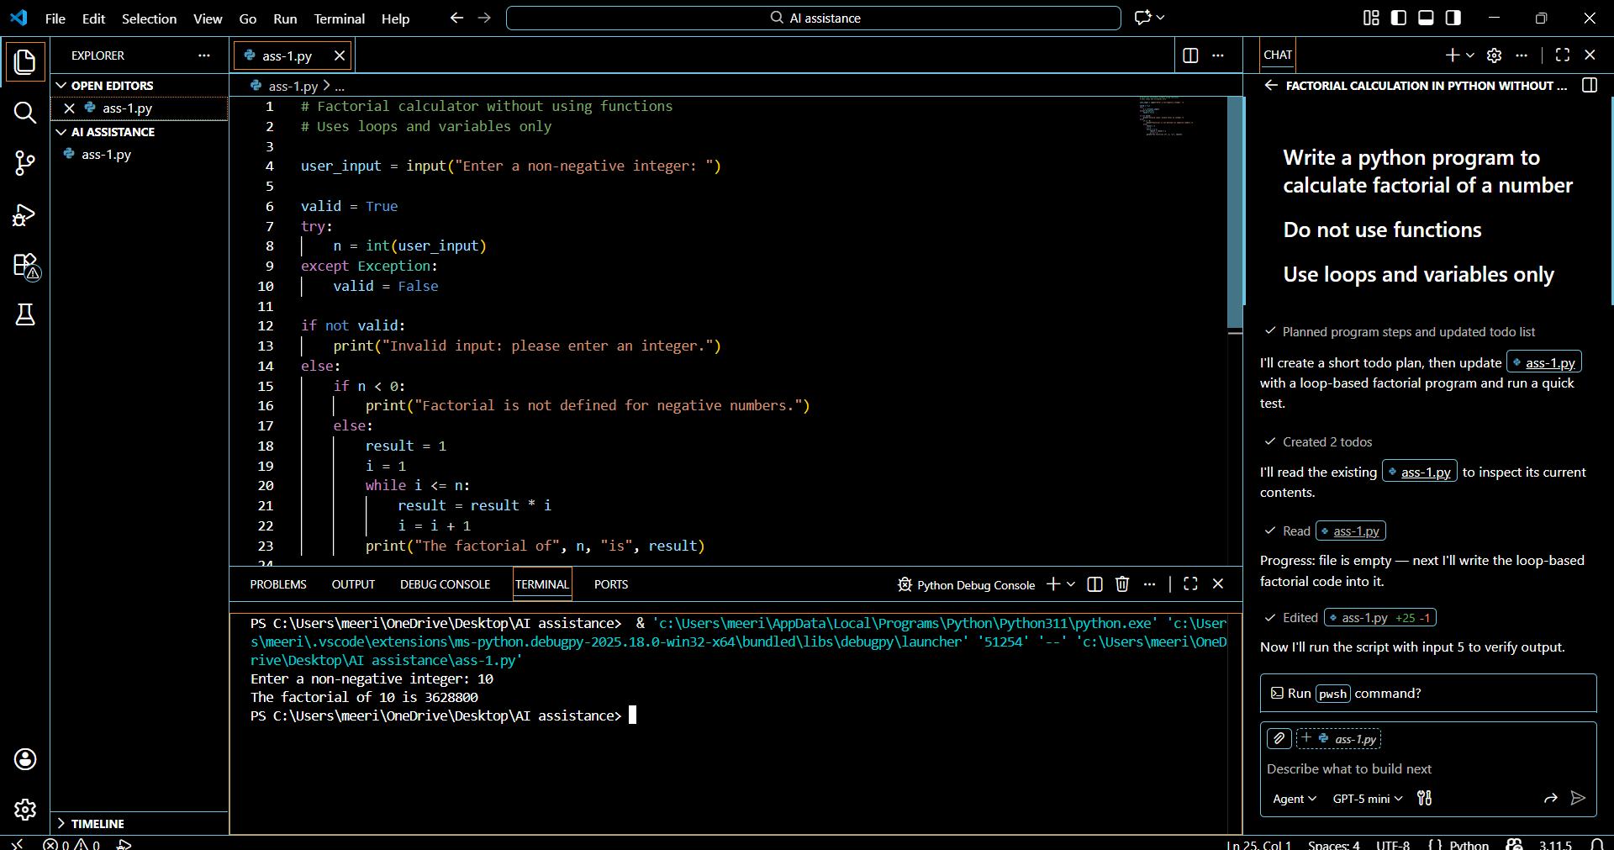

Task-2: Optimized version
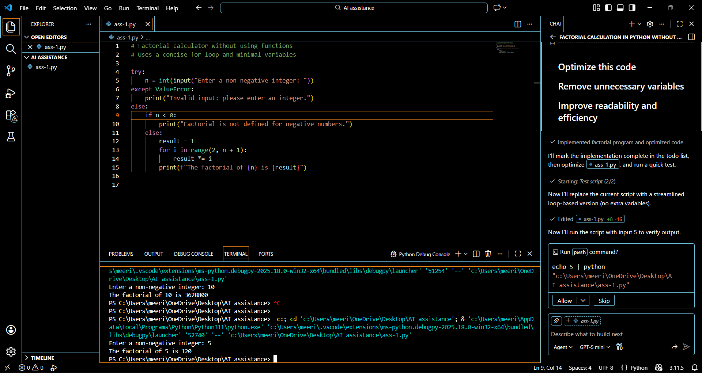

TASK 3: Modular Design (WITH FUNCTIONS)
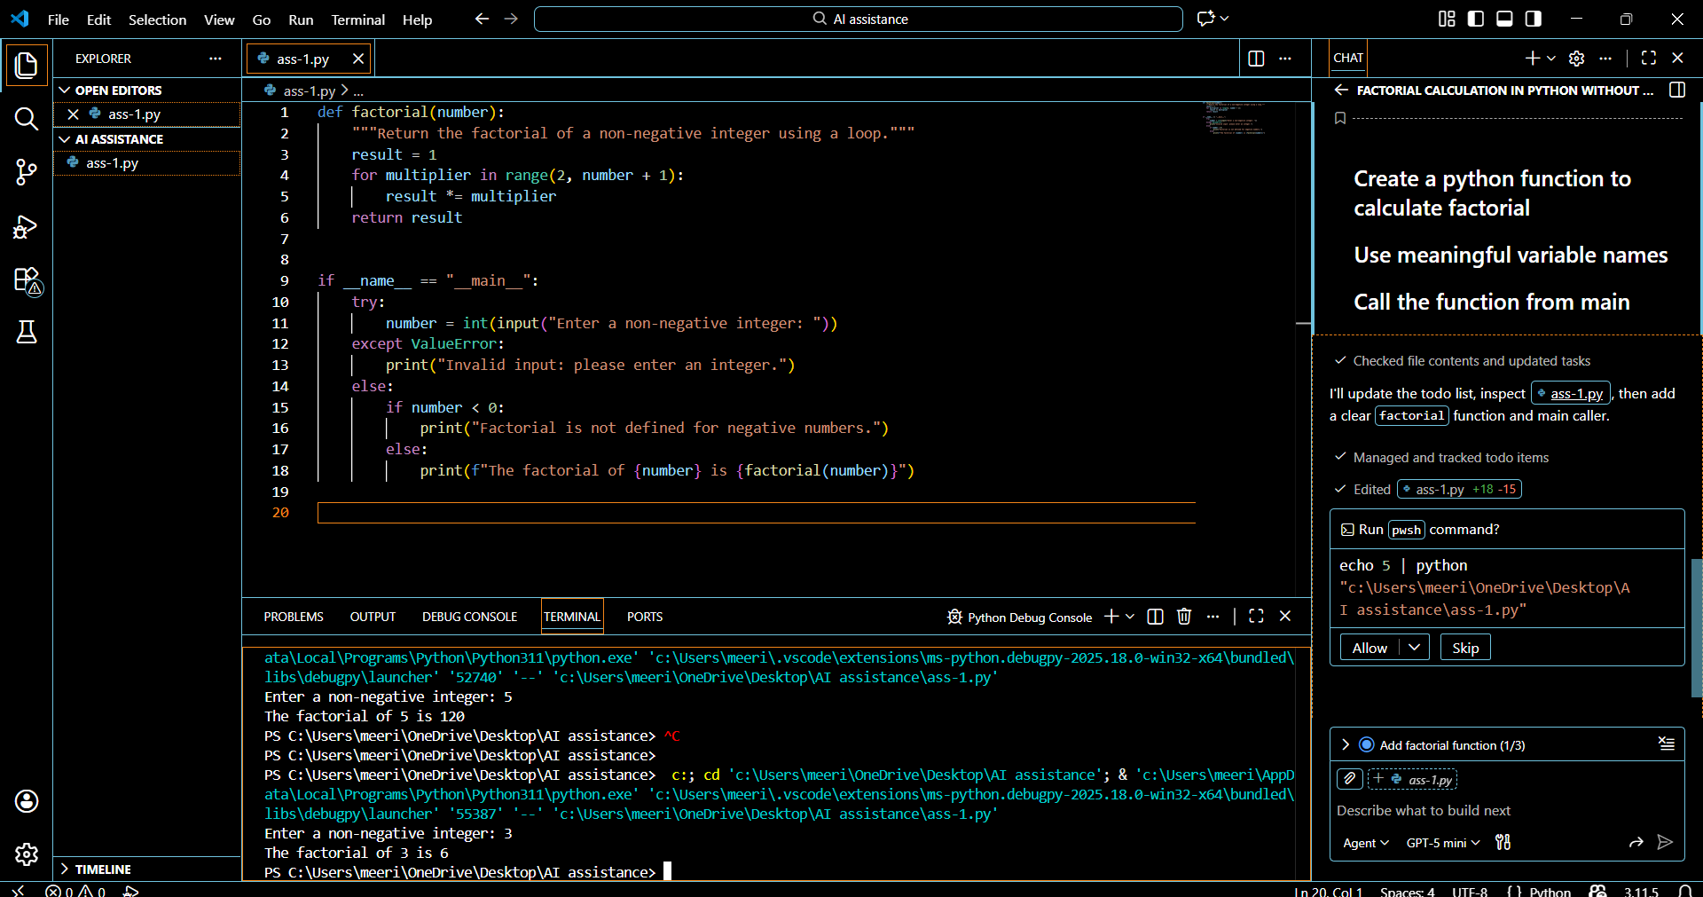

Task 4: Comparative Analysis – Procedural vs Modular AI Code
Introduction
In this task, we compare two AI-generated Python programs created using GitHub Copilot:
- A procedural version (without functions)
- A modular version (with user-defined functions)
Both programs compute the factorial of a number, but they differ in structure and design. This comparison helps justify design choices during code reviews and understand best practices in AI-assisted coding.

Comparison Table
Criteria | Procedural Code (Without Functions) | Modular Code (With Functions)
Logic Clarity | Logic is written in a single block, making it slightly harder to understand for larger programs | Logic is clearly separated into a function, making it easier to read and follow
Reusability | Cannot be reused easily; code must be rewritten if needed elsewhere | Highly reusable; the function can be called from multiple programs
Ease of Debugging | Debugging is harder since all logic is mixed together | Easier debugging because errors can be isolated inside the function
Suitability for Large Projects | Not suitable for large projects due to poor structure | Very suitable for large projects due to modular design
AI Dependency Risk | Higher risk because AI-generated code may be copied blindly without structure | Lower risk because modular code encourages review and refinement

Conclusion
The procedural approach is useful for quick, small programs or beginner-level tasks where speed is more important than structure. However, the modular approach is clearly superior for real-world applications. Function-based programs improve readability, reusability, maintainability, and debugging efficiency.
From an AI-assisted coding perspective, modular design also reduces dependency risk because developers are encouraged to understand and validate each function rather than blindly accepting AI-generated output. Therefore, for scalable and professional software development, the modular approach is strongly recommended.

TASK 5: Iterative vs Recursive AI Thinking
Iterative:
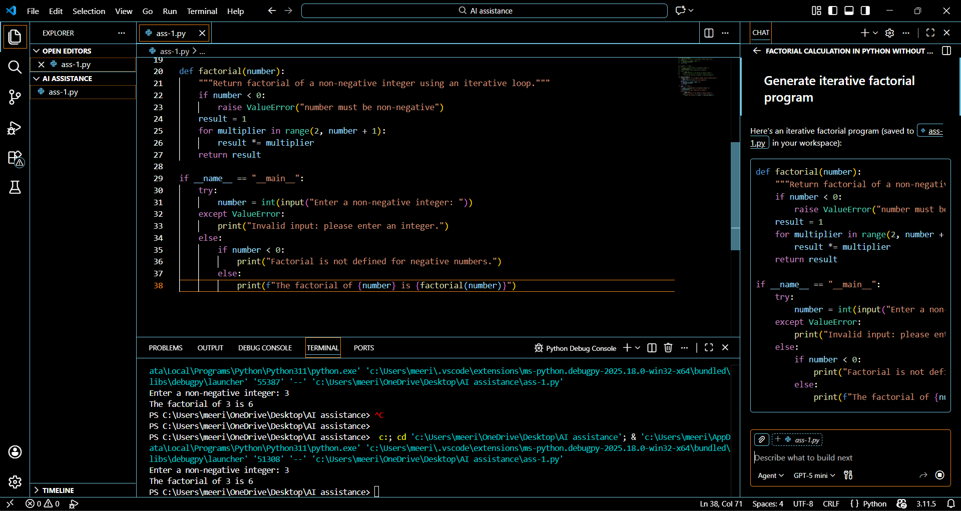

Recursive:
