School of Computer Science and Artificial Intelligence

Lab Assignment # 5.5

Program : B. Tech (CSE)
Specialization :AIML
Course Title : AI Assisted Coding
Course Code : 23CS002PC304
Semester : VI
Academic Session : 2025-2026
Name of Student : M.Sai Charani
Enrollment No. : 2303A52192
Batch No. : 34
Date :23/01/26

Task 1: Transparency in Algorithm Optimization
Prompt:
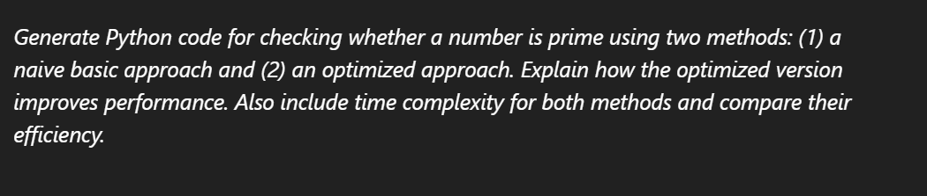
Code:
Method 1: Naive Basic Approach
def is_prime_naive(n):
if n < 2:
return False
for i in range(2, n):
if n % i == 0:
return False
return True

print(f"Is 7 prime (naive)? {is_prime_naive(7)}")
print(f"Is 10 prime (naive)? {is_prime_naive(10)}")
print(f"Is 2 prime (naive)? {is_prime_naive(2)}")
print(f"Is 1 prime (naive)? {is_prime_naive(1)}")
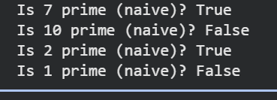

Method 2: Optimized Approach
import math

def is_prime_optimized(n):
if n < 2:
return False
if n == 2 or n == 3:
return True
if n % 2 == 0 or n % 3 == 0: # Check divisibility by 2 and 3
return False

# Check for divisors from 5 up to sqrt(n)
# We can skip numbers that are multiples of 2 or 3
# All primes greater than 3 can be written in the form 6k ± 1
i = 5
while i * i <= n:
if n % i == 0 or n % (i + 2) == 0:
return False
i += 6
return True

print(f"Is 7 prime (optimized)? {is_prime_optimized(7)}")
print(f"Is 10 prime (optimized)? {is_prime_optimized(10)}")
print(f"Is 2 prime (optimized)? {is_prime_optimized(2)}")
print(f"Is 1 prime (optimized)? {is_prime_optimized(1)}")
print(f"Is 17 prime (optimized)? {is_prime_optimized(17)}")
print(f"Is 25 prime (optimized)? {is_prime_optimized(25)}")
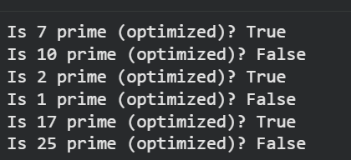
Efficiency Comparison
import time

number_to_check = 1_000_003 # A large prime number

# Time the naive approach
start_time = time.time()
result_naive = is_prime_naive(number_to_check)
end_time = time.time()
time_naive = end_time - start_time
print(f"Naive: Is {number_to_check} prime? {result_naive} (Time: {time_naive:.6f} seconds)")

# Time the optimized approach
start_time = time.time()
result_optimized = is_prime_optimized(number_to_check)
end_time = time.time()
time_optimized = end_time - start_time
print(f"Optimized: Is {number_to_check} prime? {result_optimized} (Time: {time_optimized:.6f} seconds)")

print(f"\nOptimized approach is {time_naive / time_optimized:.2f} times faster for {number_to_check}.")
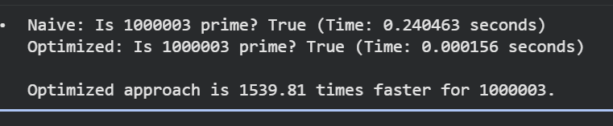
Explanation:
Method 1: Naive Basic Approach
Explanation: The naive approach for checking primality involves iterating from 2 up to the number itself (n-1) and checking if any of these numbers divide n evenly. If any number divides n without a remainder, then n is not prime. If no such divisor is found, n is prime.
Time Complexity:
- O(n): In the worst-case scenario (when n is prime), the loop runs n-2 times. For large n, this can be very slow.
Method 2: Optimized Approach
Explanation: This optimized approach leverages a few mathematical properties of prime numbers:
- Numbers less than 2 are not prime: 0 and 1 are not prime numbers.
- 2 and 3 are prime: These are base cases.
- Even numbers greater than 2 are not prime: After checking for 2, we can skip all even numbers as potential divisors.
- Divisors only need to be checked up to the square root of n: If n has a divisor d greater than sqrt(n), then it must also have a divisor n/d which is less than sqrt(n). Therefore, we only need to check for divisors up to sqrt(n). This significantly reduces the number of iterations.
How it improves performance: By reducing the upper bound of the loop from n to sqrt(n), the number of divisions performed is drastically cut down, especially for large n.
Time Complexity:
- O(sqrt(n)): In the worst-case scenario (when n is prime), the loop runs approximately sqrt(n) times. This is a significant improvement over O(n).

Task 2: Transparency in Recursive Algorithms
Prompt:
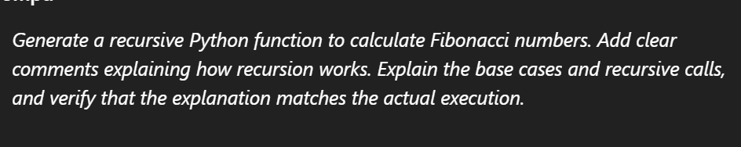
Code:
def fibonacci_recursive(n):
# Base Case 1: If n is 0, the Fibonacci number is 0
if n == 0:
return 0
# Base Case 2: If n is 1, the Fibonacci number is 1
elif n == 1:
return 1
# Recursive Case: For n > 1, sum the two preceding Fibonacci numbers
else:
return fibonacci_recursive(n - 1) + fibonacci_recursive(n - 2)

print(f"Fibonacci of 0: {fibonacci_recursive(0)}")
print(f"Fibonacci of 1: {fibonacci_recursive(1)}")
print(f"Fibonacci of 2: {fibonacci_recursive(2)}")
print(f"Fibonacci of 3: {fibonacci_recursive(3)}")
print(f"Fibonacci of 5: {fibonacci_recursive(5)}")
print(f"Fibonacci of 10: {fibonacci_recursive(10)}")
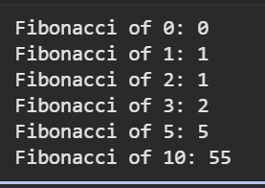
import time

number_to_check = 1_000_003 # A large prime number

# Time the naive approach
start_time = time.time()
result_naive = is_prime_naive(number_to_check)
end_time = time.time()
time_naive = end_time - start_time
print(f"Naive: Is {number_to_check} prime? {result_naive} (Time: {time_naive:.6f} seconds)")

# Time the optimized approach
start_time = time.time()
result_optimized = is_prime_optimized(number_to_check)
end_time = time.time()
time_optimized = end_time - start_time
print(f"Optimized: Is {number_to_check} prime? {result_optimized} (Time: {time_optimized:.6f} seconds)")

print(f"\nOptimized approach is {time_naive / time_optimized:.2f} times faster for {number_to_check}.")
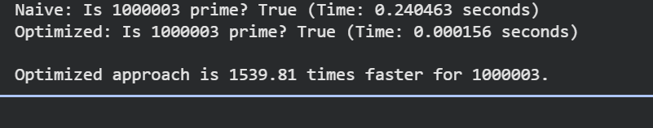
Explanation:
Explanation of Recursion: Recursion is a programming technique where a function calls itself to solve smaller instances of the same problem. To avoid infinite loops, a recursive function must have one or more 'base cases' that provide a direct solution without further recursion. The 'recursive calls' break down the problem into smaller subproblems that are solved by the function itself.
Base Cases: For the Fibonacci sequence, the first two numbers are defined as:
- fib(0) = 0
- fib(1) = 1 These are our base cases. When the function reaches n=0 or n=1, it returns a fixed value directly, stopping the recursion for that branch.
Recursive Calls: For any n > 1, the Fibonacci number is the sum of the two preceding ones: fib(n) = fib(n-1) + fib(n-2). The function makes two recursive calls to itself with n-1 and n-2 as arguments. These calls continue until they hit the base cases, and then the results are propagated back up the call stack and summed.

Task 3: Transparency in Error Handling
Prompt:
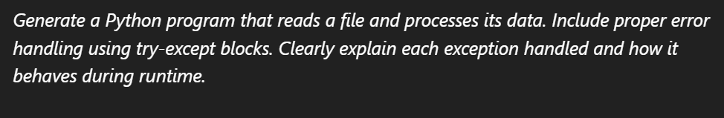
Code:
# Create a sample file for demonstration
file_content = """Line 1: Hello World!
Line 2: Python is great.
Line 3: Error Test
Line 4: 12345
"""

with open("sample_data.txt", "w") as f:
f.write(file_content)

print("Created 'sample_data.txt' for testing.")
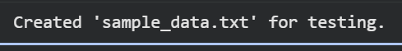
def process_file_with_error_handling(filename):
file_object = None # Initialize file_object to None
try:
# Attempt to open the file in read mode
file_object = open(filename, 'r')
print(f"\n--- Successfully opened '{filename}' ---")

processed_lines = []
line_number = 0
for line in file_object:
line_number += 1
try:
# Simulate data processing: try to convert to uppercase
# If a line is numeric, we might try to convert it to an int
clean_line = line.strip()
if clean_line.isdigit():
num = int(clean_line)
processed_lines.append(f"Line {line_number} (Number): {num * 2}") # Example operation
else:
processed_lines.append(f"Line {line_number} (Text): {clean_line.upper()}")
except ValueError as ve:
print(f"Error processing line {line_number}: '{clean_line}' - {ve}. Skipping line.")
processed_lines.append(f"Line {line_number} (Skipped due to ValueError): {clean_line}")
except Exception as e:
print(f"An unexpected error occurred on line {line_number}: {e}. Skipping line.")
processed_lines.append(f"Line {line_number} (Skipped due to unexpected error): {clean_line}")

print("\n--- Processed Data ---")
for p_line in processed_lines:
print(p_line)

except FileNotFoundError:
print(f"Error: The file '{filename}' was not found. Please check the filename and path.")
except PermissionError:
print(f"Error: You do not have sufficient permissions to access '{filename}'.")
except OSError as oe: # Catches other OS-related errors like disk full, corrupted file, etc.
print(f"An OS error occurred while accessing '{filename}': {oe}")
except Exception as e: # Catch any other unexpected errors
print(f"An unexpected error occurred during file processing: {e}")
finally:
# Ensure the file is closed, whether an error occurred or not
if file_object:
file_object.close()
print(f"\n--- File '{filename}' has been closed ---")

# --- Test Cases ---

print("\n--- Test Case 1: Valid file ---")
process_file_with_error_handling("sample_data.txt")

print("\n\n--- Test Case 2: Non-existent file ---")
process_file_with_error_handling("non_existent_file.txt")

# Example of how to trigger a permission error (might require specific OS setup)
# On Linux/macOS, try to read a file you don't have permissions for, e.g., /root/some_file.txt
# On Windows, try to read a file that's open exclusively by another program or protected
# print("\n\n--- Test Case 3: Permission error (requires specific file/OS setup) ---")
# process_file_with_error_handling("/etc/shadow") # Example on Linux (usually PermissionError)

# To simulate a ValueError during processing (e.g., if we expected an int but got text)
# This is already handled within the inner try-except for processing each line.

# Clean up the created sample file
import os
if os.path.exists("sample_data.txt"):
os.remove("sample_data.txt")
print("\nCleaned up 'sample_data.txt'.")
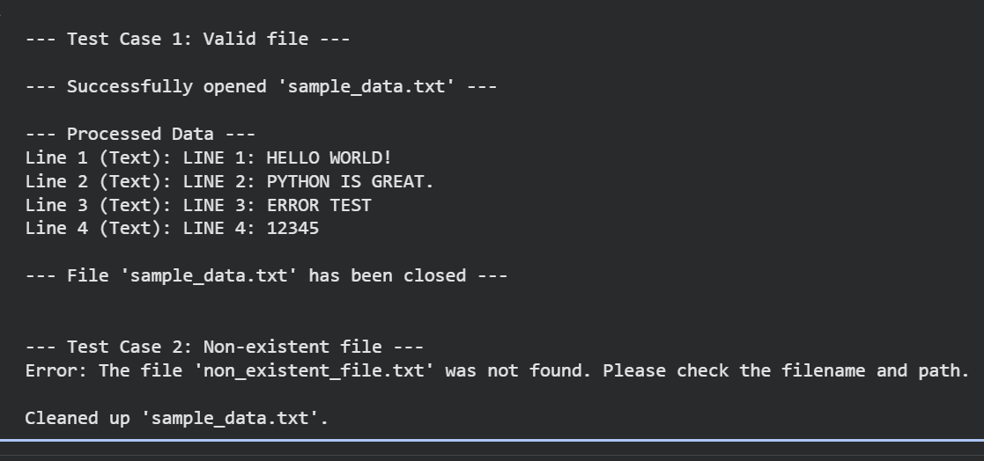
def fibonacci_recursive(n):
# Base Case 1: If n is 0, the Fibonacci number is 0
if n == 0:
return 0
# Base Case 2: If n is 1, the Fibonacci number is 1
elif n == 1:
return 1
# Recursive Case: For n > 1, sum the two preceding Fibonacci numbers
else:
return fibonacci_recursive(n - 1) + fibonacci_recursive(n - 2)

print(f"Fibonacci of 0: {fibonacci_recursive(0)}")
print(f"Fibonacci of 1: {fibonacci_recursive(1)}")
print(f"Fibonacci of 2: {fibonacci_recursive(2)}")
print(f"Fibonacci of 3: {fibonacci_recursive(3)}")
print(f"Fibonacci of 5: {fibonacci_recursive(5)}")
print(f"Fibonacci of 10: {fibonacci_recursive(10)}")
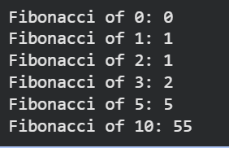
import time

number_to_check = 1_000_003 # A large prime number

# Time the naive approach
start_time = time.time()
result_naive = is_prime_naive(number_to_check)
end_time = time.time()
time_naive = end_time - start_time
print(f"Naive: Is {number_to_check} prime? {result_naive} (Time: {time_naive:.6f} seconds)")

# Time the optimized approach
start_time = time.time()
result_optimized = is_prime_optimized(number_to_check)
end_time = time.time()
time_optimized = end_time - start_time
print(f"Optimized: Is {number_to_check} prime? {result_optimized} (Time: {time_optimized:.6f} seconds)")

print(f"\nOptimized approach is {time_naive / time_optimized:.2f} times faster for {number_to_check}.")
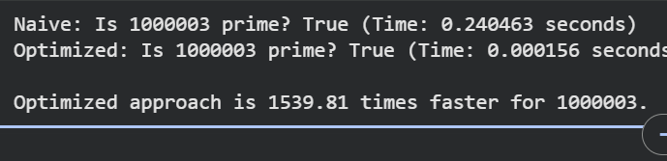
Explanation:
Explanation of Error Handling
We will handle several common exceptions that can occur during file operations:
- FileNotFoundError: This exception is raised when the program tries to open a file that does not exist at the specified path. Without handling, the program would crash.
- PermissionError: This exception occurs if the program does not have the necessary read/write permissions for the file or directory. This is a subclass of OSError.
- IOError (or OSError): This is a more general exception for I/O (Input/Output) operations. It can catch other issues like disk full errors, network connection problems when accessing remote files, or other OS-related I/O failures. FileNotFoundError and PermissionError are specific types of OSError.
- ValueError: This can occur during data processing if an operation expects a certain type of value (e.g., an integer) but receives an incompatible one (e.g., a string that cannot be converted to an integer).
- Exception: This is a catch-all exception that will capture any other unexpected errors not specifically handled by the more specific except blocks. It's a good practice to log these unexpected errors but to avoid using a bare except statement as it can hide important bugs.
We will also use a finally block to ensure that resources (like open files) are properly closed, regardless of whether an exception occurred or not.

Task 4: Security in User Authentication
Prompt:
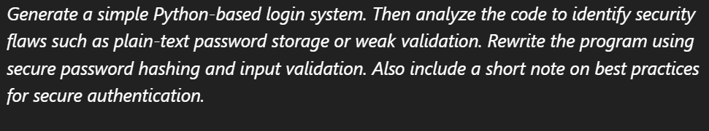
Code:
users = {}

def register_user(username, password):
if username in users:
print(f"Error: Username '{username}' already exists. Please choose a different one.")
else:
users[username] = password
print(f"User '{username}' registered successfully.")

def login_user(username, password):
if username not in users:
print(f"Error: Username '{username}' not found. Please register first.")
else:
if users[username] == password:
print(f"Login successful for user '{username}'.")
else:
print("Error: Invalid password.")

# Command-line interface
print("Welcome to the Basic Login System!")
while True:
action = input("\nChoose an action ('register', 'login', 'exit'): ").lower().strip()

if action == 'register':
username = input("Enter username: ").strip()
password = input("Enter password: ").strip()
register_user(username, password)
elif action == 'login':
username = input("Enter username: ").strip()
password = input("Enter password: ").strip()
login_user(username, password)
elif action == 'exit':
print("Exiting system. Goodbye!")
break
else:
print("Invalid action. Please choose 'register', 'login', or 'exit'.")

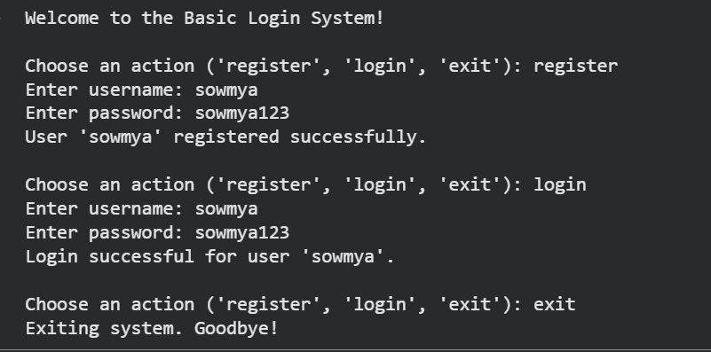
Reasoning: The first instruction is to import the bcrypt library and provide instructions for installation if it's not found. I will create a code_block to attempt the import and print a message indicating how to install it if an ImportError occurs.
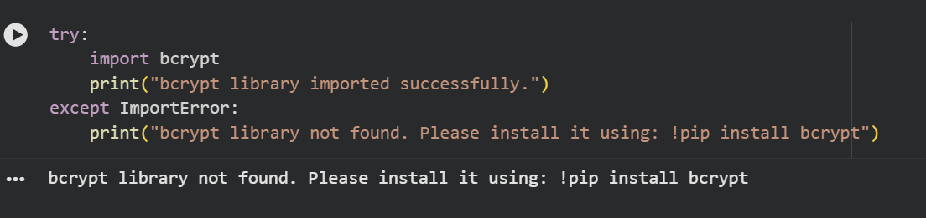
Reasoning: Since the bcrypt library was not found, I need to install it using pip as suggested in the previous output. This will make the library available for the next steps.
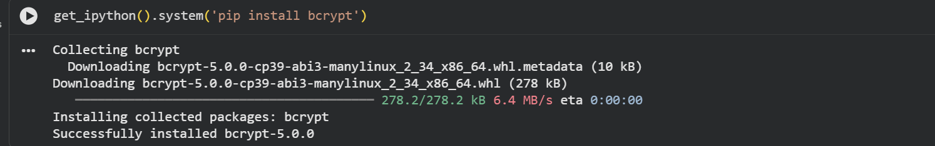
Reasoning: Now that the bcrypt library is installed, I will provide the complete, rewritten login system code that addresses the security flaws. This code will include importing bcrypt, modifying register_user to hash passwords and validate inputs, and modifying login_user to verify passwords using bcrypt.checkpw(), along with a command-line interface for testing.
Code:
import bcrypt

users = {}

def register_user(username, password):
username = username.strip()
password = password.strip()

# Input validation
if not username:
print("Error: Username cannot be empty.")
return
if len(username) < 3:
print("Error: Username must be at least 3 characters long.")
return
if not password:
print("Error: Password cannot be empty.")
return
if len(password) < 8:
print("Error: Password must be at least 8 characters long.")
return

if username in users:
print(f"Error: Username '{username}' already exists. Please choose a different one.")
else:
# Hash the password before storing
# bcrypt.gensalt() generates a salt, bcrypt.hashpw() hashes the password with the salt
hashed_password = bcrypt.hashpw(password.encode('utf-8'), bcrypt.gensalt())
users[username] = hashed_password
print(f"User '{username}' registered successfully. (Password Hashed)")

def login_user(username, password):
username = username.strip()
password = password.strip()

if username not in users:
print(f"Error: Username '{username}' not found. Please register first.")
else:
stored_hashed_password = users[username]
# Verify the provided password against the stored hash
# bcrypt.checkpw() handles salting and comparison automatically
if bcrypt.checkpw(password.encode('utf-8'), stored_hashed_password):
print(f"Login successful for user '{username}'.")
else:
print("Error: Invalid password.")

# Command-line interface
print("Welcome to the Secure Login System!")
while True:
action = input("\nChoose an action ('register', 'login', 'exit'): ").lower().strip()

if action == 'register':
username = input("Enter username (min 3 chars): ").strip()
password = input("Enter password (min 8 chars): ").strip()
register_user(username, password)
elif action == 'login':
username = input("Enter username: ").strip()
password = input("Enter password: ").strip()
login_user(username, password)
elif action == 'exit':
print("Exiting system. Goodbye!")
break
else:
print("Invalid action. Please choose 'register', 'login', or 'exit'.")

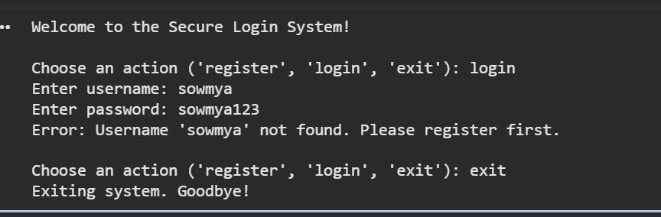
Explanation:
Explain Secure Authentication Best Practices
Subtask:
Provide a markdown explanation outlining key best practices for secure authentication, covering topics like strong password policies, multi-factor authentication, session management, and protecting against common attack vectors.

Explain Secure Authentication Best Practices
Subtask:
Provide a markdown explanation outlining key best practices for secure authentication, covering topics like strong password policies, multi-factor authentication, session management, and protecting against common attack vectors.
Secure Authentication Best Practices
Secure authentication is a critical component of any robust application, protecting user accounts and sensitive data from unauthorized access. Implementing the following best practices can significantly enhance an application's security posture.
1. Strong Password Policies
- Complexity Requirements: Enforce minimum length (e.g., 12+ characters), and require a mix of uppercase letters, lowercase letters, numbers, and special characters.
- Uniqueness: Prevent users from reusing old passwords. Encourage the use of unique passwords across different services.
- Discourage Common Passwords: Implement a blacklist of commonly used or easily guessable passwords (e.g., 'password', '123456', 'qwerty').
- No Personal Information: Advise against using easily discoverable personal information (birthdates, names) in passwords.
2. Password Hashing and Salting
- Never Store Passwords in Plain Text: This is the most fundamental rule. Plain-text passwords are a massive liability if the database is compromised.
- Use Strong, One-Way Hashing Algorithms: Employ modern, computationally intensive hashing functions like bcrypt, scrypt, or Argon2. Avoid outdated algorithms like MD5 or SHA-1, which are vulnerable to collision attacks and rainbow table attacks.
- Salt Each Password Uniquely: A "salt" is a random, unique string added to each password before hashing. This ensures that even if two users have the same password, their hashed passwords will be different. Salting prevents rainbow table attacks and makes pre-computed hash attacks ineffective.
- Adaptive Hashing (Work Factor): Modern hashing algorithms allow adjusting a "work factor" or "cost factor" to make hashing slower. This makes brute-force attacks more time-consuming, even with powerful hardware. The work factor should be periodically reviewed and increased as computing power advances.
3. Multi-Factor Authentication (MFA)
- What is MFA? MFA adds an extra layer of security by requiring users to provide two or more verification factors to gain access to an account. These factors are typically: something the user knows (password), something the user has (phone, hardware token), and something the user is (biometric).
- Why it's Important: MFA significantly reduces the risk of account compromise, even if a password is stolen or guessed, because attackers would also need access to the second factor.
- Examples: Common MFA methods include:
  - SMS-based One-Time Passwords (OTPs): A code sent to a registered mobile number.
  - Authenticator Apps: Apps like Google Authenticator or Authy generate time-based OTPs.
  - Hardware Security Keys: Physical devices like YubiKeys.
  - Biometrics: Fingerprint scans, facial recognition.
- Enable and Encourage MFA: Make MFA available to users and strongly encourage or even enforce its use, especially for privileged accounts.
4. Session Management
- Secure Session Token Generation: Generate session tokens that are long, random, unique, and unpredictable. Use cryptographically secure random number generators.
- Secure Storage: Store session tokens securely, ideally using HttpOnly and Secure flags for cookies to prevent client-side script access and ensure transmission over HTTPS only.
- Expiration: Implement strict session timeouts (e.g., inactivity timeouts, absolute timeouts) to limit the window of opportunity for attackers.
- Invalidation on Logout: Destroy session tokens on both the client and server side immediately upon user logout.
- Protection Against Session Hijacking: Regenerate session IDs after successful authentication and during privilege changes to prevent session fixation attacks.
5. Input Validation and Sanitization
- Prevent Injection Attacks: Always validate and sanitize all user input, especially for authentication credentials. This prevents common vulnerabilities such as:
  - SQL Injection (SQLi): Where malicious SQL code is injected into input fields.
  - Cross-Site Scripting (XSS): Where malicious client-side scripts are injected into web pages.
  - Command Injection: Where operating system commands are injected.
- Whitelist Validation: Prefer whitelisting (defining what is allowed) over blacklisting (defining what is forbidden) for input patterns.
- Encode Output: Encode user-provided data before displaying it in HTML or other contexts to prevent XSS.
6. Rate Limiting and Account Lockout
- Rate Limiting: Implement mechanisms to limit the number of login attempts from a single IP address or username within a given timeframe. This helps prevent brute-force and dictionary attacks.
- Account Lockout: Temporarily lock accounts after a certain number of failed login attempts. Provide clear instructions for users to unlock their accounts (e.g., via email verification).
- Progressive Delays: Instead of immediate lockout, consider progressive delays for subsequent failed attempts.
7. Logging and Monitoring
- Log Authentication Events: Record all authentication attempts, successes, and failures. Log details such as timestamp, username, IP address, and outcome.
- Monitor for Anomalies: Implement monitoring tools to detect suspicious login patterns, such as:
  - Multiple failed login attempts for a single account or from multiple accounts from a single IP.
  - Logins from unusual geographic locations or at unusual times.
  - Rapid succession of logins from different IPs.
- Alerting: Set up alerts for critical security events to enable prompt response to potential breaches.
- Retention: Retain logs for a sufficient period for forensic analysis.
8. HTTPS/TLS
- Encrypt All Communications: Always use HTTPS (HTTP Secure) with TLS (Transport Layer Security) for all communication between clients and servers. This encrypts authentication credentials and other sensitive data in transit, protecting against eavesdropping and man-in-the-middle attacks.
- Strict Transport Security (HSTS): Implement HTTP Strict Transport Security (HSTS) to force browsers to interact with the server only over HTTPS.
9. Security Headers (for Web Applications)
- Content Security Policy (CSP): Mitigates XSS attacks by specifying which dynamic resources (scripts, styles, etc.) are allowed to load.
- X-Frame-Options: Prevents clickjacking attacks by controlling whether a page can be rendered in a <frame>, <iframe>, <embed>, or <object>.
- X-Content-Type-Options: Prevents browsers from MIME-sniffing a response away from the declared content type.
- Referrer-Policy: Controls how much referrer information should be included with requests.
By diligently applying these best practices, developers and system administrators can build more secure applications that effectively protect user identities and data.

Final Task
Subtask:
Summarize the completed tasks, highlighting the evolution from an insecure to a more secure login system and the importance of secure authentication practices.

Summary:
Data Analysis Key Findings
- Initial Insecurity: The initial login system intentionally featured critical security flaws, most notably storing user passwords in plain text within a dictionary. It also lacked input validation for usernames and passwords, allowing for weak or empty credentials, and had no sanitization, which could lead to injection vulnerabilities in a more complex setup.
- Transition to Security: The system was successfully refactored to incorporate key security best practices. Passwords are now securely hashed using the bcrypt library, preventing their storage in plain text.
- Enhanced Input Validation: Robust input validation was implemented, requiring a minimum length of 3 characters for usernames and 8 characters for passwords, and ensuring neither can be empty, significantly reducing the risk of weak credentials.
- Comprehensive Security Understanding: A detailed explanation of broader secure authentication best practices was provided, covering strong password policies, multi-factor authentication (MFA), session management, input sanitization, rate limiting, logging, HTTPS/TLS, and security headers.
Insights or Next Steps
- The exercise effectively demonstrates the evolution from an insecure to a more secure login system, underscoring the critical necessity of integrating secure coding practices and robust security features to protect user data from common vulnerabilities.
- To further enhance the login system for production use, consider integrating multi-factor authentication (MFA), persisting user data in a secure database instead of in-memory, and implementing more sophisticated rate-limiting and account lockout mechanisms.

Task 5: Privacy in Data Logging
Prompt:
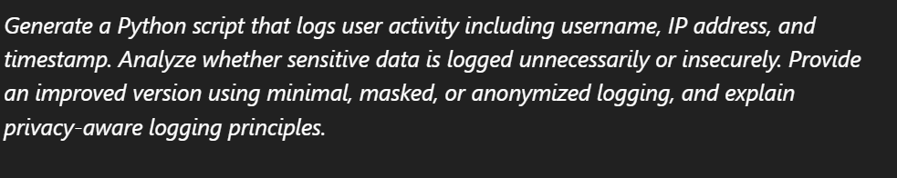
Code:
import datetime

def log_activity(username, ip_address):
"""Logs user activity including timestamp, username, and IP address to a file."""
timestamp = datetime.datetime.now().strftime("%Y-%m-%d %H:%M:%S")
log_entry = f"{timestamp} - {username} - {ip_address}\n"

try:
with open("activity_log.txt", "a") as f:
f.write(log_entry)
print(f"Activity logged for user '{username}' from IP '{ip_address}'.")
except IOError as e:
print(f"Error writing to log file: {e}")

# Simulate some user activities
print("Simulating user activities...")
log_activity("alice", "192.168.1.100")
log_activity("bob", "10.0.0.5")
log_activity("alice", "192.168.1.101") # Alice logs in from a different IP
log_activity("charlie", "172.16.0.20")
print("Simulation complete. Check 'activity_log.txt' for logs.")

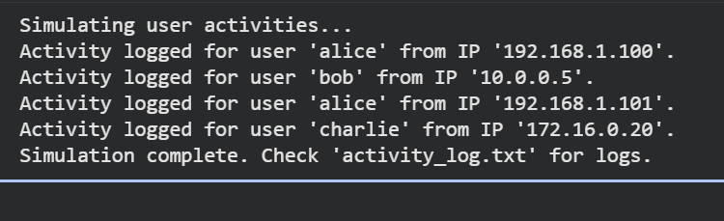
Implement Privacy-Aware Logging

import datetime
import hashlib

def log_activity_privacy_aware(username, ip_address):
"""Logs user activity with privacy-aware techniques (pseudonymized username, masked IP)."""
# 3a. Generate a current timestamp
timestamp = datetime.datetime.now().strftime("%Y-%m-%d %H:%M:%S")

# 3b. Pseudonymize the username by hashing it (SHA256)
pseudonymized_username = hashlib.sha256(username.encode('utf-8')).hexdigest()

# 3c. Mask the ip_address (assuming IPv4 and masking the last octet)
masked_ip_address = ip_address # Default to original if masking fails
if ip_address.count('.') == 3: # Simple check for IPv4 format
parts = ip_address.split('.')
if len(parts) == 4:
masked_ip_address = f"{parts[0]}.{parts[1]}.{parts[2]}.XXX"

# 3d. Construct a log entry string
log_entry = f"{timestamp} - {pseudonymized_username} - {masked_ip_address}\n"

# 3e, 3f, 3g. Open file, write entry, and handle IOError
try:
with open("privacy_activity_log.txt", "a") as f:
f.write(log_entry)
print(f"Privacy-aware activity logged for pseudonymized user (hash: {pseudonymized_username[:8]}...) from masked IP '{masked_ip_address}'.")
except IOError as e:
print(f"Error writing to privacy log file: {e}")

# 4. Simulate some privacy-aware user activities
print("\nSimulating privacy-aware user activities...")
log_activity_privacy_aware("alice", "192.168.1.100")
log_activity_privacy_aware("bob", "10.0.0.5")
log_activity_privacy_aware("alice", "192.168.1.101") # Alice logs in from a different IP
log_activity_privacy_aware("charlie", "172.16.0.20")
log_activity_privacy_aware("diana", "203.0.113.45")
print("Simulation complete. Check 'privacy_activity_log.txt' for privacy-aware logs.")

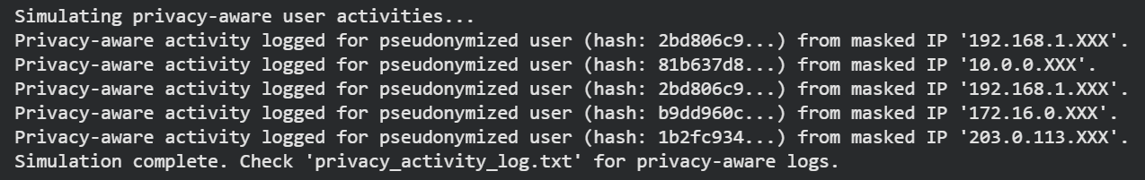
Explanation:
Explain Privacy-Aware Logging Principles
Subtask:
Provide a markdown explanation outlining key privacy-aware logging principles, including data minimization, masking, anonymization, retention policies, and secure storage.

Explain Privacy-Aware Logging Principles
Subtask:
Provide a markdown explanation outlining key privacy-aware logging principles, including data minimization, masking, anonymization, retention policies, and secure storage.
Privacy-Aware Logging Principles
Privacy-aware logging is crucial for protecting sensitive user data, maintaining user trust, and complying with data protection regulations such as GDPR, CCPA, and HIPAA. It involves implementing strategies to reduce the risk associated with logging personally identifiable information (PII) and other sensitive data.
Here are the key principles:
1. Data Minimization
Definition: Data minimization is the principle that only the absolute minimum amount of data necessary for a specific, legitimate purpose should be collected, processed, and stored. For logging, this means only recording information that is essential for operational purposes (e.g., debugging, security analysis, performance monitoring).
Importance:
- Reduces Attack Surface: Less sensitive data collected means less data is at risk in case of a breach.
- Limits Privacy Exposure: Prevents the accidental exposure of unnecessary PII.
- Enhances Compliance: Directly supports GDPR's principle of 'data minimization' and similar requirements in other privacy laws. Logging only what's needed simplifies compliance efforts.
Example: Instead of logging a full user profile on every interaction, log only a unique, non-identifying user ID and the action performed.
2. Masking
Definition: Data masking involves obscuring specific parts of sensitive data in logs to prevent its full disclosure while retaining enough information for analytical purposes. This is typically achieved by replacing sensitive characters with placeholders (e.g., asterisks, 'X's) or by using partial values.
Importance:
- Protects PII in Logs: Reduces the readability of sensitive data (like full IP addresses, email addresses, or credit card numbers) to unauthorized viewers.
- Retains Utility: Allows logs to still be useful for identifying patterns, debugging, or analyzing security incidents without revealing the exact sensitive details.
- Mitigates Breach Impact: Even if masked logs are exfiltrated, the full sensitive data is not exposed.
Example: An IP address 192.168.1.100 might be masked to 192.168.1.XXX or 192.168.XXX.XXX. An email user@example.com might be masked to u***@example.com.
3. Anonymization
Definition: Anonymization is the process of irreversibly transforming data so that it can no longer be associated with an identified or identifiable natural person. This goes beyond masking by making re-identification practically impossible.
Importance:
- Strongest Privacy Protection: Once data is properly anonymized, it generally falls outside the scope of most privacy regulations, allowing for broader use in analytics, research, and testing without privacy concerns.
- Enables Data Sharing: Facilitates the sharing of datasets for aggregate analysis without compromising individual privacy.
Example: Replacing a username with a cryptographically hashed value (e.g., hashlib.sha256('alice').hexdigest()) such that the original username cannot be recovered from the hash, but consistent activity from the same 'pseudonym' can still be tracked. This is often referred to as pseudonymization, which is a step towards full anonymization.
4. Retention Policies
Definition: Log retention policies define how long different types of log data should be stored and how they should be securely disposed of after their retention period expires. This includes specifying maximum retention periods, archiving procedures, and deletion methods.
Importance:
- Reduces Long-Term Risk: Minimizes the window of opportunity for an attacker to access old, potentially sensitive, log data.
- Cost Efficiency: Storing logs indefinitely can be expensive; policies help manage storage resources.
- Compliance with Legal Requirements: Many regulations mandate specific retention periods for certain types of data and require secure deletion. Keeping data longer than necessary can be a compliance violation.
- Ensures Secure Disposal: Mandates methods for permanently deleting logs (e.g., shredding, cryptographic erasure) to prevent recovery.
Example: Financial transaction logs might be retained for 7 years for regulatory compliance, while debugging logs might be deleted after 30 days.
5. Secure Storage
Definition: Secure storage involves implementing technical and organizational measures to protect log files from unauthorized access, modification, or destruction, both when stored at rest and when in transit.
Importance:
- Prevents Unauthorized Access: Ensures that only authorized personnel and systems can view or modify log data.
- Maintains Data Integrity: Protects logs from tampering, which is crucial for forensic analysis and auditing.
- Ensures Availability: Safeguards logs from accidental loss or corruption, ensuring they are available when needed.
- Compliance Mandate: Core requirement for almost all data protection regulations.
Examples:
- Access Controls: Restrict file system permissions, use role-based access control (RBAC) for log management systems.
- Encryption: Encrypt log files at rest (on disk) and encrypt log data in transit (e.g., using TLS for log forwarding).
- Centralized Log Management: Use secure, dedicated log management systems (e.g., SIEM solutions) with audit trails, alerting, and secure storage capabilities.
- Physical Security: Secure the infrastructure where logs are stored.
- Backup and Recovery: Implement robust backup strategies for logs and secure recovery procedures.
By systematically applying these principles, organizations can create a logging strategy that is both effective for operational needs and compliant with privacy regulations, significantly enhancing overall security and privacy posture.

Final Task
Subtask:
Summarize the transformation from insecure to privacy-aware logging, reiterating the importance of protecting user data in logging practices.

Summary:
Data Analysis Key Findings
- Initial Logging Practice: The initial logging script directly recorded Personally Identifiable Information (PII) such as full usernames and IP addresses, along with timestamps, to a plain text file (activity_log.txt).
- Insecurity Identified: Analysis revealed that logging PII in plain text to an unprotected file poses significant risks, including:
  - Plain-Text Data Storage: Direct exposure of sensitive data if file system access is compromised.
  - Privacy Violations: High risk of non-compliance with regulations like GDPR and CCPA.
  - User Profiling & Reconnaissance: Enables malicious actors to track user behavior and gather intelligence.
  - Lack of Controls: Absence of access controls, data retention policies, integrity protection, and encryption.
- Privacy-Aware Transformation: The logging script was re-engineered to incorporate privacy principles:
  - Pseudonymization: Usernames were transformed into SHA256 hashes (e.g., alice became 3ac8b0d...).
  - IP Masking: IP addresses were masked by replacing the last octet with "XXX" (e.g., 192.168.1.100 became 192.168.1.XXX).
  - The privacy-aware logs were written to a separate file (privacy_activity_log.txt), demonstrating a secure approach.
- Key Privacy Principles Explained: Comprehensive explanations were provided for:
  - Data Minimization: Only collecting essential data to reduce risk and aid compliance.
  - Masking: Obscuring parts of sensitive data to protect PII while maintaining log utility.
  - Anonymization: Irreversibly transforming data to prevent re-identification, offering strong privacy protection.
  - Retention Policies: Defining storage duration and secure disposal methods for logs.
  - Secure Storage: Implementing technical and organizational measures to protect logs from unauthorized access or modification.
Insights or Next Steps
- The transformation from insecure, direct logging of PII to a privacy-aware approach, incorporating pseudonymization and masking, significantly enhances data protection and regulatory compliance.
- Implementing robust data retention policies and secure storage mechanisms, including encryption and access controls, is crucial to fully protect logged data throughout its lifecycle and mitigate the risks identified in the initial analysis.

