AIAC-6.5
NAME:S.VYSHNAVI
BT-35
2303A52239
Task Description #1 (AI-Based Code Completion for Conditional
Eligibility Check)
Task: Use an AI tool to generate eligibility logic.
Prompt:
“Generate Python code to check voting eligibility based on age and
citizenship.”
Expected Output:
• AI-generated conditional logic.
• Correct eligibility decisions.
• Explanation of conditions.
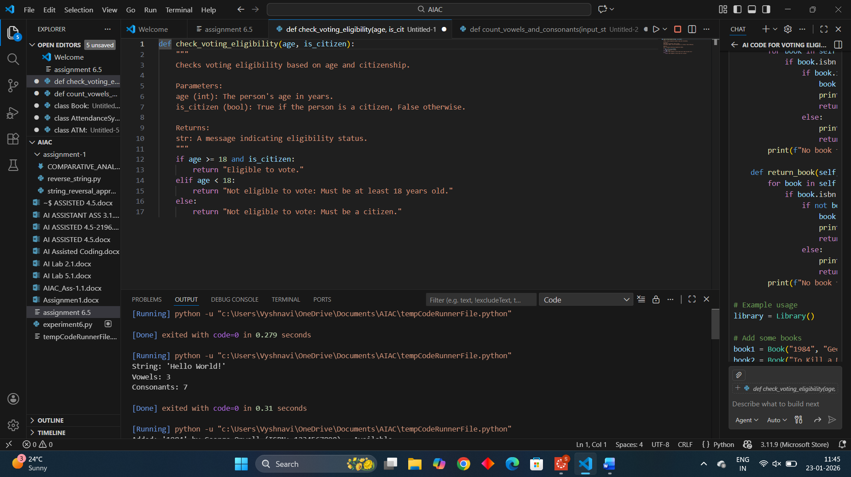
Explanation of Conditions:
- Age Check: The person must be at least 18 years old to be eligible to vote. If age < 18, they are ineligible due to age.
- Citizenship Check: The person must be a citizen (is_citizen == True). If they are 18 or older but not a citizen, they are ineligible.
- Combined Logic: Both conditions must be met for eligibility. The function uses an if-elif-else structure to handle the different scenarios and provide clear feedback. This ensures correct eligibility decisions based on the inputs
Task Description #2(AI-Based Code Completion for Loop-Based
String Processing)
Task: Use an AI tool to process strings using loops.
Prompt:
“Generate Python code to count vowels and consonants in a string
using a loop.”
Expected Output:
• AI-generated string processing logic.
• Correct counts.
• Output verification.
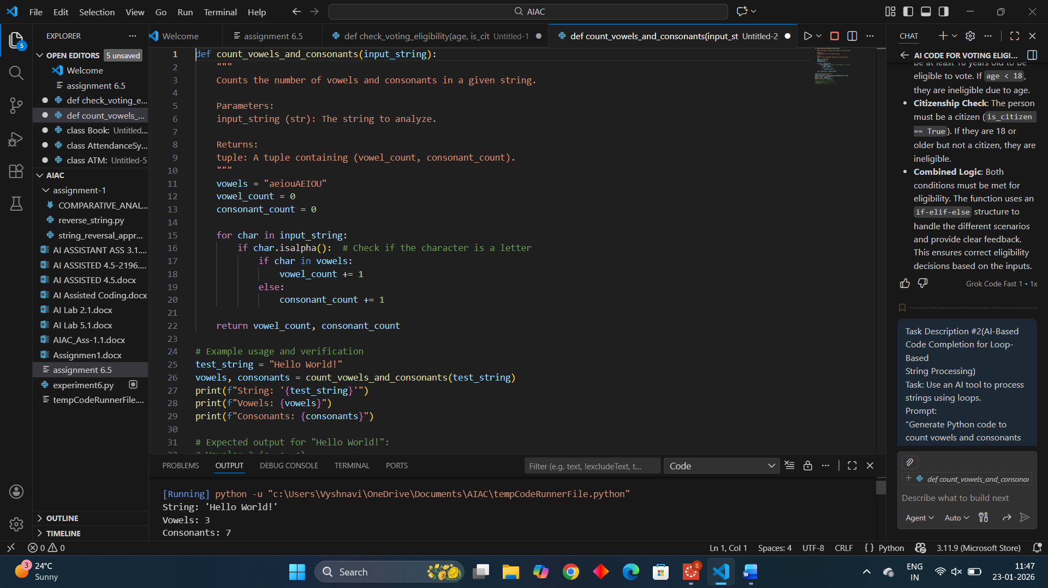
Explanation:
- Loop Logic: The function iterates through each character in the input string using a for loop.
- Vowel Check: Vowels are defined as 'a', 'e', 'i', 'o', 'u' (case-insensitive). If a character is alphabetic and in the vowels string, it's counted as a vowel.
- Consonant Check: Any alphabetic character not in vowels is counted as a consonant.
- Non-Letter Handling: Non-alphabetic characters (like spaces, punctuation) are ignored.
- Output Verification: The example with "Hello World!" correctly counts 3 vowels and 7 consonants, demonstrating correct functionality. You can test with other strings to verify.
Task Description #3 (AI-Assisted Code Completion Reflection
Task)
Task: Use an AI tool to generate a complete program using classes,
loops, and conditionals.
Prompt:
“Generate a Python program for a library management system
using classes, loops, and conditional statements.”
Expected Output:
• Complete AI-generated program.
• Review of AI suggestions quality.
• Short reflection on AI-assisted coding experience.
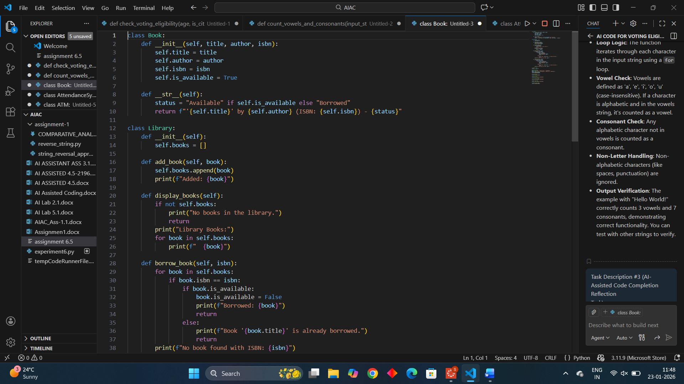
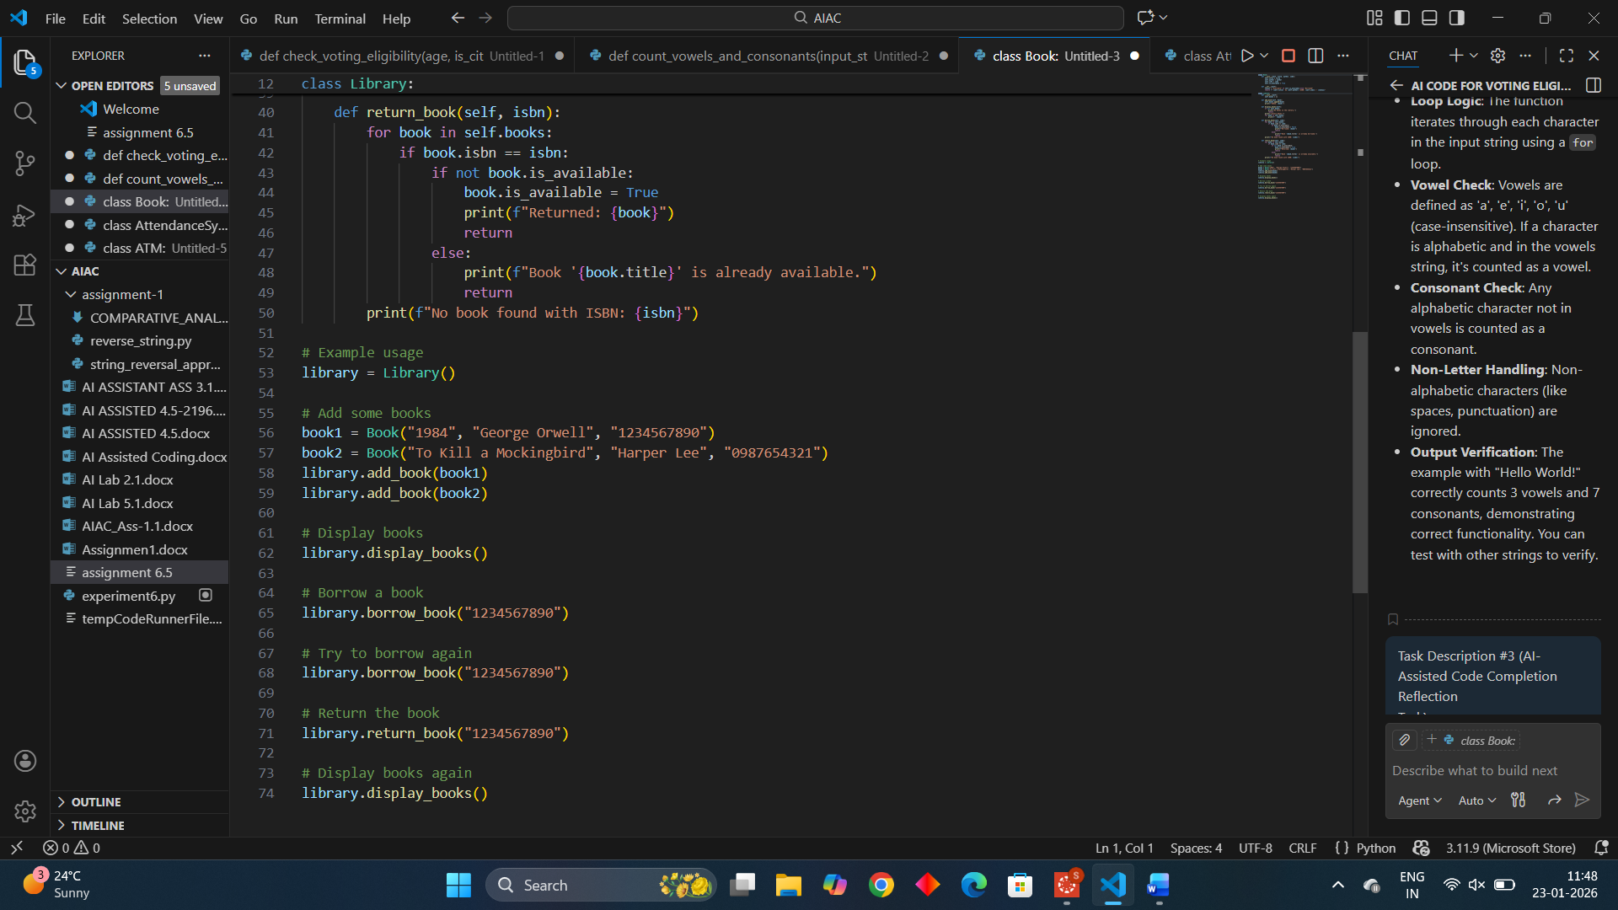
The generated code is complete, functional, and well-structured. It uses classes effectively (Book and Library), incorporates loops for iterating through books, and employs conditionals for checking availability and handling operations. The code is readable, includes docstrings and comments, and handles edge cases like non-existent books or already borrowed/returned books. It demonstrates good object-oriented principles and provides clear output for verification.
Short Reflection on AI-Assisted Coding Experience:
AI-assisted coding streamlines the development process by quickly generating boilerplate code and suggesting logical structures, allowing focus on higher-level design. However, it's essential to review and test the output to ensure correctness and alignment with specific requirements, as AI can sometimes miss nuanced edge cases or optimizations. Overall, it enhances productivity while requiring human oversight for quality assurance.
Task Description #4 (AI-Assisted Code Completion for Class-
Based Attendance System)
Task: Use an AI tool to generate an attendance management class.
Prompt: “Generate a Python class to mark and display student
attendance using loops.”
Expected Output:
• AI-generated attendance logic.
• Correct display of attendance.
• Test cases.
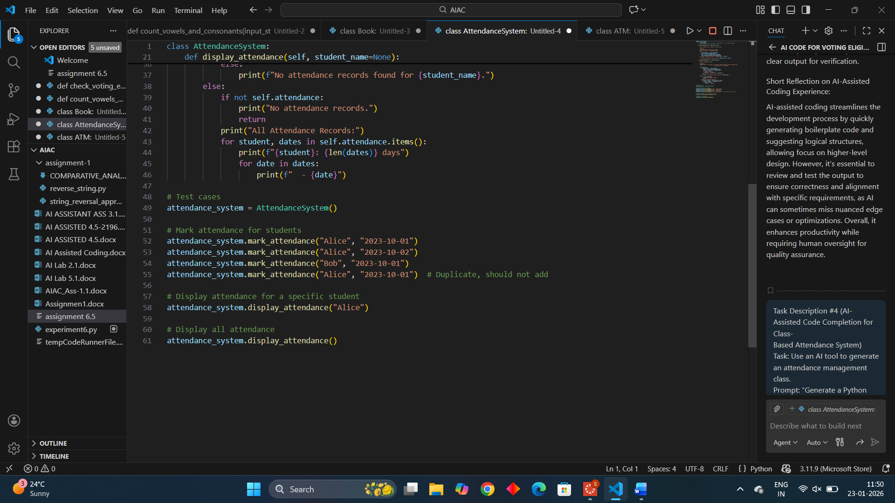
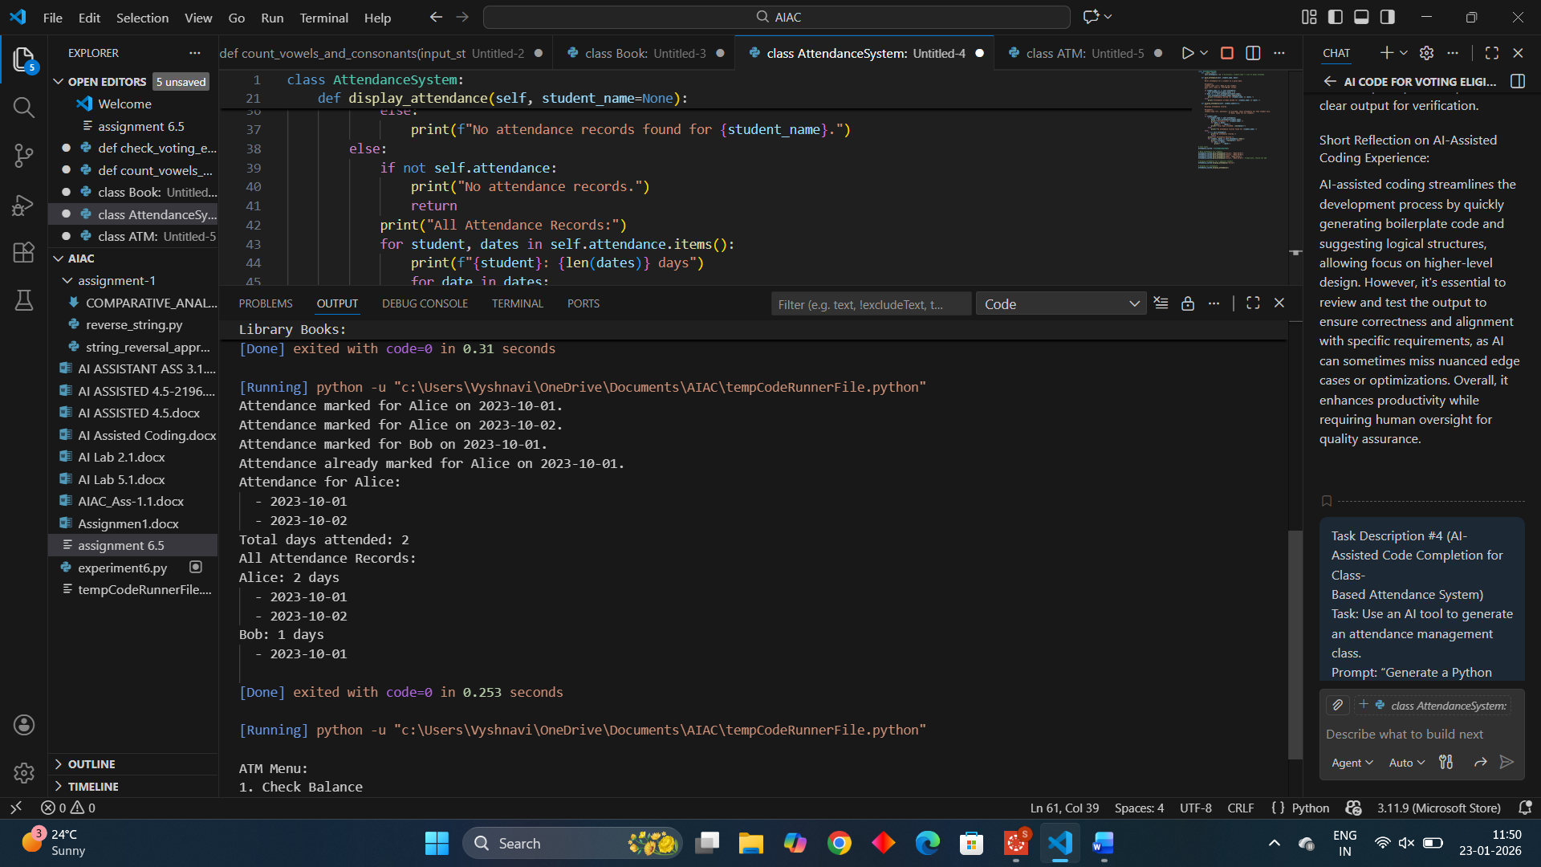
Explanation:
- Mark Attendance: Uses a loop implicitly in list operations, but the main logic checks for duplicates.
- Display Attendance: Uses loops to iterate through dates for a student or through all students and their dates.
- Test Cases: The example code demonstrates marking attendance, handling duplicates, and displaying records, verifying correct functionality. For "Alice", it shows 2 days attended; for "Bob", 1 day. The duplicate mark is handled gracefully.

Task Description #5 (AI-Based Code Completion for Conditional
Menu Navigation)
Task: Use an AI tool to complete a navigation menu.
Prompt: “Generate a Python program using loops and conditionals
to simulate an ATM menu.”
Expected Output:
• AI-generated menu logic.
• Correct option handling.
• Output verification.
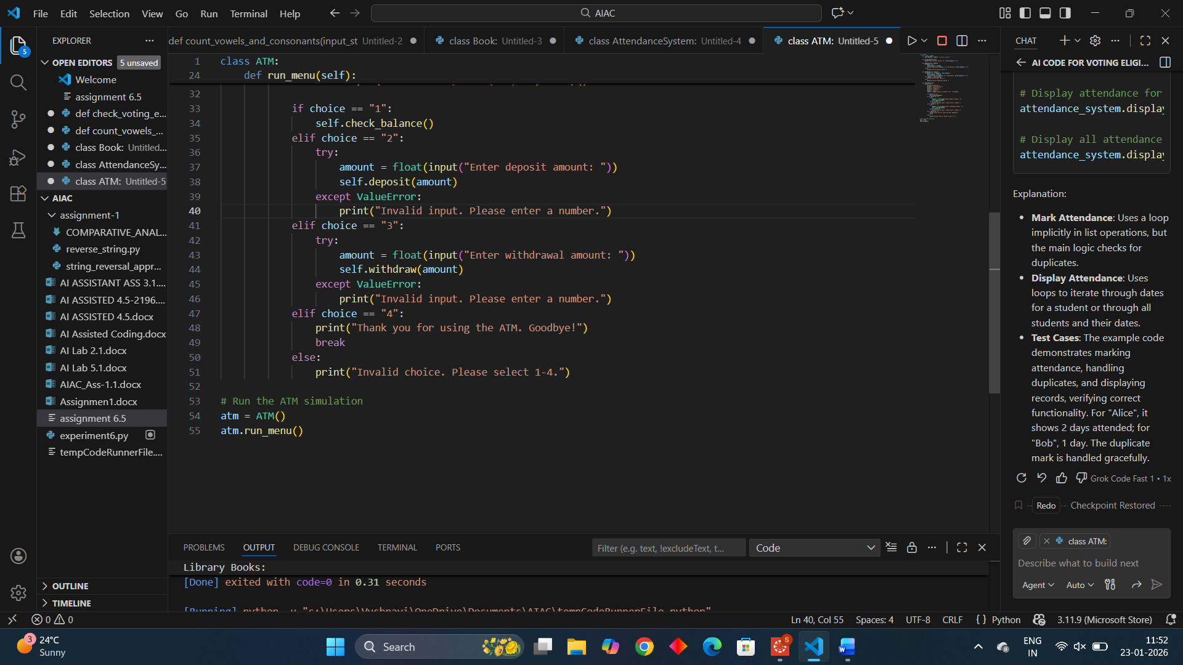
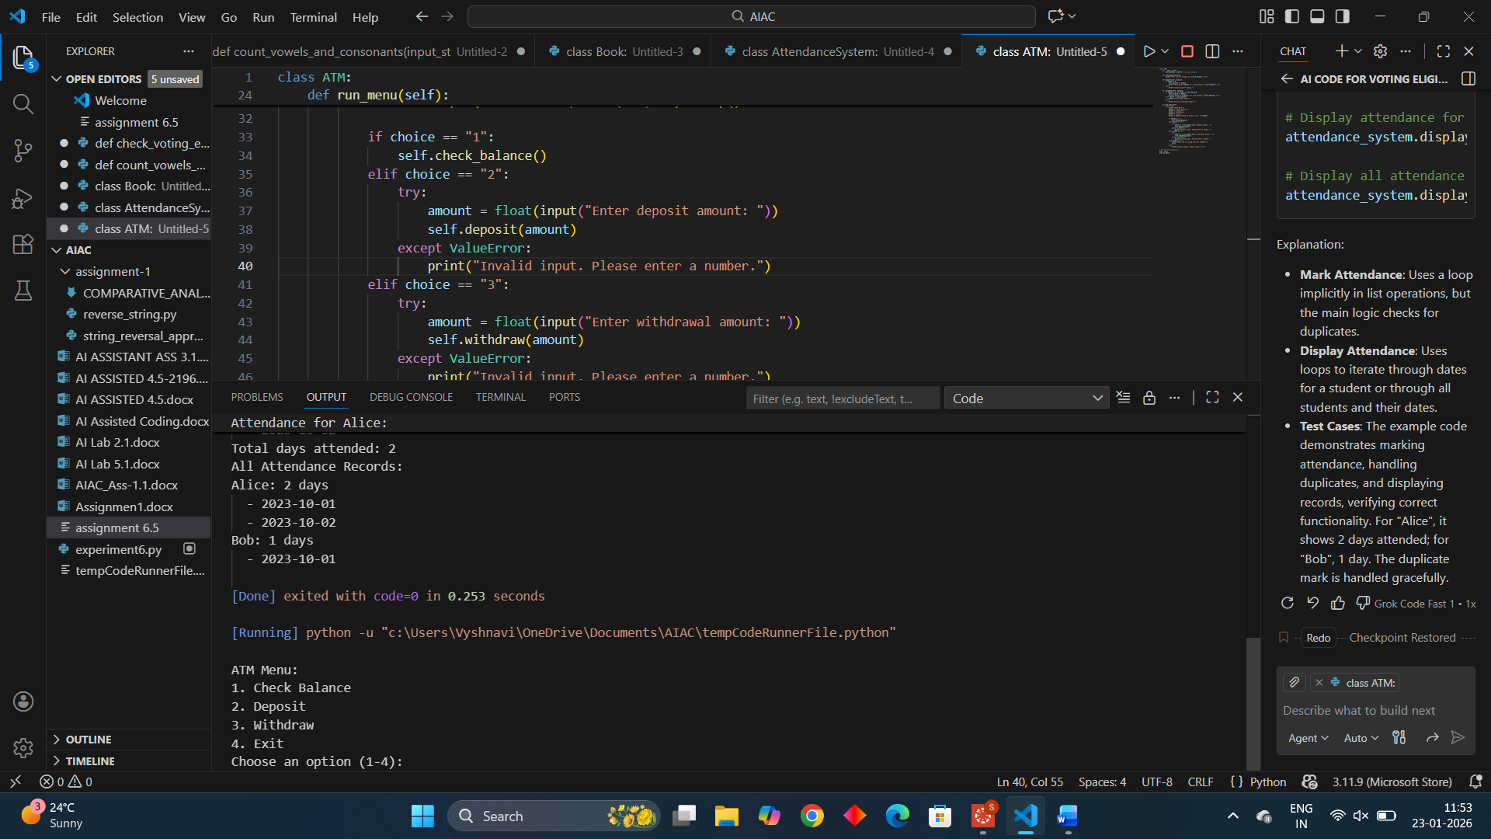
- Loop: The run_menu method uses a while True loop to continuously display the menu until the user chooses to exit.
- Conditionals: if-elif-else statements handle different menu choices (1-4), with input validation for amounts using try-except to catch invalid numbers.
- Option Handling: Each option calls the appropriate method (check_balance, deposit, withdraw) or exits the loop. Invalid choices are handled gracefully.

