ASSENMENT-1
NAME: S.ROHITH
H.T.N0 : 2303A52262
BATCH : 43

TASK 1 :
AI-Generated Logic Without Modularization (Prime Number Check Without Functions)
❖ Scenario
➢ You are developing a basic validation script for a numerical learning application.
❖ Task Description: Use GitHub Copilot to generate a Python program that:
- Checks whether a given number is prime
- Accepts user input
- Implements logic directly in the main code
- Does not use any user-defined functions PROMPT :
AI-Generated Logic Without Modularization (Prime Number Check With out Functions) CODE
:
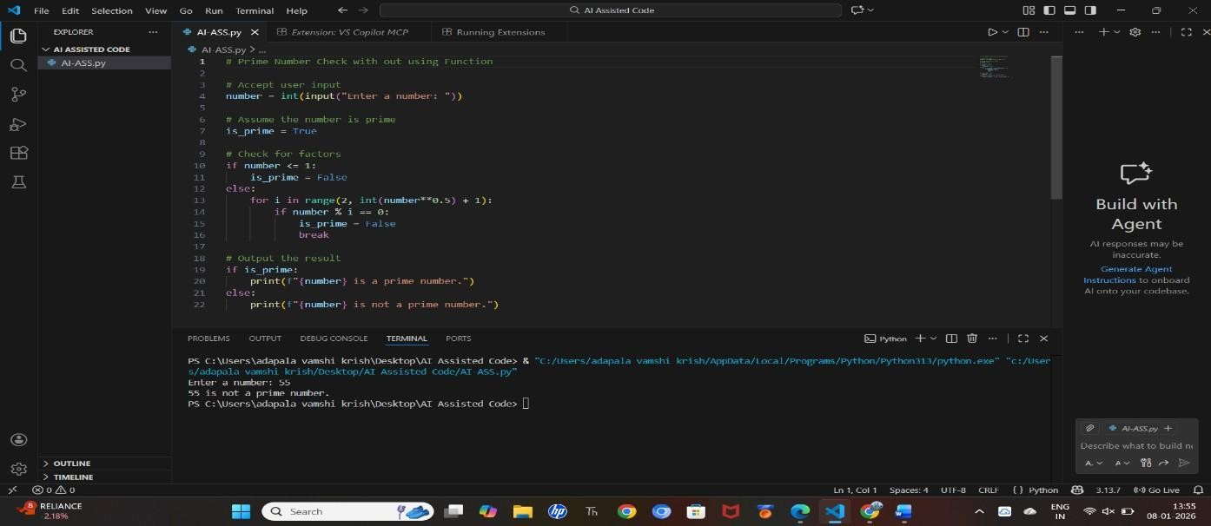

OBSERVATION :
The program demonstrates that a prime-checking algorithm can be implemented in a simple, linear, non-modular script while still being efficient and logically clear.
TASK 2 :
Efficiency & Logic Optimization (Cleanup)
- Scenario
The script must handle larger input values efficiently.
- Task Description
Review the Copilot-generated code from Task 1 and improve it by:
- Reducing unnecessary iterations
- Optimizing the loop range (e.g., early termination)
- Improving readability
- Use Copilot prompts like:
▪ “Optimize prime number checking logic”
▪ “Improve efficiency of this code” Hint:
Prompt Copilot with phrases like
“optimize this code”, “simplify logic”, or “make it more readable” PROMPT :
Prime Number Check Without Functions & Efficiency & Logic Optimization (Cleanup) CODE
:
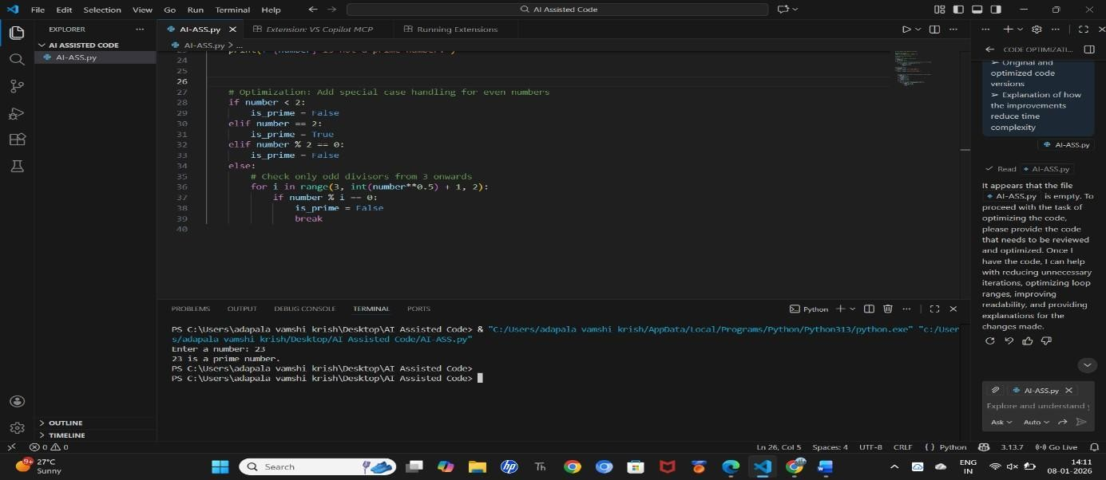
OBSERVATION :
The optimized version demonstrates how algorithmic improvements and smart looping strategies can drastically improve performance while also making the code cleaner, faster, and more professional.

TASK – 3
Modular Design Using AI Assistance (Prime Number Check Using Functions)
- Scenario
The prime-checking logic will be reused across multiple modules.
- Task Description
Use GitHub Copilot to generate a function-based Python program that:
- Uses a user-defined function to check primality
- Returns a Boolean value
- Includes meaningful comments (AI-assisted) PROMPT :
Modular Design Using AI Assistance (Prime Number Check Using Functions CODE
:
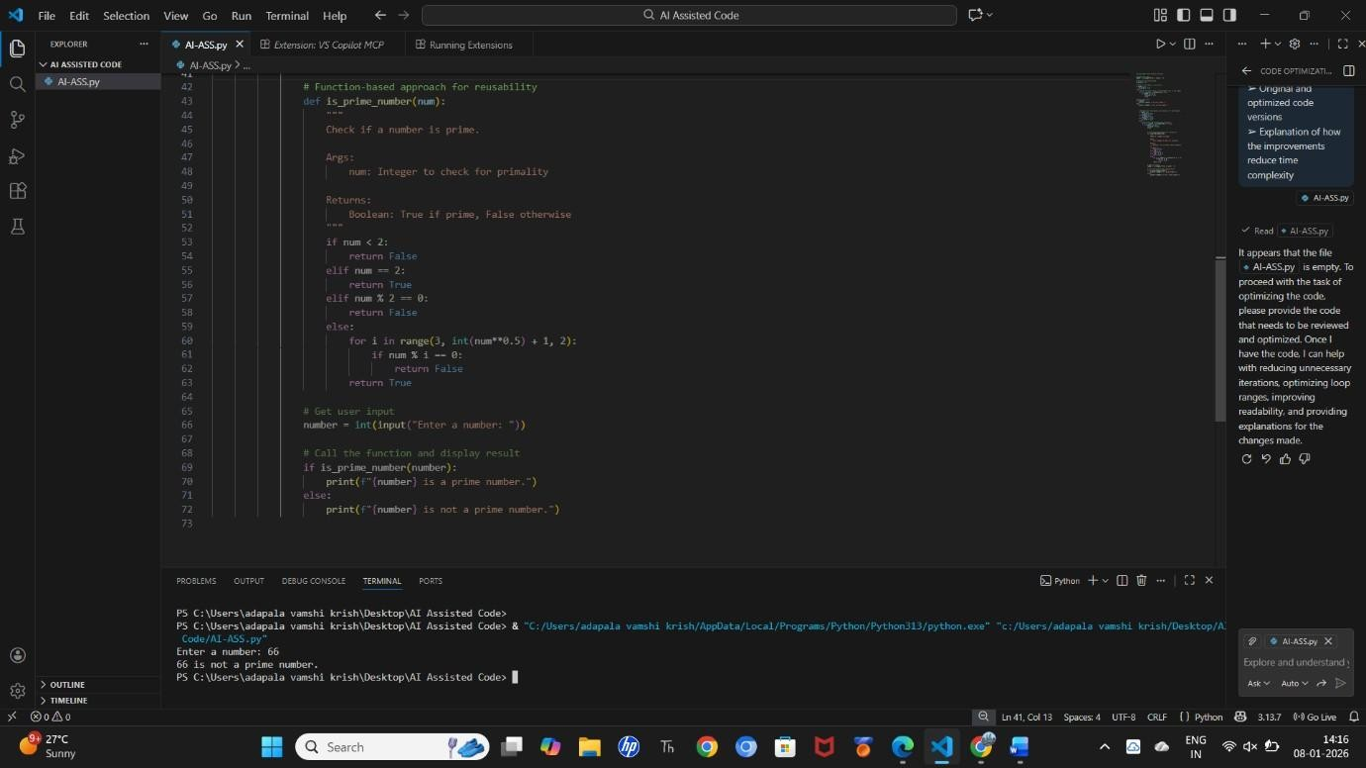
OBSERVATION :

It shows using functions improves code organization, reusability, maintainability, and professionalism while keeping the logic efficient and clean.

TASK-4
Comparative Analysis –With vs Without Functions
- Scenario: You are participating in a technical review discussion.
- Task Description: Compare the Copilot-generated programs:
- Without functions (Task 1)
- With functions (Task 3)
- Analyze them based on:
- Code clarity
- Reusability
- Debugging ease
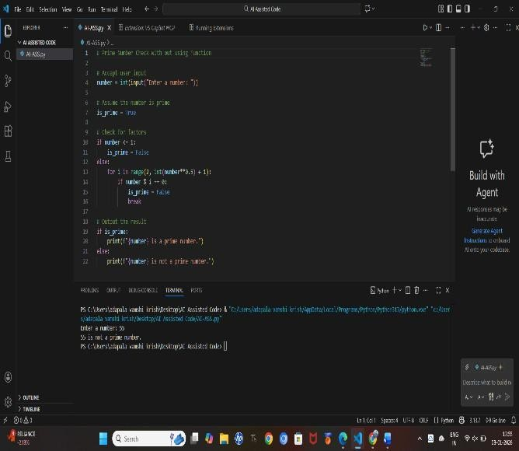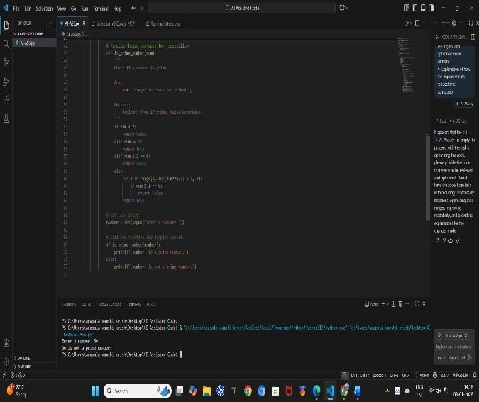
➢

Suitability for large
-
scale applications

CODE :

fig: TASK - 1 fig: TASK-2
OBSERVATION :
Task 1 demonstrates basic procedural programming, while Task 3 demonstrates structured, modular, and professional programming.
Using functions makes the code cleaner, reusable, scalable, and easier to maintain.

Feature | Task 1: Without Functions | Task 3: With Functions
Program Structure | Entire logic is written in the main script | Logic is separated into a userdefined function
Modularity | Not modular | Modular design
Reusability | Cannot easily reuse the logic | Function can be reused in multiple programs
Code Organization | Mixed input, logic, and output in one place | Clear separation: main  handles I/O, function handles logic
Readability | Acceptable for small programs, but gets messy for large ones | Much cleaner and easier to understand
Maintainability | Any change requires editing the whole script | Only the function needs to be updated
Testing | Cannot test logic independently | Function can be tested separately
Scalability | Not suitable for large projects | Suitable for large and multimodule projects
Return Value | Uses flags/print statements | Returns a Boolean (True /  False)
Professional  Coding Style | Basic / beginner style | Industry-standard structured approach

TASK – 5
AI-Generated Iterative vs Recursive Fibonacci Approaches (Different Algorithmic Approaches to Prime
Checking)
- Scenario: Your mentor wants to evaluate how AI handles alternative logical strategies.
- Task Description: Prompt GitHub Copilot to generate:
- A basic divisibility check approach
- An optimized approach (e.g., checking up to √n)

PROMPT :
AI-Generated Iterative vs Recursive Fibonacci Approaches (Different Algorithmic Approaches to Prime Checking) CODE :
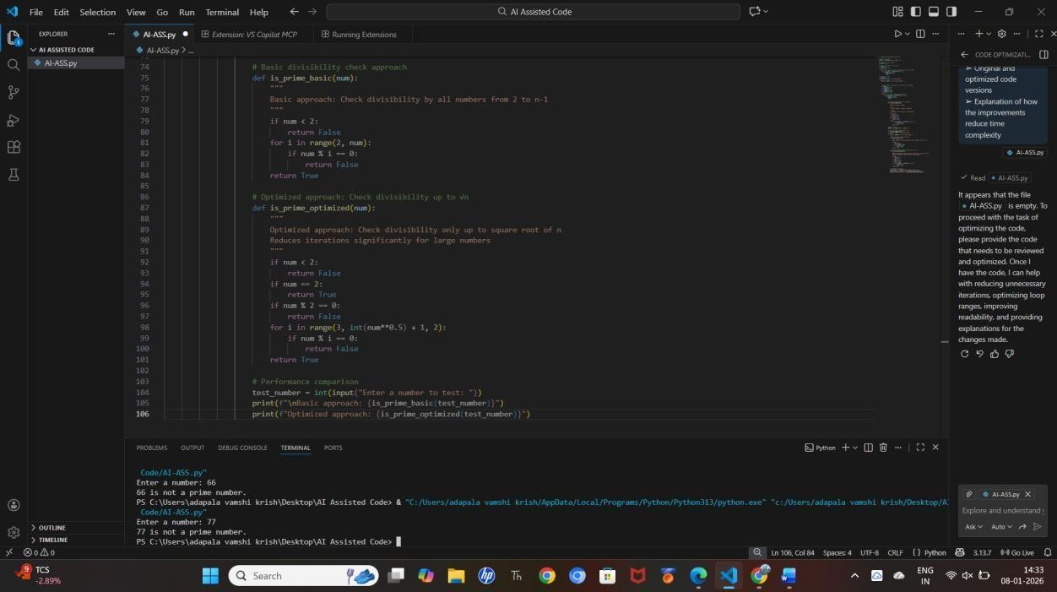
OBSERVATION :
It clearly shows how different logical strategies for the same problem lead to huge differences in efficiency, and how AI can assist in generating and comparing both naive and optimized solutions.

