LAB ASSIGNMENT 7.3

N.Manotej
2303A52293
BATCH 42

TASK 1
Fixing Syntax Errors

Prompt:
Review the following Python function and identify any syntax errors.
The function definition may be missing required punctuation.Detect the syntax issue using AI-based code analysis.Correct the function and explain the error clearly.
Code:
Error
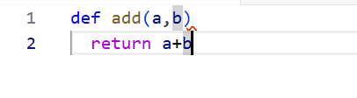

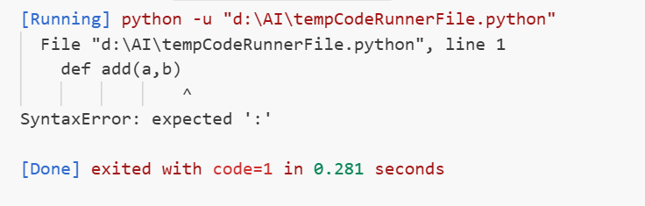

Corrected
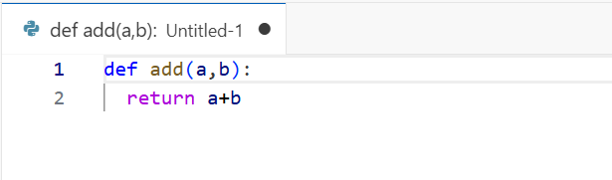

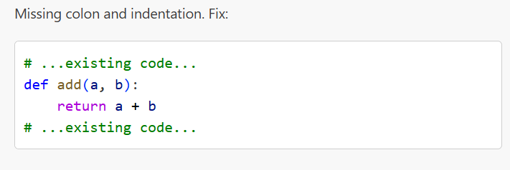

Justification:
The AI identifies a missing colon in the function definition.Python requires a colon to indicate the start of a function block.Adding the colon resolves the SyntaxError and allows execution.The corrected function now follows proper Python syntax rules.

TASK 2
Debugging Logic Errors in Loops

Prompt:
Analyze the given Python loop and identify the logical error.Explain why the loop results in infinite execution.Correct the increment or decrement operation in the loop.Describe how the corrected loop terminates properly.

Code:
Error
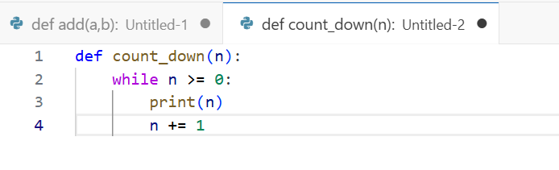

Corrected
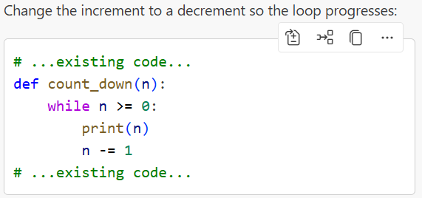

Justification:
The loop runs infinitely because n is incremented instead of decremented.
Since n keeps increasing, the condition n >= 0 is always true.Changing n += 1 to n -= 1 fixes the logic error.The loop now counts down and stops when n becomes less than zero.

TASK 3
Handling Runtime Errors (Division by Zero)

Prompt:
Analyze the given Python function that performs division.Identify the runtime error that occurs during execution.Modify the code using try–except blocks to prevent crashing.Explain how the error is handled safely.

Code:
Error
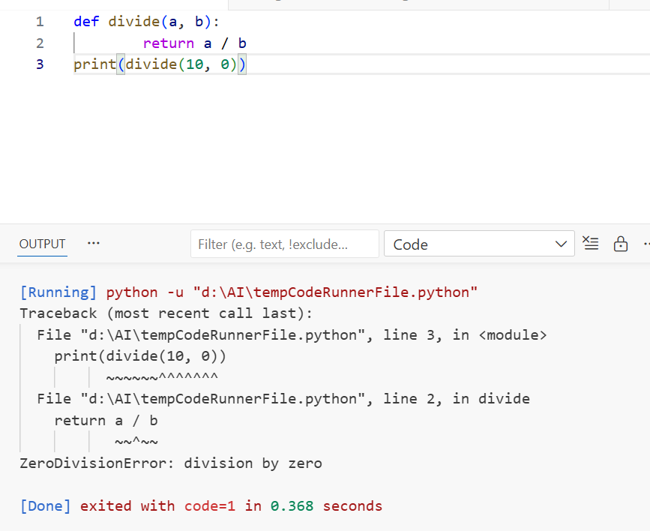
Corrected
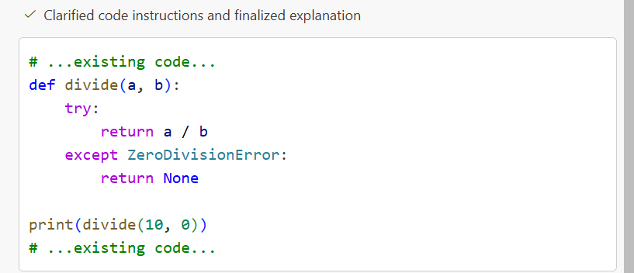

Justification:
The program crashes because division by zero raises a runtime error.Python throws a ZeroDivisionError when the denominator is zero.Using a try–except block catches the error gracefully.The function now executes safely without terminating the program.

TASK 4
Debugging Class Definition Errors
Prompt:
Identify and fix the missing self parameter in the Rectangle __init__ so instance attributes are stored correctly.

Code:
Error
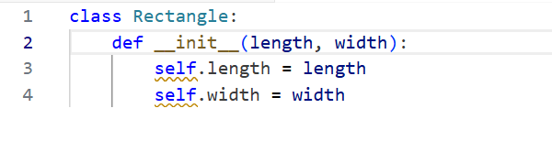
Correct
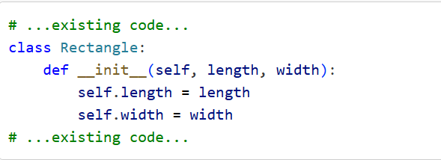
Justification:
self is required so methods can access and assign attributes on the specific object instance rather than creating local variables.

TASK 5
Resolving Index Errors in Lists
Prompt:
Fix the Rectangle class by adding the missing self parameter to __init__ so instance attributes are assigned to the object.
Code:
Error
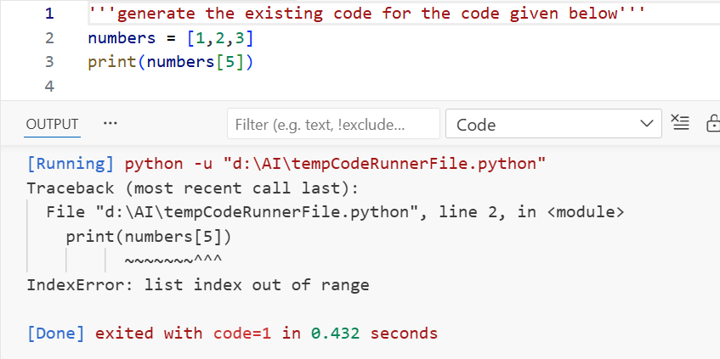
Corrected
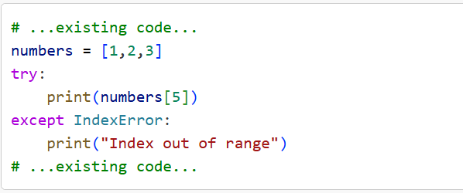
Justification:
self is the instance reference; using self.length = length and self.width = width stores values on the object rather than local variables.Without self, length and width exist only inside __init__ and are lost after construction.Python requires self as the first parameter to methods to access and mutate per-instance state in OOP.

