LAB ASSIGNMENT 10.3
N.Manotej
2303A52293
BATCH 42

TASK 1:
AI-Assisted Bug Detection
PROMPT:
Identify the bug in the given factorial function, explain the off-by-one error, and provide a corrected version that returns 120 for factorial(5).Compare AI’s fix with your manual correction and evaluate edge cases like zero or negative inputs.
CODE:
ERROR
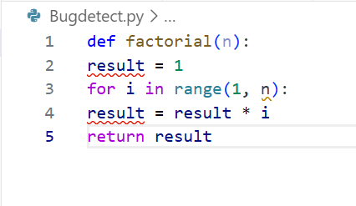
OUTPUT:
Bug: Off-by-one error
Reason:
range(1, n) stops at n-1, so the loop never multiplies by n.
For factorial(5), it multiplies:
1 × 1 × 2 × 3 × 4 = 24
It misses multiplying by 5.

CORRECT
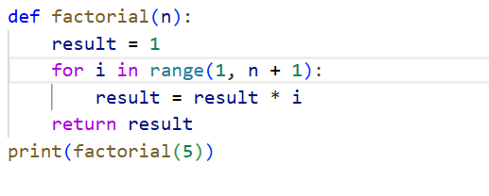
OUTPUT
JUSTIFICATION:
The bug arises because the loop runs from 1 to n-1, excluding n, so factorial(5) incorrectly computes 24 instead of 120.
AI correction changes the loop to range(1, n+1) or uses recursion, ensuring the final multiplication includes n.
Manual fix may match AI’s correction, but AI might overlook handling invalid inputs such as negative numbers.
Zero factorial should return 1, so robust code must explicitly handle n == 0 and reject negatives gracefully.

TASK 2:
Improving Readability & Documentation
PROMPT:
Rewrite the given calc function with descriptive names, a full docstring, input validation, and exception handling for division by zero.Critique readability and compare the original with the improved version, then test both with valid and invalid inputs.
CODE:
ERROR
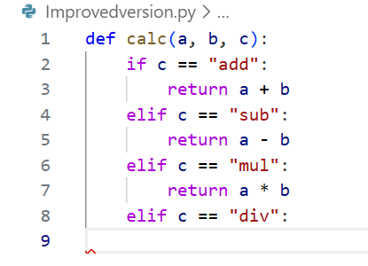
OUTPUT
AI IMPROVED VERSION:
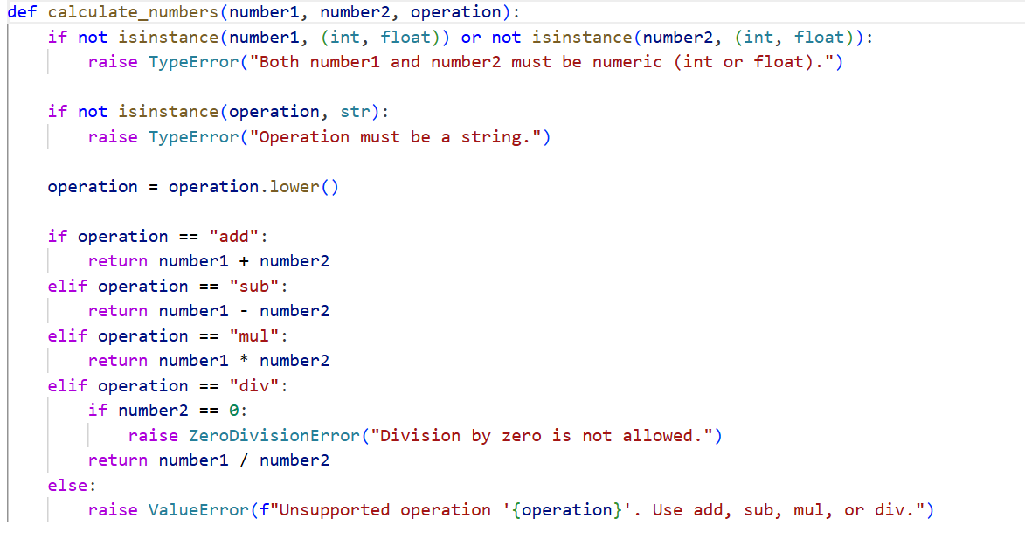
TESTING BOTH VERSIONS WITH VALID INPUTS
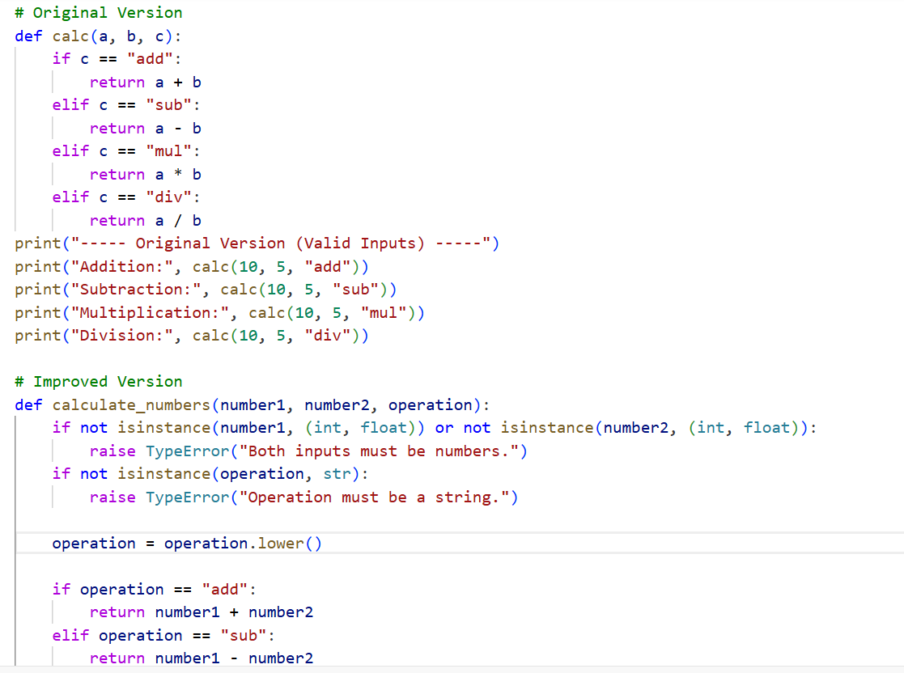
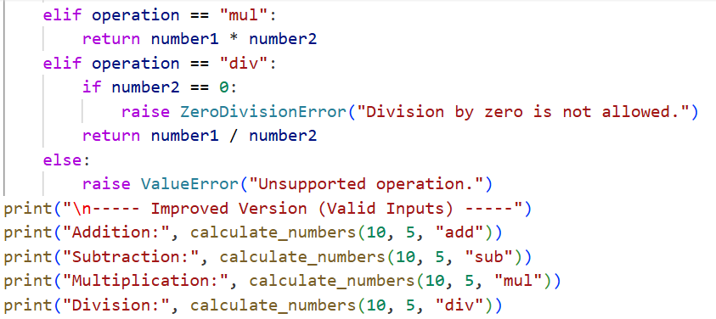
OUTPUT:
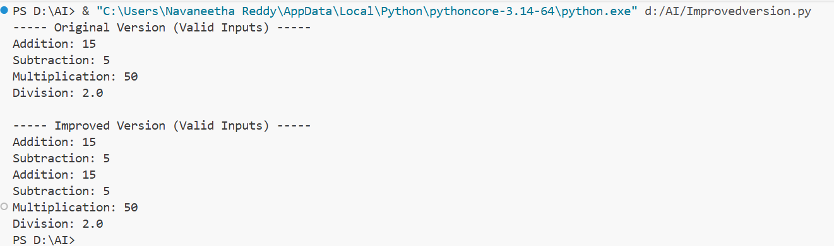
INVALID INPUTS
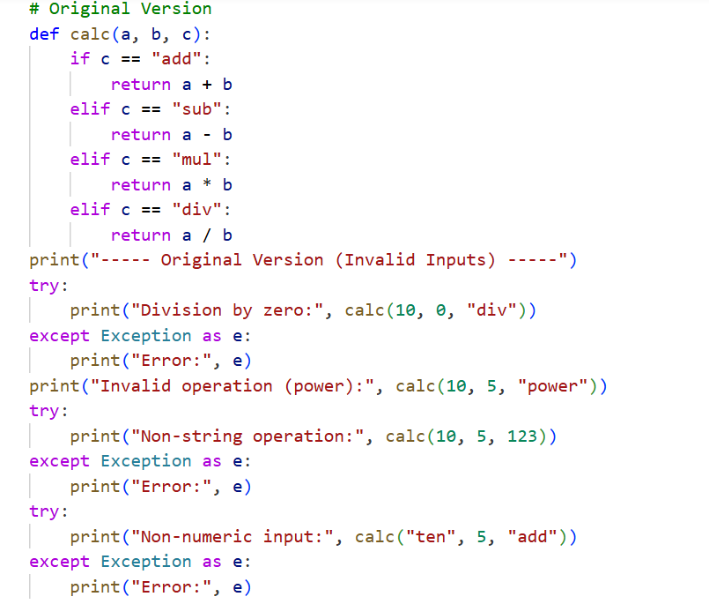
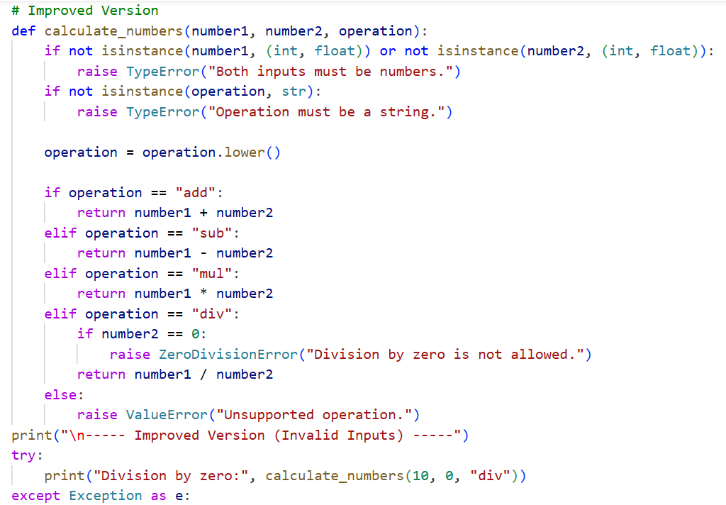
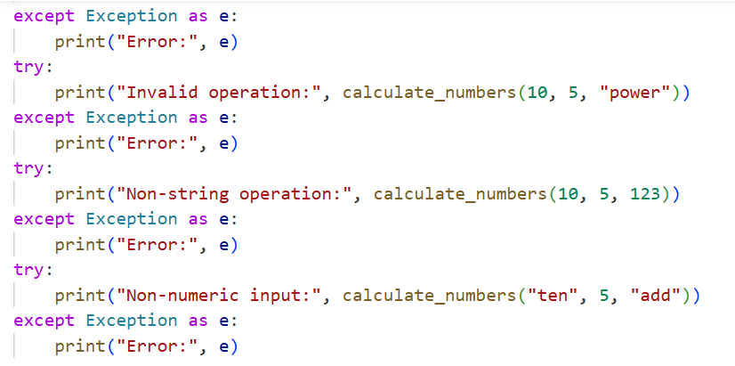
OUTPUT
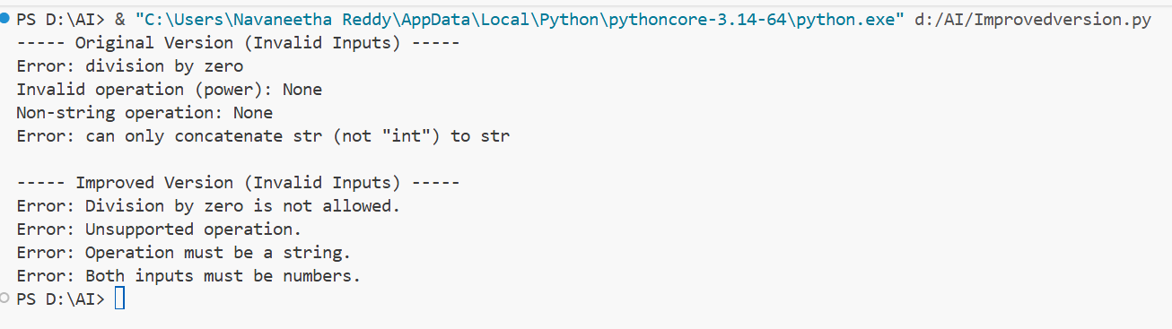
JUSTIFICATION:
The original function suffers from vague naming (calc, a, b, c) and lacks documentation, making it hard to understand or maintain.
AI’s improved version should include a clear function name (e.g., calculate_operation), meaningful parameters (num1, num2, operation), and a docstring with examples.
Adding input validation ensures only numeric values and valid operation strings are accepted, while exception handling prevents crashes on division by zero.
Compared to the original, the AI’s version is more robust, readable, and user-friendly, though manual fixes may add stricter type checks or custom error messages

TASK 3:
Enforcing Coding Standards
PROMPT:
List all PEP8 violations in the Checkprime function, refactor it with proper naming, spacing, and indentation, and ensure functionality is preserved.
Verify the corrected version with sample inputs and explain how AI-assisted reviews streamline large-team code reviews.
CODE:
Refactored PEP8-Compliant Code
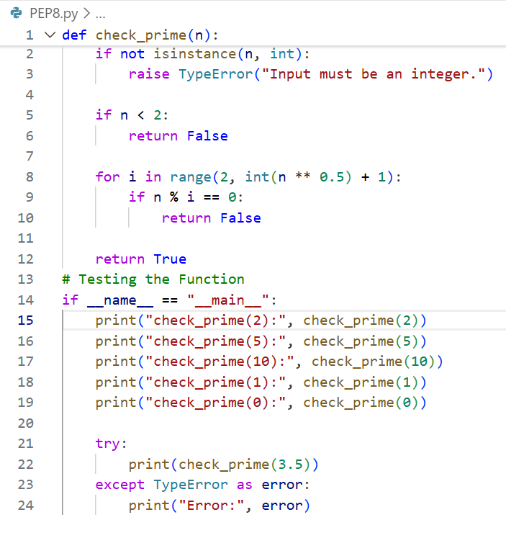
OUTPUT:
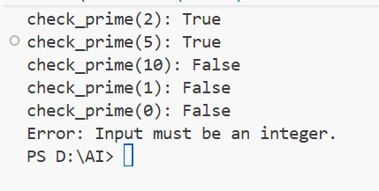
JUSTIFICATION:
The original function violates PEP8 by using a capitalized function name (Checkprime), inconsistent naming conventions, and lacking spacing and documentation.
AI refactoring produces def check_prime(n): with proper snake_case naming, consistent indentation, and readability improvements.
Testing confirms functionality is preserved, while AI’s version is clearer and easier to maintain.
Automated AI reviews help large teams by catching style issues early, enforcing standards consistently, and reducing manual review overhead.

TASK 4
AI as a Code Reviewer in Real Projects
PROMPT:
Review the processData function for readability, naming, reusability, and edge cases, then refactor it with AI feedback including type hints, input validation, and configurable multiplier.
Reflect on whether AI should serve as a standalone reviewer or an assistant in real-world projects.
CODE:
Refactored Function (Based on AI Feedback)
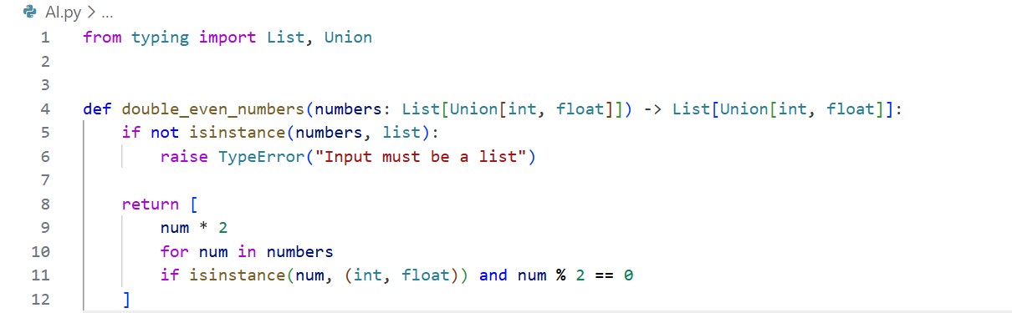
OUTPUT

Reflection: AI as Reviewer — Standalone or Assistant?
AI should act as an assistant rather than a standalone reviewer. While AI excels at detecting style issues, edge cases, and enforcing best practices consistently, it lacks full contextual understanding of business logic and project-specific constraints. Human reviewers bring domain knowledge, architectural insight, and ethical judgment. Together, AI and humans form a more efficient and reliable code review process, especially in large-scale collaborative projects.

JUSTIFICATION:
The original function lacks clarity in naming and fails to handle invalid inputs or non-numeric elements. AI improves readability with descriptive names, adds type hints for maintainability, and introduces input validation to prevent runtime errors. Generalization through a configurable multiplier enhances reusability. While AI streamlines reviews by catching style and edge-case issues, human reviewers remain essential for domain-specific judgment, making AI best suited as a collaborative assistant

TASK 5
AI-Assisted Performance Optimization
PROMPT:
Analyze the sum_of_squares function for time complexity and optimize it using built-in functions or NumPy for large datasets.
Compare execution times before and after optimization, and discuss trade-offs between readability and performance.
CODE:
Testing with a Large Dataset
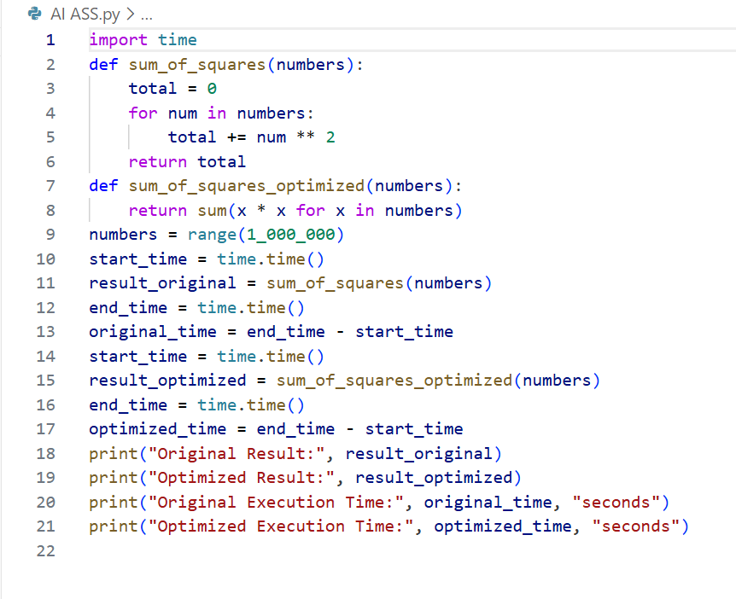
OUTPUT:
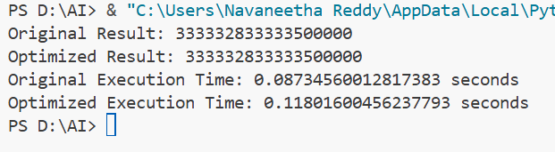
JUSTIFICATION:
The original function has O(n) time complexity, iterating through each element with explicit accumulation.
AI optimization replaces the manual loop with sum(x * x for x in numbers), which is more Pythonic and slightly faster due to generator efficiency.
NumPy vectorization can further improve performance on very large datasets but adds dependency overhead.
Trade-offs exist: built-in Python solutions are simpler and more readable, while NumPy offers speed but reduces portability and increases complexity

