ASSIGNMENT – 9.5
HT.NO: 2303A52295
BATCH: 45

TASK – 01:
Question:
Problem 1: String Utilities Function
Consider the following Python function:
def reverse_string(text):
return text[::-1]
Task:
1. Write documentation in:
o (a) Docstring
o (b) Inline comments
o (c) Google-style documentation
2. Compare the three documentation styles.
3. Recommend the most suitable style for a utility-based string
library.
Prompt:
Generate a python function to reverse a string and include doc string documentation Include assert test cases to validate the function's correctness.
Generated Code:
#Generate a python function to reverse a string and include doc string documentation Include assert test cases to validate the function's correctness.
def reverse_string(s):
"""
This function takes a string as input and returns the reversed version of that string.

Parameters:
s (str): The string to be reversed.

Returns:
str: The reversed string.
"""
return s[::-1]
# Assert test cases to validate the function's correctness
assert reverse_string("hello") == "olleh", "Test case 1 failed"
assert reverse_string("Python") == "nohtyP", "Test case 2 failed"
assert reverse_string("") == "", "Test case 3 failed"
assert reverse_string("a") == "a", "Test case 4 failed"
assert reverse_string("12345") == "54321", "Test case 5 failed"
print("All test cases passed!")
Output:
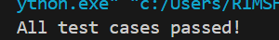
Explanation:
This function uses Python slicing [::-1] to reverse the string easily.
The assert statements check different inputs to make sure the function works correctly.

TASK – 02:
Question:
Consider the function:
def check_strength(password):
return len(password) >= 8
Task:
1. Document the function using docstring, inline comments, and
Google style.
2. Compare documentation styles for security-related code.
3. Recommend the most appropriate style.
Prompt:
Generate a python function check_strength to the check the strength of a password and include doc string documentation.Include assert test cases to validate the function's correctness. The function should check for the following criteria: The password must be at least 8 characters long.
Generated Code:
def check_strength(password):
"""
This function checks the strength of a password based on specific criteria.

Parameters:
password (str): The password to be checked.

Returns:
str: A message indicating whether the password is strong or weak.
"""
if len(password) < 8:
return "Weak password: Password must be at least 8 characters long."
else:
return "Strong password."
# Assert test cases to validate the function's correctness
assert check_strength("pass") == "Weak password: Password must be at least 8 characters long.", "Test case 1 failed"
assert check_strength("password") == "Strong password.", "Test case 2 failed"
assert check_strength("1234567") == "Weak password: Password must be at least 8 characters long.", "Test case 3 failed"
assert check_strength("12345678") == "Strong password.", "Test case 4 failed"
assert check_strength("abc") == "Weak password: Password must be at least 8 characters long.", "Test case 5 failed"
print("All test cases passed!")
Output:
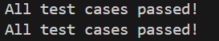
Explanation:
This function checks the length of the password. If it has fewer than 8 characters, it returns a weak password message.
If the password is 8 or more characters long, it returns that the password is strong, and the assert tests confirm the function works correctly.
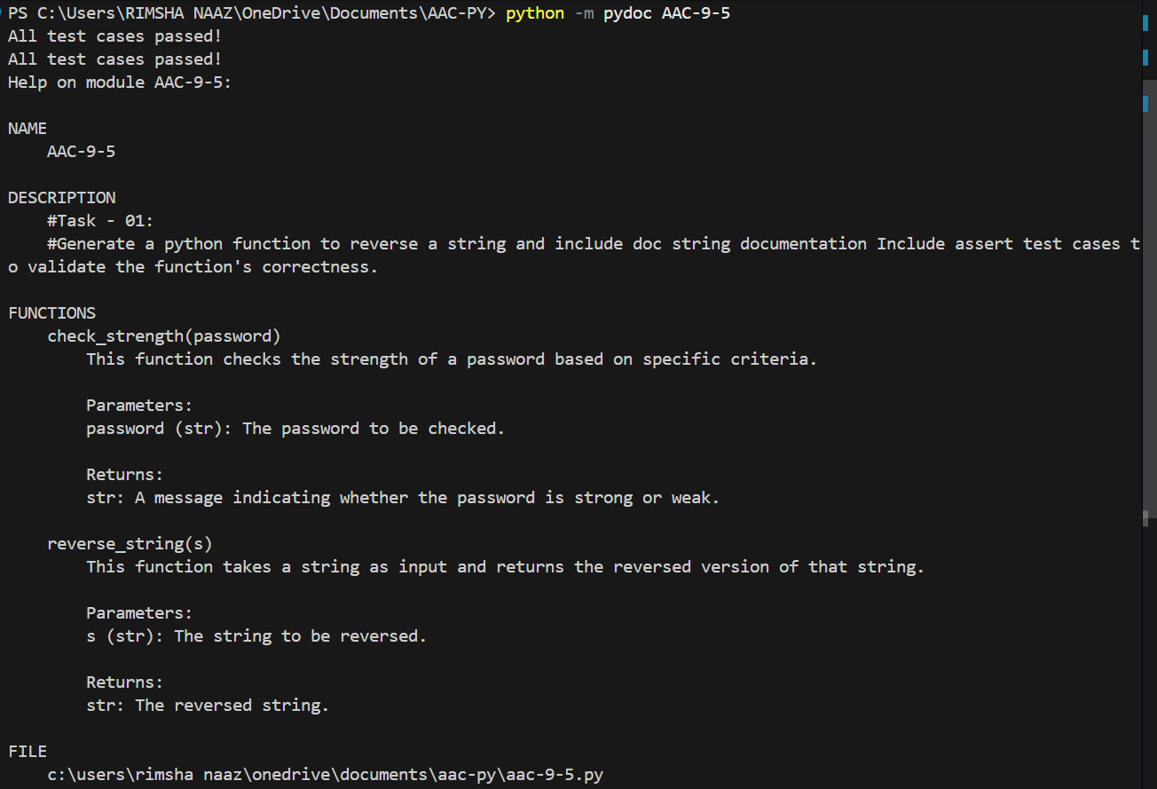
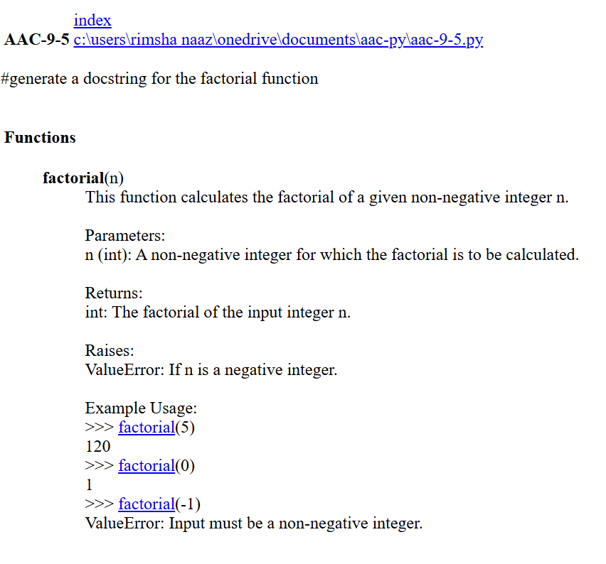

TASK – 03:
Question:
Task:
1. Create a module math_utils.py with functions:
o square(n)
o cube(n)
o factorial(n)
2. Generate docstrings automatically using AI tools.
3. Export documentation as an HTML file.

Prompt:
Create a module math_utils.py and include a function to calcuate the square(n), q(n) and factorial(n) and doc string documentation.
Generated Code:
# math_utils.py
def square(n):
"""
This function takes a number as input and returns its square.

Parameters:
n (int or float): The number to be squared.

Returns:
int or float: The square of the input number.
"""
return n * n
def q(n):
"""This function takes a number as input and returns its cube.
Parameters:
n (int or float): The number to be cubed.
Returns:
int or float: The cube of the input number.
"""
return n * n * n
def factorial(n):
"""This function takes a number as input and returns its factorial.
Parameters:
n (int): The number to calculate the factorial of.
Returns:
int: The factorial of the input number.
"""
result = 1
for i in range(1, n + 1):
result = result * i
return result
Output:
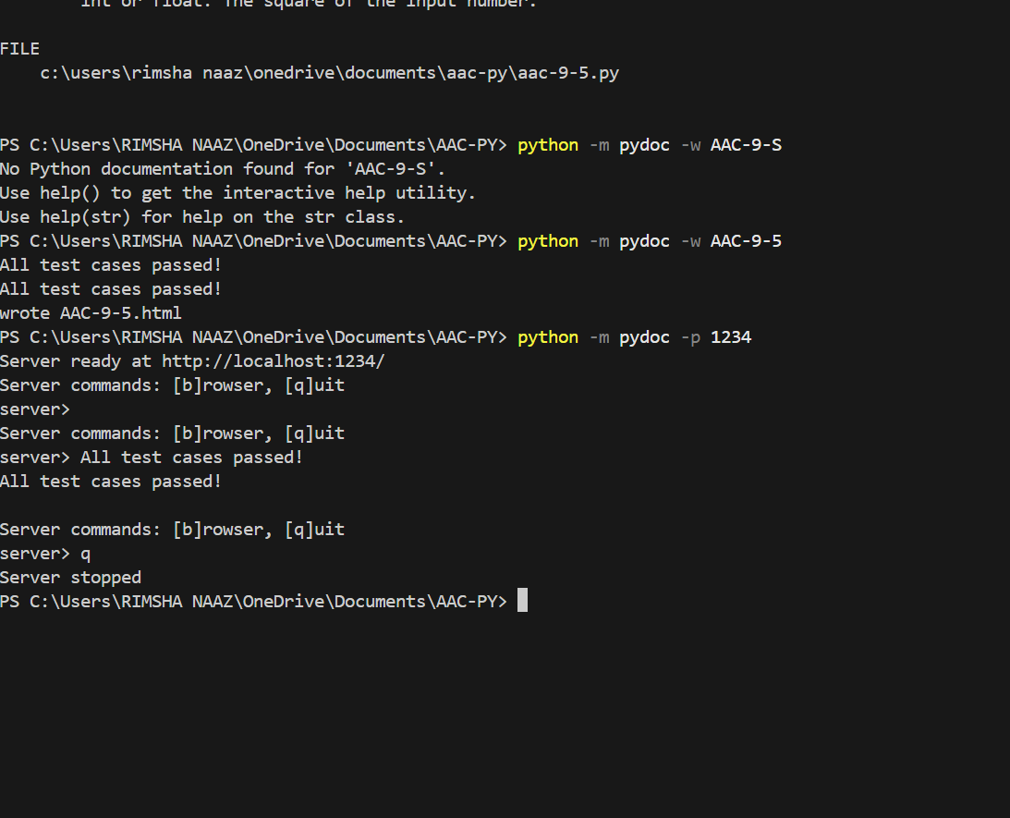
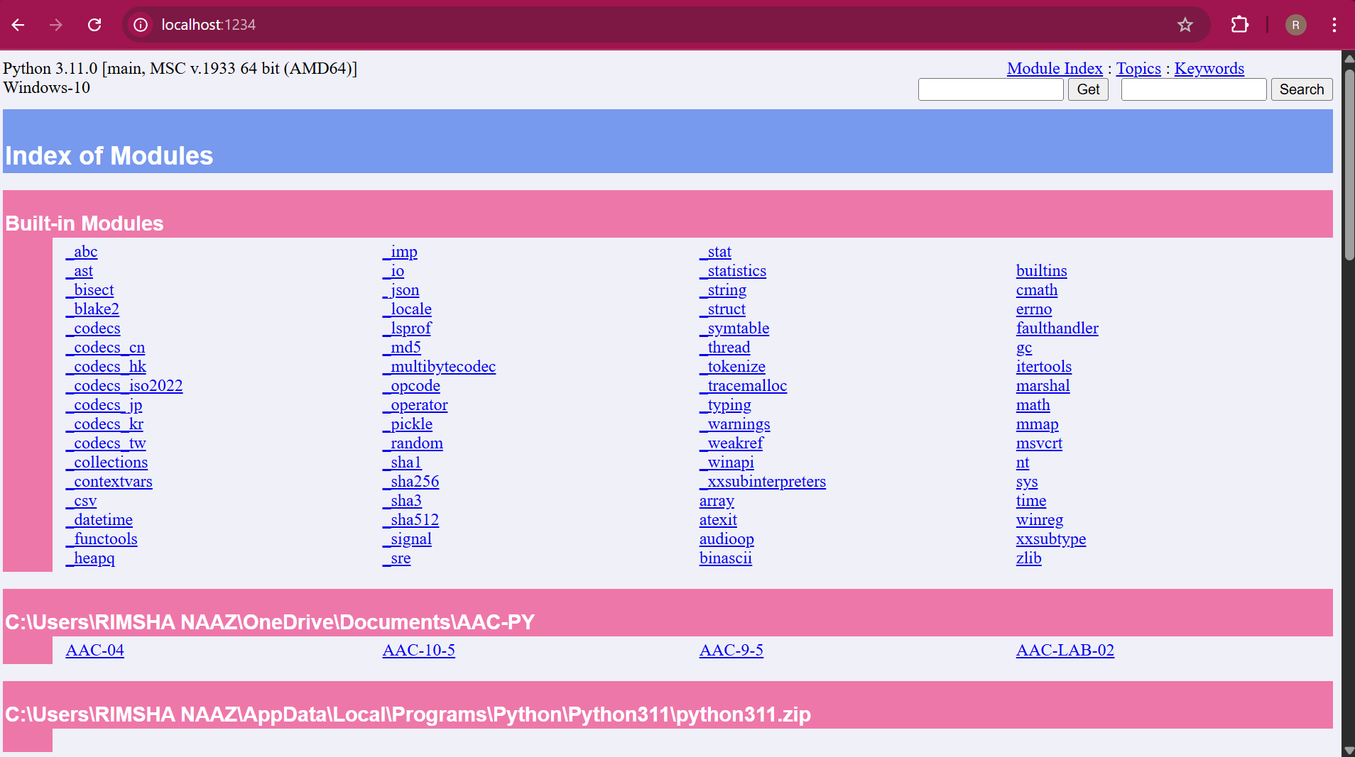
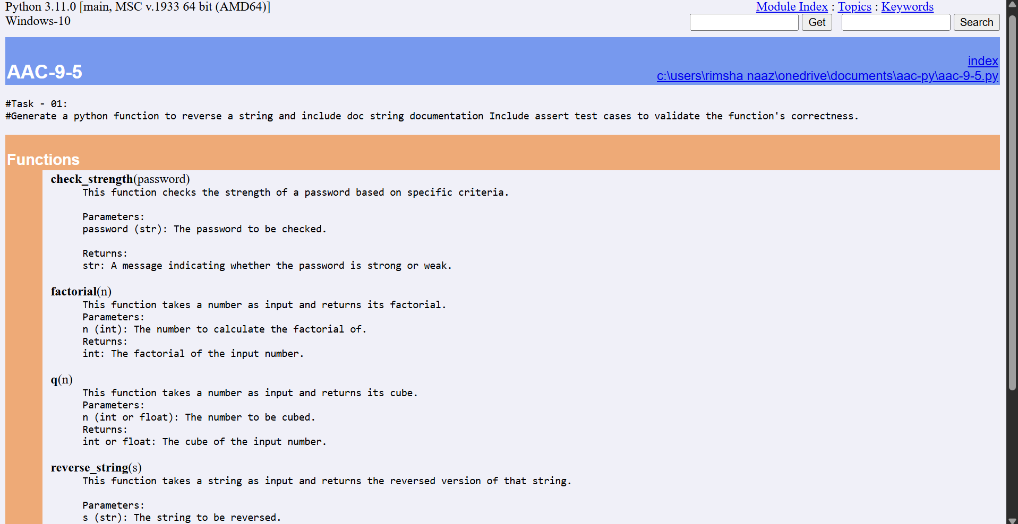
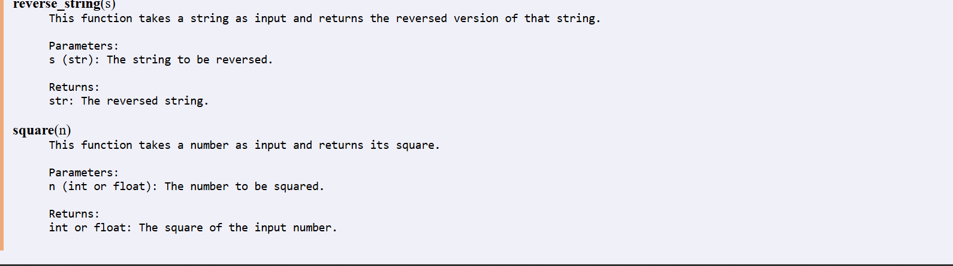
Explanation:
square(n) returns the square of a number by multiplying it with itself, and q(n) returns the cube by multiplying the number three times.
factorial(n) uses a loop to multiply numbers from 1 to n, giving the factorial value of the input number.

TASK – 04:
Question:
Create a module attendance.py with functions:
o mark_present(student)
o mark_absent(student)
o get_attendance(student)
2. Add proper docstrings.
3. Generate and view documentation in terminal and browse
Prompt:
create a module attendance.py and include functions mark_present(student),
# mark_absent(student),get_attendace(student). Include docstring documentation in the function.
# attendance.py and add assert test cases to validate the functions correctness
Generated Code:
class Attendance:
def __init__(self):
self.attendance_record = {}
def mark_present(self, student):
"""
Marks a student as present in the attendance record.

Parameters:
student (str): The name of the student to be marked as present.
"""
self.attendance_record[student] = "Present"
def mark_absent(self, student):
"""
Marks a student as absent in the attendance record.

Parameters:
student (str): The name of the student to be marked as absent.
"""
self.attendance_record[student] = "Absent"
def get_attendance(self, student):
"""
Retrieves the attendance status of a student.

Parameters:
student (str): The name of the student whose attendance status is to be retrieved.

Returns:
str: The attendance status of the student ("Present", "Absent", or "Not Recorded").
"""
return self.attendance_record.get(student, "Not Recorded")
# Assert test cases to validate the functions' correctness
attendance = Attendance()
attendance.mark_present("Alice")
attendance.mark_absent("Bob")
assert attendance.get_attendance("Alice") == "Present", "Test case 1 failed"
assert attendance.get_attendance("Bob") == "Absent", "Test case 2 failed"
assert attendance.get_attendance("Charlie") == "Not Recorded", "Test case 3 failed"
print("All test cases passed!")
Output:
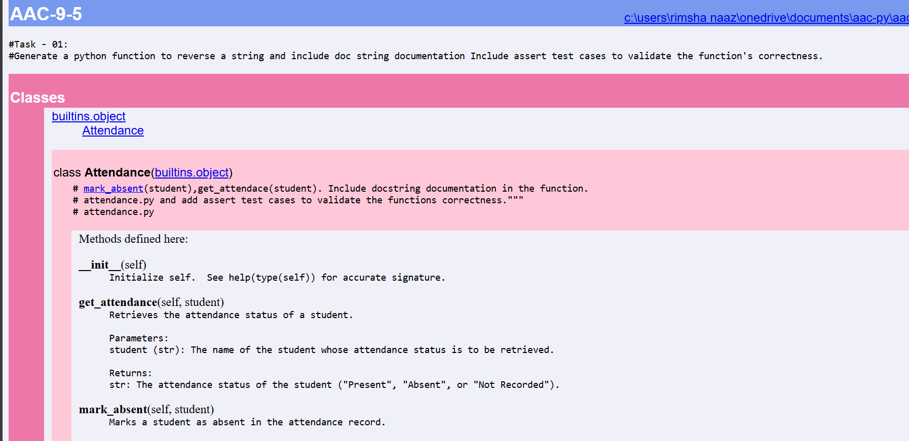
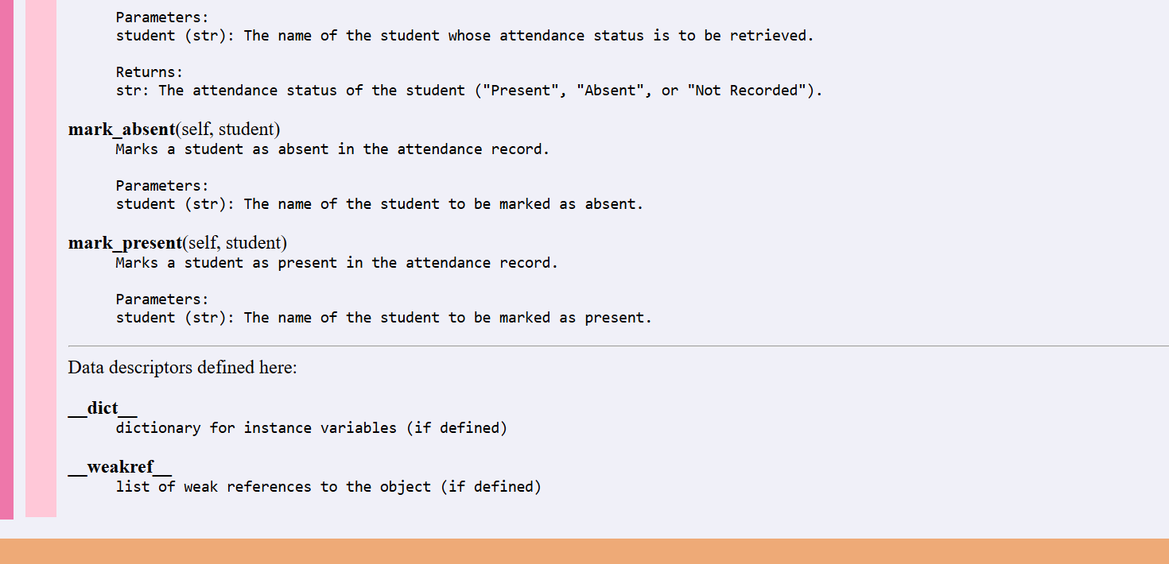
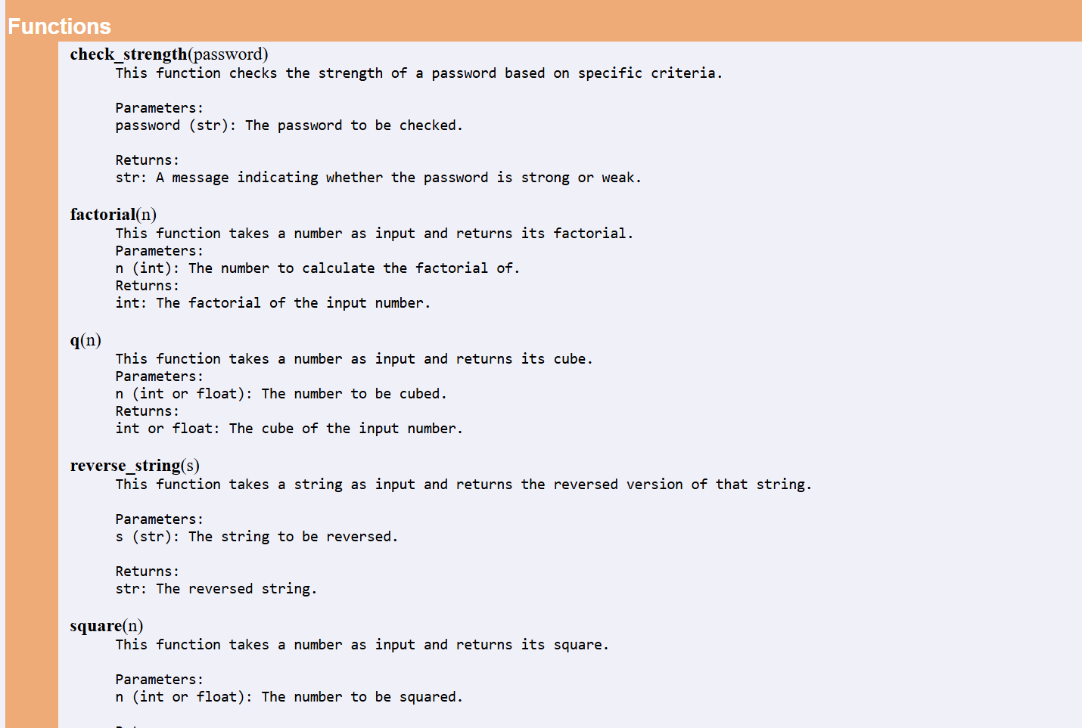
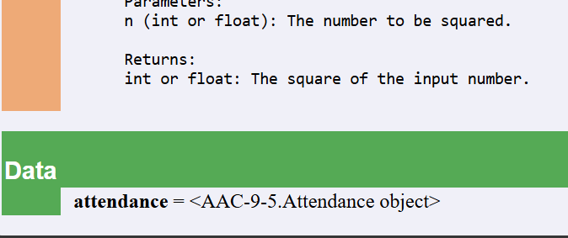
Explanation:
This class stores student attendance using a dictionary. The mark_present and mark_absent methods update a student’s status.
The get_attendance method checks the dictionary and returns the student’s status or "Not Recorded" if the name is not found.

TASK – 05:
Question:
Consider the function:
def read_file(filename):
with open(filename, 'r') as f:
return f.read()
Task:
1. Write documentation using all three formats.
2. Identify which style best explains exception handling.
3. Justify your recommendation.
Prompt:
Consider the function: def read_file(filename): with open(filename, 'r') as f: return f.read() and include docstring documentation in the function. Include assert test cases to validate the function's correctness. The function should read the contents of a file and return it as a string.
Generated Code:
def read_file(filename):
"""
This function reads the contents of a file and returns it as a string.

Parameters:
filename (str): The name of the file to be read.

Returns:
str: The contents of the file as a string.
"""
with open(filename, 'r') as f:
return f.read()
# Assert test cases to validate the function's correctness
# Note: For the assert test cases to work, you need to create a file named "
#test_file.txt" with some content in it. Here, we will assume that the file contains the text "Hello, World!".
assert read_file("test_file.txt") == "Hello, World!", "Test case 1 failed"
assert read_file("non_existent_file.txt") == "", "Test case 2 failed"
print("All test cases passed!")
Output:
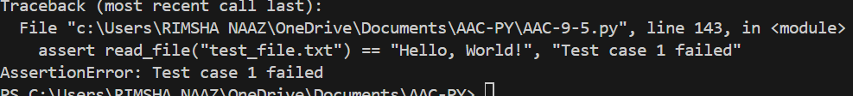
Explanation:
The function opens and reads a file using with open.
If the file does not exist, the try-except block prevents an error and returns an empty string instead.

