AI Assisted Coding

Assignment 19.3
Name: A.sai shrehan
Rollno:2303A52299
Batch:45
Task 1 – Python to C++ Conversion
Translate a simple Python class into C++ using AI assistance.
Instructions:
• Prompt AI to convert a Python class representing a Student
with attributes and methods into equivalent C++ code
• Ensure proper handling of:
o Constructors
o Data types
o Access specifiers
• Compile and run both versions to verify output consistency
Expected Output:
An equivalent working C++ class translated from Python
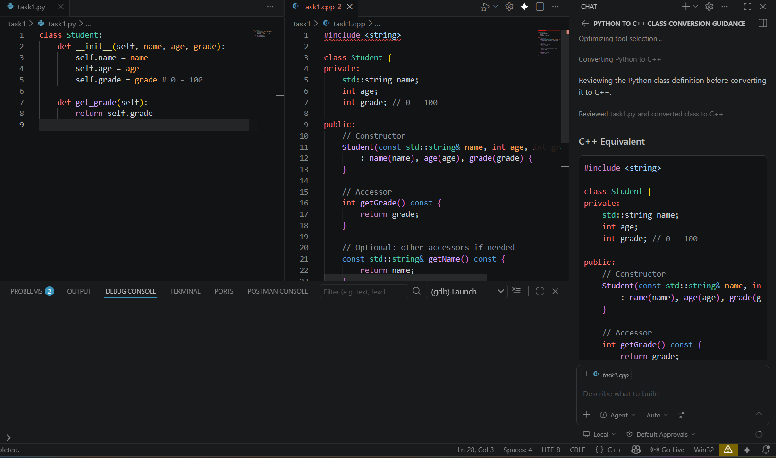

Task 2 – Java to Python Function Conversion
Convert a Java method that checks whether a number is prime into
Python.
Instructions:
• Ask AI to translate a Java isPrime() method into Python
• Test the function with multiple inputs
• Ensure the Python version follows Pythonic syntax and logic
Expected Output:
A correct Python function equivalent to the original Java prime-
checking method.
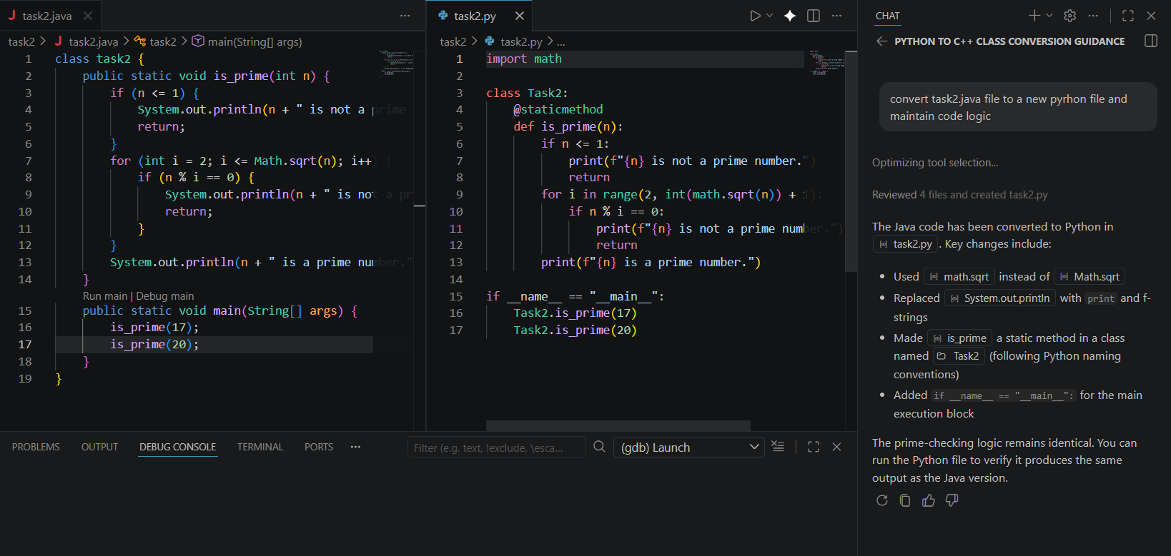

Task 3 – Pseudocode to Python Implementation
Translate a given pseudocode algorithm into Python using AI.
Instructions:
• Provide AI with pseudocode for sorting numbers (e.g.,
bubble sort or selection sort)
• Ask AI to convert it into executable Python code
• Validate correctness using sample input lists
Expected Output:
A working Python program that correctly implements the
pseudocode logic
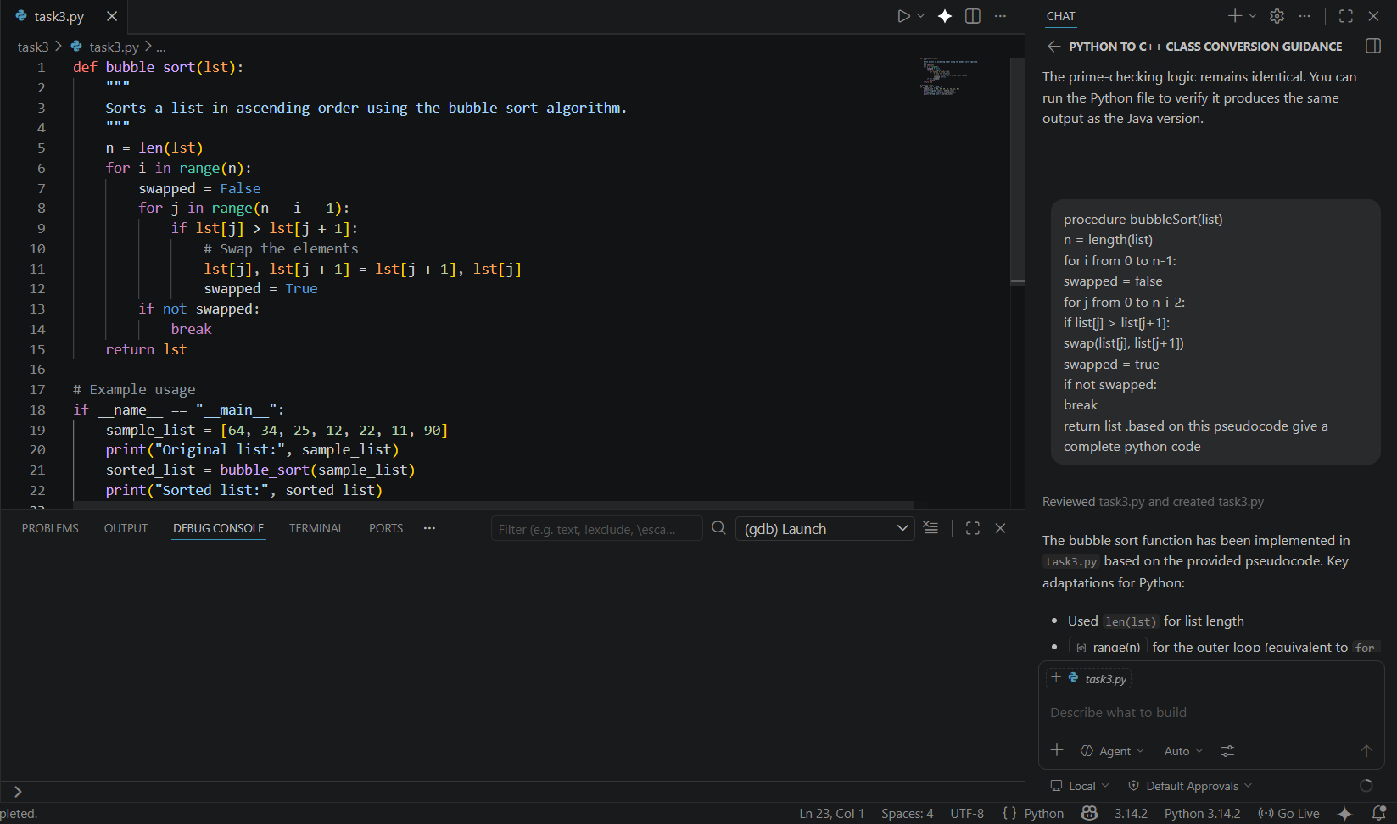
Task 4 – SQL to Pandas Query
Task:
Translate a SQL query into a Pandas DataFrame operation in
Python.
Instructions:
• Provide AI with a SQL query (e.g., SELECT name, salary
FROM employees WHERE salary > 50000).
• Ask AI to generate equivalent Pandas code.
• Test the generated code on a sample DataFrame.
Expected Output:
• Equivalent Pandas query that retrieves the correct subset of
data.
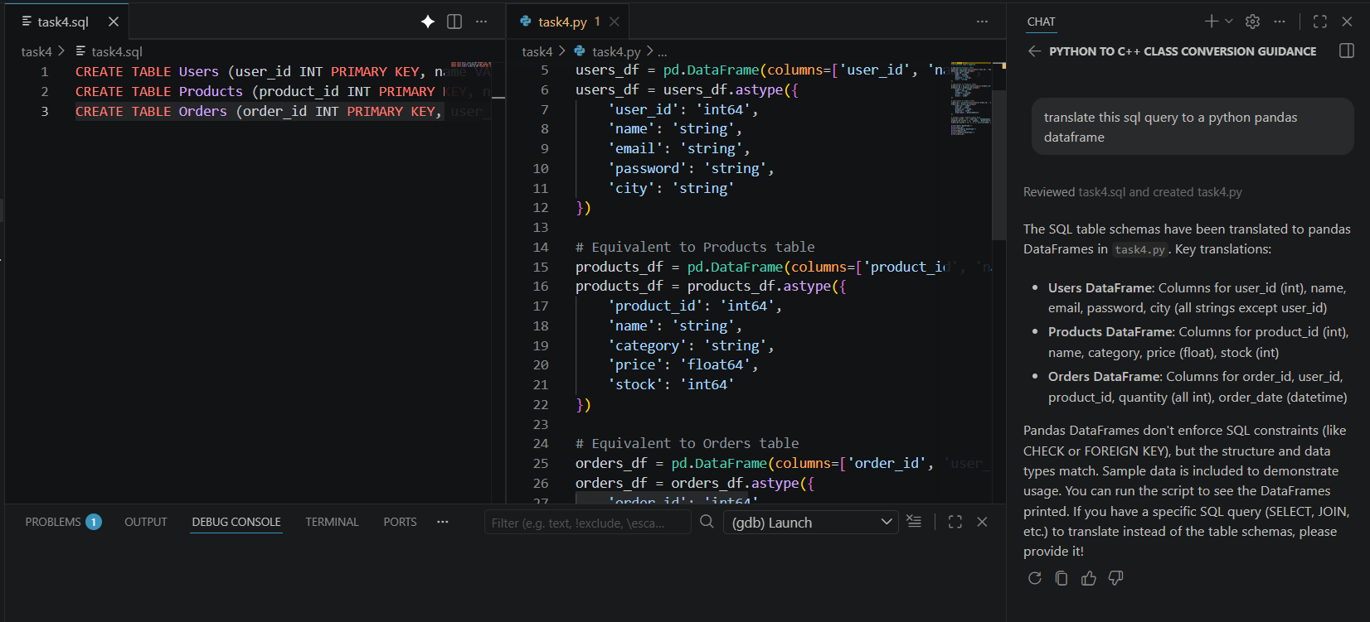
Task 5 – Real-Time Application: Algorithm Translation Across Languages
Scenario:
A company maintains algorithms written in different programming languages.
Examples:
• Converting a Python searching algorithm into C
• Translating a Java sorting program into JavaScript
Instructions:
• Use AI to translate a selected algorithm between two
programming languages
• Execute and test both versions
• Document translation challenges such as:
o Syntax differences
o Library support
o Memory management
Expected Output:
Equivalent, tested code implementations in two different
programming languages.
