Name:K.JASHWANTH
H.NO:2303A52300
ASSIGNMENT-10.3
BATCH-42
PROBLEM STATEMENT 1:
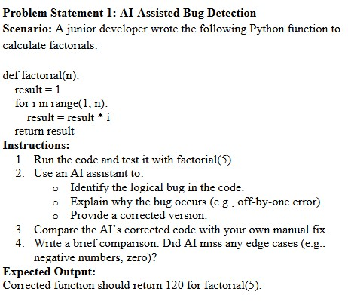
1.
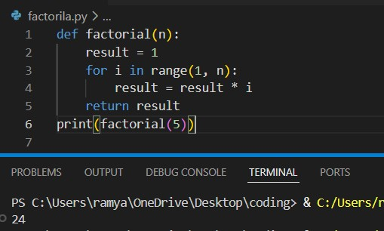
2.
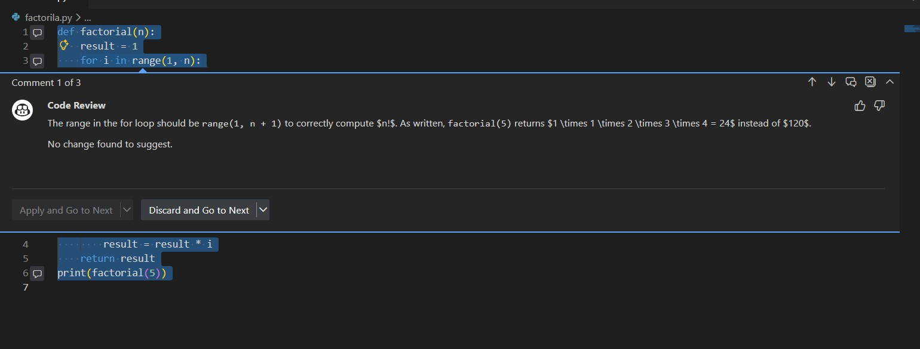
Corrected Version:
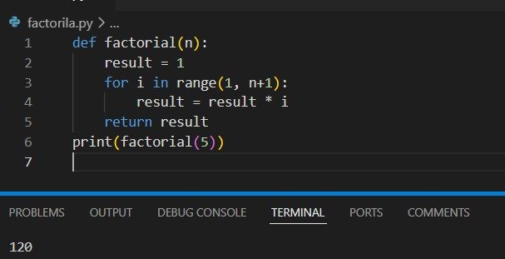
3.Comparision between AI and Manual :
Manual Fix:
- Changed range(1, n) → range(1, n+1)
- Solves main logic issue.
AI Fix:
- Identified off-by-one error.
- Included n+1 correction.
- Also handled:
  - Negative numbers o Zero
  - Non-integer inputs
4. The AI correctly identified the off-by-one error caused by using range(1, n) instead of range(1, n+1).
However, a more advanced AI-assisted correction also includes validation for:
- Negative inputs
- Non-integer inputs
- Mathematical edge case of 0! = 1
Thus, AI-assisted debugging not only fixes logic errors but can improve robustness and reliability of the code.

JUSTIFICATION:
In this problem the code is about factorization of a number the loop runs only from starting to ending -1.if we want to know the factorial of a end number the loop should run upto end+1 times.

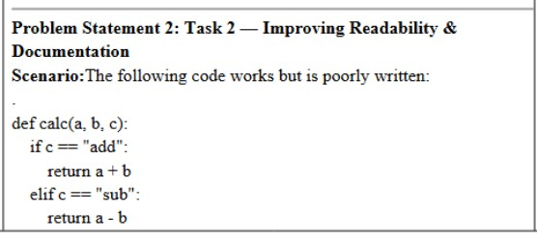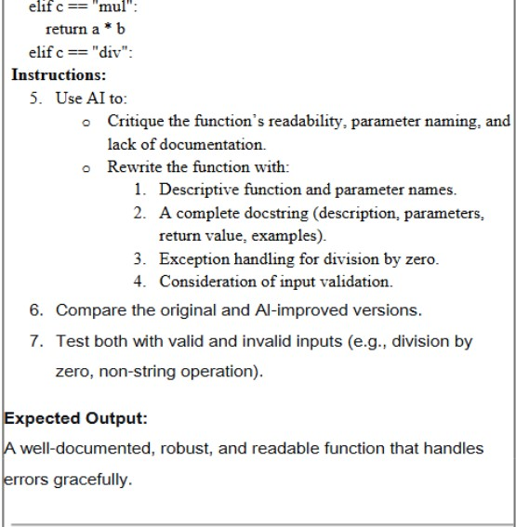
5.
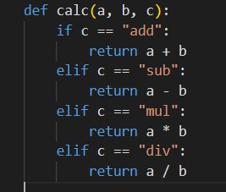
- AI Critique of the Original Code
1. Poor Readability
  - Function name calc is vague.
  - Parameter names a, b, c are not descriptive.
  - No comments or documentation.
  - No explanation of expected inputs.
- No Documentation
• No docstring explaining: o What the function does o What parameters mean o What it returns
o Example usage
3. No Error Handling
- Division by zero will crash the program.
- If operation is invalid (e.g., "power"), function returns None.
- No type checking for inputs.
4. No Input Validation
- What if numbers are strings?
- What if operation is not a string?
2. AI Improved version:
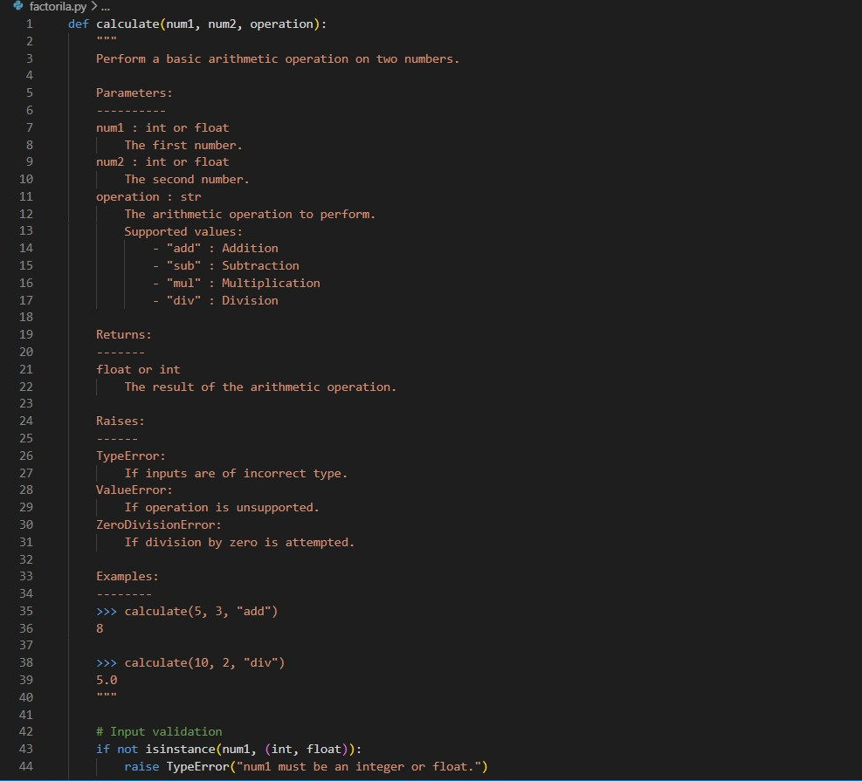
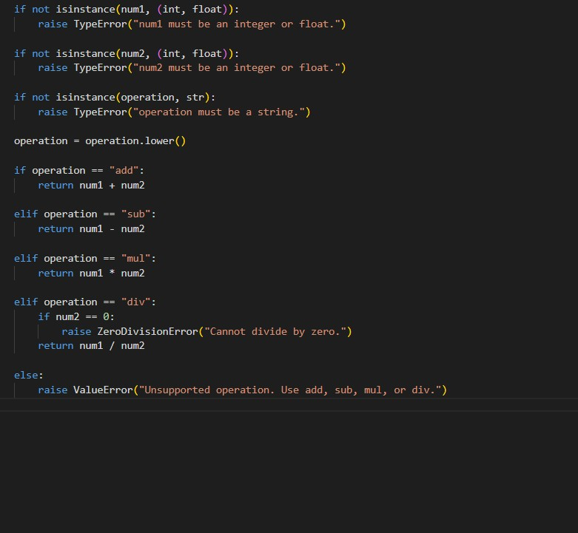
Comparision:
Comparison – Original vs Improved Version
Feature Original Version AI-Improved Version
Function Name calc (unclear) calculate (descriptive)
Parameter Names a, b, c | num1, num2, operation
Documentation None | Complete docstring
Error Handling None | Division by zero handled
Invalid Operation Returns None Raises ValueError
Input Validation No checks Type checking added
Readability Low High
IMPROVED:
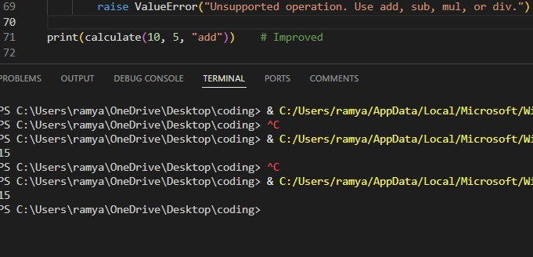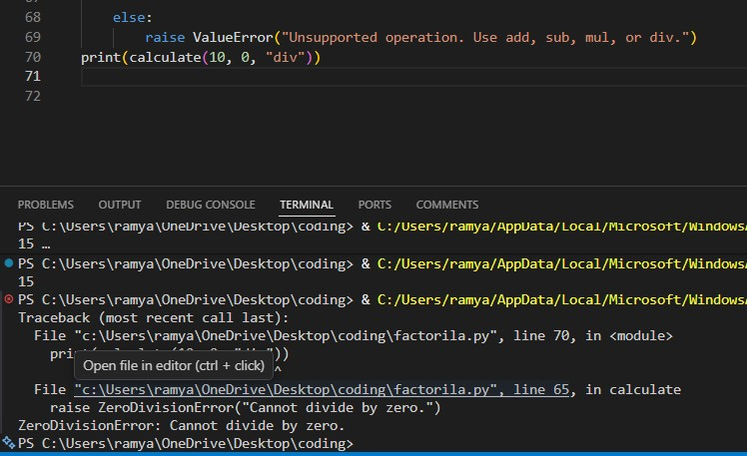
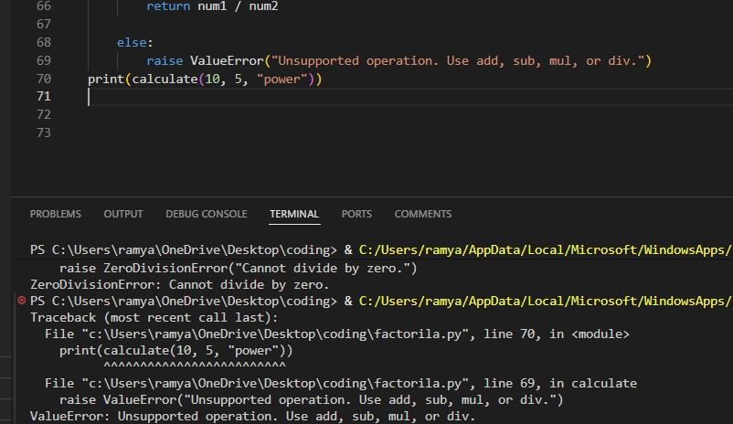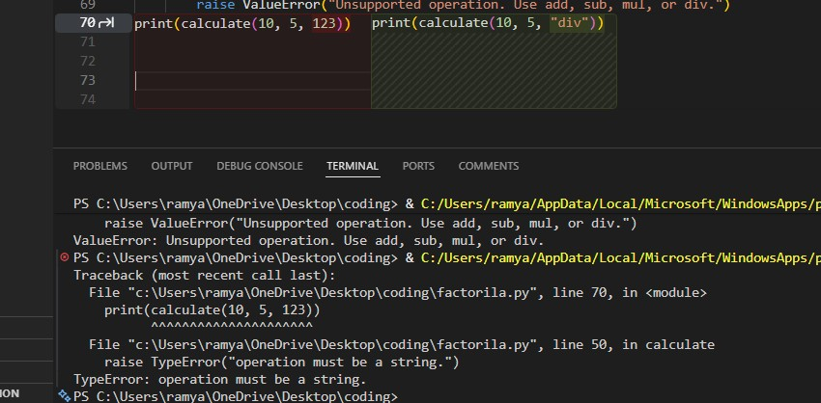
ORIGINAL CODE:
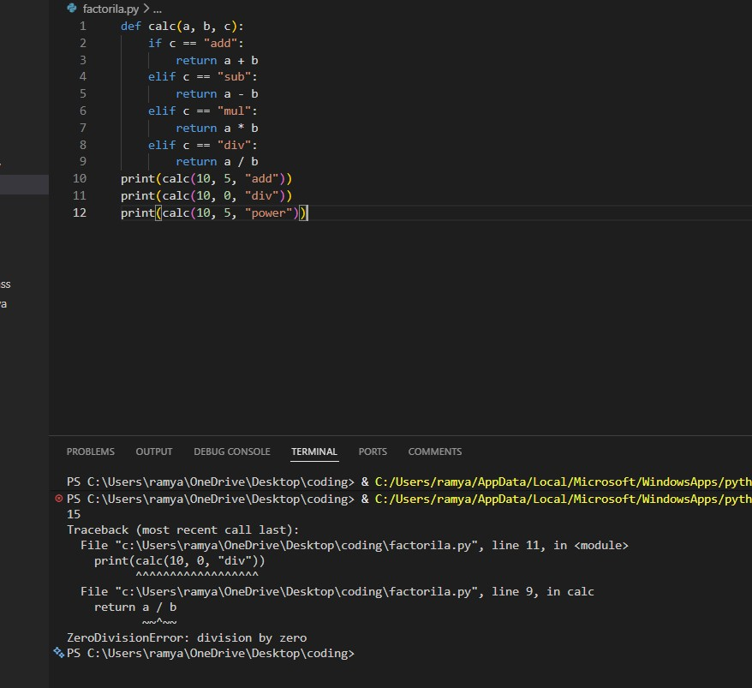
JUSTIFICATION:
The original version works for ideal inputs but fails under invalid conditions. The AI-enhanced version handles errors gracefully and follows professional coding standards.
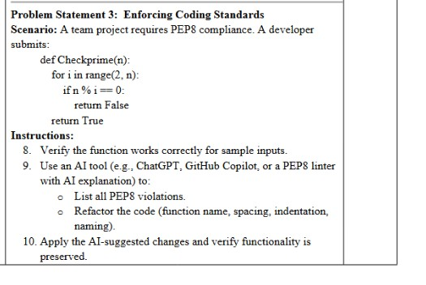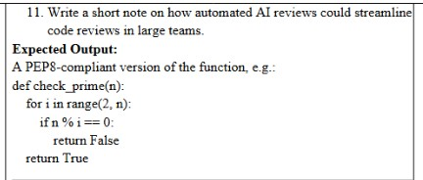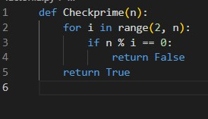

Test case:
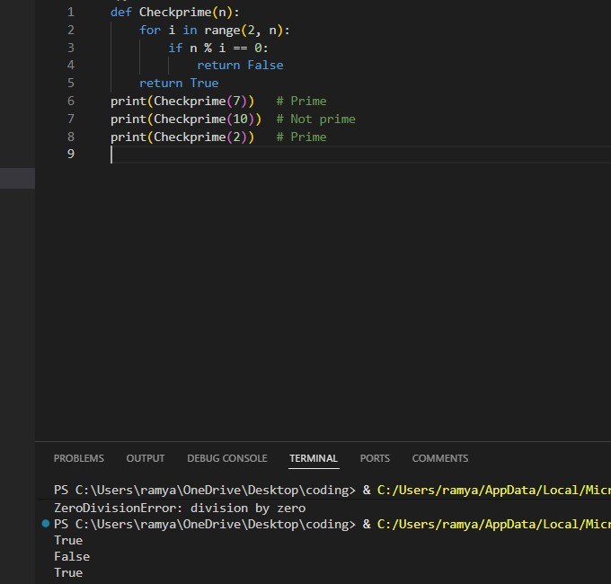
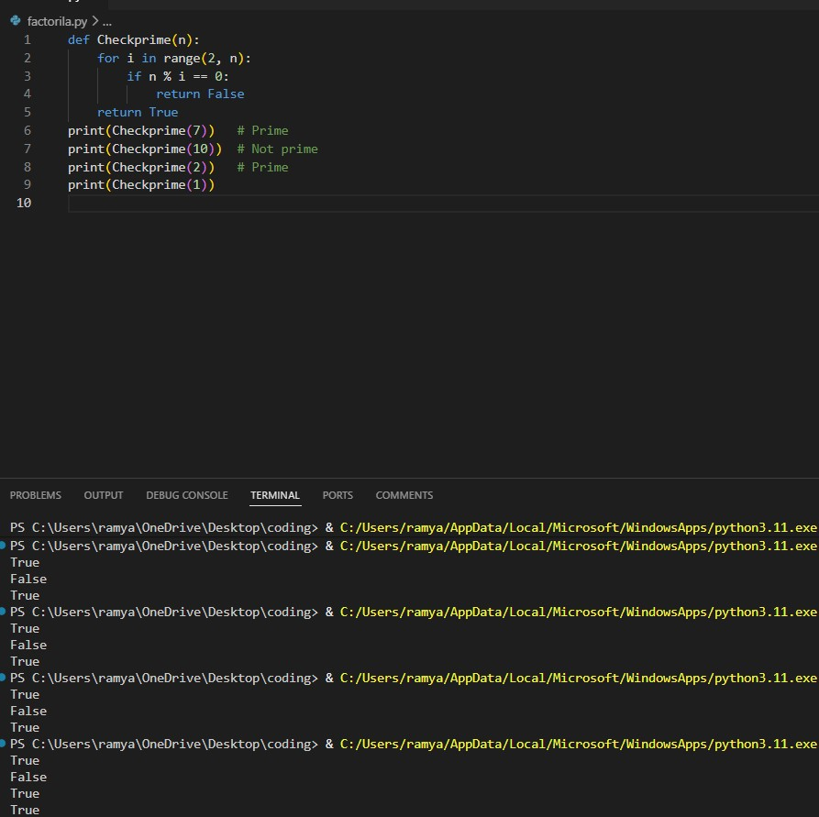
PEP8 Violations Identified
According to PEP8 (Python Style Guide):
Violations in Original Code
- Function name Checkprime o Should use snake_case → check_prime
- Missing docstring o Functions should include documentation.
- No input validation o Should check if n is integer and > 1.
- Inefficient loop
o Checking up to n instead of √n.
- No spacing after function definition line (readability issue in formatting submissions)
- No blank line before function (PEP8 requires spacing between top-level functions)

AI-Refactored PEP8-Compliant Version
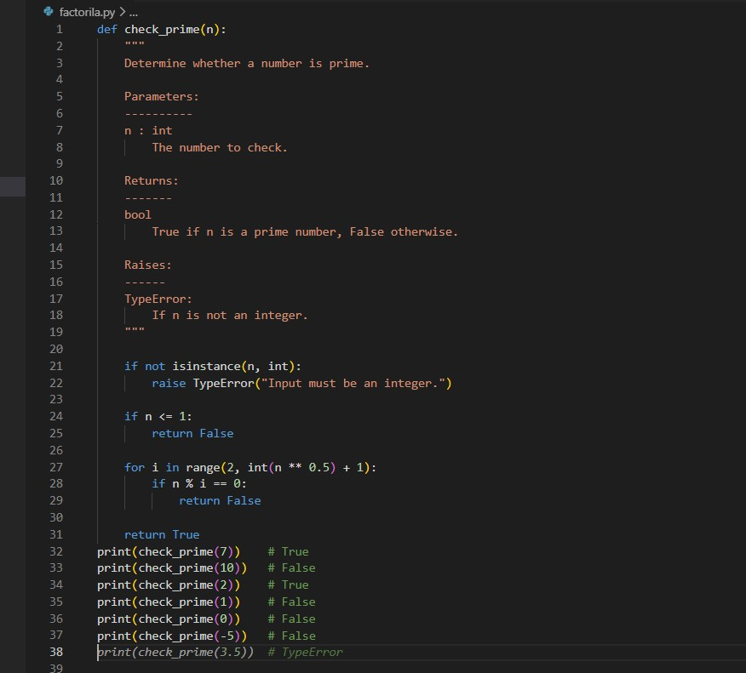

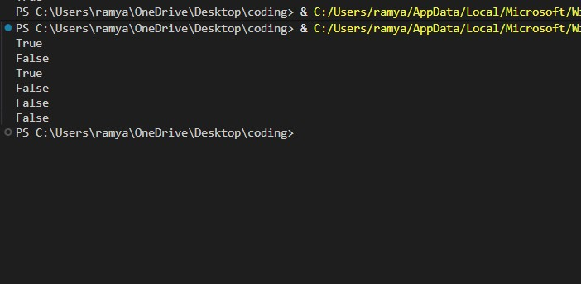
Comparison – Original vs Refactored
Feature Original Refactored
Function Name Checkprime check_prime
PEP8 Compliant No | Yes
Docstring None | Added
Edge Case Handling No | Yes
Input Validation No | Type check added
Efficiency O(n) | O(√n)
Readability Basic | Professional
Role of AI in Code Reviews
Automated AI-based code reviews can significantly streamline development in large teams by:
- Instant PEP8 Compliance Checks
AI tools automatically detect naming issues, spacing problems, and formatting violations.
- Early Bug Detection
Logical errors and missing edge cases can be identified before manual review.
- Improved Code Quality
AI suggests optimizations (e.g., checking up to √n instead of n).
- Reduced Review Time
Senior developers can focus on architecture instead of style corrections.
- Consistent Coding Standards
AI ensures uniform coding style across the team.
- Educational Benefit
Junior developers learn best practices through AI-generated explanations.
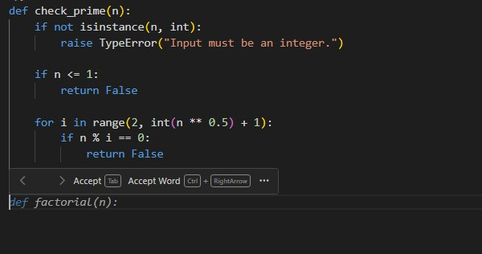
Justification:
The original function worked for basic inputs but violated PEP8 coding standards, lacked proper naming conventions, documentation, and edge-case handling.
The refactored version improves:
- ✔ Readability (snake_case naming: check_prime)
- ✔ Maintainability (clear structure and formatting)
- ✔ Robustness (handles invalid inputs and edge cases like n ≤ 1)
- ✔ Efficiency (checks up to √n instead of n)
Using AI-assisted review helps enforce coding standards automatically, reduces manual review effort, and improves overall code quality in large team projects.

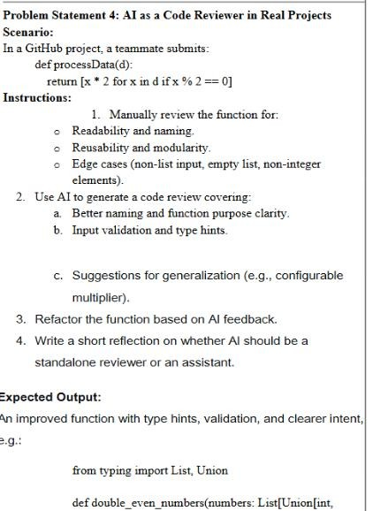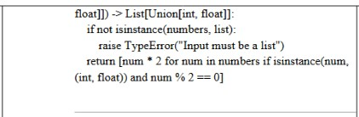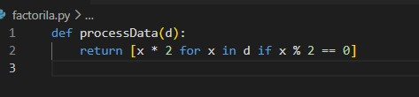

1. Readability & Naming Issues
- Function name processData is vague.
- Parameter name d is unclear.
- No docstring explaining purpose.
- No type hints.
Better naming should reflect intent, such as:
double_even_numbers(numbers)
2. Reusability & Modularity
- Multiplier 2 is hardcoded.
- Not reusable for other multipliers (e.g., triple even numbers).
- Not modular — lacks flexibility.
- 3. Edge Cases
Case Problem
Non-list input Will raise unexpected error
Empty list Works (returns empty list)
Non-integer elements May raise error (x % 2)
String elements Crashes
None input Crashes

AI-Generated Code Review Suggestions
Improvements Suggested by AI
a) Better Naming
- Rename function to reflect behavior clearly.
- Use descriptive parameter names.
b) Add Type Hints
• Improve clarity and static analysis support.
c) Input Validation
- Ensure input is a list.
- Ensure elements are numeric.
d) Generalization
- Make multiplier configurable.
- Improve flexibility.
from typing import List, Union
Refactored Version (AI-Improved)
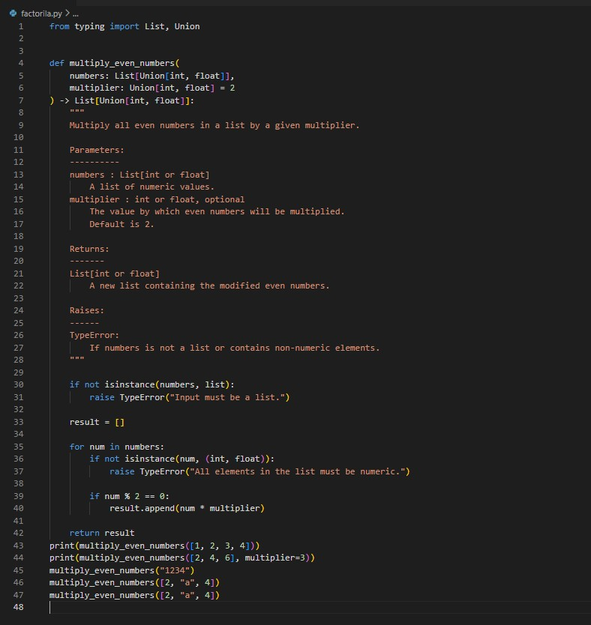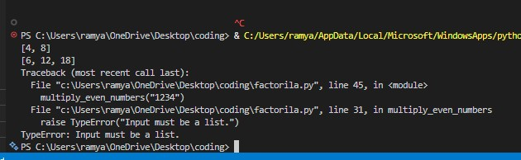
Comparison – Original vs Improved
Feature | Original | Improved
Naming | Vague | Clear & descriptive
Type Hints | None | Added
Input Validation | No | Yes
Flexibility | Fixed multiplier | Configurable
Documentation | None | Full docstring
Error Handling | None | Explicit
JUSTIFICATION:
AI works best as a first-line automated reviewer, while humans handle architectural decisions and deeper logic validation.
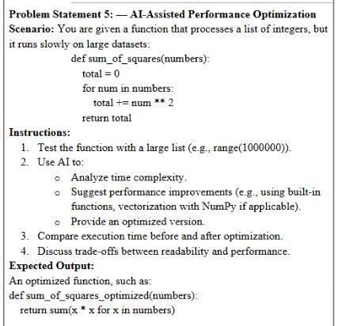
ORIGINAL FUNCTION:
def sum_of_squares(numbers):
total = 0
for num in numbers: total += num ** 2 return total
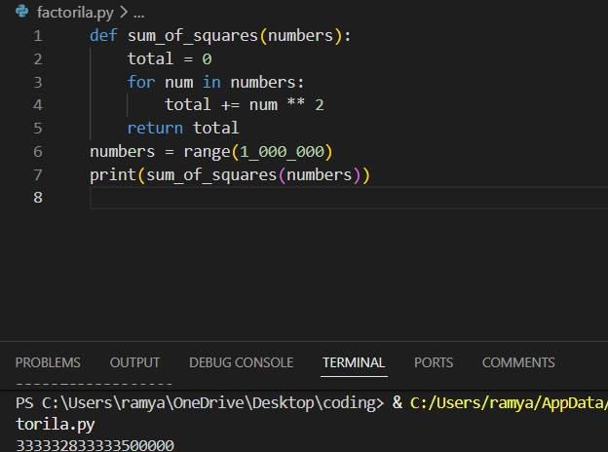
Time Complexity Analysis
- The function iterates through all elements once.
- Each operation (num ** 2) is O(1).
- Therefore:
Time Complexity: O(n)
Space Complexity: O(1) (constant extra space)
The complexity cannot be reduced below O(n) because every element must be processed.
However, we can optimize implementation efficiency.
AI-Suggested Performance Improvements
Improvement 1: Use Built-in sum() with Generator Expression Python’s built-in functions are implemented in C and are faster.
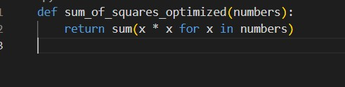
List Comprehension (slightly less memory efficient)
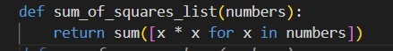
Improvement 3 (Advanced): Using NumPy (for very large datasets)
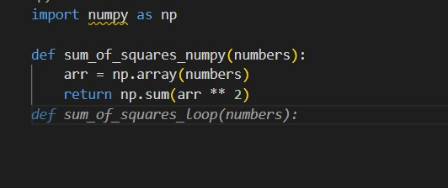
Trade-offs Between Readability and Performance
Approach Readability Performance Memory Usage
Original Loop Medium Good Low
Generator + sum() High Better Low
List Comprehension High Good Higher
NumPy Medium Best (large data) Higher
JUSTIFICATION:

- The original function has optimal time complexity O(n).
- Performance improvement comes from using optimized built-in functions.
- AI-assisted optimization helps:
  - Improve readability
  - Suggest Pythonic solutions
  - Recommend advanced tools like NumPy
  - Balance performance vs maintainability

