Assignment 8.3
K. JASHWANTH
2303A52300
Batch – 42
Task 1: Email Validation using TDD
Prompt:
Create a Python program that checks whether an email address is valid or not using some basic rules.
The program should: Check that the email contains exactly one @ symbol. Check that it has a proper domain with an extension like .com or .in. Make sure special characters are placed correctly. Prevent errors like double dots (..) or missing parts in the email. Handle wrong inputs safely without crashing.
CODE:
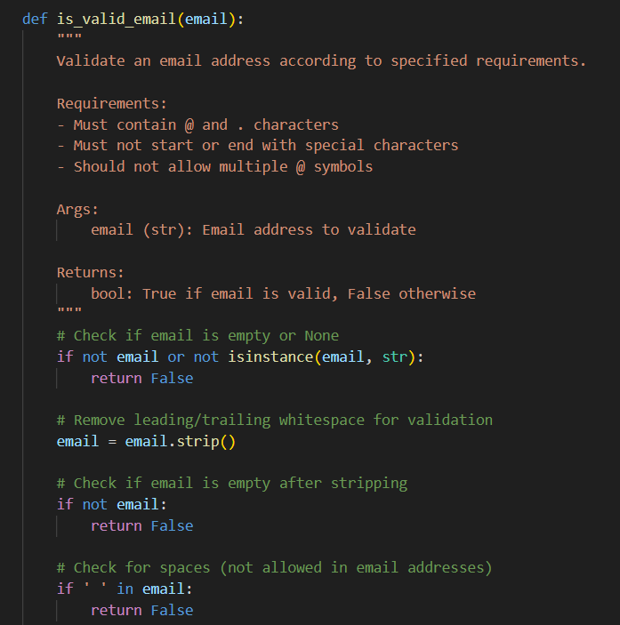
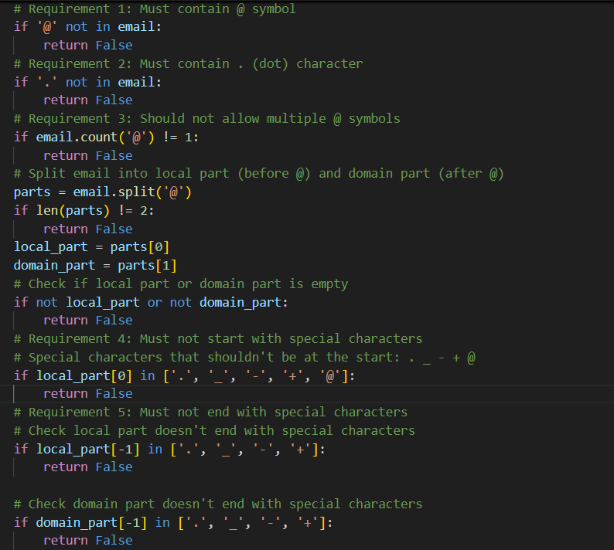
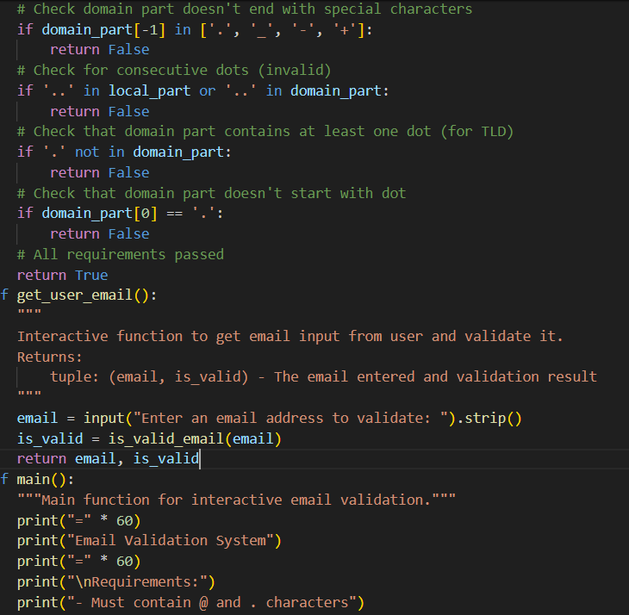
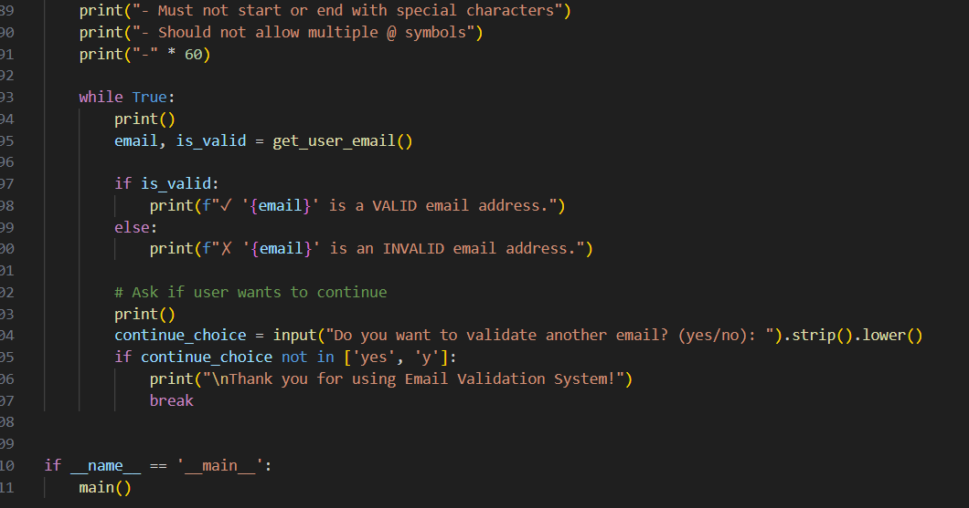
OUTPUT:
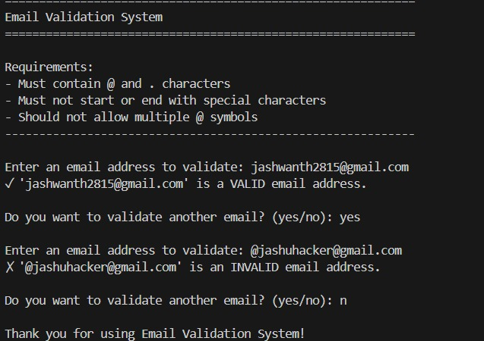
JUSTIFICATION
Email validation is important in real applications like registration forms. This project helps in understanding how real systems check email formats before accepting them. It improves basic programming skills and logical thinking.
Task 2: Grade Assignment using Loops
PROMPT:
Develop a Python function assign_grade(score) that correctly assigns grades from A to F, safely handles invalid or non-numeric inputs, and passes comprehensive unittest cases covering boundaries, normal values, and edge cases.

CODE: 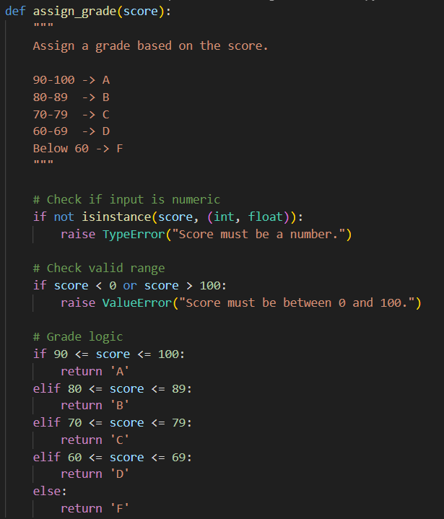

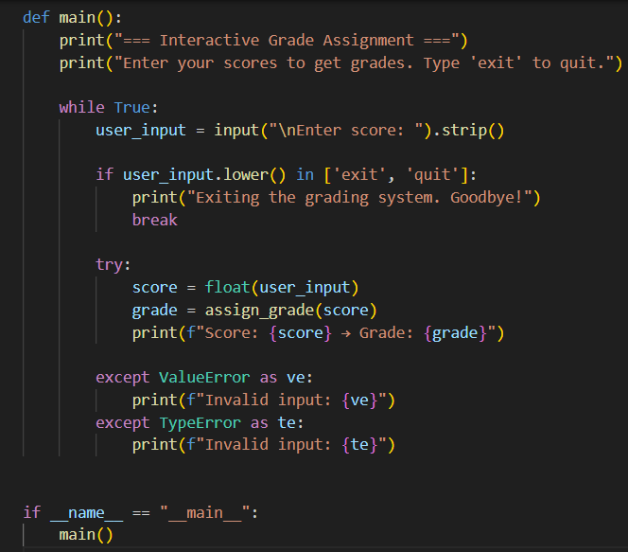
OUTPUT:
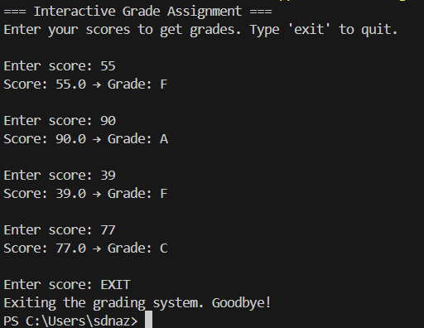
Justification:
The grading system is designed with strong input validation and structured conditional logic. By raising appropriate errors for invalid inputs and handling them in the main function, the program maintains robustness and stability. The interactive loop improves usability by allowing multiple grade checks in a single run.
Task 3: Sentence Palindrome Checker
Prompt:
Create a Python function is_sentence_palindrome(sentence) that checks whether a sentence is a palindrome. Ignore uppercase/lowercase differences, spaces, and punctuation marks. Also, write unittest test cases to verify both palindromic and non-palindromic sentences.
CODE: 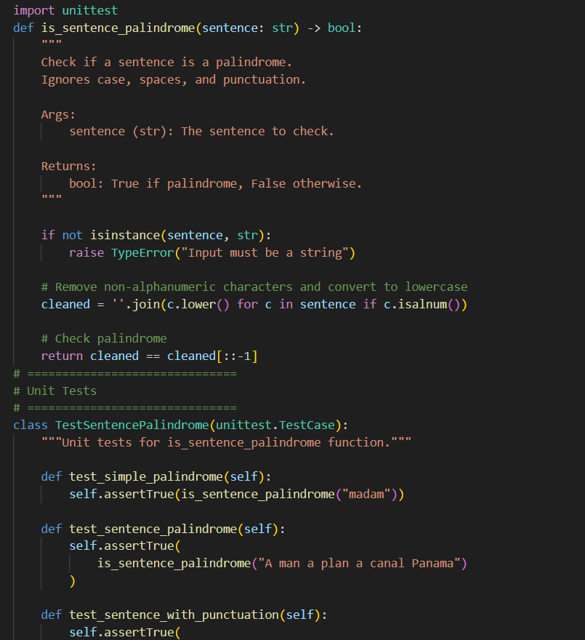
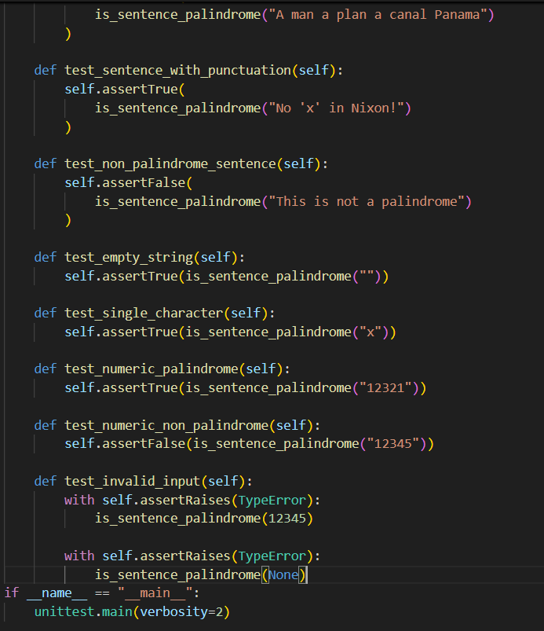
OUTPUT:
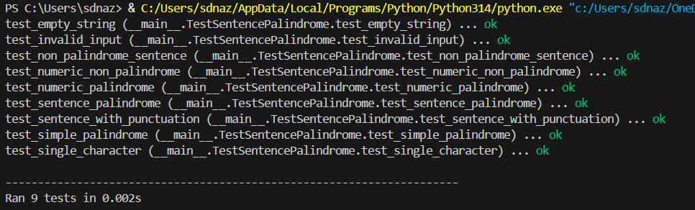
JUSTIFICATION:
The function follows a robust validation approach by first checking the input type and raising a TypeError for non-string inputs. It normalizes the sentence using alphanumeric filtering and lowercase conversion, ensuring logical consistency. The comprehensive unittest suite provides boundary testing (empty string, single character), functional testing (palindromic sentences), and negative testing (invalid inputs), ensuring full logical coverage.
Task 4: ShoppingCart Class
Prompt:
Design a Python program that creates a class-based shopping cart system. The program should allow users to add items with prices, remove items, display cart contents, calculate total cost, and exit the program. Implement proper input validation and handle invalid price entries using exception handling.
CODE:
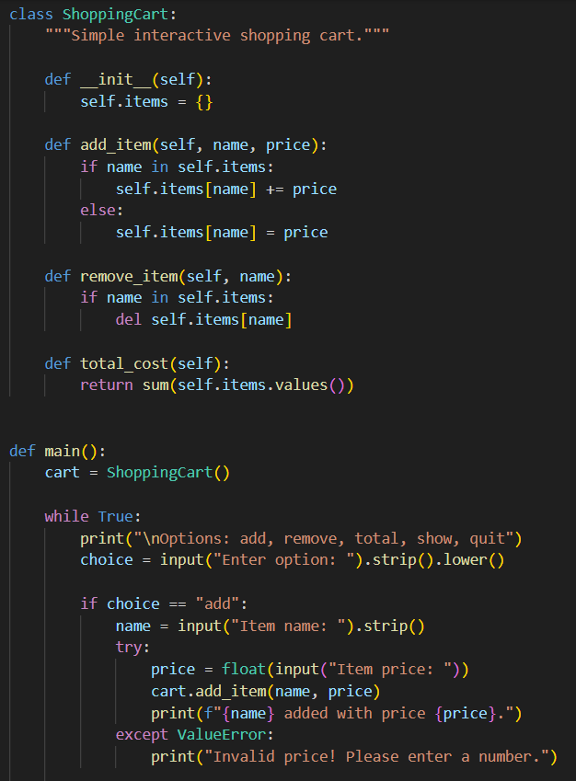
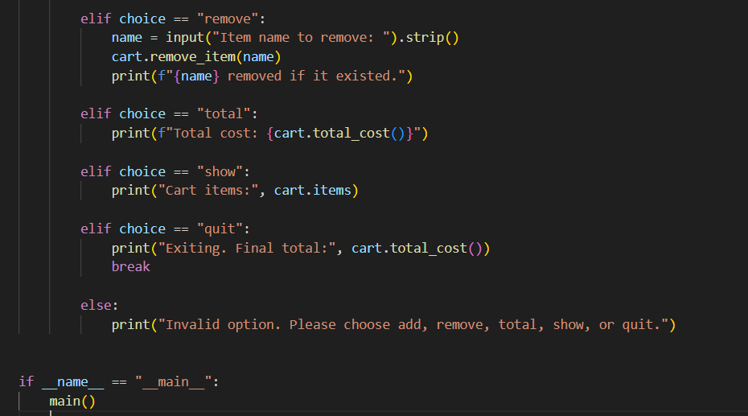
OUTPUT:
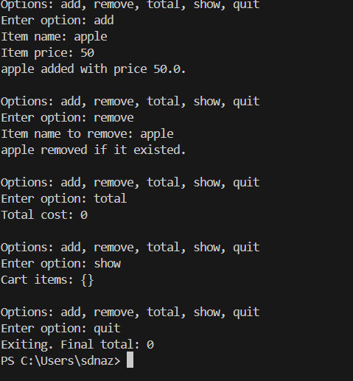
JUSTIFICATION:
The implementation follows modular design principles by separating cart logic inside a ShoppingCart class and user interaction inside the main() function. The dictionary structure efficiently stores items and their prices. Input validation and exception handling improve robustness and prevent runtime errors, ensuring stable execution.
Task 5: Date Format Conversion
PROMPT:
Create a Python function convert_date_format(date_str) that converts a date from YYYY-MM-DD to DD-MM-YYYY, validates input format, and handles invalid inputs using exceptions.
CODE:
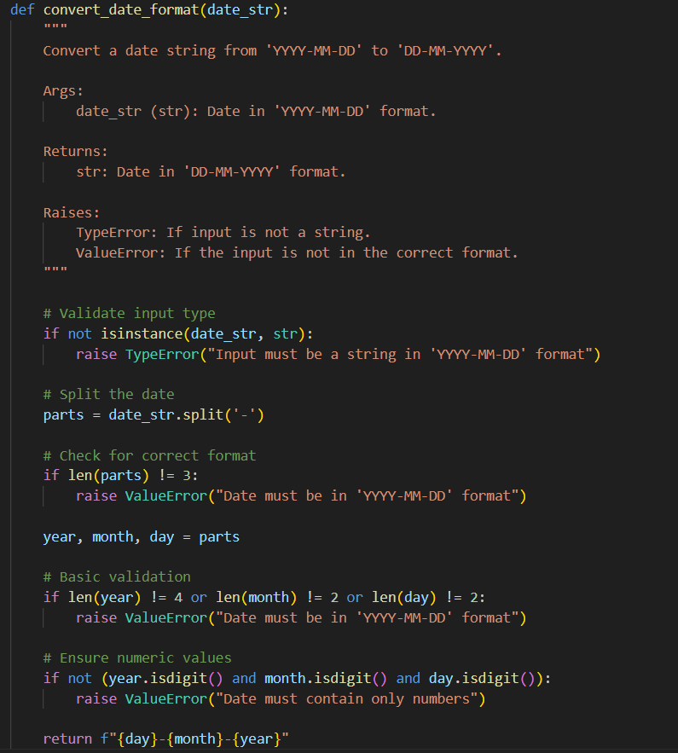
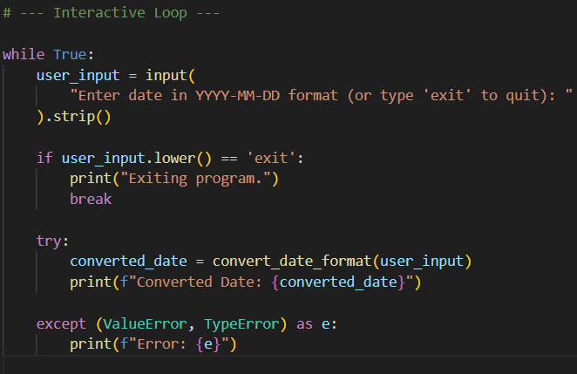
OUTPUT:
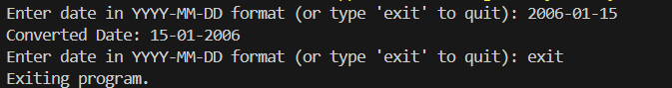
JUSTIFICATION:
This function ensures accurate date conversion by validating the input type and format before processing.
It prevents incorrect data from being converted.
Exception handling makes the program reliable and user-friendly.

