Assignment-11.1

D.Varshitha
2303a52317

Task Description -1 – (Stack Using AI Guidance)
• Task: With the help of AI, design and implement a Stack data
structure supporting basic stack operations.
Expected Output:
• A Python Stack class supporting push, pop, peek, and empty-
check operations with proper documentation.

Prompt:
Design and implement a Stack data structure supporting basic stack operations.

Code:
# design and implement a Stack data structure supporting basic stack operations.
class Stack:
def __init__(self):
self.stack = []

def push(self, item):
"""Add an item to the top of the stack."""
self.stack.append(item)

def pop(self):
"""Remove and return the item at the top of the stack. Raises an error if the stack is empty."""
if not self.is_empty():
return self.stack.pop()
else:
raise IndexError("Stack is empty")

def peek(self):
"""Return the item at the top of the stack without removing it. Raises an error if the stack is empty."""
if not self.is_empty():
return self.stack[-1]
else:
raise IndexError("Stack is empty")

def is_empty(self):
"""Return True if the stack is empty, False otherwise."""
return len(self.stack) == 0

def size(self):
"""Return the number of items in the stack."""
return len(self.stack)

# Create a stack and test it
s = Stack()

# Push some items
s.push(10)
s.push(20)
s.push(30)

print("Stack size:", s.size())
print("Top item:", s.peek())
print("Popped item:", s.pop())
print("Stack size after pop:", s.size())
print("Is empty:", s.is_empty())

Output:
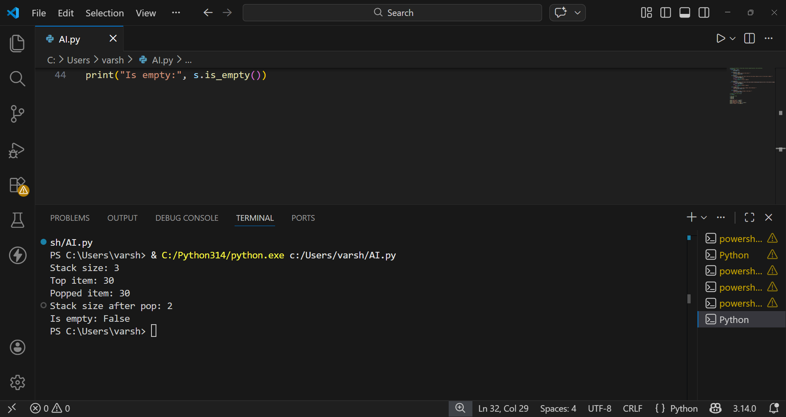

Explanation:
This code implements a Stack — a Last-In-First-Out (LIFO) data structure where items are added and removed from the same end (top).
Methods:
__init__() - Initializes an empty stack using a list
push(item) - Adds an item to the top of the stack
pop() - Removes and returns the top item; raises an error if empty
peek() - Returns the top item without removing it
is_empty() - Checks if the stack has no items
size() - Returns the number of items in the stack

Task Description -2 – (Queue Design)
• Task:Use AI assistance to create a Queue data structure
following FIFO principles
Expected Output:
• A complete Queue implementation including enqueue, dequeue,
front element access, and size calculation

Prompt: create a Queue data structure following FIFO principles

Code:
#create a Queue data structure following FIFO principles
class Queue:
def __init__(self):
self.queue = []

def enqueue(self, item):
"""Add an item to the rear of the queue."""
self.queue.append(item)

def dequeue(self):
"""Remove and return the item at the front of the queue. Raises an error if the queue is empty."""
if not self.is_empty():
return self.queue.pop(0)
else:
raise IndexError("Queue is empty")

def front(self):
"""Return the item at the front of the queue without removing it. Raises an error if the queue is empty."""
if not self.is_empty():
return self.queue[0]
else:
raise IndexError("Queue is empty")

def is_empty(self):
"""Return True if the queue is empty, False otherwise."""
return len(self.queue) == 0

def size(self):
"""Return the number of items in the queue."""
return len(self.queue)

# Create a queue and test it
q = Queue()

# Enqueue some items
q.enqueue(10)
q.enqueue(20)
q.enqueue(30)

print("Queue size:", q.size())
print("Front item:", q.front())
print("Dequeued item:", q.dequeue())
print("Queue size after dequeue:", q.size())
print("Is empty:", q.is_empty())

Output:
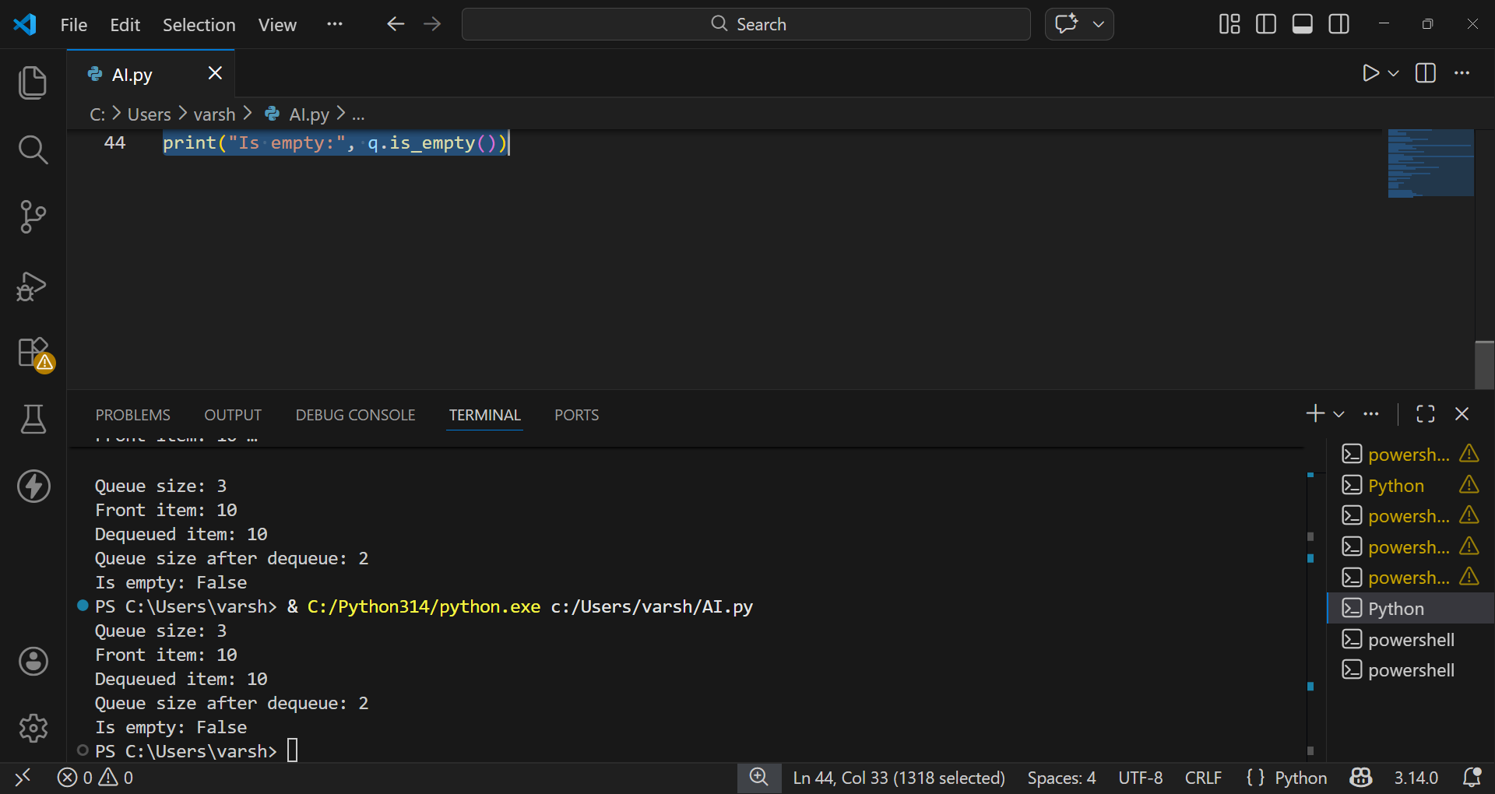

Explanation of the code:
This code implements a Queue — a First-In-First-Out (FIFO) data structure where items are added at the rear and removed from the front. Methods:
- __init__() - Initializes an empty queue using a list enqueue(item) - Adds an item to the rear of the queue
- dequeue() - Removes and returns the item at the front; raises an error if empty
- front() - Returns the front item without removing it
- is_empty() - Checks if the queue has no items
- size() - Returns the number of items in the queue
Task Description -3 –(Singly Linked List Construction)
• Task: Utilize AI to build a singly linked list supporting insertion
and traversal.
Expected Output:
• Correctly functioning linked list with node creation, insertion
logic, and display functionality.

Code:
#build a singly linked list supporting insertion and traversal
class Node:
def __init__(self, data):
"""Initialize a node with data and next pointer."""
self.data = data
self.next = None

class SinglyLinkedList:
def __init__(self):
"""Initialize an empty linked list."""
self.head = None

def insert_at_beginning(self, data):
"""Insert a node at the beginning of the list."""
new_node = Node(data)
new_node.next = self.head
self.head = new_node

def insert_at_end(self, data):
"""Insert a node at the end of the list."""
new_node = Node(data)
if not self.head:
self.head = new_node
return

current = self.head
while current.next:
current = current.next
current.next = new_node

def insert_at_position(self, data, position):
"""Insert a node at a specific position (0-indexed)."""
if position == 0:
self.insert_at_beginning(data)
return

new_node = Node(data)
current = self.head

for _ in range(position - 1):
if not current:
raise IndexError("Position out of range")
current = current.next

if not current:
raise IndexError("Position out of range")

new_node.next = current.next
current.next = new_node

def traverse(self):
"""Traverse and print all elements in the list."""
elements = []
current = self.head
while current:
elements.append(str(current.data))
current = current.next
return " -> ".join(elements) if elements else "Empty list"

def display(self):
"""Display the linked list."""
print(self.traverse())

# Test the singly linked list
print("=== Singly Linked List Demo ===\n")

ll = SinglyLinkedList()

# Insert at beginning
ll.insert_at_beginning(10)
ll.insert_at_beginning(5)
print("After inserting 10, then 5 at beginning:")
ll.display()

# Insert at end
ll.insert_at_end(20)
ll.insert_at_end(30)
print("\nAfter inserting 20, then 30 at end:")
ll.display()

# Insert at specific position
ll.insert_at_position(15, 2)
print("\nAfter inserting 15 at position 2:")
ll.display()

# Traverse the list
print("\nFinal list traversal:")
ll.display()

Output:

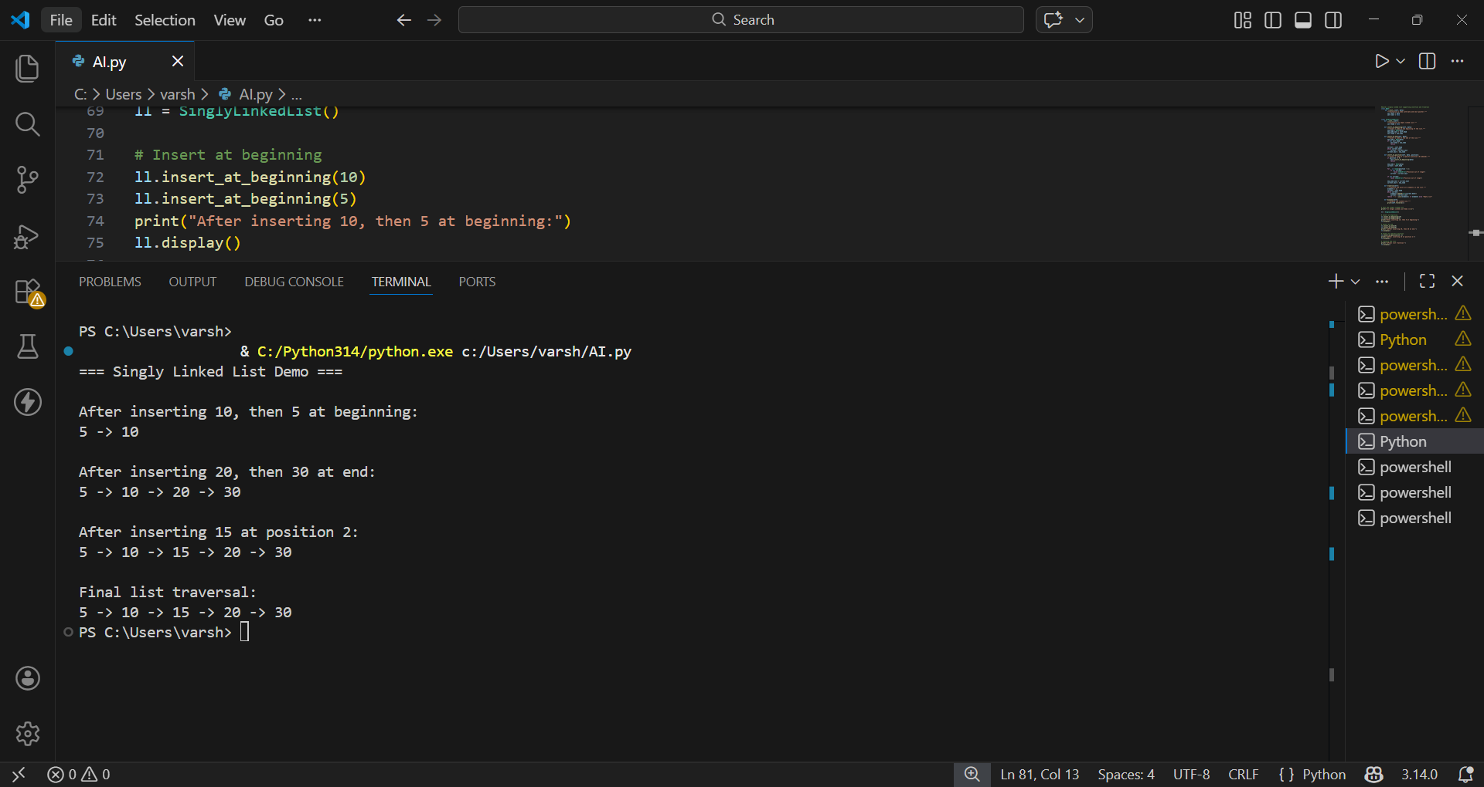

Explanation:
Classes: Node - Represents each element in the list data - stores the value next - points to the next node (or None if it's the last node) SinglyLinkedList - Manages the list head - points to the first node Methods: insert_at_beginning(data) - Adds a node at the front by making it the new head insert_at_end(data) - Traverses to the last node and appends a new node insert_at_position(data, position) - Inserts at a specific index (0-based) traverse() - Walks through all nodes and returns them as a formatted string display() - Prints the list

Task Description -4 – (Binary Search Tree Operations)
• Task: Implement a Binary Search Tree with AI support focusing
on insertion and traversal.
Expected Output:
• BST program with correct node insertion and in-order traversal
output.
Prompt: Implement a Binary Search Tree with AI support focusing on insertion and traversal
Code:

# Implement a Binary Search Tree with AI support focusing on insertion and traversal
class TreeNode:
def __init__(self, data):
"""Initialize a tree node with data and left/right pointers."""
self.data = data
self.left = None
self.right = None

class BinarySearchTree:
def __init__(self):
"""Initialize an empty binary search tree."""
self.root = None

def insert(self, data):
"""Insert a value into the BST maintaining the BST property."""
if self.root is None:
self.root = TreeNode(data)
else:
self._insert_recursive(self.root, data)

def _insert_recursive(self, node, data):
"""Helper method to recursively insert data into the tree."""
if data < node.data:
# Insert into left subtree
if node.left is None:
node.left = TreeNode(data)
else:
self._insert_recursive(node.left, data)
else:
# Insert into right subtree
if node.right is None:
node.right = TreeNode(data)
else:
self._insert_recursive(node.right, data)

def inorder_traversal(self):
"""Traverse the tree in inorder (Left, Root, Right) and return as list."""
result = []
self._inorder_recursive(self.root, result)
return result

def _inorder_recursive(self, node, result):
"""Helper method for inorder traversal."""
if node:
self._inorder_recursive(node.left, result)
result.append(node.data)
self._inorder_recursive(node.right, result)

def preorder_traversal(self):
"""Traverse the tree in preorder (Root, Left, Right) and return as list."""
result = []
self._preorder_recursive(self.root, result)
return result

def _preorder_recursive(self, node, result):
"""Helper method for preorder traversal."""
if node:
result.append(node.data)
self._preorder_recursive(node.left, result)
self._preorder_recursive(node.right, result)

def postorder_traversal(self):
"""Traverse the tree in postorder (Left, Right, Root) and return as list."""
result = []
self._postorder_recursive(self.root, result)
return result

def _postorder_recursive(self, node, result):
"""Helper method for postorder traversal."""
if node:
self._postorder_recursive(node.left, result)
self._postorder_recursive(node.right, result)
result.append(node.data)

def search(self, data):
"""Search for a value in the BST."""
return self._search_recursive(self.root, data)

def _search_recursive(self, node, data):
"""Helper method to recursively search for data."""
if node is None:
return False
if data == node.data:
return True
elif data < node.data:
return self._search_recursive(node.left, data)
else:
return self._search_recursive(node.right, data)

def find_min(self):
"""Find the minimum value in the BST."""
if self.root is None:
return None
current = self.root
while current.left:
current = current.left
return current.data

def find_max(self):
"""Find the maximum value in the BST."""
if self.root is None:
return None
current = self.root
while current.right:
current = current.right
return current.data

# Test the Binary Search Tree
print("=== Binary Search Tree Demo with AI Support ===\n")

bst = BinarySearchTree()

# Insert values
values = [50, 30, 70, 20, 40, 60, 80, 10, 25, 35, 65]
print(f"Inserting values: {values}")
for val in values:
bst.insert(val)

print("\nTraversals:")
print(f"Inorder (sorted): {bst.inorder_traversal()}")
print(f"Preorder: {bst.preorder_traversal()}")
print(f"Postorder: {bst.postorder_traversal()}")

print("\nSearching & Min/Max:")
print(f"Search for 35: {bst.search(35)}")
print(f"Search for 100: {bst.search(100)}")
print(f"Minimum value: {bst.find_min()}")
print(f"Maximum value: {bst.find_max()}")

print("\n=== BST Structure ===")
print(" 50")
print(" / \\")
print(" 30 70")
print(" / \\ / \\")
print(" 20 40 60 80")
print(" / \\ \\ \\")
print("10 25 35 65")

Output:
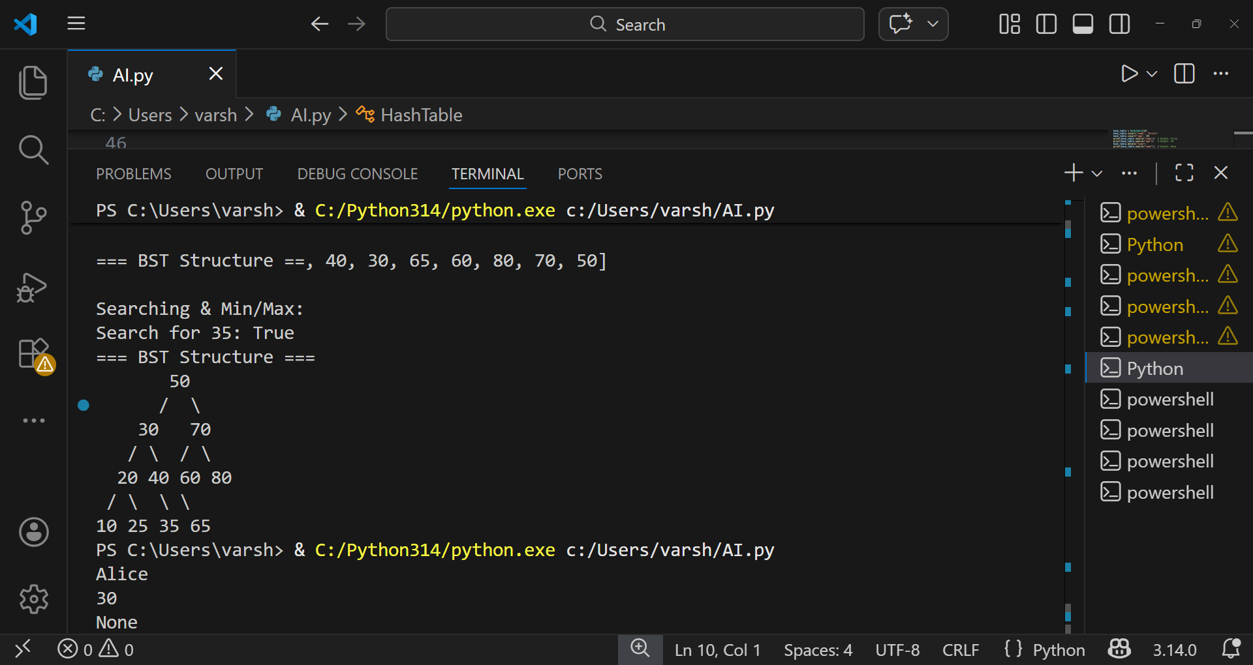
Explanation:
TreeNode - Represents individual nodes data - stores the value left - points to smaller values right - points to larger values BinarySearchTree - Manages the BST root - points to the top node Key Methods: insert(data) - Adds values maintaining BST property (left < parent < right) Uses recursion to find correct position Smaller values go left, larger go right inorder_traversal() - Left → Root → Right Returns values in sorted order (10, 20, 25, 30, 35, 40, 50, 60, 65, 70, 80) preorder_traversal() - Root → Left → Right Visits root first, useful for copying trees postorder_traversal() - Left → Right → Root Visits root last, useful for deleting trees search(data) - Finds if a value exists using binary

Task Description -5 – (Hash Table Implementation)
• Task: Create a hash table using AI with collision handling
Expected Output:
• Hash table supporting insert, search, and delete using chaining
or open
Prompt: Create a hash table with collision handling

Code:
#Create a hash table with collision handling

class HashTable:
def __init__(self, size):
self.size = size
self.table = [None] * size

def hash_function(self, key):
return hash(key) % self.size

def insert(self, key, value):
index = self.hash_function(key)
if self.table[index] is None:
self.table[index] = [(key, value)]
else:
for i, (k, v) in enumerate(self.table[index]):
if k == key:
self.table[index][i] = (key, value)
return
self.table[index].append((key, value))

def search(self, key):
index = self.hash_function(key)
if self.table[index] is not None:
for k, v in self.table[index]:
if k == key:
return v
return None

def delete(self, key):
index = self.hash_function(key)
if self.table[index] is not None:
for i, (k, v) in enumerate(self.table[index]):
if k == key:
del self.table[index][i]
return True
return False
# Example usage
hash_table = HashTable(10)
hash_table.insert("name", "Alice")
hash_table.insert("age", 30)
print(hash_table.search("name")) # Output: Alice
print(hash_table.search("age")) # Output: 30
hash_table.delete("name")
print(hash_table.search("name")) # Output: None

Output: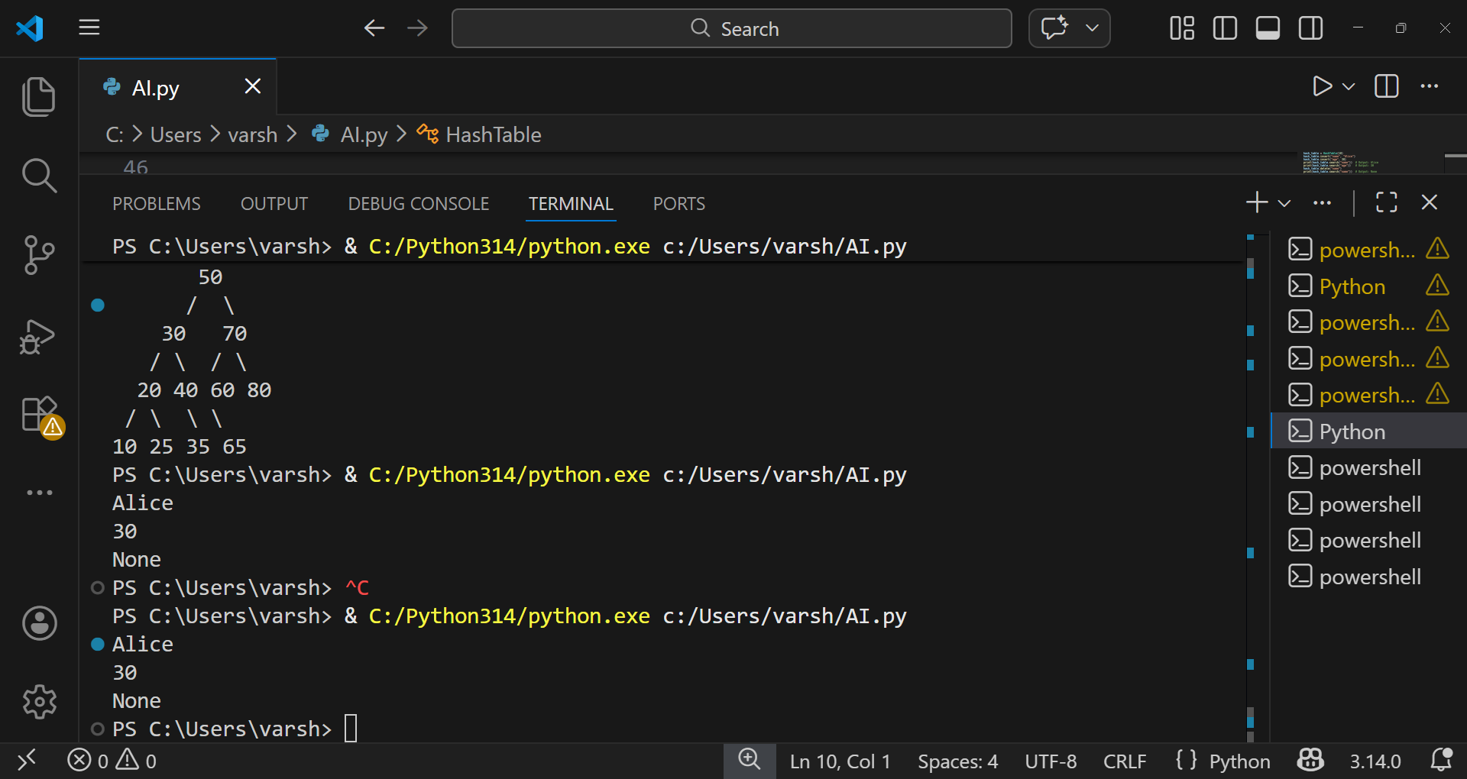

Explanation of code:
Purpose:Implements a hash table using separate chaining (each bucket is a list of (key, value) pairs) to handle collisions.
- __init__(self, size): Initializes self.size (number of buckets) and self.table (list of buckets, initially None entries). Buckets are created lazily (a bucket becomes a list when first used).
- hash_function(self, key): Computes hash(key) % self.size to map any hashable key to a bucket index.
- insert(self, key, value): Computes bucket index. If bucket is None, creates a list and appends (key, value). If bucket exists, scans for an existing key: if found, updates value; otherwise appends the new pair. Collision handling: multiple keys that hash to the same index live in the same bucket list.
- Search(self, key): Computes index and scans the bucket list (if present). Returns the associated value if found, else returns None.
- delete(self, key): Computes index and scans the bucket list. Removes the matching pair if found and returns True; otherwise returns False.

