ASSIGNMENT-2.2

Batch-37
2303A52317

Question:-

Lab 2: Exploring Additional AI Coding Tools beyond Copilot – Gemini (Colab) and Cursor AI

Task 1: Cleaning Sensor Data
❖ Scenario:
❖ You are cleaning IoT sensor data where negative values are invalid.
❖ Task:
Use Gemini in Colab to generate a function that filters out all negative
numbers from a list.
❖ Expected Output:
➢ Before/after list
➢ Screenshot of Colab execution

Prompt:-

Given a list of numbers, separate them into two new lists: one for negative numbers and another for non-negative numbers. Then, print the original list, the negative numbers, and the non-negative numbers.

Code:-

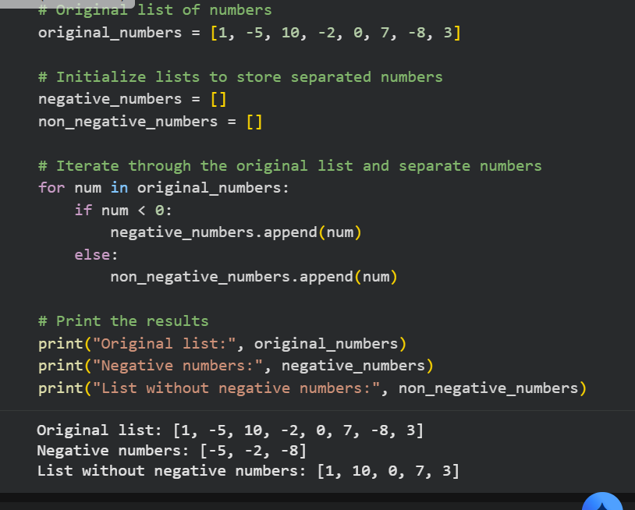

Explanation of code:-

IoT sensor data may contain negative values due to errors or noise, which are invalid.
A Python function is used to clean the sensor data by filtering out negative numbers.
The function takes a list of sensor readings as input.
Only non-negative values (zero and positive) are selected and stored in a new list.
The program displays the sensor data before and after cleaning.
This cleaning process improves the accuracy and reliability of IoT data for analysis

Question-2:

Task 2: String Character Analysis
❖ Scenario:
You are building a text-analysis feature.
❖ Task:
Use Gemini to generate a Python function that counts vowels, consonants,
and digits in a string.
❖ Expected Output:
➢ Working function
➢ Sample inputs and outputs

Prompt:-

Create a Python function that counts the number of vowels, consonants, and digits in a given string. Afterwards, show how to use this function with an example string and print all the resulting counts.

code:-

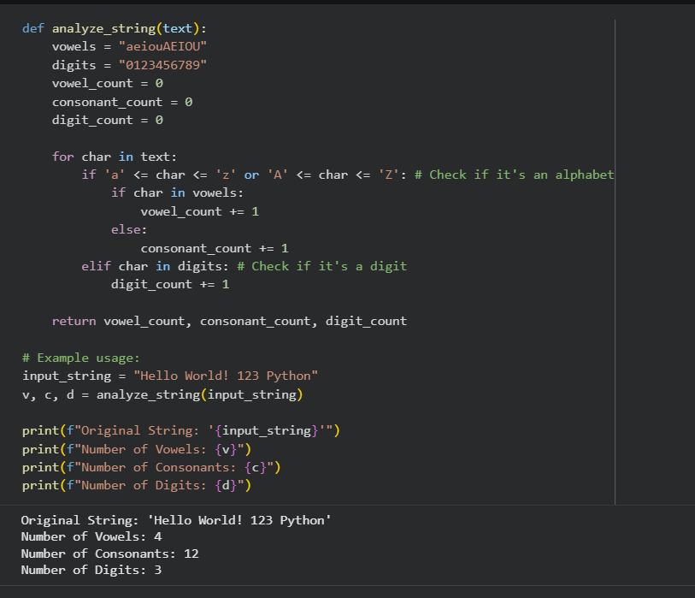

Explanatio of code:-

This program uses a function called analyze_string to study the contents of a given string. The function receives a string as input and goes through each character individually. During this process, it identifies whether a character is a vowel, a consonant, or a digit. Depending on the type of character found, the corresponding counter is increased. Once all the characters in the string have been examined, the function returns the total counts of vowels, consonants, and digits. In the given example, the function is applied to the string "Hello World! 123 Python", and the final output displays how many vowels, consonants, and digits are present in the text.

Task 3: Palindrome Check – Tool Comparison
❖ Scenario:
You must decide which AI tool is clearer for string logic.
❖ Task:
Generate a palindrome-checking function using Gemini and Copilot, then
compare the results.
❖ Expected Output:
➢ Side-by-side code comparison
➢ Observations on clarity and structure

Prompt:-

Write a Python program using a function to check whether the given text is a palindrome or not.
The program should take input from the user and display an appropriate message based on the result.

Code:-
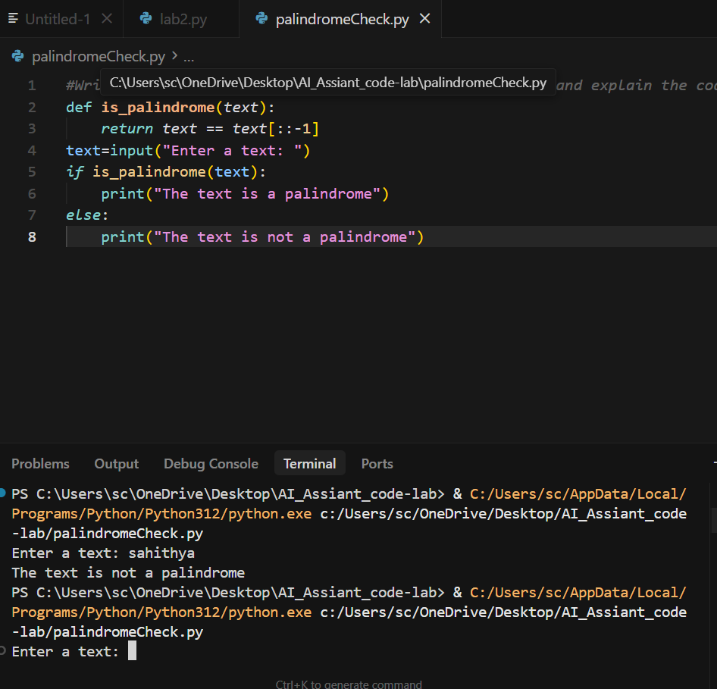

Explain Code:-

This program includes a function named is_palindrome that is used to test whether a given text is a palindrome. A palindrome is a word or sentence that remains the same when read from left to right and from right to left. The function works by reversing the input text and checking if it matches the original text. The program then takes input from the user and sends it to the function. Based on the result returned by the function, the program displays a message stating whether the entered text is a palindrome or not.

Question –4:-
Task 4: Code Explanation Using AI
❖ Scenario:
You are reviewing unfamiliar code written by another developer.
❖ Task:
Ask Gemini to explain a Python function (prime check OR palindrome
check) line by line.
❖ Expected Output:
➢ Code snippet
➢ AI explanation
➢ Student comments on understanding

Prompt:-
Write a Python program using a function to check whether a given number is a prime number or not.
The program should test the function with sample numbers and display the results.

Code:-

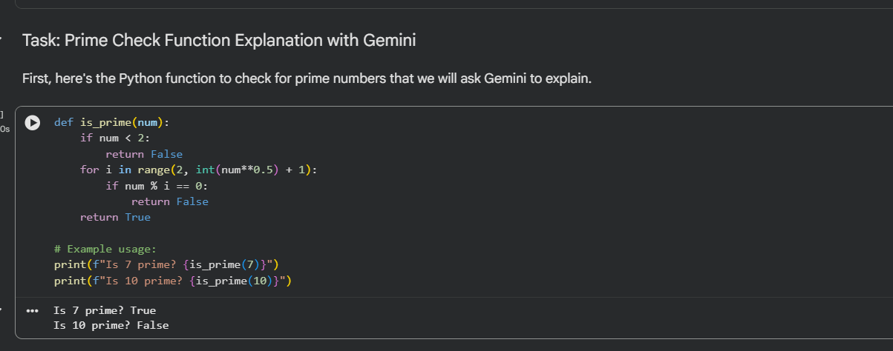

Explain Code:-
This program uses a function named is_prime to determine whether a given number is a prime number. The function begins by eliminating numbers smaller than 2, since they cannot be prime. It then tests the number by dividing it with possible factors starting from 2 up to the square root of the number. If any division results in no remainder, the number is not prime and the function returns false. If no such factor is found, the function confirms that the number is prime by returning true. In the example, the function is used to check the numbers 7 and 10, and the results are printed to show which number is prime and which is not.
.

