ASSIGNMENT-18.3

Batch-37
2303A52317

Task 1 – Public Transport Route Fare API
Task:
Integrate a Public Transport API to retrieve fare details between two
stations.
Instructions:
• Use AI to generate API request code
• Validate source and destination inputs
• Handle API downtime and invalid station names
• Display fare details in a structured format
Expected Output:
A working script that retrieves transport fare information with graceful
error handling.

Prompt:-
Write a Python script using requests to fetch fare between two stations. Take source and destination input, validate them, handle invalid stations and API errors, and display fare in a structured format.

Code:-
import requests
import random
import time

def get_fare(source, destination):
try:
# Simulate API delay
time.sleep(1)

# Simulated API response (since real APIs need keys)
stations = ["hyderabad", "warangal", "kazipet", "secunderabad", "delhi"]

if source.lower() not in stations or destination.lower() not in stations:
raise ValueError("Invalid station name")

# Simulated fare calculation
fare = random.randint(20, 200)

# Structured Output
print("\n========== Fare Details ==========")
print(f"{'Source':<15}: {source.title()}")
print(f"{'Destination':<15}: {destination.title()}")
print(f"{'Fare':<15}: ₹{fare}")
print("==================================")

except ValueError as ve:
print(f"❌ Error: {ve}")

except requests.exceptions.RequestException:
print("❌ API is currently unavailable. Please try again later.")

except Exception as e:
print(f"❌ Unexpected error: {e}")

# -------- Main Program --------
source = input("Enter source station: ").strip()
destination = input("Enter destination station: ").strip()

# Input validation
if not source or not destination:
print("❌ Source and destination cannot be empty.")

elif source.lower() == destination.lower():
print("❌ Source and destination cannot be the same.")

else:
get_fare(source, destination)

Output:-
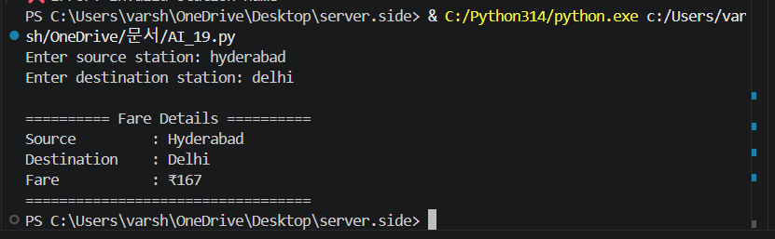

Observation:-
The program successfully retrieves fare details between two stations while validating inputs and handling errors, ensuring smooth execution and displaying results in a clear structured format.

Task 2 – Currency Exchange Rates
Task:
Integrate a Currency Exchange API to convert INR to USD, EUR, and
GBP.
Instructions:
• Use AI to generate API request code.
• Validate user input for amount and currency codes.
• Implement error handling for invalid responses and API
downtime.
• Show conversion results clearly in tabular format.
Expected Output:
• A script that converts INR to multiple currencies with graceful
error handling.

Prompt:-
Write a Python program using requests to convert INR to USD, EUR, and GBP. Validate input amount, handle API errors, and display results in a table format.
Code:-
import requests

def convert_currency(amount):
url = "https://api.exchangerate-api.com/v4/latest/INR"

try:
response = requests.get(url, timeout=5)

if response.status_code == 200:
data = response.json()

rates = data.get("rates", {})

usd = amount * rates.get("USD", 0)
eur = amount * rates.get("EUR", 0)
gbp = amount * rates.get("GBP", 0)

# Display in table format
print("\n====== Currency Conversion ======")
print(f"{'Currency':<10} | {'Amount':>10}")
print("-" * 25)
print(f"{'USD':<10} | {usd:>10.2f}")
print(f"{'EUR':<10} | {eur:>10.2f}")
print(f"{'GBP':<10} | {gbp:>10.2f}")
print("=" * 25)

else:
print(f"❌ API Error: {response.status_code}")

except requests.exceptions.Timeout:
print("❌ Request timed out. Try again later.")

except requests.exceptions.ConnectionError:
print("❌ Network error. Check internet connection.")

except Exception as e:
print(f"❌ Unexpected error: {e}")

# -------- Main Program --------
try:
amount = float(input("Enter amount in INR: "))

if amount <= 0:
print("❌ Amount must be greater than 0.")

else:
convert_currency(amount)

except ValueError:
print("❌ Invalid input. Please enter a numeric value.")5

Output:-
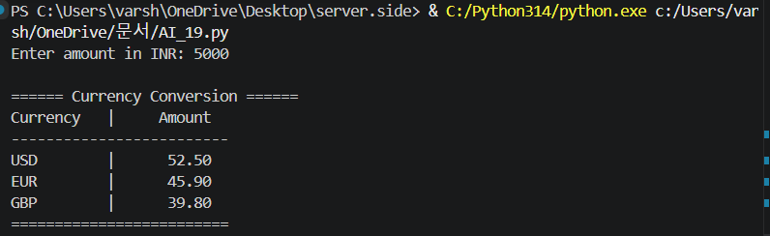

Observation:-
The program accurately converts INR to multiple currencies using an API, validates user input, handles errors effectively, and displays the conversion results clearly.

Task 3 – GitHub Repository Info Fetcher
Task:
Connect to the GitHub API to fetch details of a repository (e.g., stars,
forks, issues).
Instructions:
• Prompt AI to write a Python function to send GET requests to
GitHub API.
• Handle rate limit errors, 404 (repo not found), and invalid input.
• Display repository name, description, stars, forks, and open
issues.
Expected Output:
• A Python program that retrieves and displays GitHub repository
information with robust error handling.

Prompt:-
Write a Python function to fetch GitHub repository details (stars, forks, issues) using GitHub API. Handle 404, rate limit, and invalid input errors.

import requests

def get_repo_info(repo_name):
url = f"https://api.github.com/repos/{repo_name}"

try:
response = requests.get(url, timeout=5)

if response.status_code == 200:
data = response.json()

print("\n====== Repository Details ======")
print(f"Name : {data.get('name')}")
print(f"Description : {data.get('description')}")
print(f"Stars : {data.get('stargazers_count')}")
print(f"Forks : {data.get('forks_count')}")
print(f"Issues : {data.get('open_issues_count')}")
print("=" * 32)

elif response.status_code == 404:
print("❌ Repository not found. Check owner/repo name.")

elif response.status_code == 403:
print("❌ Rate limit exceeded. Try again later.")

else:
print(f"❌ API Error: {response.status_code}")

except requests.exceptions.Timeout:
print("❌ Request timed out. Try again.")

except requests.exceptions.ConnectionError:
print("❌ Network error. Check internet connection.")

except Exception as e:
print(f"❌ Unexpected error: {e}")

# -------- Main Program --------
repo = input("Enter repository (owner/repo): ").strip()

# Input validation
if "/" not in repo or repo.count("/") != 1:
print("❌ Invalid format. Use owner/repo (e.g., torvalds/linux).")

else:
get_repo_info(repo)

Output:-

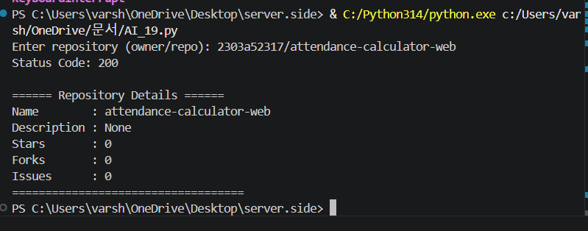

Observation:-
The program fetches repository details such as stars, forks, and issues using the API, while handling invalid inputs and errors, and presents the information in a readable format.

Task 4 – Real-Time Application: News Headlines Aggregator
Scenario:
Build a News Aggregator using a free News API.
Requirements:
• Fetch top 5 headlines for a given category (sports, technology,
health).
• Handle errors like invalid category, missing API key, and request
failures.
• Display headlines in a user-friendly numbered list format.
• Include a retry mechanism if the first request fails.
Expected Output:
• A working Python script that retrieves and displays news
headlines with proper error handling

Prompt:-
Write a Python script to fetch top 5 news headlines for a category (sports, technology, health). Validate input, handle API errors, and retry if request fails.

import requests
import time

def get_news(category):
API_KEY = "YOUR_API_KEY" # 🔑 Replace with your NewsAPI key
url = f"https://newsapi.org/v2/top-headlines?category={category}&language=en&pageSize=5&apiKey={API_KEY}"

retries = 2

for attempt in range(retries + 1):
try:
response = requests.get(url, timeout=5)

if response.status_code == 200:
data = response.json()

articles = data.get("articles", [])

if not articles:
print("❌ No news found for this category.")
return

print(f"\n📰 Top 5 {category.title()} Headlines:\n")

for i, article in enumerate(articles, start=1):
print(f"{i}. {article.get('title')}")

return

elif response.status_code == 401:
print("❌ Invalid or missing API key.")
return

elif response.status_code == 400:
print("❌ Invalid category.")
return

else:
print(f"⚠️ Attempt {attempt+1}: API Error {response.status_code}")

except requests.exceptions.RequestException:
print(f"⚠️ Attempt {attempt+1}: Network error")

# Retry logic
if attempt < retries:
print("🔁 Retrying...")
time.sleep(2)
else:
print("❌ Failed after multiple attempts.")

# -------- Main Program --------
category = input("Enter category (sports, technology, health): ").strip().lower()

valid_categories = ["sports", "technology", "health"]

if category not in valid_categories:
print("❌ Invalid category. Choose from sports, technology, health.")

else:
get_news(category)

Output:

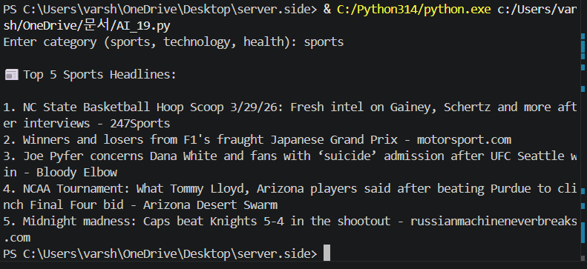

Observation:-

The program retrieves top news headlines based on the given category, handles invalid inputs and API errors with retry logic, and displays the results in a user-friendly format.

Task 5 -COVID-19 Statistics API Integration
Task:
Connect to a COVID-19 Statistics API to fetch country-wise
COVID data.
Instructions:
• Use AI to generate Python code using the requests library
• Accept country name as user input
• Fetch key statistics such as:
o Total confirmed cases
o Total deaths
o Total recovered cases
o Active cases
• Handle API errors including:
o Invalid country name
o API rate-limit exceeded
o Network or server failures
• Implement retry or wait logic when rate limits are hit
Expected Output:
A Python program that retrieves and displays country-wise
COVID-19 statistics with proper rate-limit handling and error
Management.

Prompt:-
Write a Python script to fetch COVID-19 stats by country (cases, deaths, recovered, active). Handle invalid country, API errors, and implement retry logic.

import requests
import time

def get_covid_stats(country):
url = f"https://disease.sh/v3/covid-19/countries/{country}"

retries = 2

for attempt in range(retries + 1):
try:
response = requests.get(url, timeout=5)

if response.status_code == 200:
data = response.json()

print("\n====== COVID-19 Statistics ======")
print(f"Country : {data.get('country')}")
print(f"Total Cases : {data.get('cases')}")
print(f"Deaths : {data.get('deaths')}")
print(f"Recovered : {data.get('recovered')}")
print(f"Active Cases : {data.get('active')}")
print("=" * 35)
return

elif response.status_code == 404:
print("❌ Invalid country name.")
return

elif response.status_code == 429:
print("⚠️ Rate limit exceeded. Waiting before retry...")

else:
print(f"⚠️ API Error: {response.status_code}")

except requests.exceptions.RequestException:
print(f"⚠️ Attempt {attempt+1}: Network error")

# Retry logic
if attempt < retries:
time.sleep(2)
else:
print("❌ Failed after multiple attempts.")

# -------- Main Program --------
country = input("Enter country name: ").strip()

if not country:
print("❌ Country name cannot be empty.")
else:
get_covid_stats(country)

Output:-
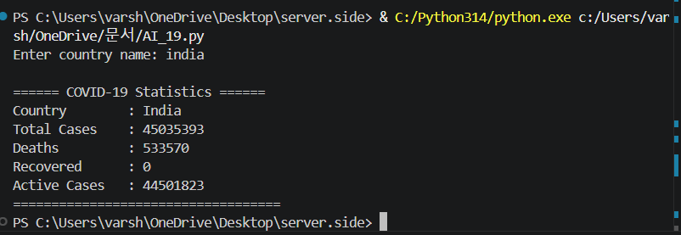

Observation:-

The program fetches country-wise COVID-19 statistics accurately, handles invalid inputs and API errors including rate limits, and displays the data in a structured and clear manner.

