Assignment-7.3
D.Varshitha
2303a52317

Task 1: Fixing Syntax Errors
Scenario
You are reviewing a Python program where a basic function definition contains a syntax error.
Requirements
• Provide a Python function add(a, b) with a missing colon
• Use an AI tool to detect the syntax error
• Allow AI to correct the function definition
• Observe how AI explains the syntax issue
Expected Output
• Corrected function with proper syntax
• Syntax error resolved successfully
• AI-generated explanation of the fix

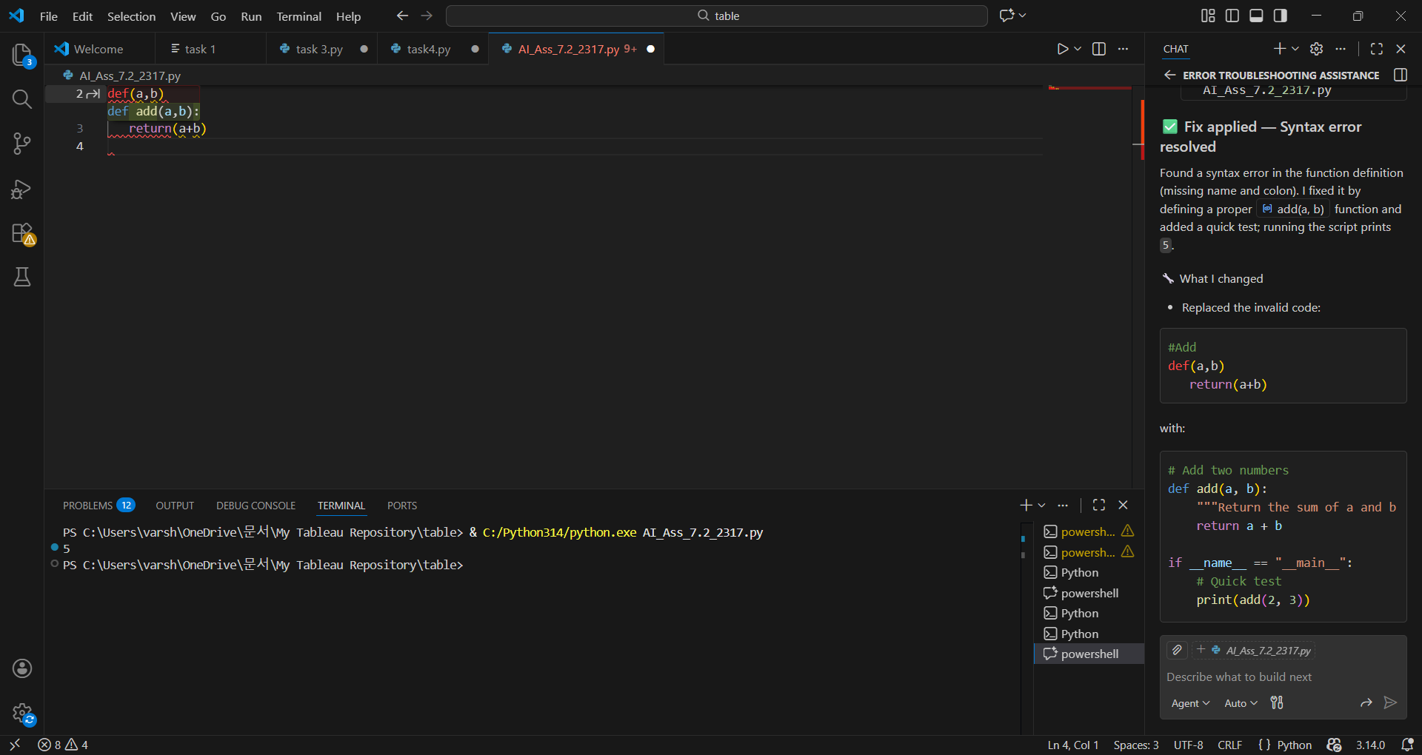

Correct syntax:
# Add two numbers
def add(a, b):
"""Return the sum of a and b."""
return a + b

if __name__ == "__main__":
# Quick test
print(add(2, 3))

AI Generated explanation of the fix:

Found an invalid function definition (syntax error). I'll replace it with a properly named function and a quick test print.
✅ Fix applied — Syntax error resolved
Found a syntax error in the function definition (missing name and colon). I fixed it by defining a proper add(a, b) function and added a quick test; running the script prints 5.

Task 2: Debugging Logic Errors in Loops
Scenario
You are debugging a loop that runs infinitely due to a logical mistake.
Requirements
• Provide a loop with an increment or decrement error
• Use AI to identify the cause of infinite iteration
• Let AI fix the loop logic
• Analyze the corrected loop behavior
Expected Output
• Infinite loop issue resolved
• Correct increment/decrement logic applied
• AI explanation of the logic error

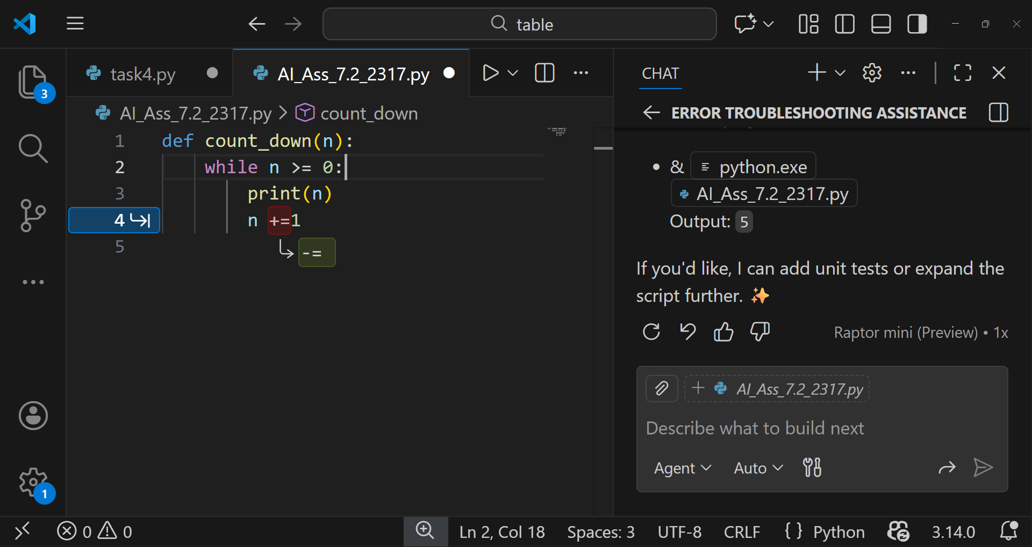

Corrected Code:
def count_down(n):
"""Print numbers from n down to 0 (inclusive)."""
while n >= 0:
print(n)
n -= 1

if __name__ == "__main__":
# Quick demo: counts down from 5 to 0 and exits
count_down(5)

Explanation of the AI:
Good catch — the loop increments so it never ends. I'll change n += 1 to n -= 1 and add a quick test to show it finishes.

Task 3: Handling Runtime Errors (Division by Zero)
Scenario
A Python function crashes during execution due to a division by zero error.
Requirements
• Provide a function that performs division without validation
• Use AI to identify the runtime error
• Let AI add try-except blocks for safe execution
• Review AI’s error-handling approach
Expected Output
• Function executes safely without crashing
• Division by zero handled using try-except
• Clear AI-generated explanation of runtime error handling

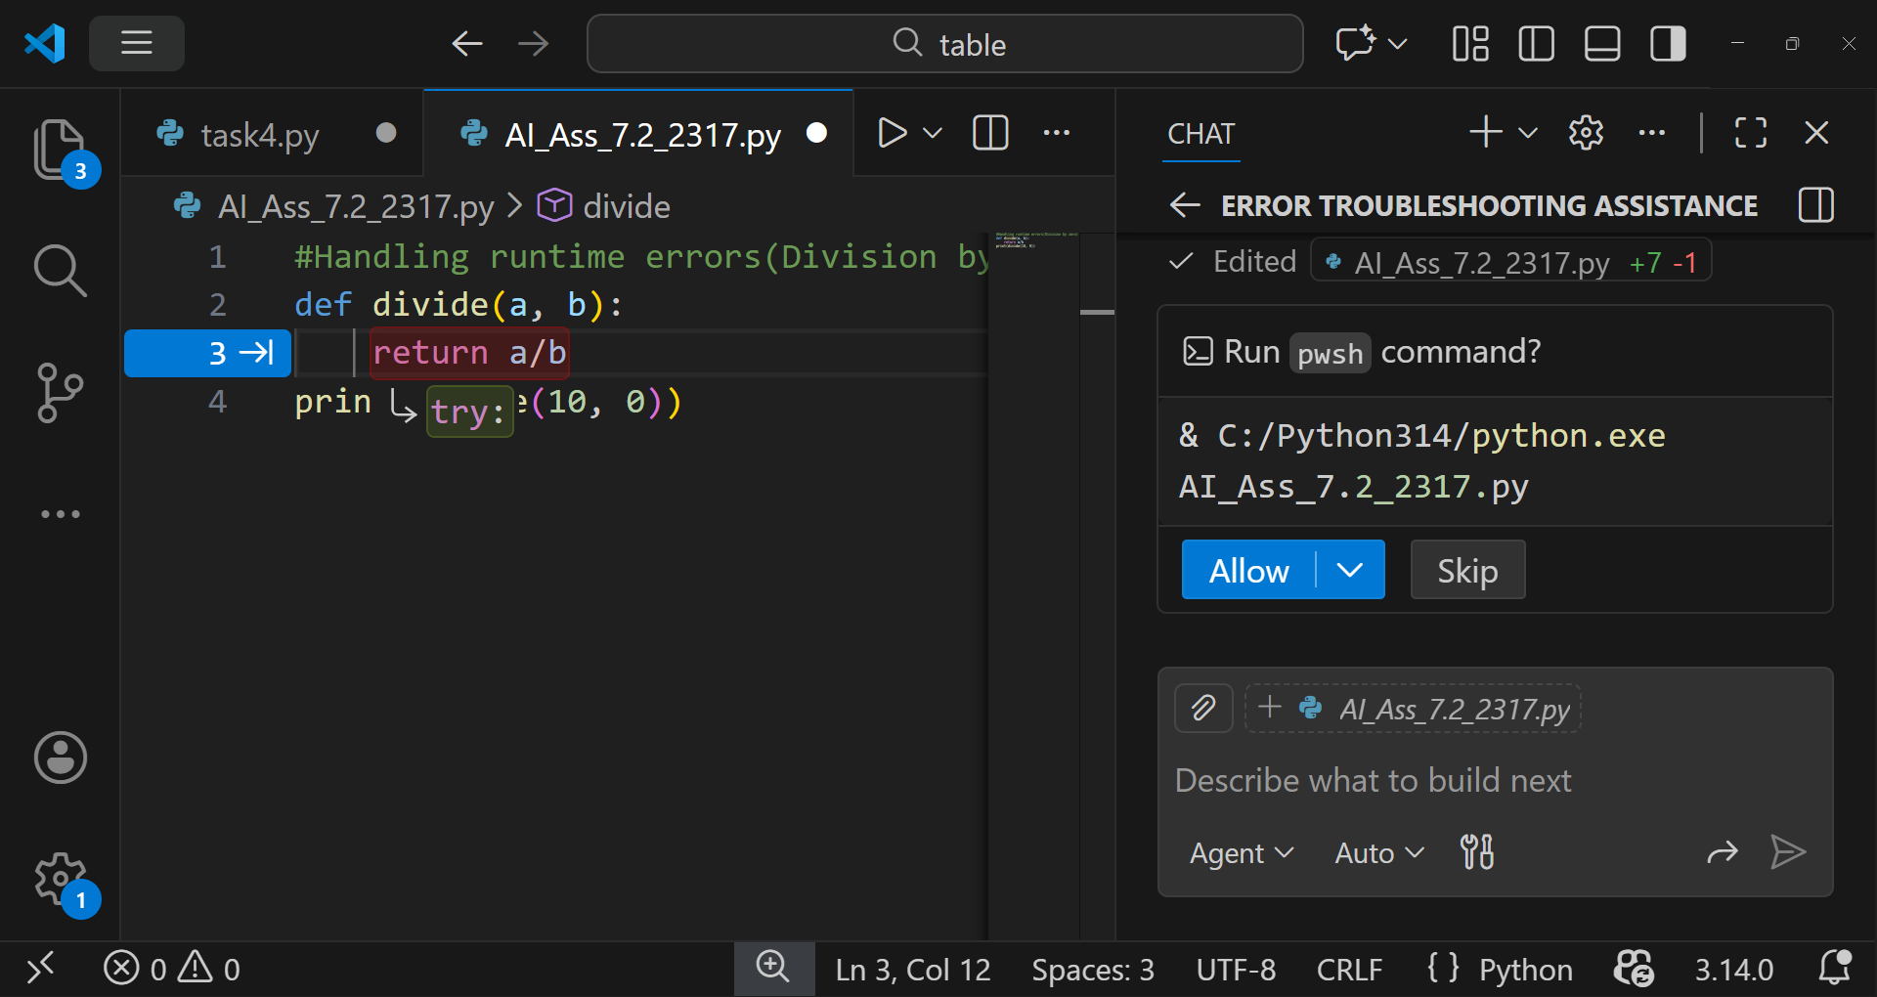

Error generated:

KeyboardInterrupt
>>> & C:/Python314/python.exe "c:/Users/varsh/OneDrive/문서/My Tableau Repository/table/AI_Ass_7.2_2317.py"
File "<stdin>", line 1
& C:/Python314/python.exe "c:/Users/varsh/OneDrive/문서/My Tableau Repository/table/AI_Ass_7.2_2317.py"
^
SyntaxError: invalid syntax

Corrected code:
# Handling runtime errors (Division by zero)
def divide(a, b):
"""Return a / b. Raises ZeroDivisionError if b is 0."""
if b == 0:
raise ZeroDivisionError("division by zero is not allowed")
return a / b

if __name__ == "__main__":
# Safe demo: handle division-by-zero gracefully
try:
print(divide(10, 0))
except ZeroDivisionError as e:
print("Error:", e)

Explanation of AI:
The script defines a safe divide(a, b) function and demonstrates handling of a division-by-zero error in a short runnable example.

Code breakdown 🔧
def divide(a, b): — function that returns a / b. The docstring explains the behavior.
if b == 0: raise ZeroDivisionError("division by zero is not allowed") — explicit check that prevents an unhandled zero-division and raises a clear error message.
return a / b — performs the division (normal path).
if __name__ == "__main__": — demo block that calls divide(10, 0) inside a try/except and prints the error message instead of crashing.

Task 4: Debugging Class Definition Errors
Scenario
You are given a faulty Python class where the constructor is incorrectly defined.
Requirements
• Provide a class definition with missing self-parameter
• Use AI to identify the issue in the __init__() method
• Allow AI to correct the class definition
• Understand why self is required
Expected Output
• Corrected __init__() method
• Proper use of self in class definition
• AI explanation of object-oriented error

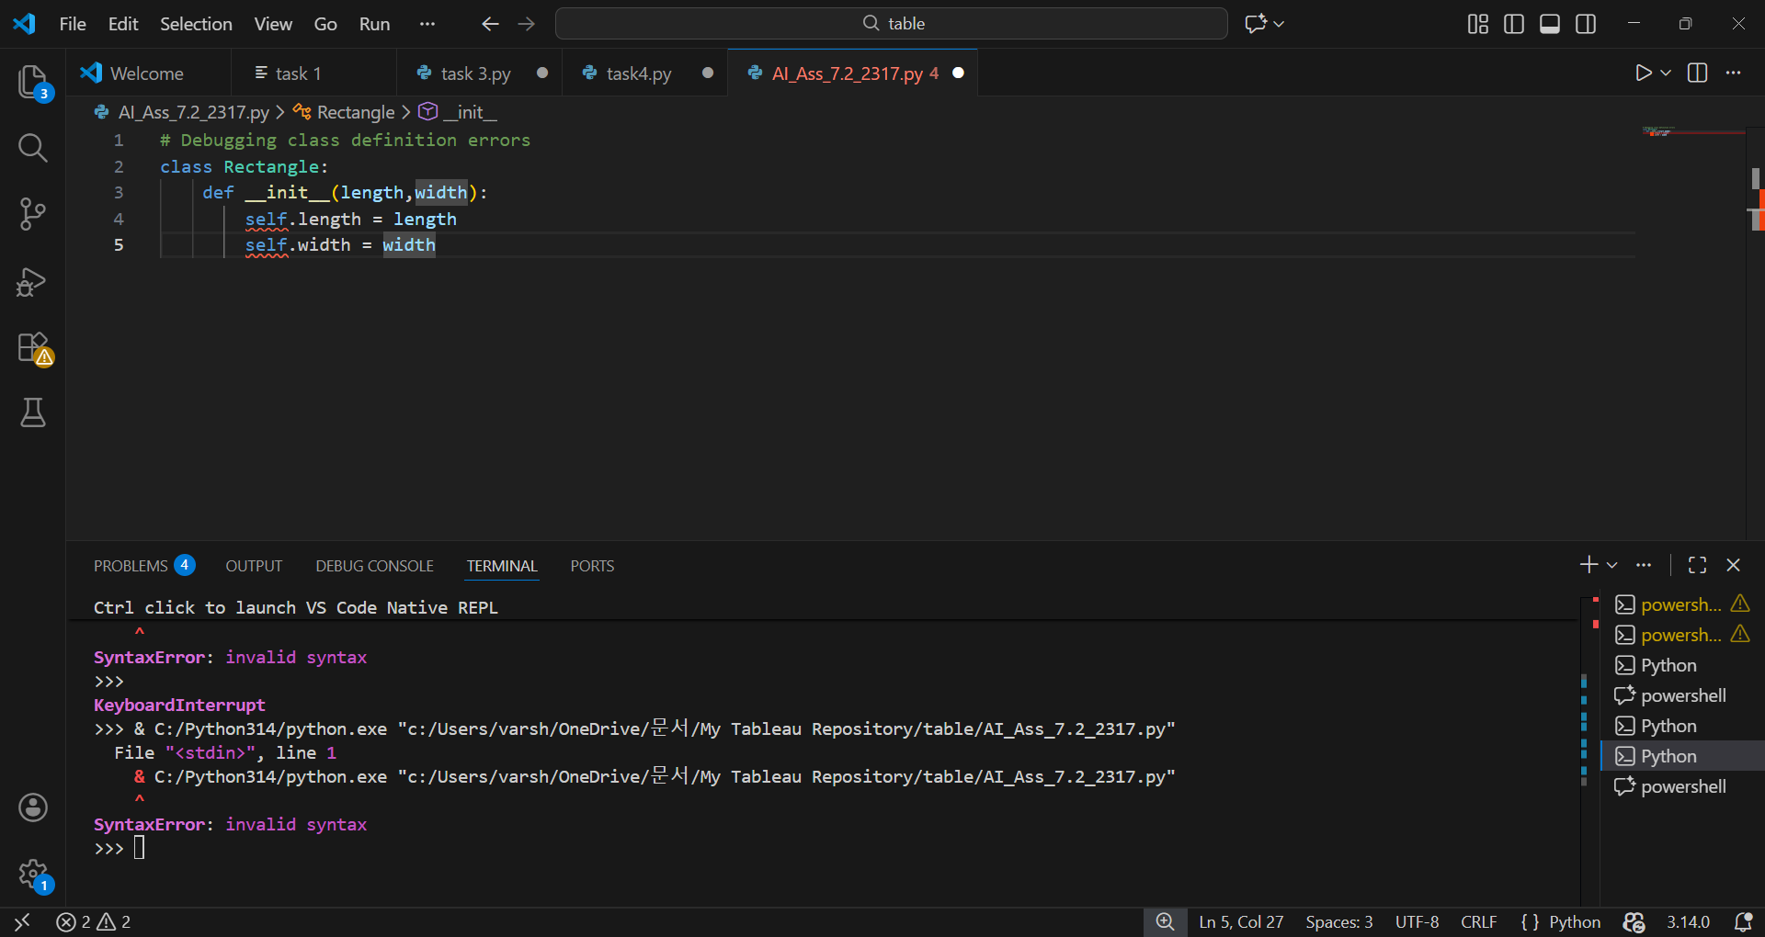

Corrected code :
# Debugging class definition errors
class Rectangle:
def __init__(self, length, width):
self.length = length
self.width = width

Explanation of AI:

I found the issue: your _init_ is defined as def _init(length, width): (missing the self parameter). This causes the error TypeError: __init_() takes 2 positional arguments but 3 were given when you try to create Rectangle(...) because Python implicitly passes the instance as the first argument

Task 5: Resolving Index Errors in Lists
Scenario
A program crashes when accessing an invalid index in a list.
Requirements
• Provide code that accesses an out-of-range list index
• Use AI to identify the Index Error
• Let AI suggest safe access methods
• Apply bounds checking or exception handling
Expected Output
• Index error resolved
• Safe list access logic implemented
• AI suggestion using length checks or exception handling

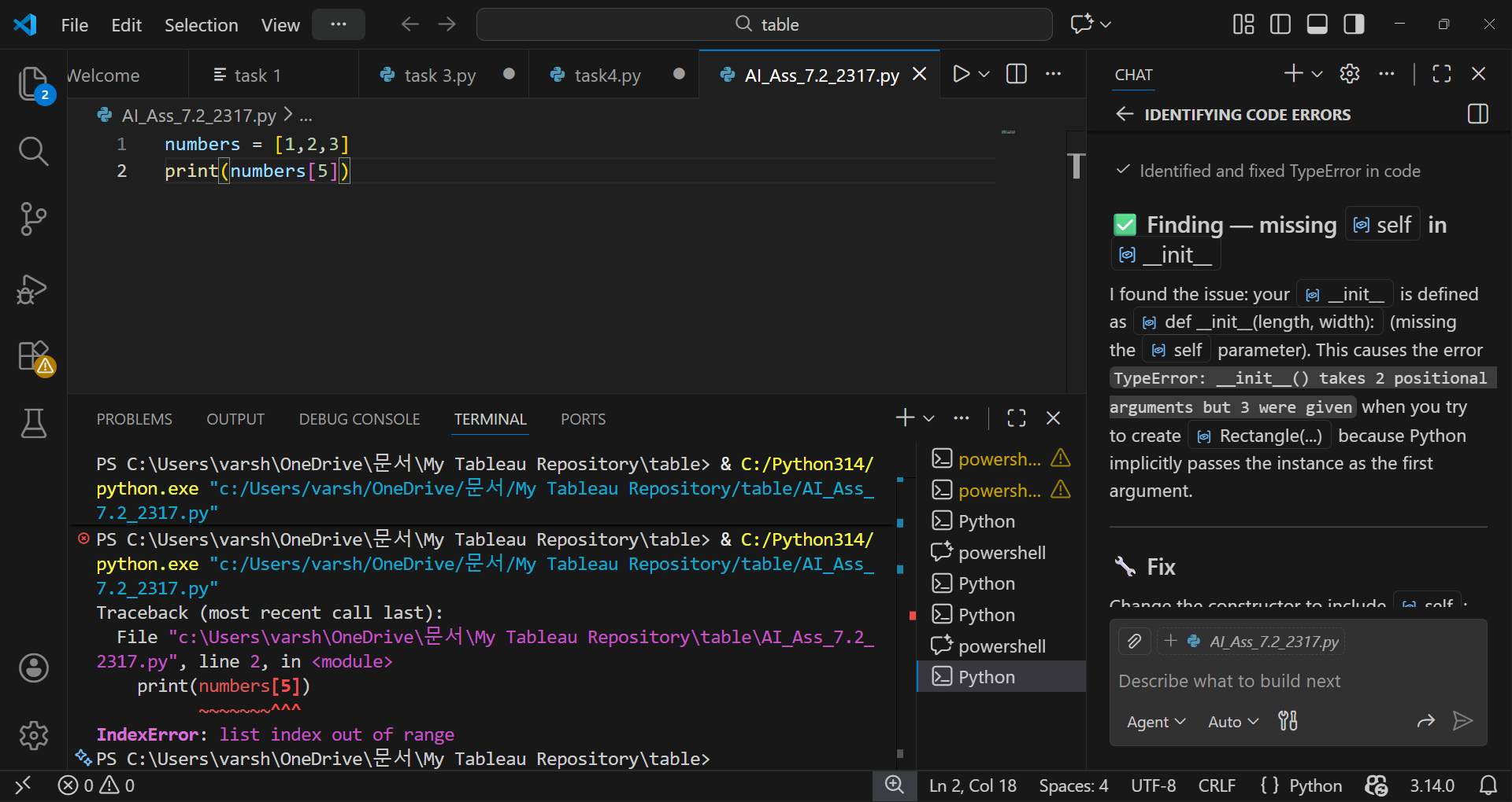

Corrected code:
numbers = [1, 2, 3]

def safe_get(seq, index, default=None):
"""Return seq[index] if possible, else default. Handles None and out-of-range indexes."""
try:
return seq[index]
except (IndexError, TypeError):
return default

if __name__ == '__main__':
# Unsafe access with explicit exception handling
try:
print(numbers[5])
except IndexError as e:
print("IndexError caught:", e)

# Safe access using helper
print("safe_get(numbers, 5, 'missing'):", safe_get(numbers, 5, 'missing'))

Explanation of AI:
I’ll fix the constructor, add robust exception handling, and add a safe list access helper; applying the changes now.

