AI ASSISTANT CODING
LAB-3.1
Name : K.Tejaswini
Roll No : 2303A52332
Batch No : 33

Experiment – Prompt Engineering Techniques
Task Description
Design and refine prompts using different prompting strategies to
generate Python programs for basic computational problems.
Question 1: Zero-Shot Prompting (Palindrome Number Program)
Write a zero-shot prompt (without providing any examples) to generate
a Python function that checks whether a given number is a palindrome.
Task:
• Record the AI-generated code.
• Test the code with multiple inputs.
• Identify any logical errors or missing edge-case handling.
Prompt Used :
Write a Python function that checks whether a given integer number is a palindrome.
The function should return True if the number reads the same forward and backward, otherwise return False.
AI-Refactored Code :
def is_palindrome_number(number: int) -> bool:
"""
Checks if a given integer number is a palindrome.
A number is a palindrome if it reads the same forward and backward.
Args:
number (int): The integer number to check.
Returns:
bool: True if the number is a palindrome, False otherwise.
"""
if not isinstance(number, int):
raise TypeError("Input must be an integer.")

# Convert the integer to a string to easily reverse it
num_str = str(number)

# Compare the string with its reverse
return num_str == num_str[::-1]

print(is_palindrome_number(121))
print(is_palindrome_number(12321))
print(is_palindrome_number(10021))
print(is_palindrome_number(71))
print(is_palindrome_number(0))
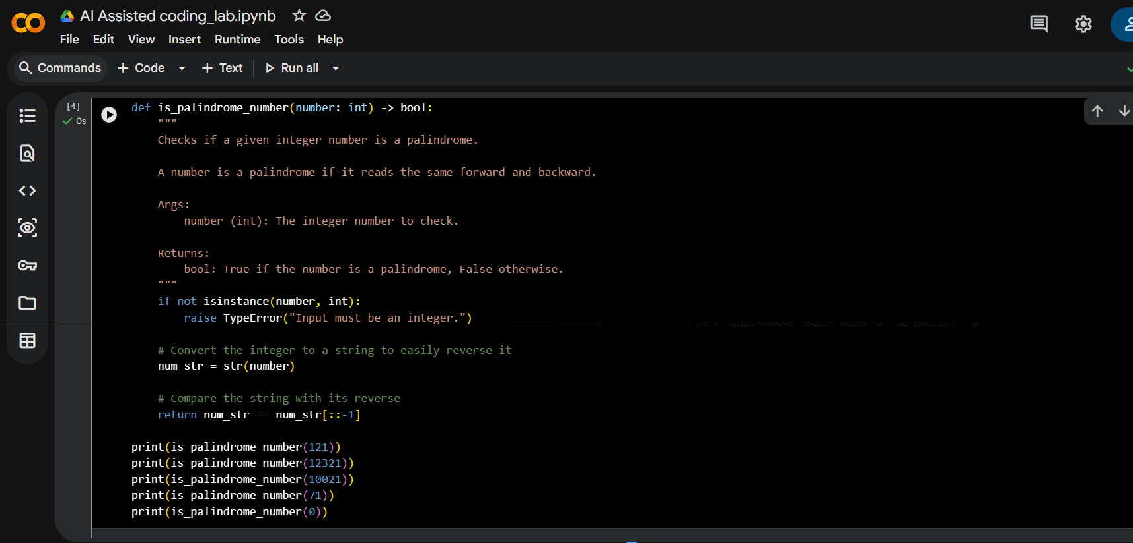
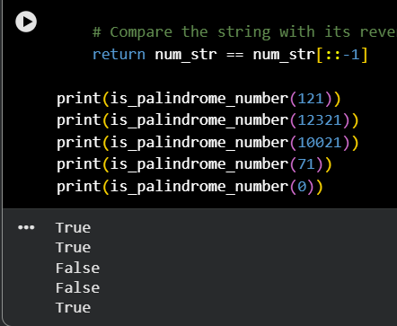
Question 2: One-Shot Prompting (Factorial Calculation)
Write a one-shot prompt by providing one input-output example and
ask the AI to generate a Python function to compute the factorial of a
given number.
Example:
Input: 5 → Output: 120
Task:
• Compare the generated code with a zero-shot solution.
• Examine improvements in clarity and correctness.
Prompt Used :
Write a Python function to compute the factorial of a given non-negative integer.

CODE:
def factorial(n: int) -> int:
"""
Computes the factorial of a given non-negative integer.

Args:
n (int): The non-negative integer for which to compute the factorial.

Returns:
int: The factorial of n.

Raises:
ValueError: If n is a negative integer.
TypeError: If n is not an integer.
"""
if not isinstance(n, int):
raise TypeError("Input must be an integer.")
if n < 0:
raise ValueError("Factorial is not defined for negative numbers.")
if n == 0:
return 1
else:
result = 1
for i in range(1, n + 1):
result *= i
return result

print(factorial(5))
print(factorial(10))
print(factorial(0))
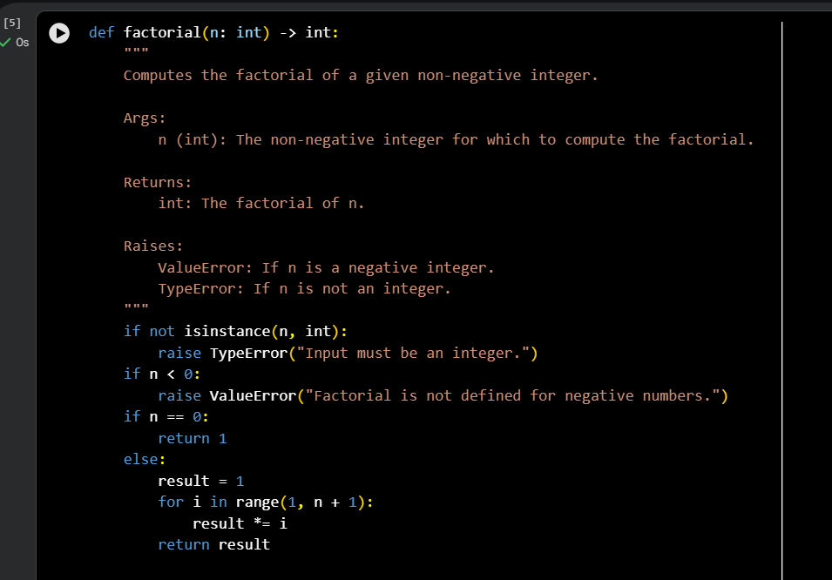

Question 3: Few-Shot Prompting (Armstrong Number Check)
Write a few-shot prompt by providing multiple input-output examples
to guide the AI in generating a Python function to check whether a
given number is an Armstrong number.
Examples:
• Input: 153 → Output: Armstrong Number
• Input: 370 → Output: Armstrong Number
• Input: 123 → Output: Not an Armstrong Number
Task:
• Analyze how multiple examples influence code structure and
accuracy.
• Test the function with boundary values and invalid inputs.

Prompts Used :
Write a Python function to check whether a given integer is an Armstrong number.

CODE:
def is_armstrong_number(number: int) -> bool:
"""
Checks if a given integer number is an Armstrong number.
An Armstrong number is a number that is the sum of its own digits
each raised to the power of the number of digits.
Args:
number (int): The integer number to check.
Returns:
bool: True if the number is an Armstrong number, False otherwise.
Raises:
TypeError: If the input is not an integer.
ValueError: If the input is a negative integer (Armstrong numbers are typically defined for positive integers).
"""
if not isinstance(number, int):
raise TypeError("Input must be an integer.")
if number < 0:
raise ValueError("Armstrong numbers are typically defined for non-negative integers.")

# Convert the number to a string to easily access its digits and count them
num_str = str(number)
num_digits = len(num_str)

sum_of_powers = 0
for digit_char in num_str:
digit = int(digit_char)
sum_of_powers += digit ** num_digits

return sum_of_powers == number
print(is_armstrong_number(153))
print(is_armstrong_number(370))
print(is_armstrong_number(371))
print(is_armstrong_number(407))
print(is_armstrong_number(1634))
print(is_armstrong_number(8208))
print(is_armstrong_number(9474))

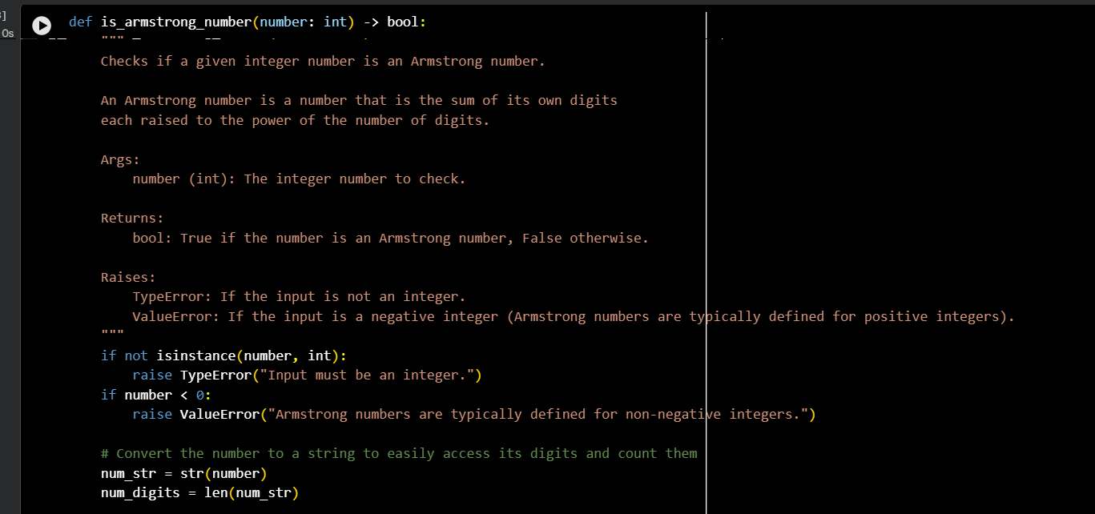
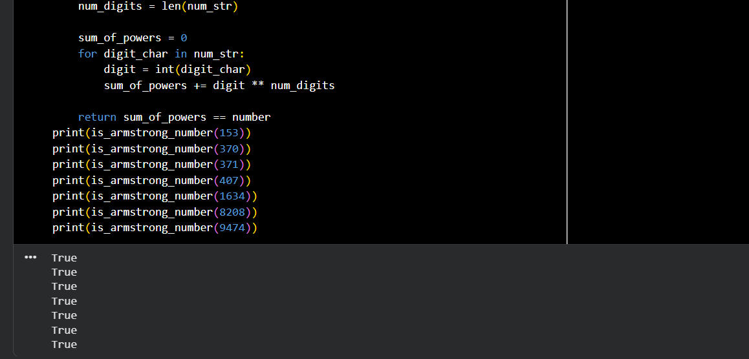

Question 4: Context-Managed Prompting (Optimized Number
Classification)
Design a context-managed prompt with clear instructions and
constraints to generate an optimized Python program that classifies a
number as prime, composite, or neither.

Prompt:
You are an expert Python developer writing optimized and readable code.
Task: Write a Python program that classifies a given integer number as Prime, Composite, or Neither.
Rules & Constraints:
• If the number is less than or equal to 1, classify it as Neither.
• A Prime number has exactly two distinct positive divisors.
• A Composite number has more than two positive divisors.
• Use an optimized approach by checking divisibility only up to √n.
• The program must handle invalid inputs gracefully.
• Output must be one of the following strings only: "Prime", "Composite", or "Neither".
• Write clean, efficient, and well-commented Python code.

CODE:
def classify_number(n):
if not isinstance(n, int):
return "Neither"

if n <= 1:
return "Neither"

for i in range(2, int(n ** 0.5) + 1):
if n % i == 0:
return "Composite"

return "Prime"
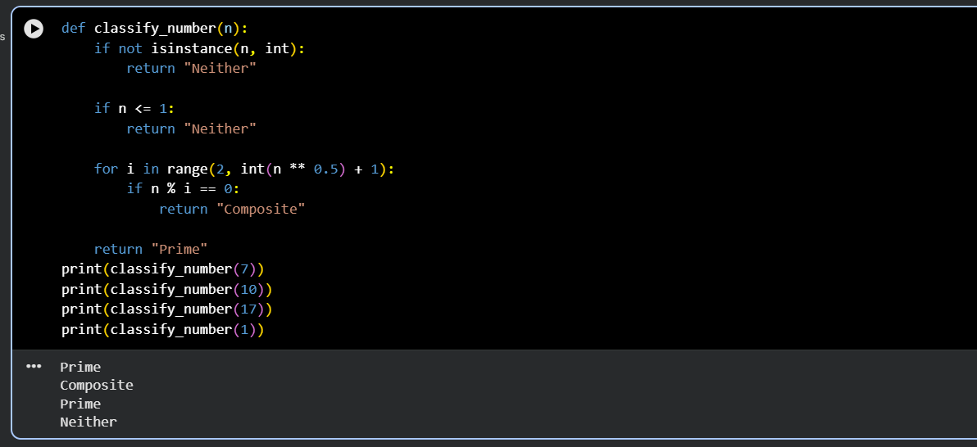

Conclusion :
This experiment demonstrated how different prompting techniques influence AI-generated code quality. Zero-shot prompting produced basic solutions, while one-shot and few-shot prompting improved clarity and accuracy through examples. Context-managed prompting delivered the most optimized and reliable results by clearly defining constraints and expectations. Overall, effective prompt design significantly enhances the correctness, efficiency, and robustness of AI-assisted coding.

