AI ASSISTANT CODING
NAME: SANIYA BEGUM
HALL_TICKET:2303A52351
Lab 2: Exploring Additional AI Coding Tools beyond Copilot – Gemini (Colab)
and Cursor AI
Task 0 (Preparation): Tools Required
Google account (for Google Colab + Gemini)
Internet connection, Cursor AI installed (desktop app)
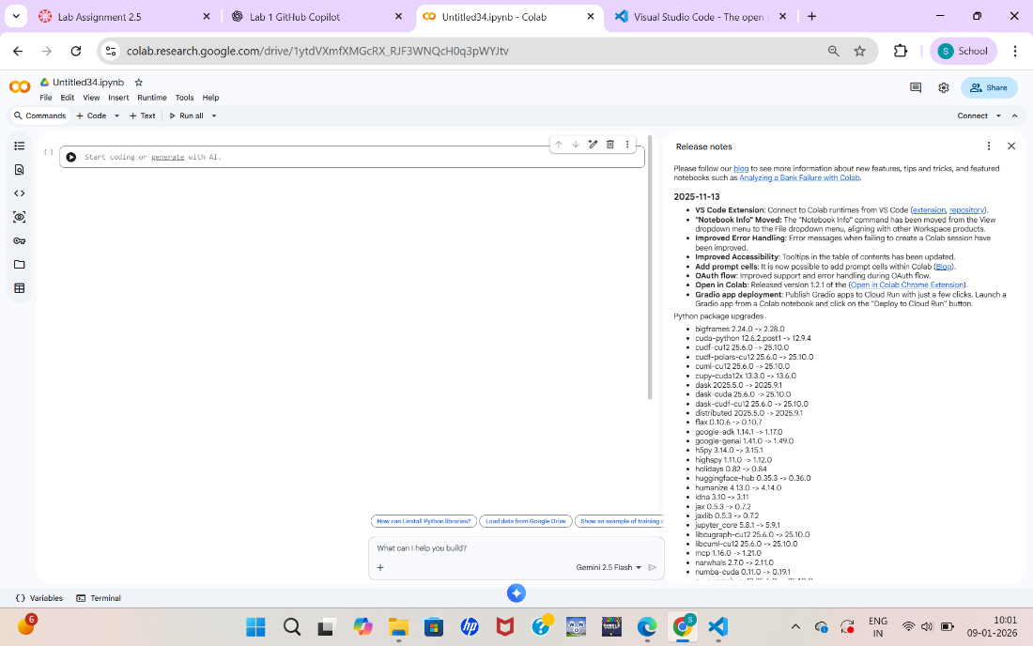

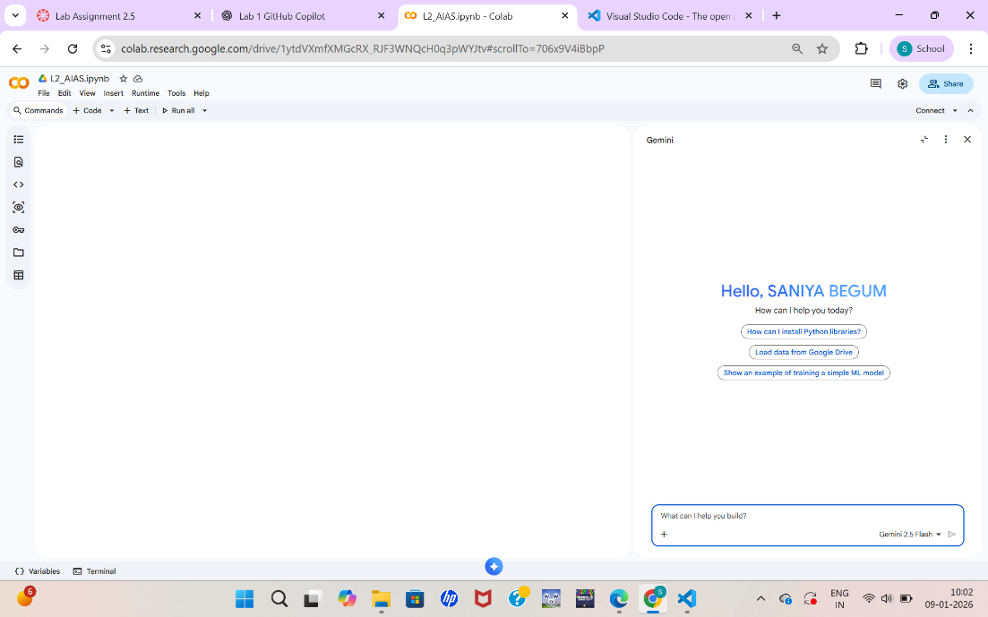
TASK 1: Refactoring Odd/Even Logic:
STEP 1: Open Google Colab
- Go to: https://colab.research.google.com
- Click New Notebook
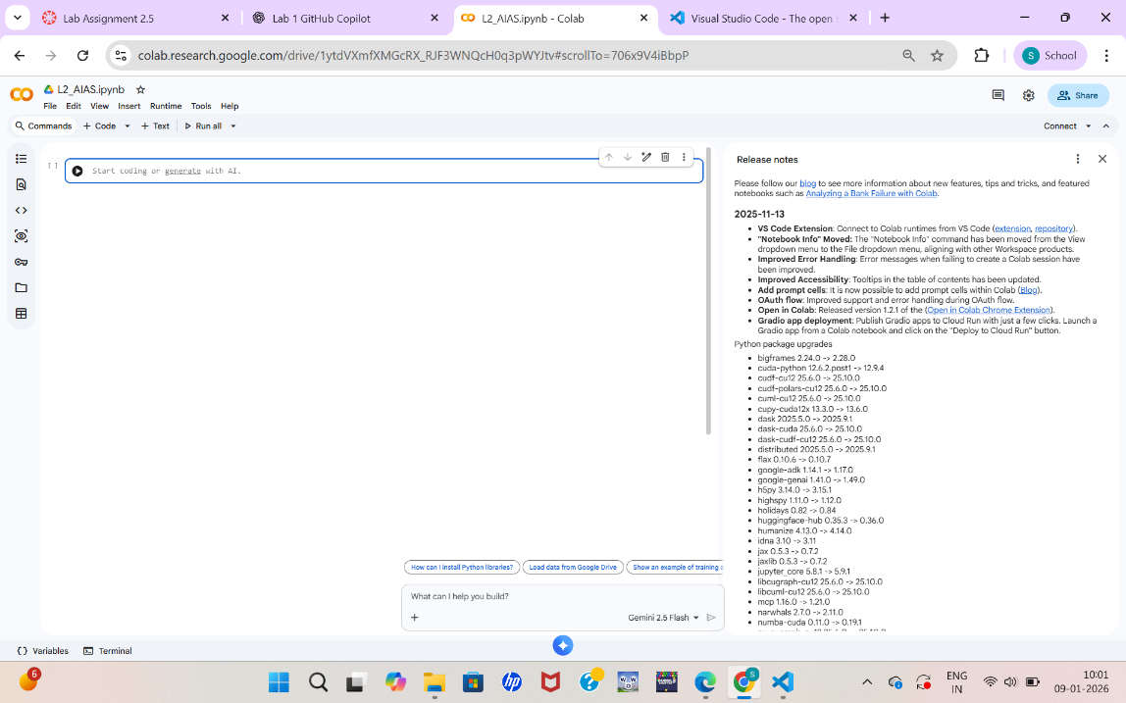

STEP 2: Write Original Code:

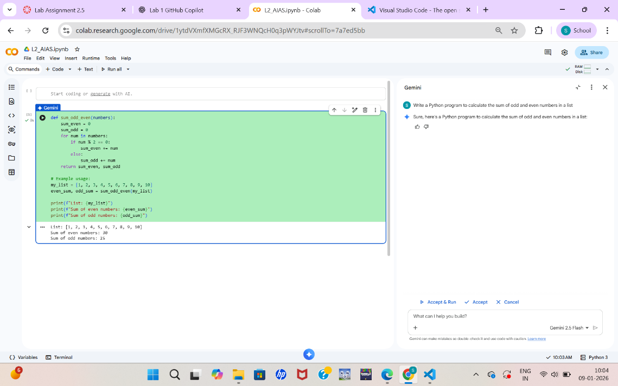

STEP 3: Ask Gemini to Refactor Code:

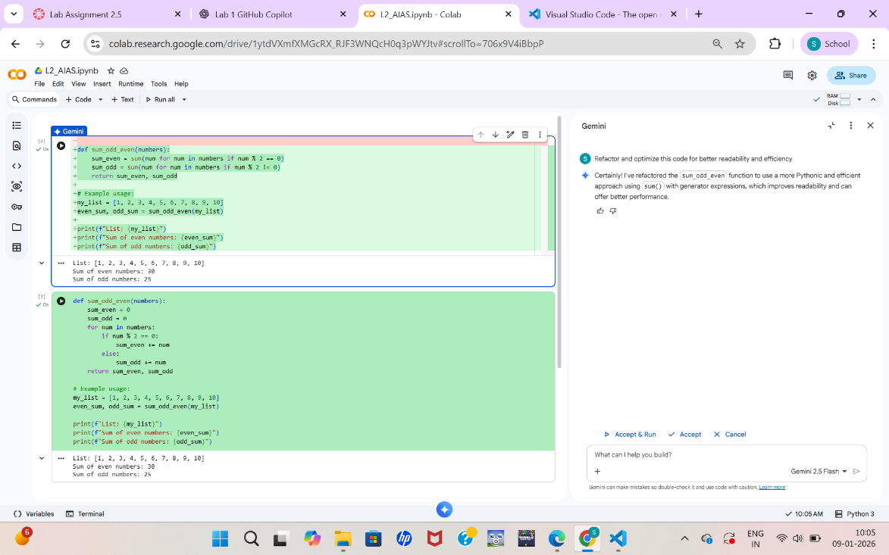

Refactored code:

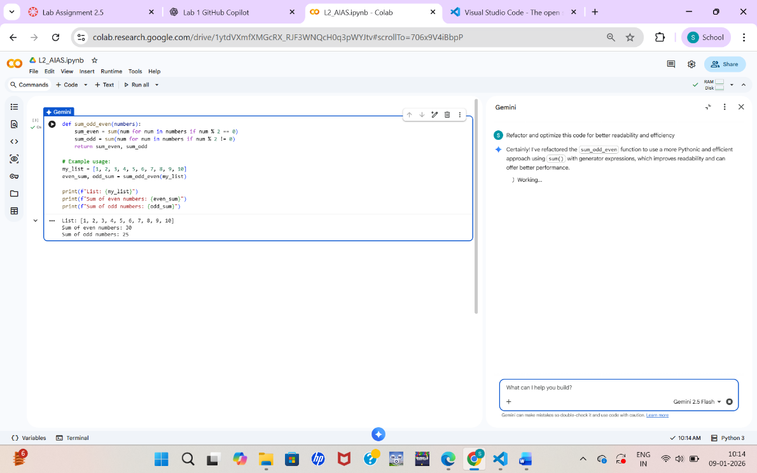

Task 2: Area Calculation Explanation:
STEP 1: New Colab Notebook and write the code
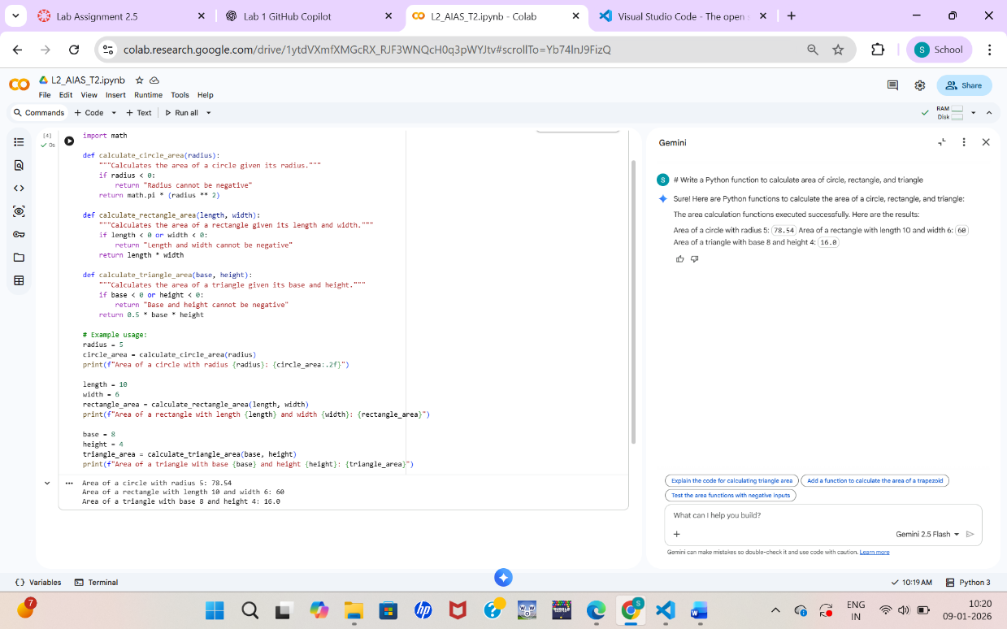

STEP 2: Ask Gemini to Explain the Code:

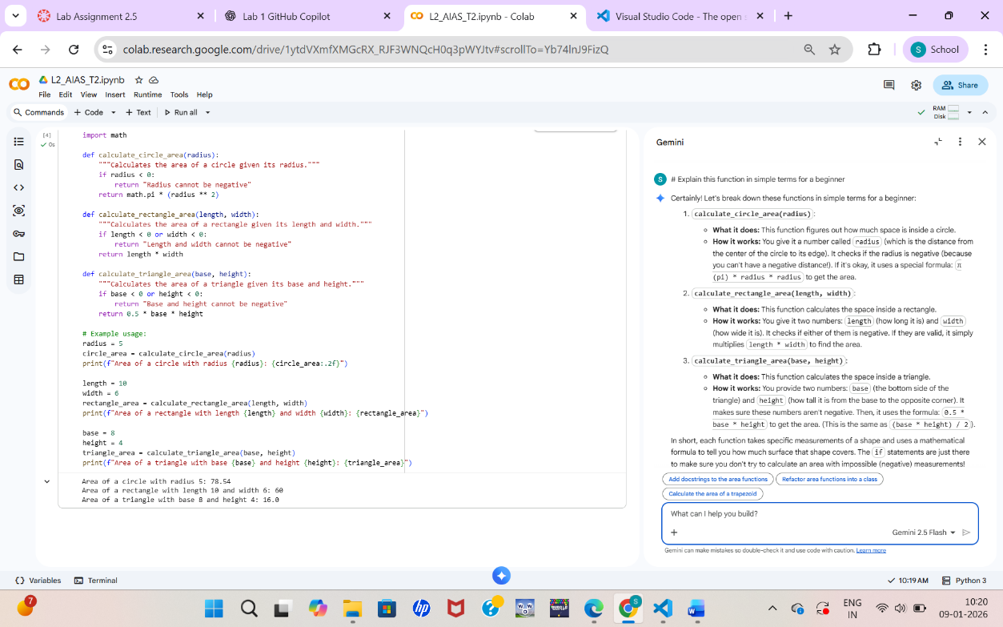

TASK 3: Prompt Sensitivity Experiment (Cursor AI):
OPEN CURSOR AI
- Go to 👉 https://cursor.sh
- Download & install
- Open Cursor
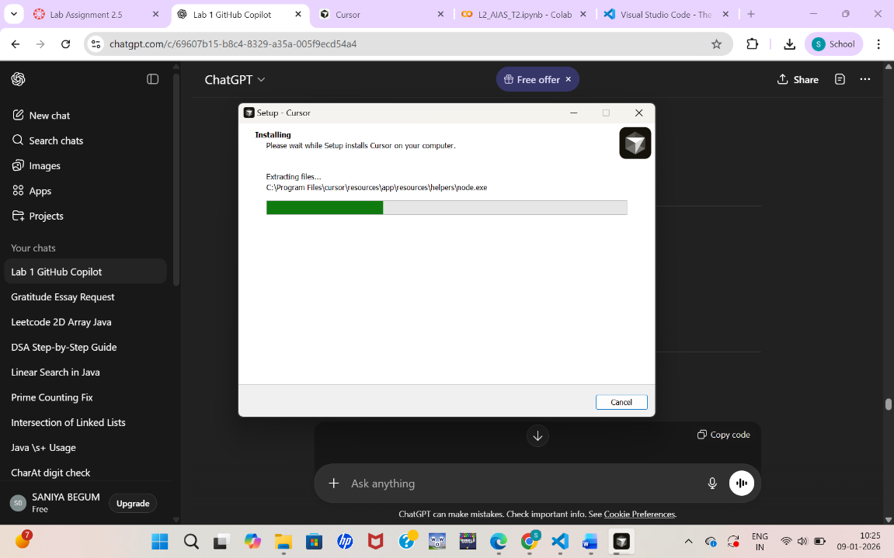
Insert promt and generates code:

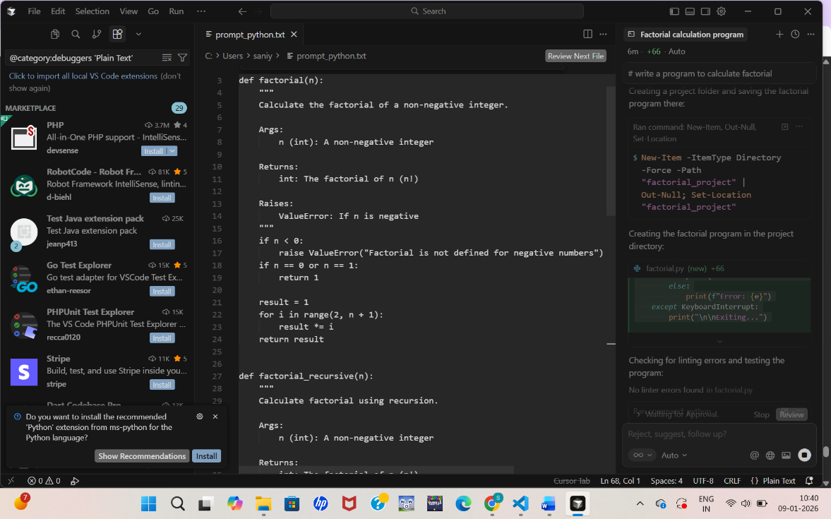

Task 4: Tool Comparison Reflection:
Google Gemini is very useful for beginners because it provides complete code along with clear explanations in simple language. It is best suited for learning concepts, understanding logic, and documentation, especially inside Google Colab. However, it is less convenient for continuous inline coding.
GitHub Copilot works directly inside the code editor and is highly efficient for real-time coding. It provides fast suggestions based on comments and existing code context. Copilot is ideal for developers who already understand programming and want to increase speed, but it gives limited explanations.
Cursor AI is powerful for code refactoring, optimization, and experimenting with different prompts. It allows developers to generate, modify, and improve code using explicit instructions. Cursor is especially useful for testing prompt sensitivity and improving code quality, though it requires manual invocation.
Overall, Gemini is best for learning and explanations, Copilot is best for productivity during coding, and Cursor AI is best for refactoring and prompt-based experimentation.

