AI ASSISTED CODING
HALLTICKET:2303A52351
Lab 1: Environment Setup – GitHub Copilot and VS Code Integration +
Understanding AI-assisted Coding Workflow

Task 0: Install & Configure GitHub Copilot in VS Code
Step 1: Install Visual Studio Code
- Open browser → go to https://code.visualstudio.com
- Download VS Code for your OS
- Install and open VS Code
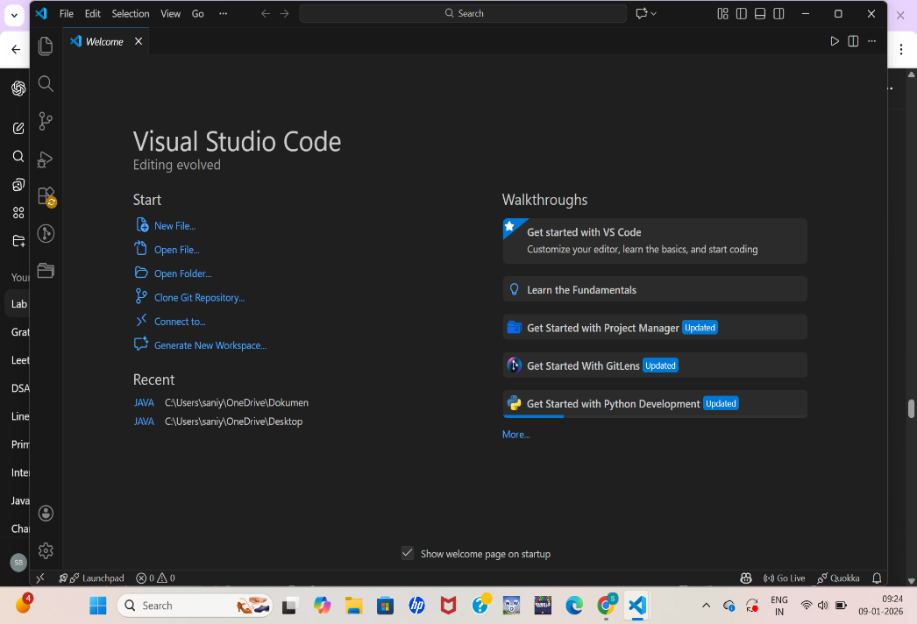

Step 2: Install GitHub Copilot Extension
- In VS Code → press Ctrl + Shift + X
- Search GitHub Copilot
- Click Install
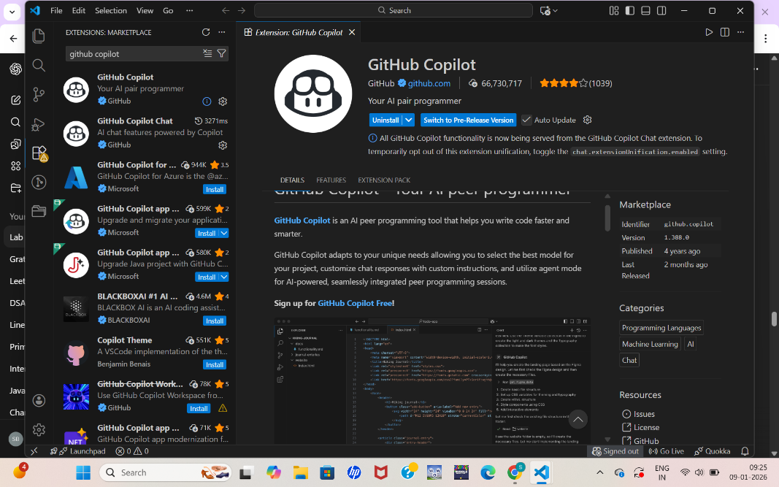

Step 3: Sign In to GitHub
- Click Sign in to GitHub
- Login using GitHub account
- Authorize Copilot
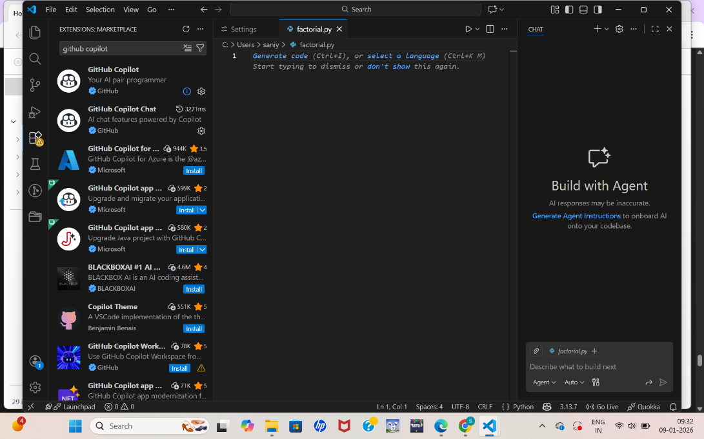

Step 4: Verify Copilot Works
- Create new file → factorial.py
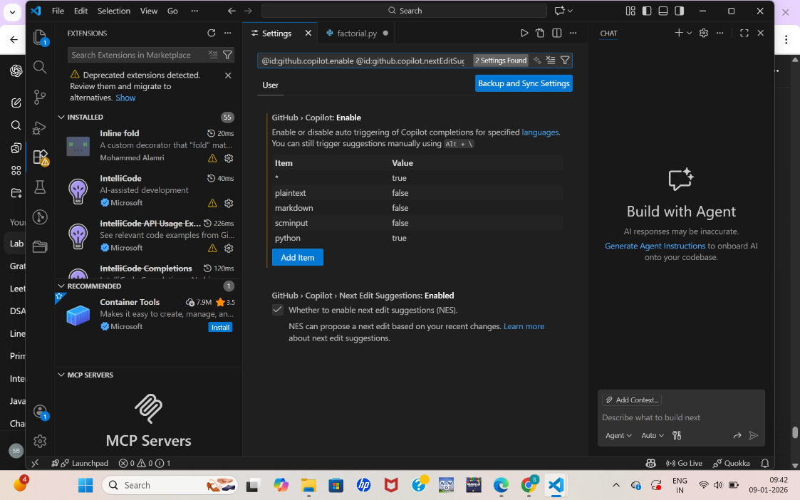

🔹 TASK 1: AI-Generated Logic Without Modularization

Step 2: Write Prompt as Comment
# Write a Python program to calculate factorial of a number
# Do not use any functions
# Use loops and variables only
Step 3: Accept Copilot Suggestion
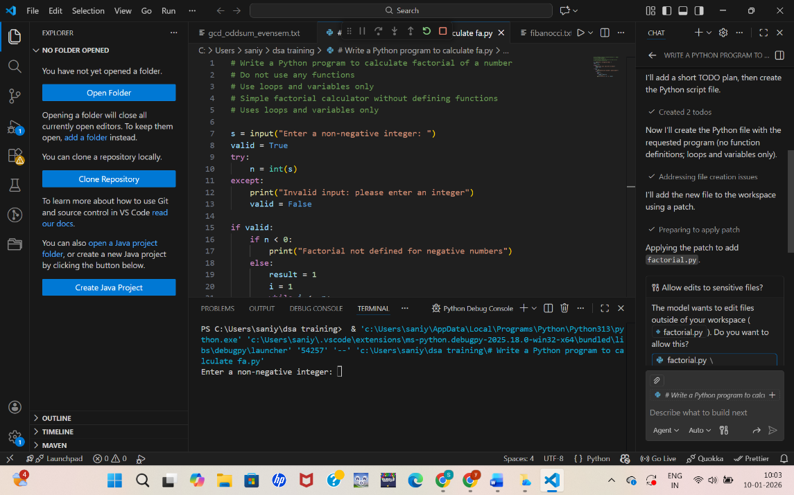

Step 4: Run and Test
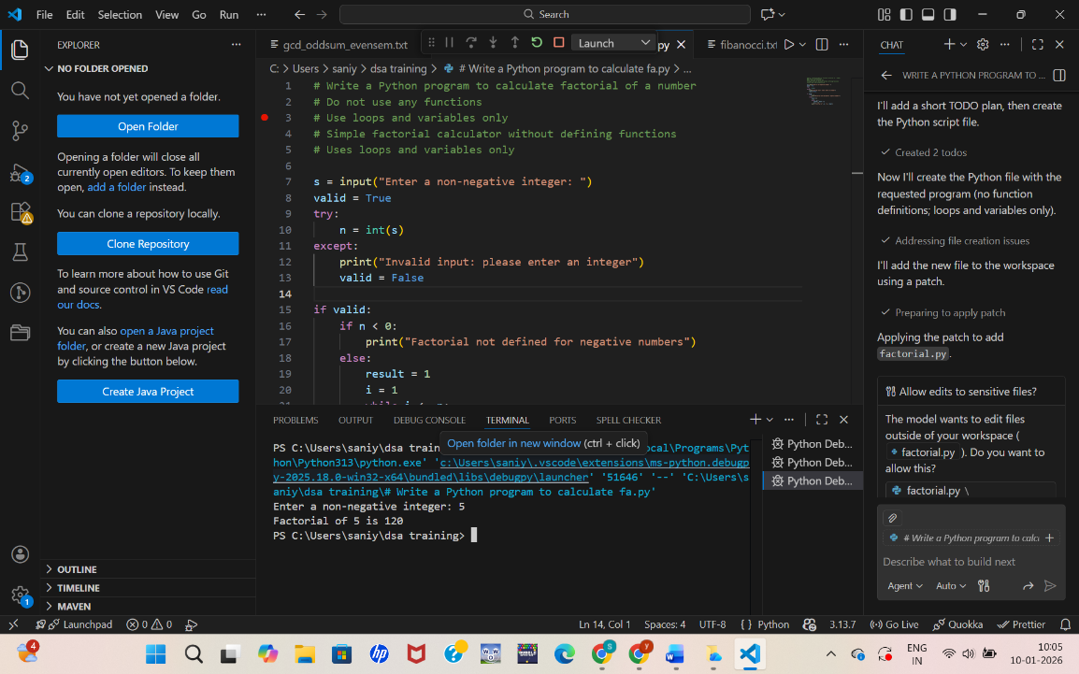
Reflection:
Copilot is beginner-friendly and fast
Generated correct logic instantly
Follows basic Python practices
Does not optimize unless prompted
Helpful for quick scripting tasks

🔹 TASK 2: AI Code Optimization & Cleanup

Step 1: Paste Original Code:
s = input("Enter a non-negative integer: ")
valid = True
try:
n = int(s)
except:
print("Invalid input: please enter an integer")
valid = False
if valid:
if n < 0:
print("Factorial not defined for negative numbers")
else:
result = 1
i = 1
while i <= n:
result = result * i
i = i + 1
print("Factorial of", n, "is", result)
Step 2: Prompt Copilot for Optimization
Add comment:
# Optimize this code and improve readability
Step 3: Accept Optimized Suggestion

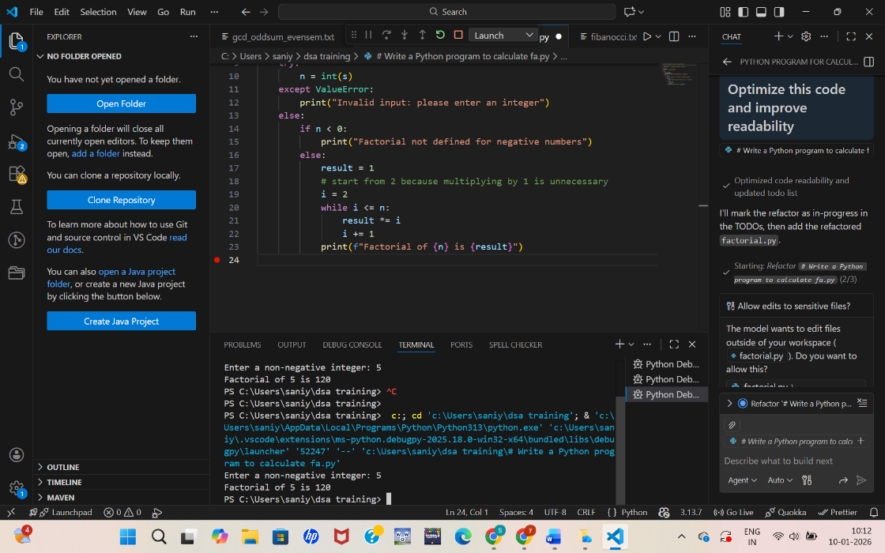

Step 4: Side-by-Side Comparison
Aspect | Original | Optimized
Variable naming | Basic | Meaningful
Readability | Medium | High
Efficiency | Same | Cleaner
Maintainability | Low | Better

Explanation
- Improved variable names
- Cleaner loop
- Better print formatting
- Easier to understand

🔹 TASK 3: Modular Design Using AI Assistance
Step 1: New File
Step 2: Prompt Copilot Using Comments
# Create a Python function to calculate factorial
# Use meaningful variable names
# Call the function from main
# Add comments
Step 3: Copilot-Generated Code
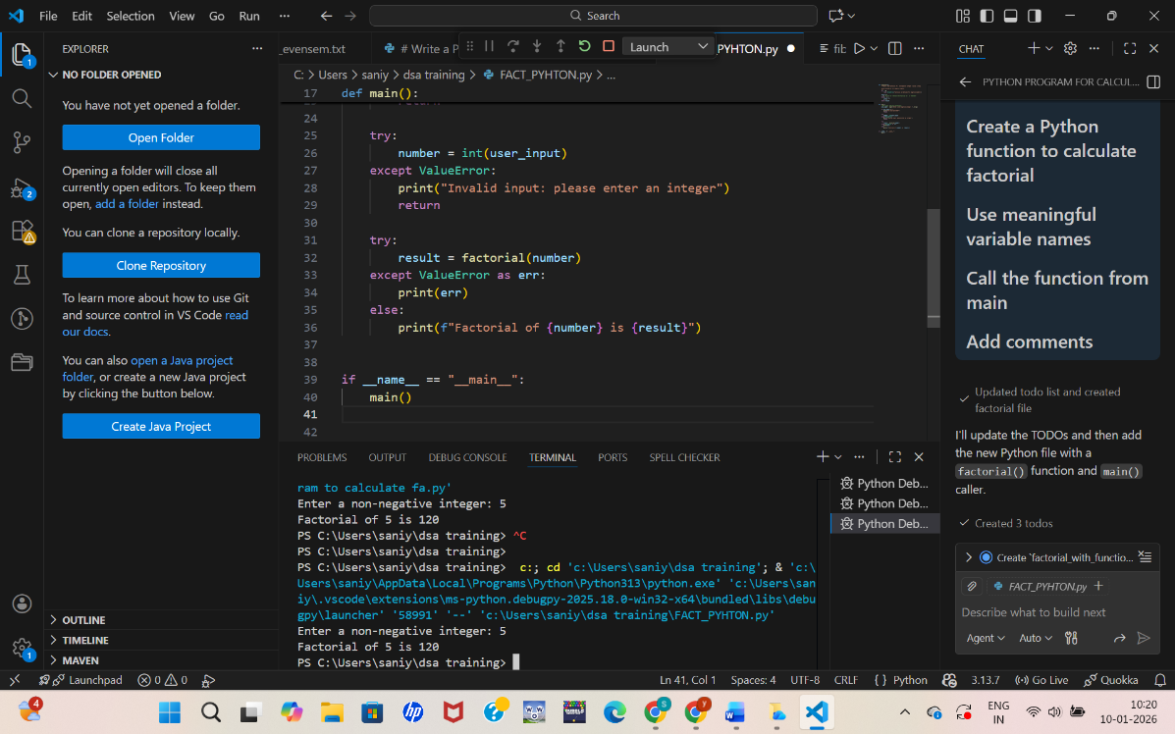
Modular code improves reusability, testing, and maintenance.

🔹 TASK 4: Comparative Analysis
(Procedural vs Modular Code)
Comparison Table
Criteria | Without Function | With Function
Logic clarity | Moderate | High
Reusability | No | Yes
Debugging | Difficult | Easy
Large projects | Not suitable | Suitable
AI dependency risk | High | Lower

🔹 TASK 5: Iterative vs Recursive AI Code
Step 1: Prompt Copilot (Iterative)
# Generate an iterative factorial program
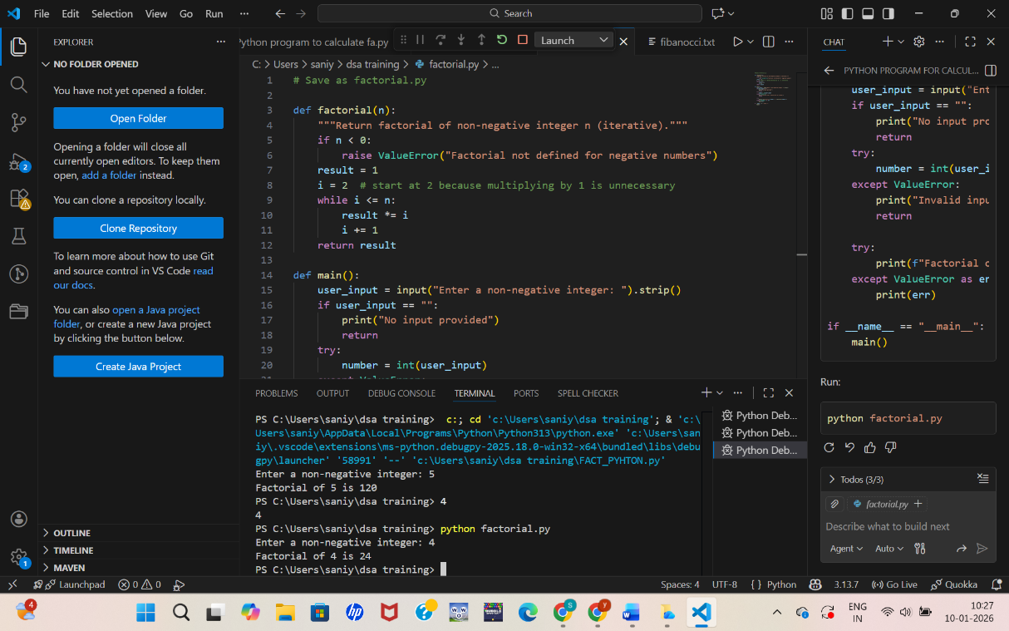

Step 2: Prompt Copilot (Recursive)
# Generate a recursive factorial program
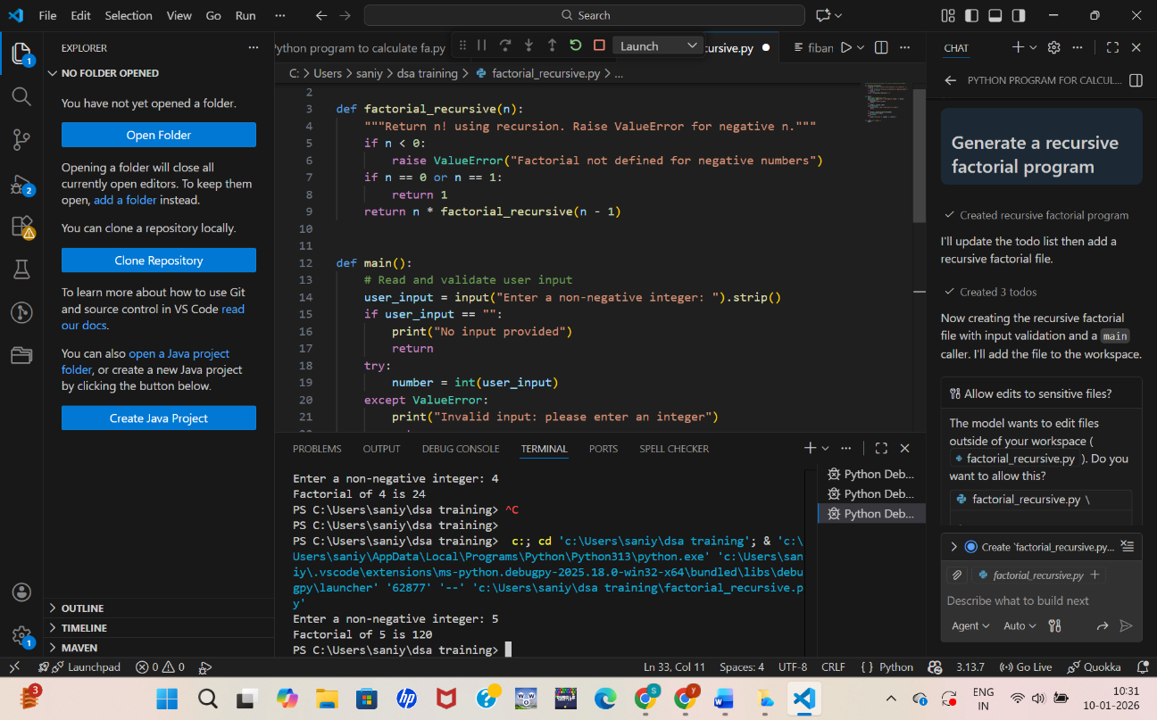
Comparison
Aspect | Iterative | Recursive
Readability | Simple | Mathematical
Stack usage | Low | High
Performance | Better | Slower
Not recommended | — | Large inputs

