COURSE: AI Assisted Coding.
NAME: G.Sandeep
BATCH- 34
HALLTICKET.NO: 2303A52371
LAB-ASS-AIAC -1.2

Task-1:
AI-Generated Logic Without Modularization (Factorial without Functions)
• Scenario You are building a small command-line utility for a startup intern onboarding task. The program is simple and must be written quickly without modular design.
• Task Description Use GitHub Copilot to generate a Python program that computes a mathematical product-based value (factorial-like logic) directly in the main execution flow, without using any user-defined functions.
• Constraint:
➢ Do not define any custom function
➢ Logic must be implemented using loops and variables only • Expected Deliverables
➢ A working Python program generated with Copilot assistance
➢ Screenshot(s) showing:
➢ The prompt you typed
➢ Copilot’s suggestions
➢ Sample input/output screenshots
➢ Brief reflection (5–6 lines):
➢ How helpful was Copilot for a beginner?
➢ Did it follow best practices automatically?
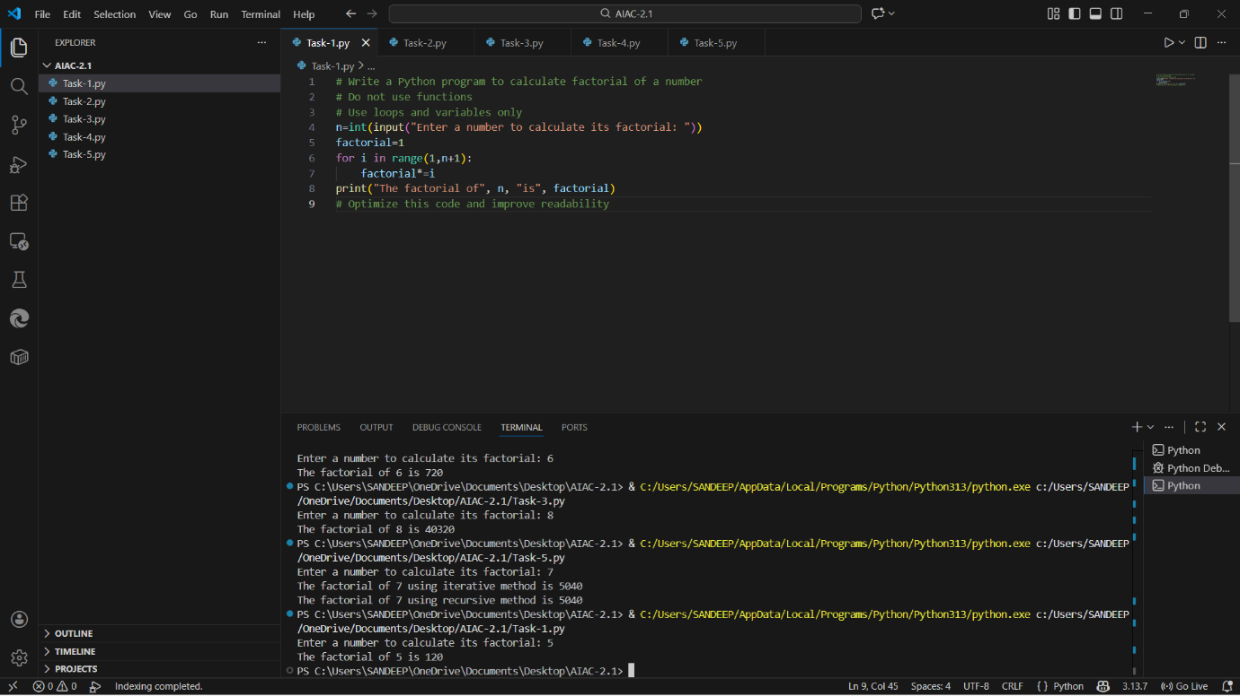
Brief Reflection
GitHub Copilot was very helpful for a beginner because it quickly generated correct and readable code.
It understood the comment prompt and followed the constraint of not using functions. The generated logic was simple and easy to understand. Copilot automatically used a loop and proper variable naming. However, beginners should still verify the logic instead of blindly trusting the output. Overall, Copilot improves productivity and learning speed.
Conclusion
This lab helped in understanding how AI tools like GitHub Copilot assist in coding tasks. It demonstrated prompt-based programming and highlighted the importance of reviewing AI-generated code.
Task-2:
❖ Scenario
Your team lead asks you to review AI-generated code before committing it to
a shared repository.
❖ Task Description
Analyze the code generated in Task 1 and use Copilot again to:
➢ Reduce unnecessary variables
➢ Improve loop clarity
➢ Enhance readability and efficiency
Hint:
Prompt Copilot with phrases like
“optimize this code”, “simplify logic”, or “make it more readable”
❖ Expected Deliverables
➢ Original AI-generated code
➢ Optimized version of the same code
➢ Side-by-side comparison
➢ Written explanation:
▪ What was improved?
▪ Why the new version is better (readability, performance,
maintainability.
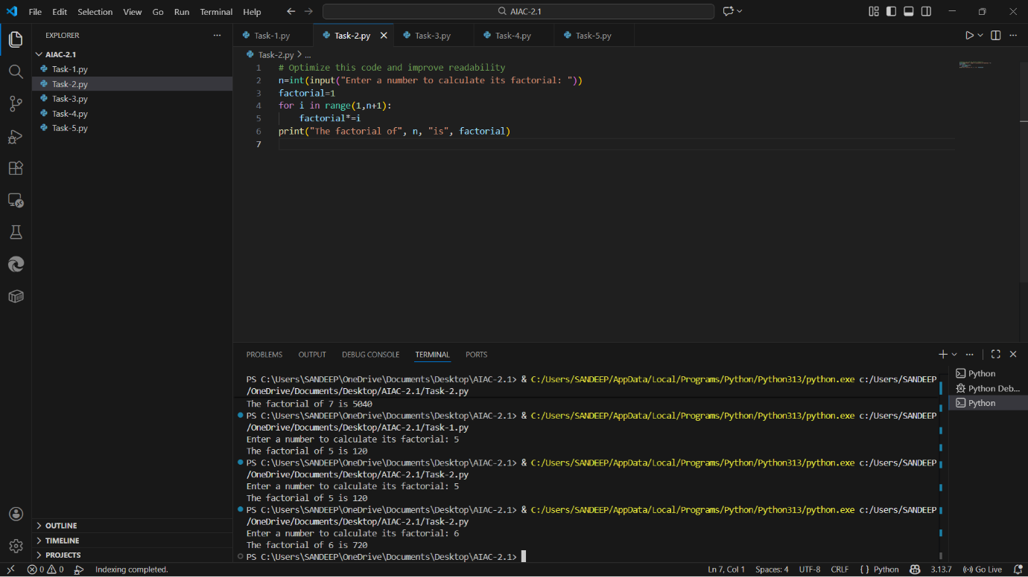
What Was Improved?
- Variable names are more meaningful
- Multiplication shorthand operator used
- Output message is clearer
Why This Version Is Better
- Improved readability
- Easier maintenance
- More professional output formatting
- Same performance with cleaner logic
Task 3:
Modular Design Using AI Assistance (Factorial with Functions)
❖ Scenario
The same logic now needs to be reused in multiple scripts.
❖ Task Description
Use GitHub Copilot to generate a modular version of the program by:
➢ Creating a user-defined function
➢ Calling the function from the main block
❖ Constraints
➢ Use meaningful function and variable names
➢ Include inline comments (preferably suggested by Copilot)
❖ Expected Deliverables
➢ AI-assisted function-based program
➢ Screenshots showing:
o Prompt evolution
o Copilot-generated function logic
➢ Sample inputs/outputs
➢ Short note:
o How modularity improves reusability
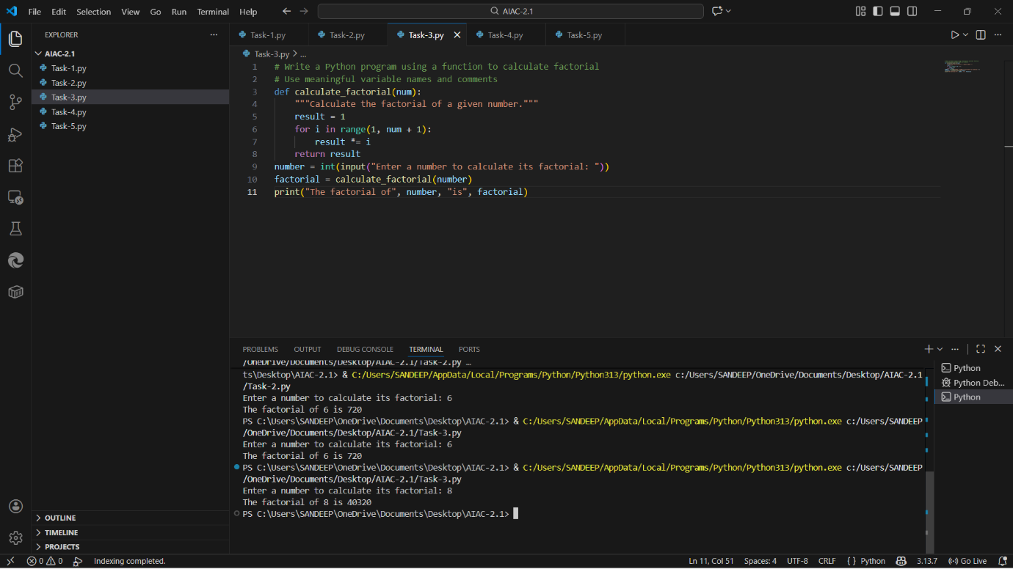

Task 4:
Comparative Analysis – Procedural vs Modular AI Code (With vs
Without Functions)
❖ Scenario
As part of a code review meeting, you are asked to justify design choices.
❖ Task Description
Compare the non-function and function-based Copilot-generated
programs on the following criteria:
➢ Logic clarity
➢ Reusability
➢ Debugging ease
➢ Suitability for large projects
➢ AI dependency risk
❖ Expected Deliverables
Choose one:
➢ A comparison table
OR
➢ A short technical report (300–400 words).
Comparative Analysis – Procedural vs Modular AI Code
Comparison: Without Functions vs With Functions (AI-Generated Code)
Comparison Table
Criteria | Without Functions | With Functions
Logic Clarity | Simple but mixed | Clear separation
Reusability | Not reusable | Highly reusable
Debugging Ease | Harder | Easier
Large Project Suitability | Poor | Excellent
AI Dependency Risk | Higher | Lower (structured)

Task 5: AI-Generated Iterative vs Recursive Thinking
❖ Scenario
Your mentor wants to test how well AI understands different
computational paradigms.
❖ Task Description
Prompt Copilot to generate:
An iterative version of the logic
A recursive version of the same logic
❖ Constraints
Both implementations must produce identical outputs
Students must not manually write the code first
❖ Expected Deliverables
Two AI-generated implementations
Execution flow explanation (in your own words)
Comparison covering:
➢ Readability
➢ Stack usage
➢ Performance implications
➢ When recursion is not recommended.
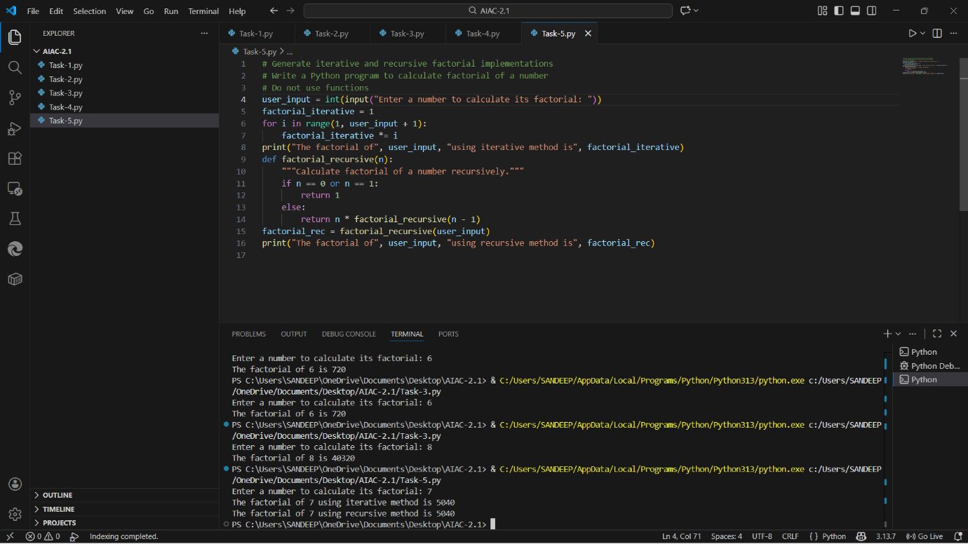

Execution Flow Explanation:
- Iterative approach uses loops and updates a variable step-by-step.
- Recursive approach breaks the problem into smaller sub-problems until a base case is reached.
Comparison:
Aspect | Iterative | Recursive
Readability | Simple | Elegant
Stack Usage | Low | High
Performance | Better | Slower
Risk | Safe | Stack overflow
When Not Recommended | — | Large inputs

Conclusion:
This lab demonstrated how GitHub Copilot assists in coding, optimization, and design decisions. While Copilot accelerates development, human understanding and validation remain essential. Modular and optimized code generated by AI improves maintainability and scalability.

