AIAC-ASSIGNMENT

NAME: G.Sandeep
HALLTICKET NO:2303A52371
BATCH:07
ASS-11.3
Lab 11:
Data Structures with AI Implementing Fundamental Data
Structures using AI Assistance
Lab Objectives:
By the end of this lab, students will be able to:
• Design and implement fundamental data structures in Python using AI assistance.
• Effectively prompt AI tools (e.g., GitHub Copilot) for code generation, optimization, and documentation.
• Understand and compare core data structures: Arrays, Linked Lists, Stacks, Queues, Priority Queues, Trees, and Graphs.
• Improve code readability, efficiency, and maintainability using AI-
generated suggestions.
Learning Outcomes After completing this lab, students will be able to:
• Apply appropriate data structures to solve real-world problems.
• Analyze time and space complexity of different data structure
operations.
• Use AI tools responsibly to assist (not replace) logical thinking and problem-solving.
• Validate, test, and refine AI-generated code.
Task 1: Smart Contact Manager (Arrays & Linked Lists)
Scenario
SR University’s student club requires a simple Contact Manager Application
to store members’ names and phone numbers. The system should support
efficient addition, searching, and deletion of contacts.
Tasks
1. Implement the contact manager using arrays (lists).
2. Implement the same functionality using a linked list for dynamic
memory allocation.
3. Implement the following operations in both approaches:
o Add a contact
o Search for a contact
o Delete a contact
4. Use GitHub Copilot to assist in generating search and delete methods.
5. Compare array vs. linked list approaches with respect to:
o Insertion efficiency
o Deletion efficiency
Expected Outcome
• Two working implementations (array-based and linked-list-based).
• A brief comparison explaining performance differences.
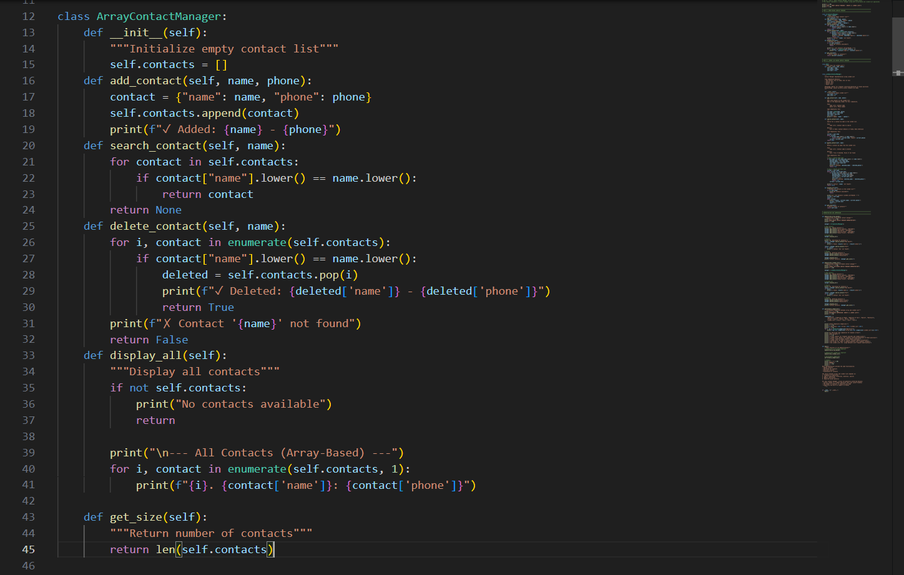
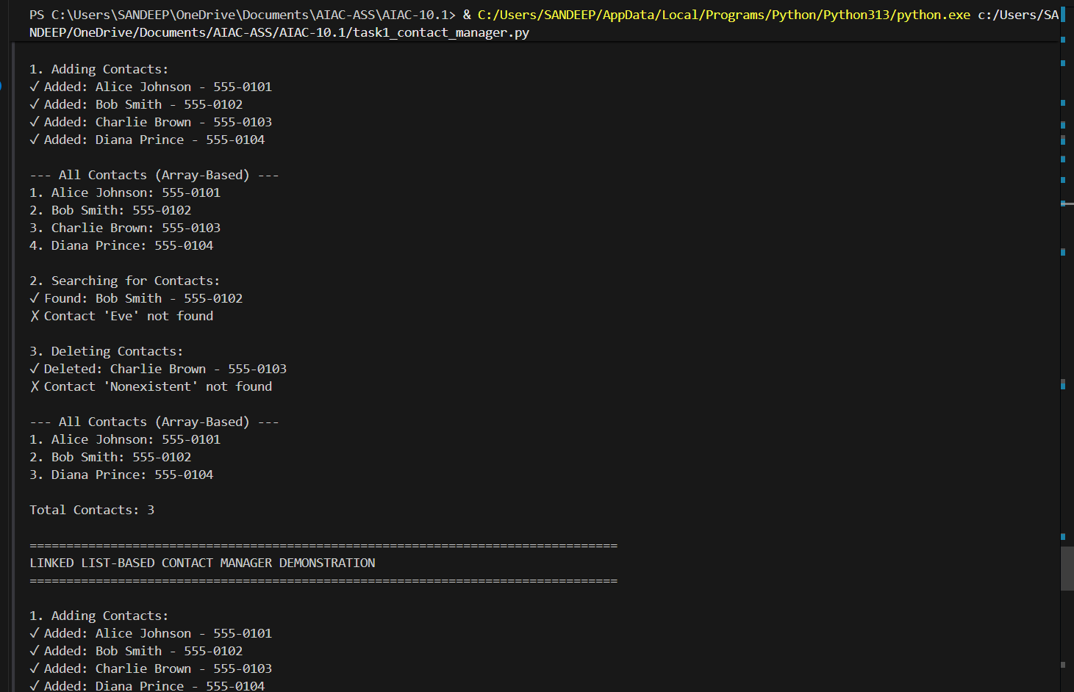

Task 2: Library Book Search System (Queues & Priority Queues)
Scenario
The SRU Library manages book borrow requests. Students and faculty submit
requests, but faculty requests must be prioritized over student requests.
Tasks:

1. Implement a Queue (FIFO) to manage book requests.
2. Extend the system to a Priority Queue, prioritizing faculty requests.
3. Use GitHub Copilot to assist in generating:
o enqueue() method
o dequeue() method
4. Test the system with a mix of student and faculty requests.
Expected Outcome
• Working queue and priority queue implementations.
• Correct prioritization of faculty requests.
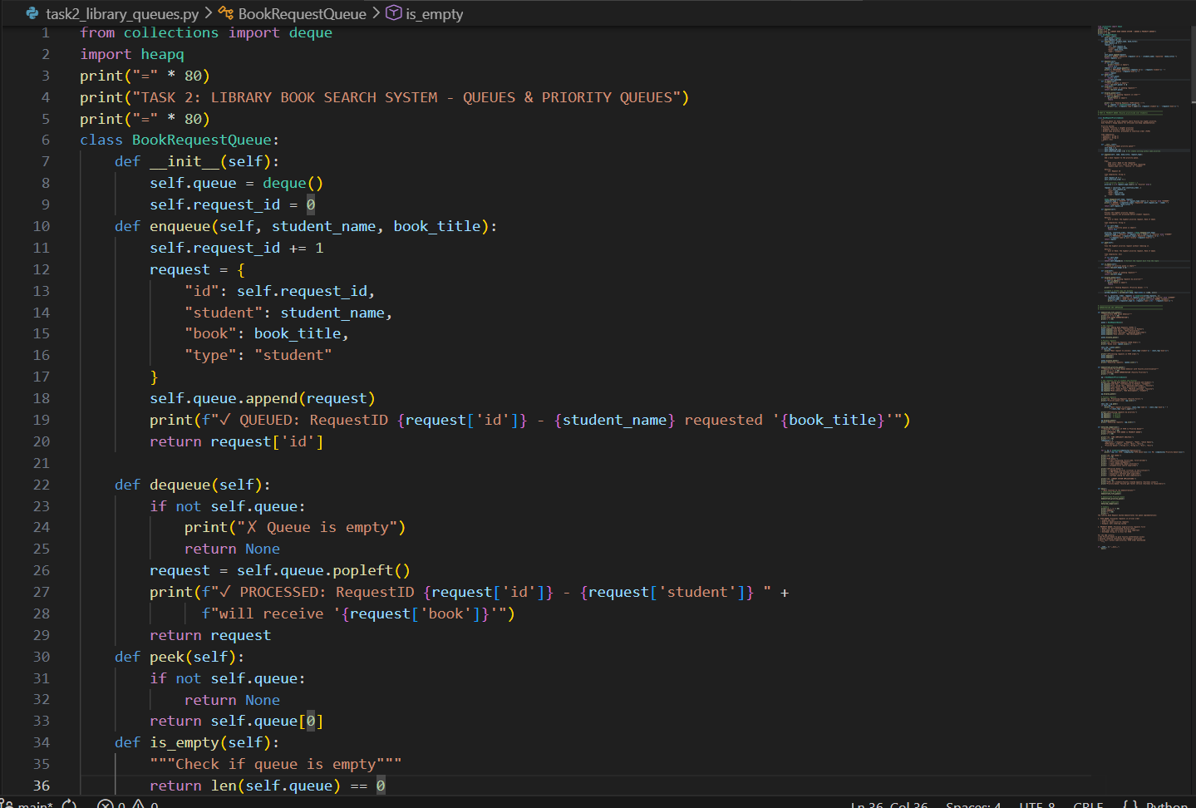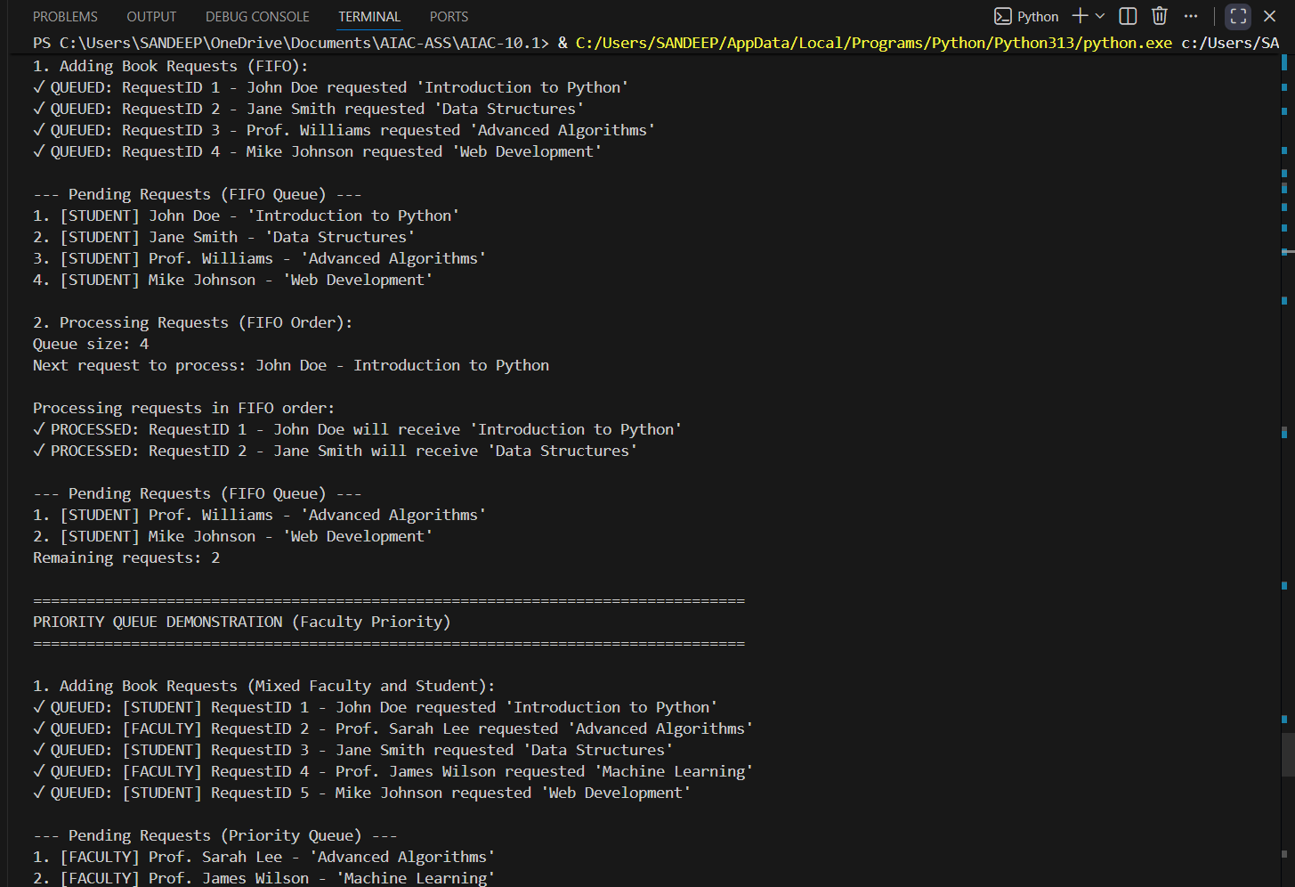
Task 3: Emergency Help Desk (Stack Implementation)
Scenario
SR University’s IT Help Desk receives technical support tickets from students
and staff. While tickets are received sequentially, issue escalation follows a
Last-In, First-Out (LIFO) approach.
Tasks
1. Implement a Stack to manage support tickets.
2. Provide the following operations:
o push(ticket)
o pop()
o peek()
3. Simulate at least five tickets being raised and resolved.
4. Use GitHub Copilot to suggest additional stack operations such as:
o Checking whether the stack is empty
o Checking whether the stack is full (if applicable) Expected Outcome
• Functional stack-based ticket management system.
• Clear demonstration of LIFO behavior.
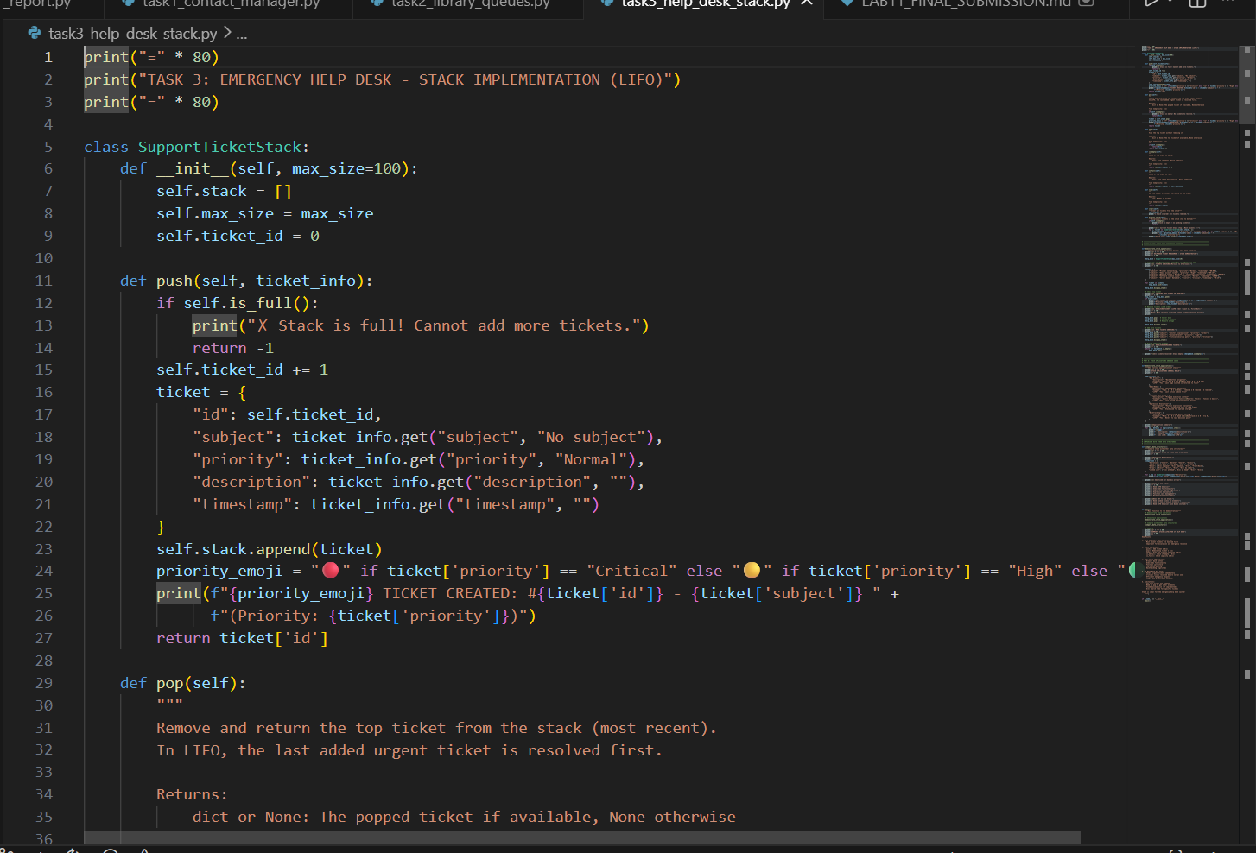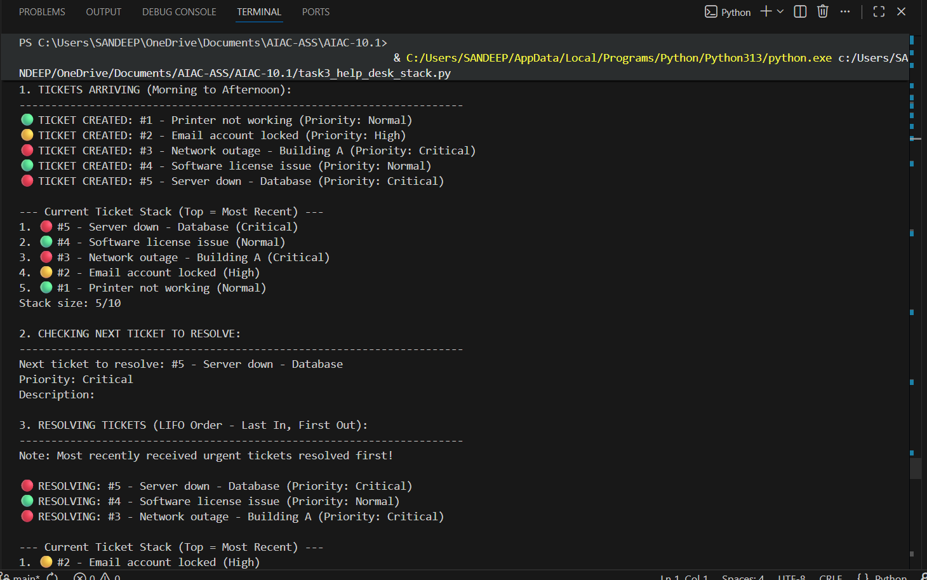
Task 4: Hash Table
Objective
To implement a Hash Table and understand collision handling.
Task Description
Use AI to generate a hash table with:
• Insert
• Search
• Delete
Starter Code
class HashTable:
pass
Expected Outcome
• Collision handling using chaining
• Well-commented methods
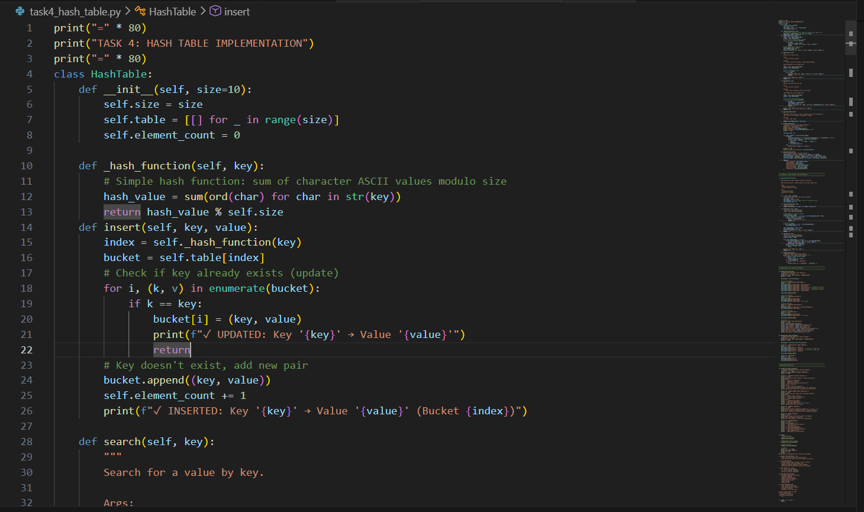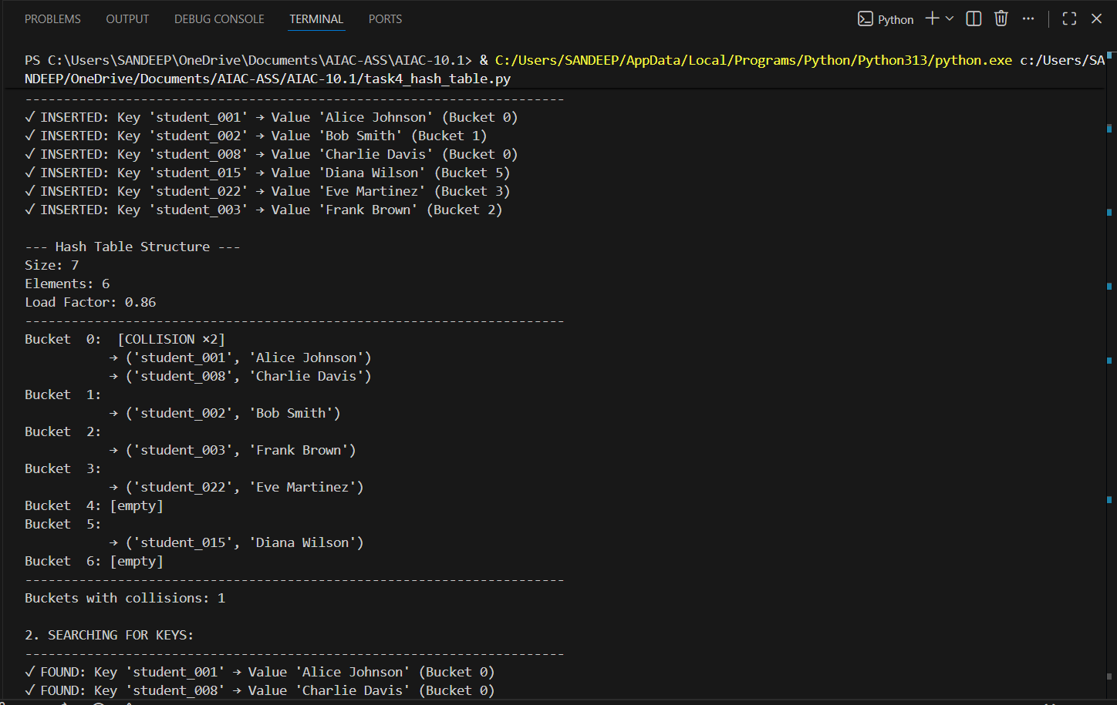
Task 5: Real-Time Application Challenge
Scenario
Design a Campus Resource Management System with the following
features:
• Student Attendance Tracking
• Event Registration System
• Library Book Borrowing
• Bus Scheduling System
• Cafeteria Order Queue
Student Tasks
1. Choose the most appropriate data structure for each feature.
2. Justify your choice in 2–3 sentences.
3. Implement one selected feature using AI-assisted code generation.
Expected Outcome
• Mapping table: Feature → Data Structure → Justification
• One fully working Python implementation
Note: Report should be submitted as a word document for all tasks in a single
document with prompts, comments & code explanation, and output and if
required, screenshots.
