COURSE: AI Assisted Coding
NAME : G.Sandeep
BATCH-34
HALLTICKET.NO : 2303A52371
AIAC-ASS-4.2

Lab 4:
Advanced Prompt Engineering – Zero-shot, One-shot, and Few-shot Techniques

Task Description-1
• Zero-shot: Prompt AI with only the instruction. Write a Python function to determine
whether a given number is prime.
Prompt:
#Write a Python function to determine whether a given number is prime.
Explanation:
- Numbers ≤ 1 are not prime.
- The loop checks divisibility only up to √n to optimize performance.
- If no divisor is found, the number is prime.

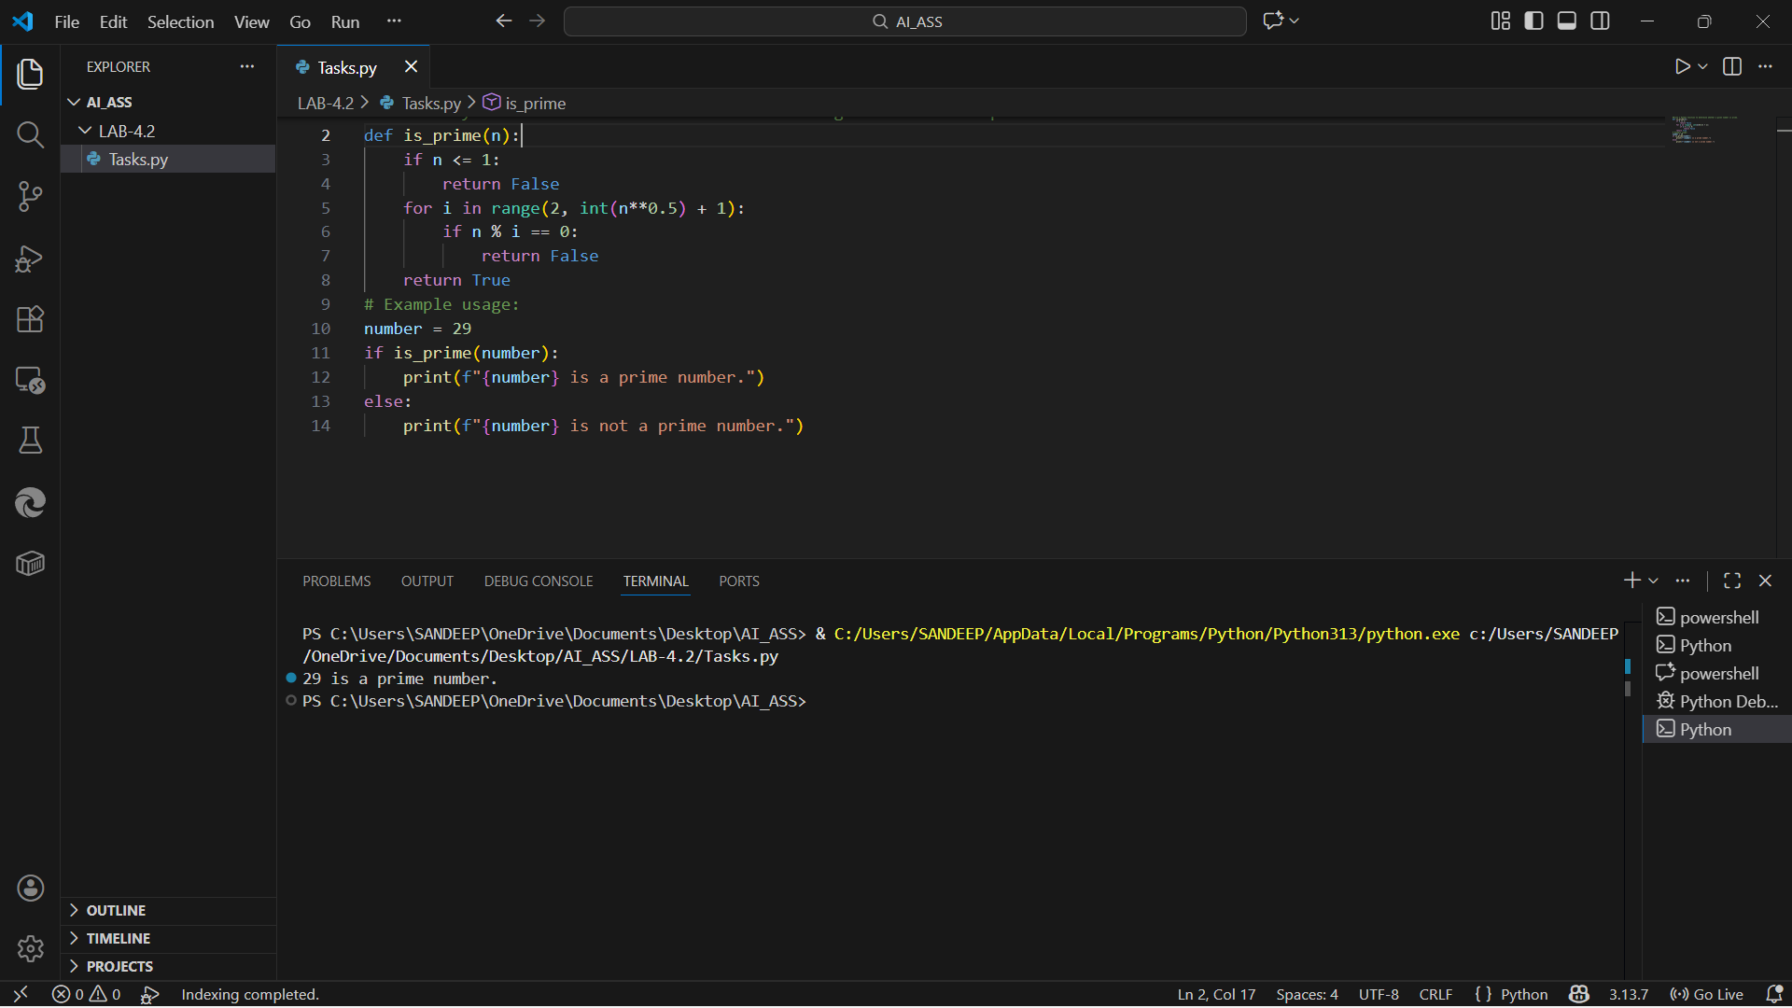
Task Description-2
• One-shot: Provide one example: Input: [1, 2, 3, 4], Output: 10 to help AI generate a
function that calculates the sum of elements in a list.
Prompt:
#Write a Python function that calculates the sum of elements in a list.
Explanation:
- The example clarifies the expected operation (addition).
- The function iterates through the list and accumulates the sum.
- Does not rely on the built-in sum() function.

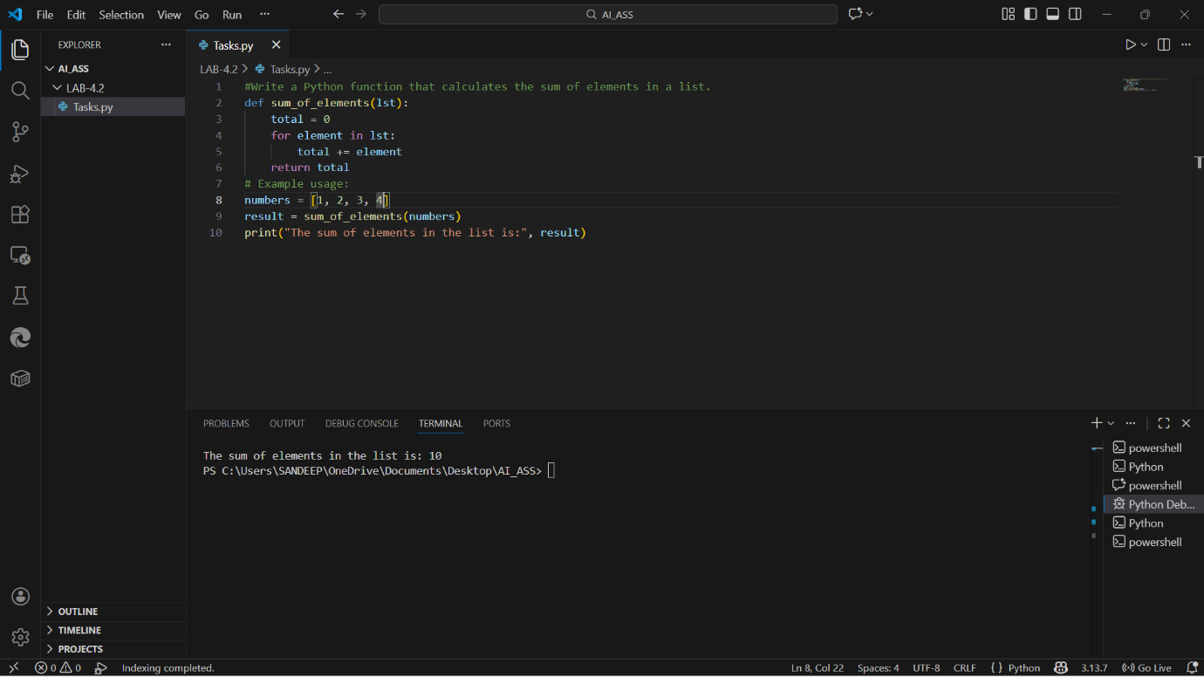

Task Description-3
• Few-shot: Give 2–3 examples to create a function that extracts digits from an
alphanumeric string.
Prompt:
#Write a Python function that extracts digits from an alphanumeric string.
Explanation
- Multiple examples clearly define the pattern.
- The function checks each character using isdigit().
- Only numeric characters are appended to the result string.

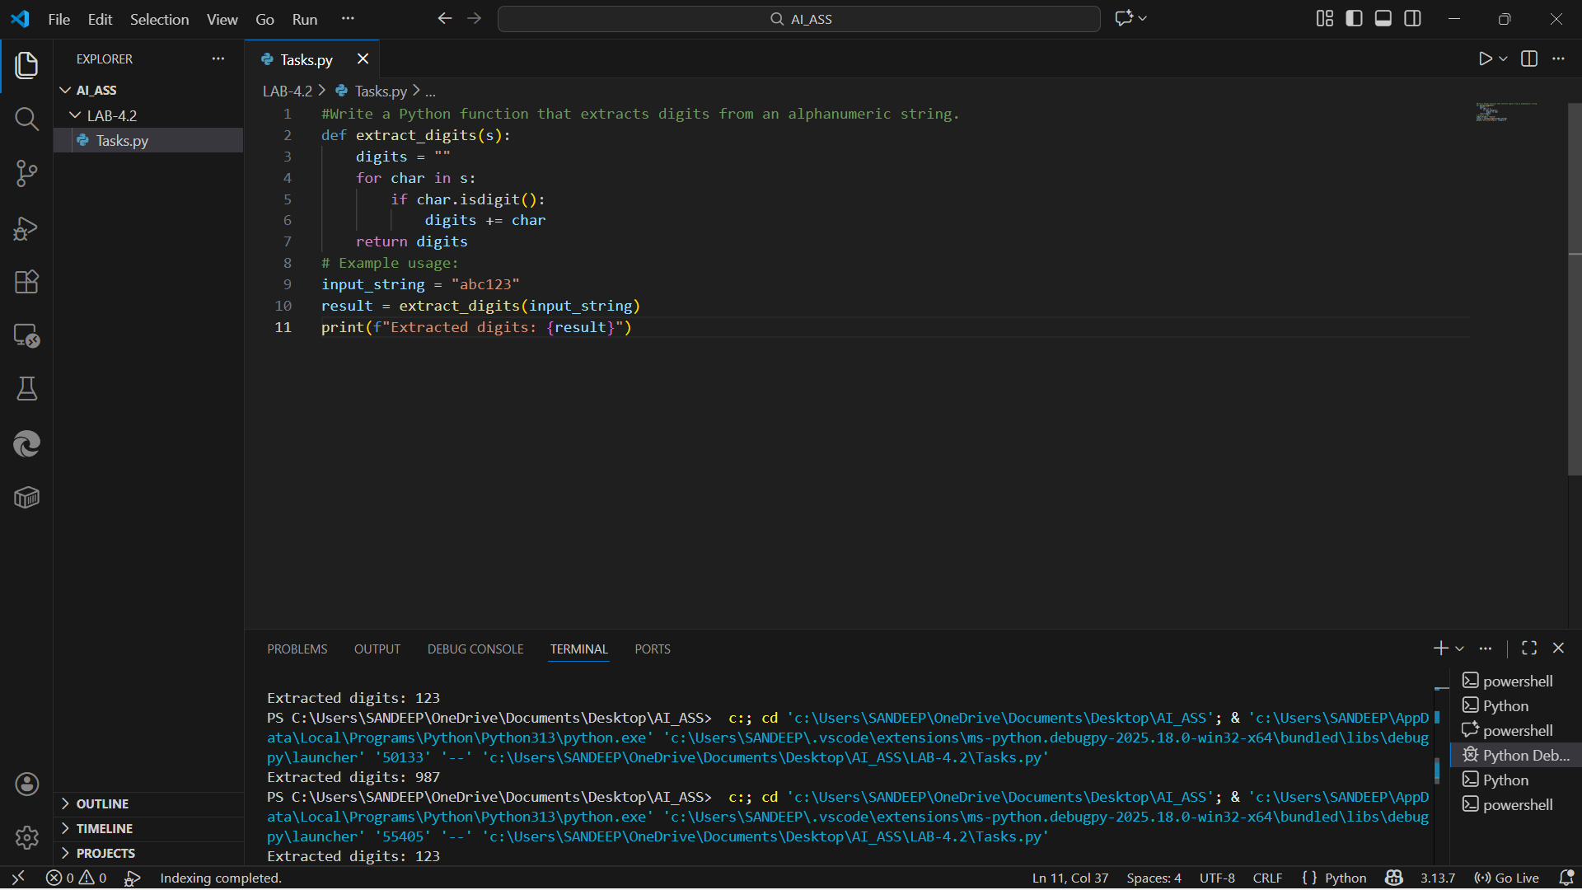

Task Description-4
• Compare zero-shot vs few-shot prompting for generating a function that counts the
number of vowels in a string.
Prompt:
#Write a Python function to count the number of vowels in a string
# Write a Python function to count vowels in a string.
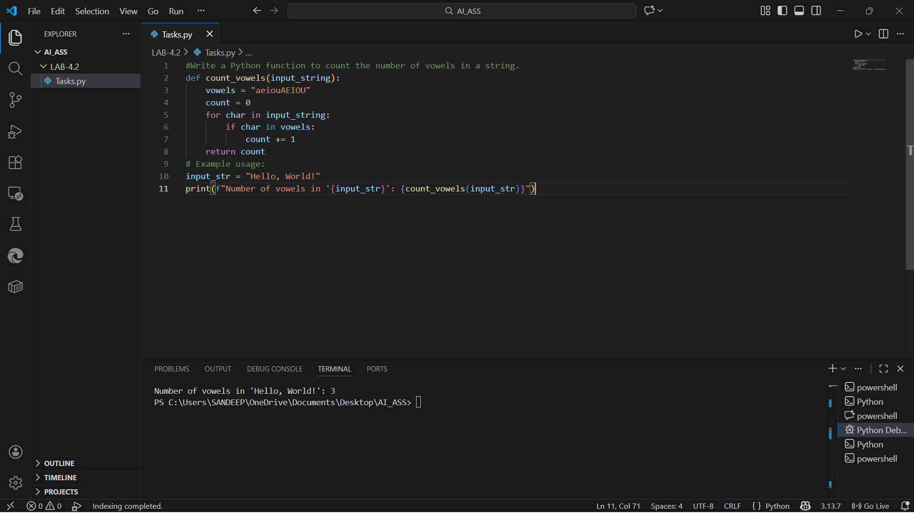
Task Description-5
• Use few-shot prompting with 3 sample inputs to generate a function that determines
the minimum of three numbers without using the built-in min() function.
Prompt:
#Write a Python function to find the minimum of three numbers without using min().
Explanation:
- Conditional comparisons handle all possible cases.
- Equality conditions are included using <=.
- Does not use any built-in minimum functions.
