NAME:VALLALA VYSHNAVI
BATCH-32
2303A52429
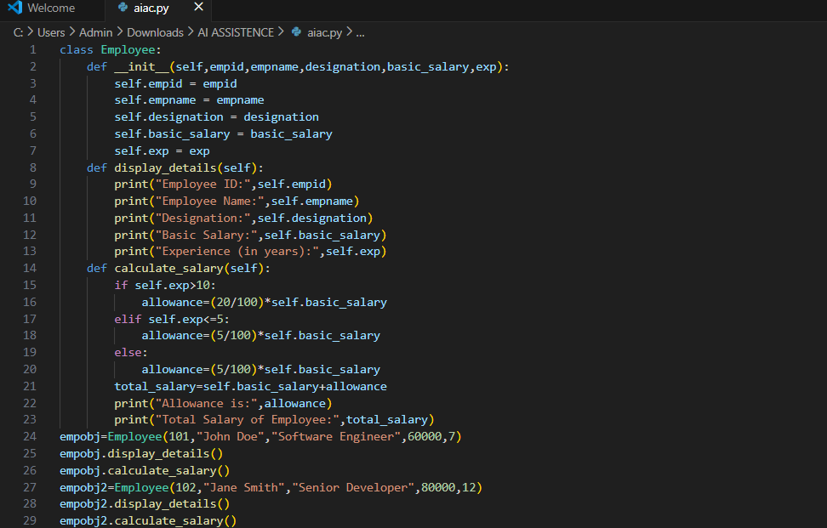
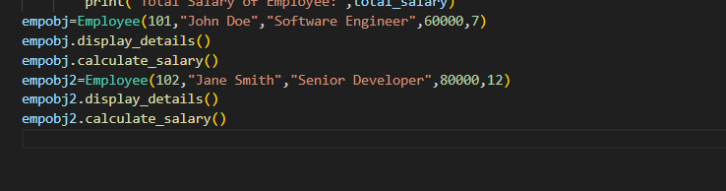
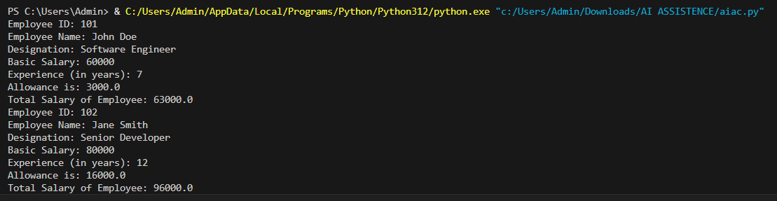
Observations:
1. The code defines an `Employee` class that encapsulates employee details and provides methods to display those details and calculate the total salary based on experience. The salary calculation includes an allowance that varies depending on the years of experience, demonstrating a practical application of conditional logic.
2. AI was useful in generating this code by quickly creating a structured class with relevant attributes and methods, saving time and effort in coding. It also ensured that the logic for salary calculation was clear and correctly implemented, which can be particularly beneficial for developers who may not be familiar with such calculations.
TASK-2
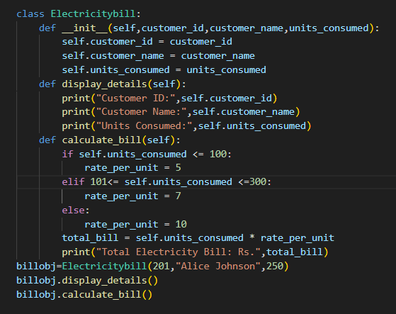
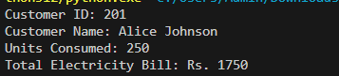
Observations:
1. The Employee class calculates allowances based on years of experience, while the Electricitybill class calculates the total bill based on units consumed, demonstrating different business logic implementations.
2. Both classes encapsulate related data and behaviors, promoting code organization and reusability
TASK-3
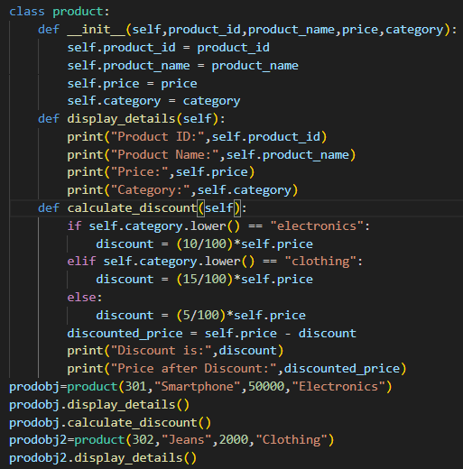
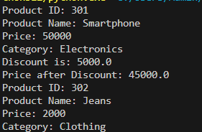
Observations:
1. The Product class calculates discounts based on product categories, showcasing how different business rules can be applied within a single class structure.
2. Both classes encapsulate related data and behaviors, promoting code organization and reusability
TASK-4
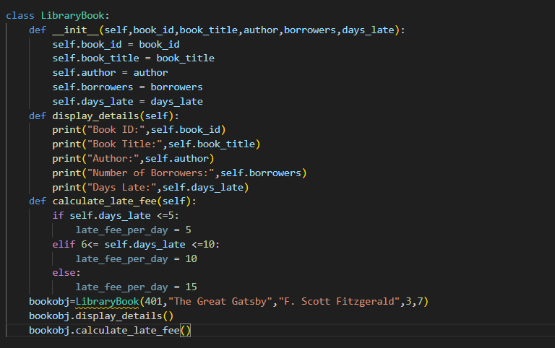
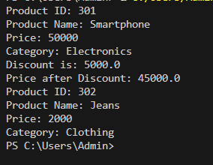
Observations:
1. The LibraryBook class calculates late fees based on the number of days a book is returned late, demonstrating a practical application of conditional logic.
2. Both classes encapsulate related data and behaviors, promoting code organization and reusability
TASK-5
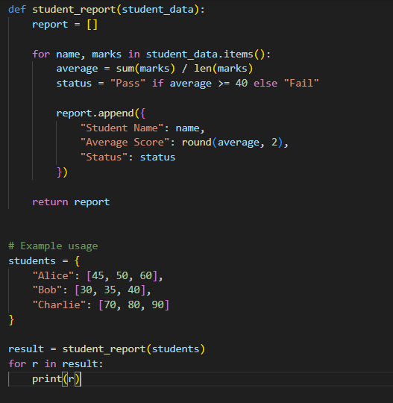
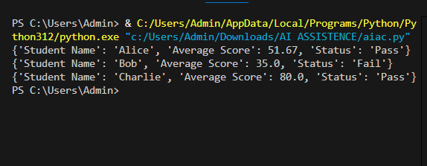
Observation:
1. The student_report function calculates the average score for each student and determines their pass/fail status
2. The function uses a dictionary to store student names and their corresponding marks, demonstrating the use of data structures for organizing information.
TASK-6
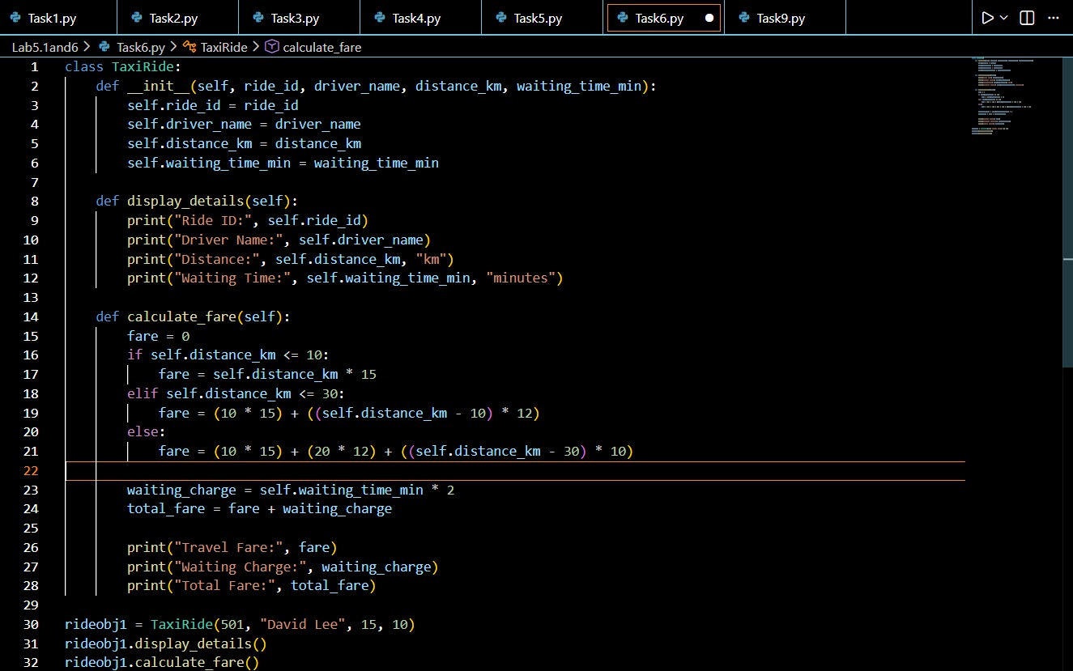
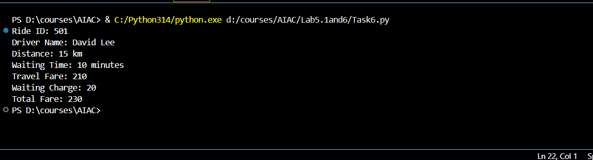
Observations:
• The TaxiRide class stores ride details and calculates the travel fare using slab-based distance pricing, where different per-kilometer rates are applied for the first 10 km, the next 20 km, and distances beyond 30 km.
• The calculate_fare() method adds a waiting charge based on waiting time, computes the total fare, and displays the travel fare, waiting charge, and final amount for the ride.

TASK-7
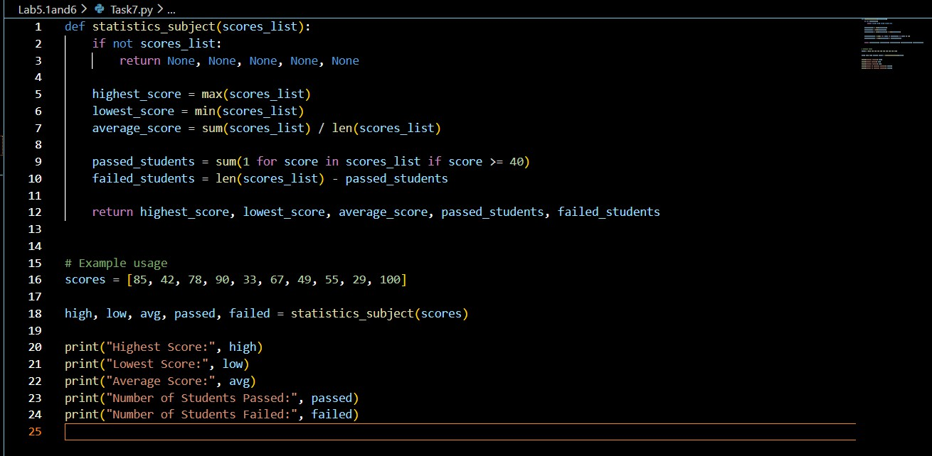
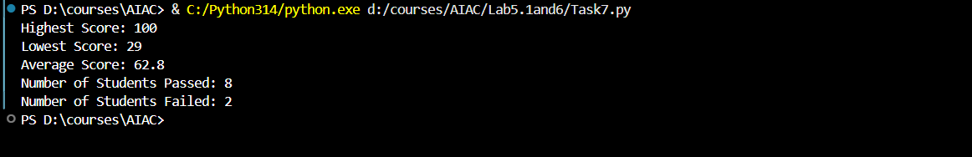
Observations:
1.The statistics_subject() function analyzes a list of student scores by calculating the highest score, lowest score, average score, and counting how many students passed or failed based on a minimum pass mark of 40.
2.The function returns all computed values together, which are then unpacked and printed to display a complete performance summary for the subject.

Lab 5: Ethical Foundations – Responsible AI Coding Practices
- Prompt:
“Generate Python code for two prime-checking methods and explain how the optimized version improves performance.”
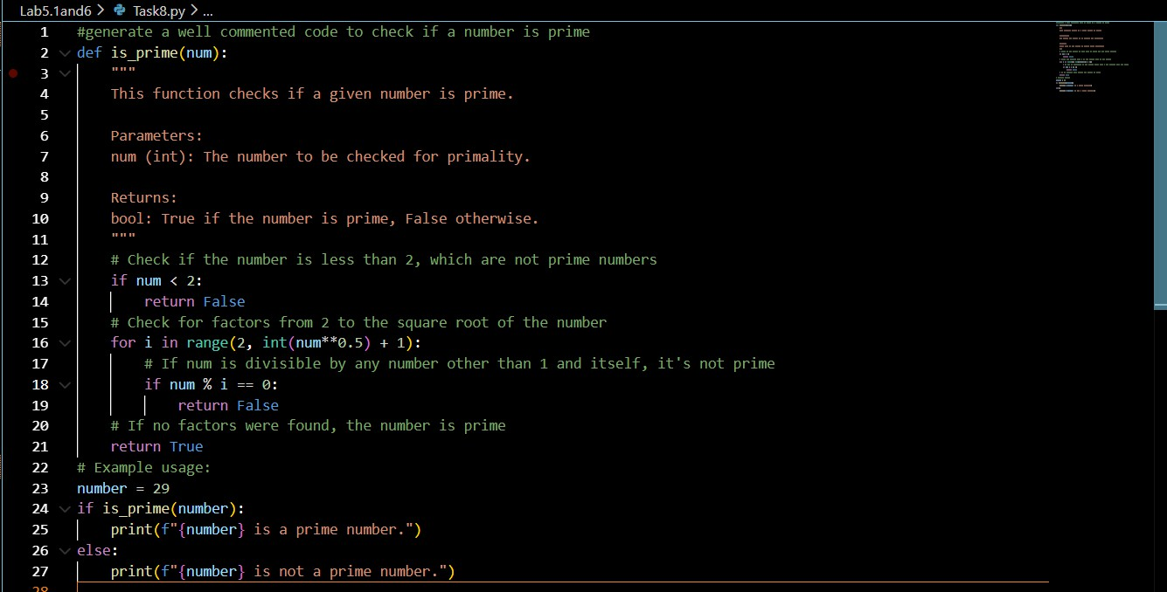
1.The is_prime() function checks whether a given number is prime by first eliminating numbers less than 2 and then testing divisibility only up to the square root of the number to reduce unnecessary checks.
2. If the number has no divisors other than 1 and itself, the function returns True; otherwise, it returns False, and the result is printed using a simple example.
Task Description #9 (Transparency in Recursive Algorithms)
Objective: Use AI to generate a recursive function to calculate Fibonacci numbers.

Instructions:
- Ask AI to add clear comments explaining recursion.
- Ask AI to explain base cases and recursive calls. Expected Output:
  - Well-commented recursive code.
  - Clear explanation of how recursion works.
  - Verification that explanation matches actual execution.

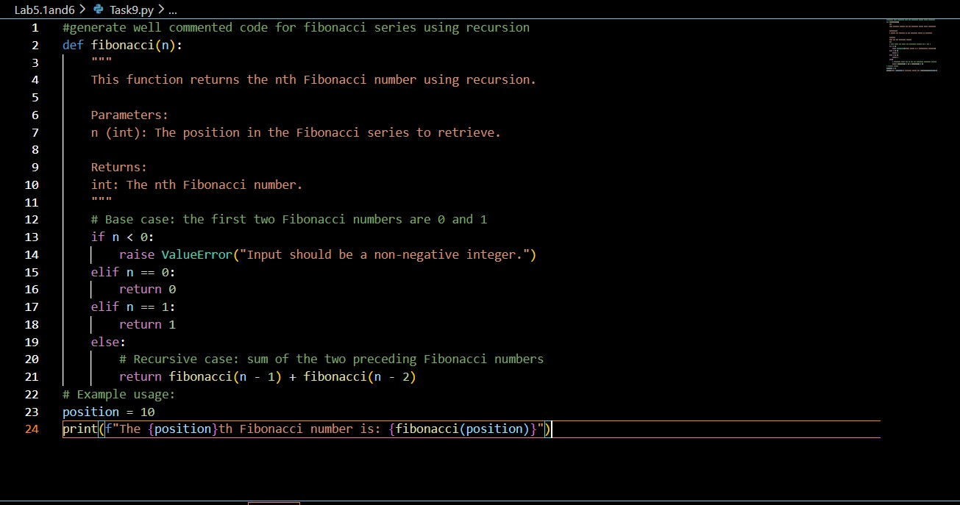
Observations:
1. The fibonacci() function computes the nth Fibonacci number using recursion by defining base cases for n = 0 and n = 1, which stop further recursive calls.
2. For values greater than 1, the function returns the sum of the two preceding Fibonacci numbers, and the result is displayed for a given position.

Task Description #10 (Transparency in Error Handling)
Task: Use AI to generate a Python program that reads a file and processes data. Prompt:
“Generate code with proper error handling and clear explanations for each exception.”

observations: 1.The read_and_process_file() function reads numbers from a file, converts each line into an integer, and calculates their average, while checking for empty files or invalid data.
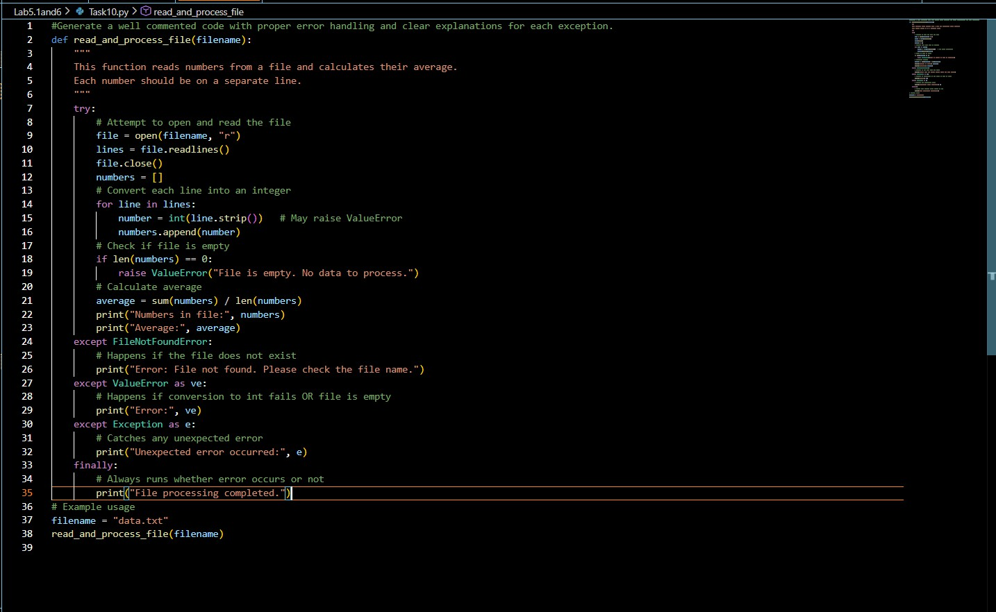
2.The function uses structured exception handling to manage file-not-found errors, value conversion errors, and unexpected exceptions, ensuring the program terminates safely with clear messages.
