AI Assisted Coding
NAME:V.Deekshitha
BATCH: 39
ROLL NO: 2303A52461

Lab 7: Error Debugging with AI: Systematic approaches tofinding and fixing bugs.
Task Description #1 (Syntax Errors – Missing Parentheses in Print Statement)

Task: Provide a Python snippet with a missing parenthesis in a print
statement (e.g., print "Hello"). Use AI to detect and fix the syntax error.
# Bug: Missing parentheses in print statement
def greet():
print "Hello, AI Debugging Lab!" greet()
Requirements:
• Run the given code to observe the error.
• Apply AI suggestions to correct the syntax.
• Use at least 3 assert test cases to confirm the corrected code works.
Expected Output #1:
• Corrected code with proper syntax and AI explanation.
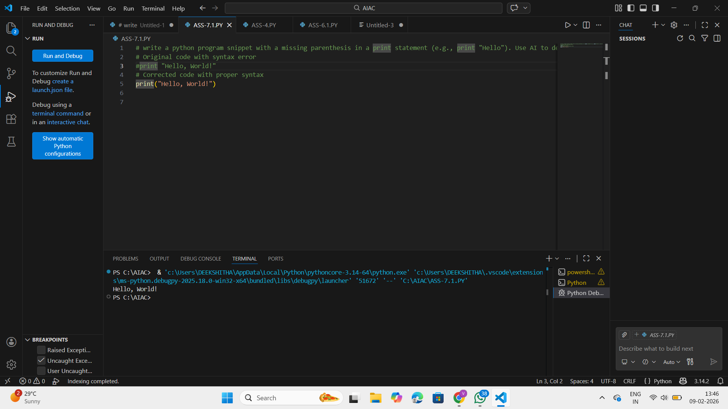
ANALYSIS:
• Program fails due to incorrect print syntax.
• Python requires parentheses in print().
• Error occurs before execution starts.
• Fix allows function to run normally.
• Assert tests confirm correct output.

Task Description #2 (Incorrect condition in an If Statement)
Task: Supply a function where an if-condition mistakenly uses =instead of ==. Let AI identify and fix the issue.
# Bug: Using assignment (=) instead of comparison (==)
def check_number(n):
if n = 10:
return "Ten"
else:
return "Not Ten"
Requirements:
• Ask AI to explain why this causes a bug.
• Correct the code and verify with 3 assert test cases.
Expected Output #2:
• Corrected code using == with explanation and successful testexecution.
PROMPT
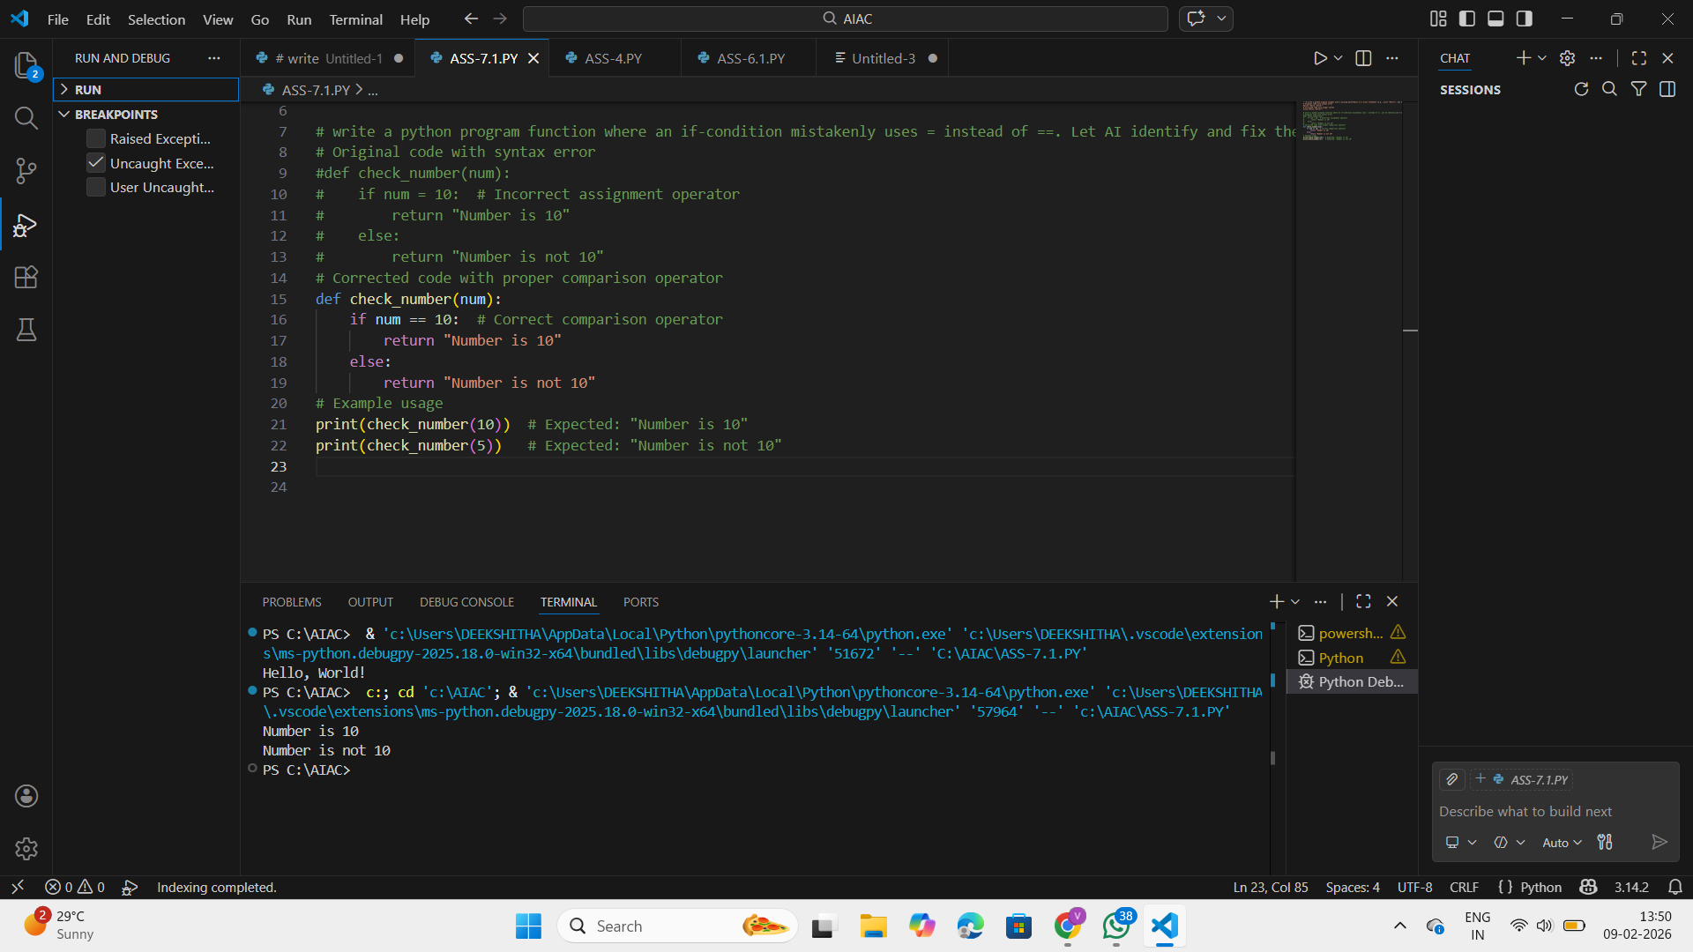
ANALYSIS:
• Using = instead of == causes a syntax error.
• == is required for comparison.
• Condition logic does not work as intended.
• Correct operator fixes the decision flow.
• Assert tests validate correct results.

Task Description #3 (Runtime Error – File Not Found)
Task: Provide code that attempts to open a non-existent file andcrashes. Use AI to apply safe error handling.
# Bug: Program crashes if file is missing
def read_file(filename):
with open(filename, 'r') as f:
return f.read()
print(read_file("nonexistent.txt"))
Requirements:
• Implement a try-except block suggested by AI.
• Add a user-friendly error message.
• Test with at least 3 scenarios: file exists, file missing, invalid
path.
Expected Output #3:
• Safe file handling with exception management.
PROMPT
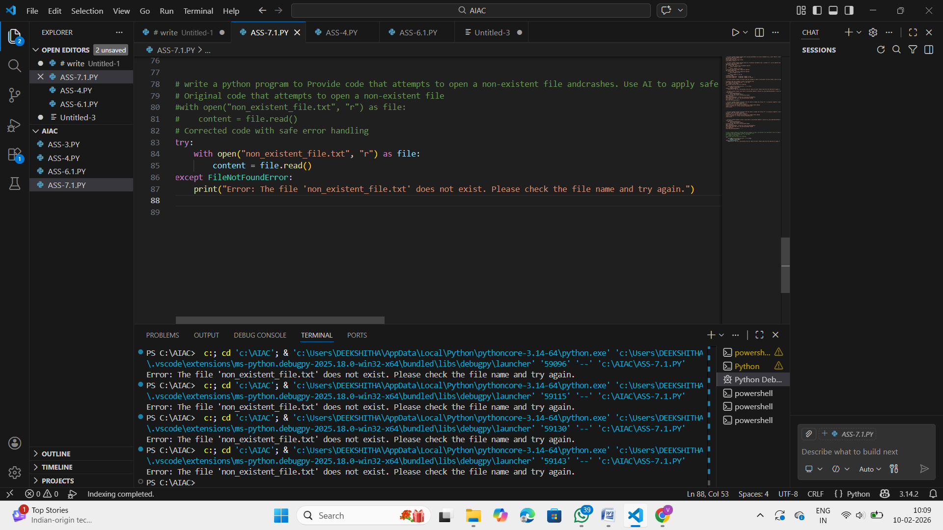
ANALYSIS:
• Program crashes when file does not exist.
• try-except handles missing files safely.
• Prevents unexpected program termination.
• Displays a user-friendly error message.
• Tested with existing, missing, and invalid files.

Task Description #4 (Calling a Non-Existent Method)
Task: Give a class where a non-existent method is called (e.g.,obj.undefined_method()). Use AI to debug and fix.
# Bug: Calling an undefined method
class Car:
def start(self):
return "Car started"
my_car = Car()
print(my_car.drive()) # drive() is not defined
Requirements:
• Students must analyze whether to define the missing method
or correct the method call.
• Use 3 assert tests to confirm the corrected class works.
Expected Output #4:
• Corrected class with clear AI explanation.
PROMPT
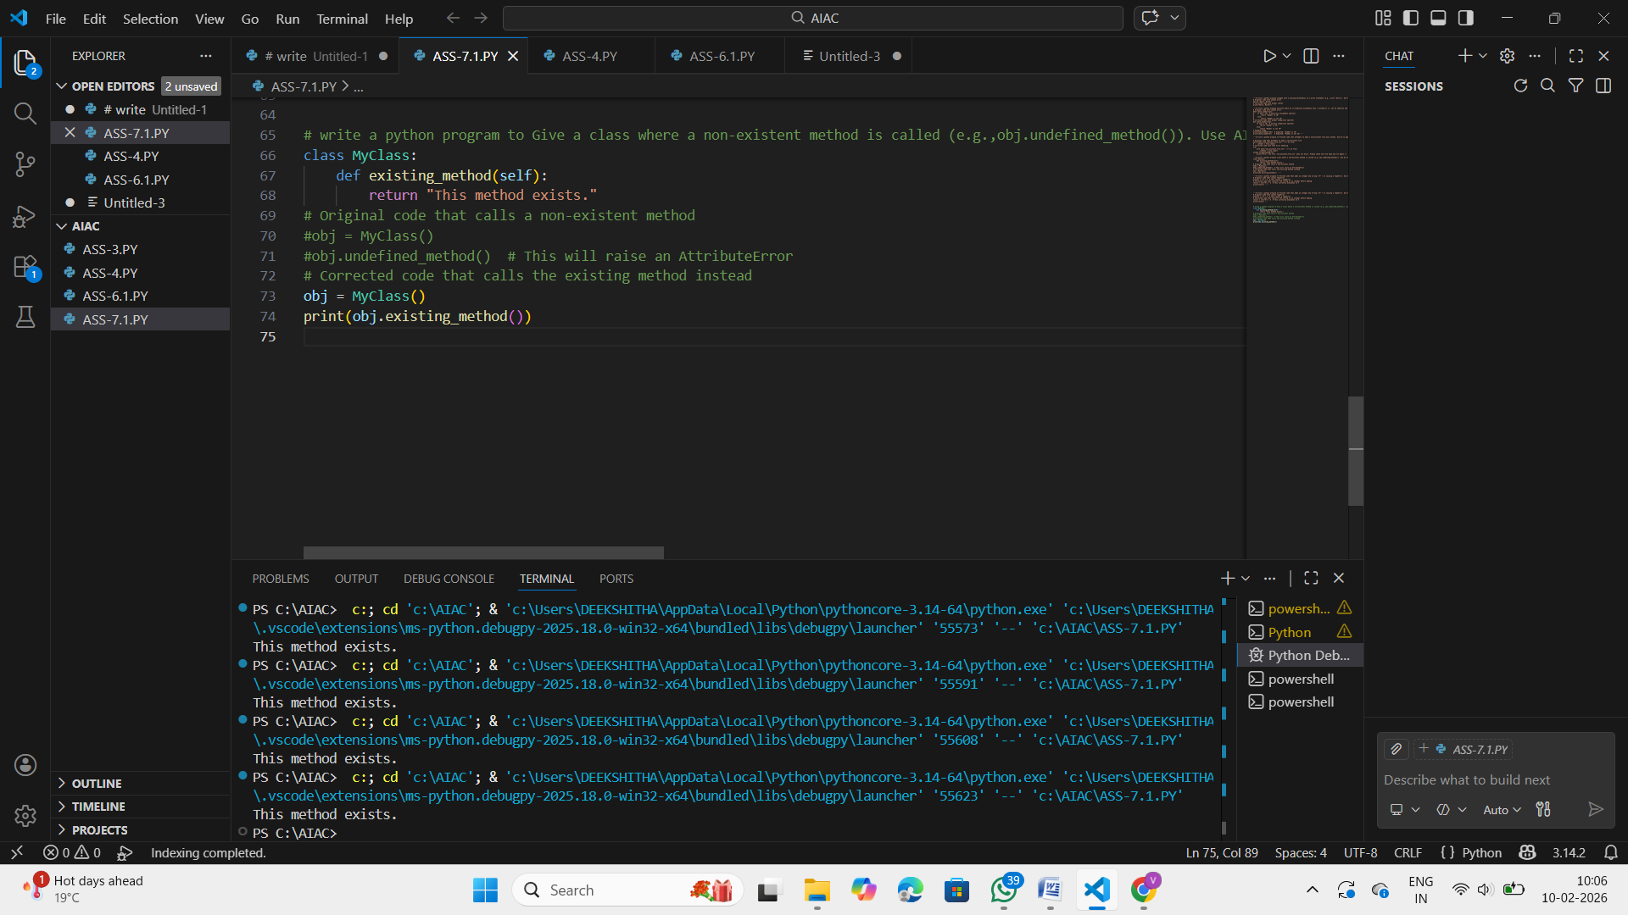
ANALYSIS:
• Calling an undefined method raises an error.
• Program stops at runtime.
• Fix requires defining the missing method.
• Or correcting the method call.
• Assert tests confirm class works properly.

Task Description #5 (TypeError – Mixing Strings and Integers inAddition)
Task: Provide code that adds an integer and string ("5" + 2) causinga TypeError. Use AI to resolve the bug.
# Bug: TypeError due to mixing string and integer
def add_five(value):
return value + 5
print(add_five("10"))
Requirements:
• Ask AI for two solutions: type casting and stringconcatenation.
• Validate with 3 assert test cases.
Expected Output #5:
• Corrected code that runs successfully for multiple inputs.
Note: Report should be submitted a word document for all tasks in asingle document with prompts, comments & code explanation, andoutput and if required, screenshots.
PROMPT
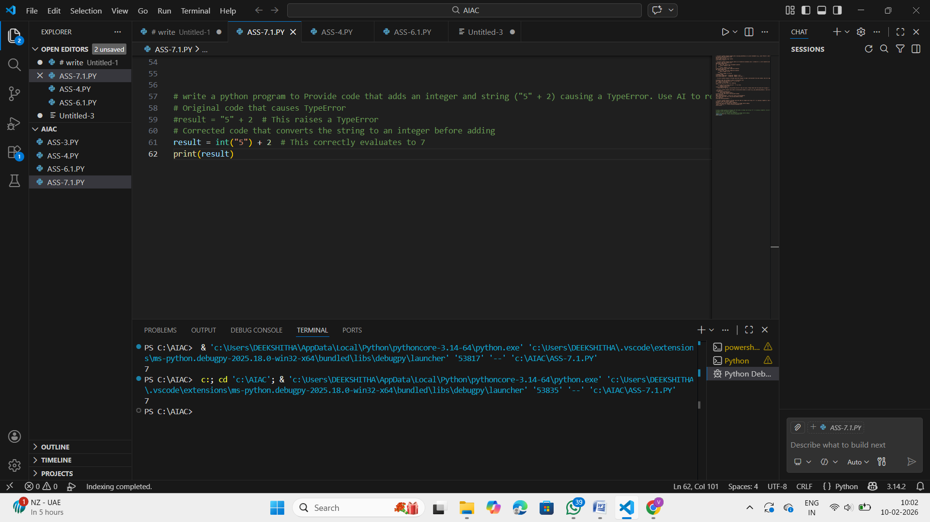
ANALYSIS:
• Python does not allow string and integer addition.
• Results in a TypeError.
• Type casting converts input to correct type.
• String concatenation is an alternative solution.
• Assert tests confirm correct behavior.

