Assignment-13.4
V.Sriram
2303A53009
Batch-46

Lab 13: Code Refactoring – Improving Legacy Code with AI Suggestions

Task 1:
Refactoring Data Transformation Logic
Scenario
You are maintaining a data preprocessing script where numerical transformations are written using verbose loops.
Task Description
- Review the legacy code that computes transformed values using an explicit loop.
- Use an AI tool to suggest a more Pythonic refactoring approach. • Refactor the code using list comprehensions or helper functions while preserving the output. Legacy Code
values = [2, 4, 6, 8, 10]
doubled = [] for v in values: doubled.append(v * 2) print(doubled) Expected Output [4, 8, 12, 16, 20]
AI Prompt Used:
Refactor the following Python code to make it more Pythonic and concise without changing its output.
Use modern Python best practices such as list comprehensions if applicable.

values = [2, 4, 6, 8, 10]
doubled = [] for v in values: doubled.append(v * 2) print(doubled) Code:
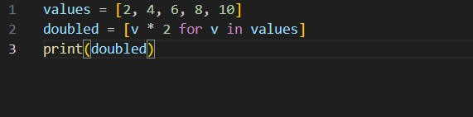

Output:
Task 2:
Improving Text Processing Code Readability
Scenario
You are working on a log message generator that builds messages word by word.
Task Description
- Analyze the legacy code that constructs a sentence using repeated string concatenation.
- Ask AI to suggest a more efficient and readable approach.
- Refactor the code accordingly while keeping the final output unchanged. Legacy Code
words = ["Refactoring", "with", "AI", "improves",
"quality"] message = "" for w in words: message += w + " " print(message.strip())
Expected Output
Refactoring with AI improves quality

AI Prompt Used:
Improve the readability and efficiency of the following Python code.
Avoid repeated string concatenation and suggest a more efficient approach while preserving the same output.

words = ["Refactoring", "with", "AI", "improves", "quality"] message = "" for w in words:
message += w + " " print(message.strip())
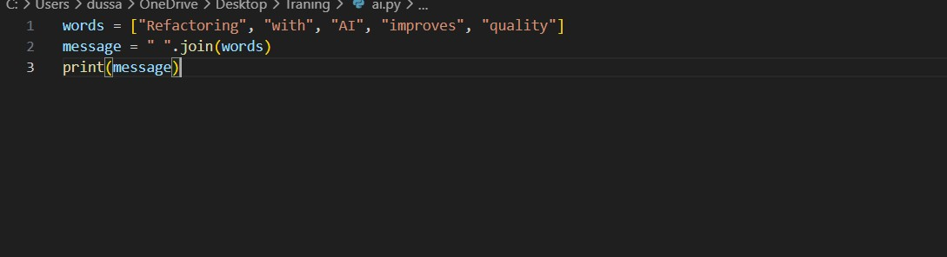
Output:
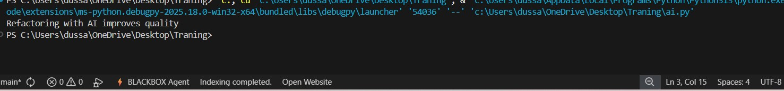

Task 3:
Safer Access to Configuration Data
Scenario
You are maintaining a configuration loader where dictionary keys may or may not exist depending on deployment settings.
Task Description
- Review the legacy code that manually checks for dictionary keys. • Use AI suggestions to refactor the code using safer dictionary access methods.
- Ensure the behavior remains the same for missing keys Legacy Code
config = {"host": "localhost", "port": 8080} if "timeout" in config: print(config["timeout"]) else:
print("Default timeout used")
Expected Output
Default timeout used

AI Prompt Used:
Refactor the following Python code to safely access dictionary values using modern Python methods.
Ensure that the behavior remains the same if the key does not exist.

config = {"host": "localhost", "port": 8080} if "timeout" in config:
print(config["timeout"]) else: print("Default timeout used")
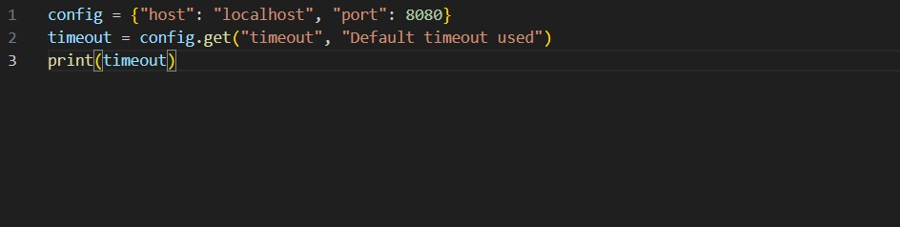
Output:
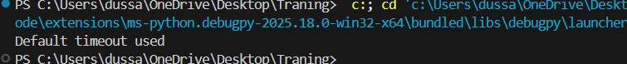

Task 4:
Refactoring Conditional Logic for
Scalability
Scenario
You are enhancing a utility module that performs different operations based on user input.
Task Description
- Examine the multiple if–elif conditions used to determine operations.
- Ask AI to suggest a cleaner, scalable alternative.
- Refactor the logic using mapping techniques while preserving functionality. Legacy Code action = "divide" x, y = 10, 2 if action == "add":
result = x + y elif action == "subtract":
result = x - y elif action == "multiply":
result = x * y elif action == "divide":
result = x / y else:
result = None print(result)
Expected Output
5.0
AI Prompt Used:
The following Python code uses multiple if-elif conditions to perform operations.
Refactor it into a cleaner and more scalable approach using mapping techniques or functions, without changing the output.
action = "divide"
x, y = 10, 2

if action == "add": result = x + y elif action == "subtract": result = x - y elif action == "multiply": result = x * y elif action == "divide":
result = x / y else:
result = None

print(result)

Code:
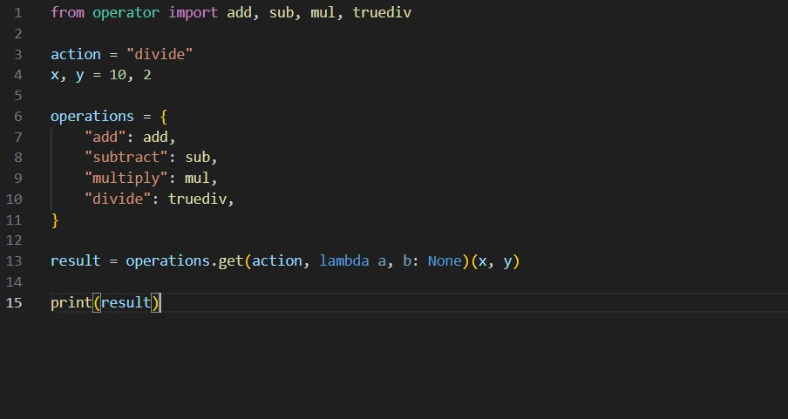
Output:
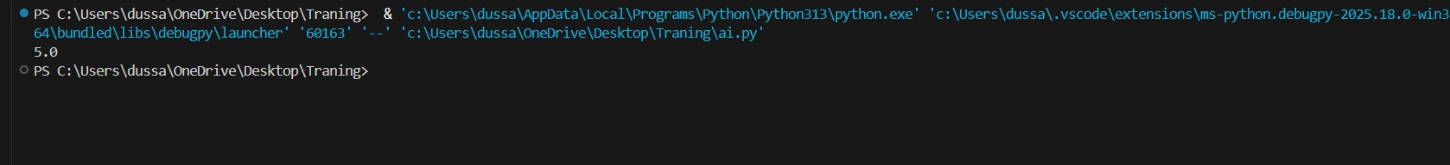

Task 5:
Simplifying Search Logic in Collections
Scenario
You are reviewing legacy inventory-check code that uses manual loops to find elements.
Task Description
- Identify the explicit loop used for searching an item.
- Use AI assistance to refactor the logic into a more concise and readable form.
- Maintain the same output behavior. Legacy Code
inventory = ["pen", "notebook", "eraser", "marker"] found = False for item in inventory: if item == "eraser":
found = True break
print("Item Available" if found else "Item Not Available")
Expected Output
Item Available

AI Prompt Used:
Refactor the following Python code to simplify the search logic.
Replace manual looping and flag variables with a more concise and Pythonic solution while keeping the same output behavior.

inventory = ["pen", "notebook", "eraser", "marker"] found = False

for item in inventory: if item == "eraser":
found = True
break

print("Item Available" if found else "Item Not Available")

Code:
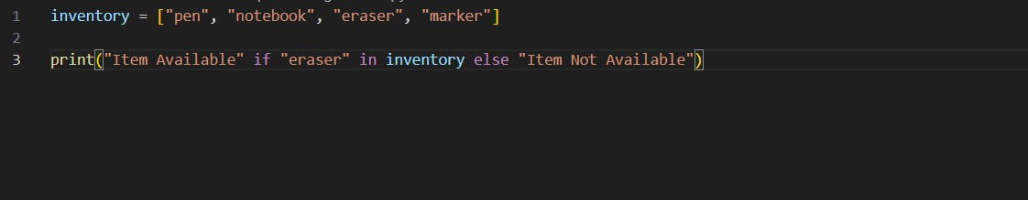

Output:

