Lab-15.1

Name V.Sriram
2303A53009
Batch:46

Lab 15 – Backend API Development: Creating RESTful services with AI

Task 1 – Student Records API Task:
Use AI to build a RESTful API for managing student records.
Instructions:
- Endpoints required: o GET /students → List all students o POST /students → Add a new student o PUT /students/{id} → Update student details o DELETE /students/{id} → Delete a student record
- Use an in-memory data structure (list or dictionary) to store records.
- Ensure API responses are in JSON format. Expected Output:
- Working API with CRUD functionality for student records.

AI Prompt:
"Act as a Backend Developer. Write a Python Flask REST API to manage student records using an inmemory list. Implement the following endpoints: GET /students (list all), POST /students (add new), PUT /students/<id> (update details), and DELETE /students/<id> (remove record). Ensure responses are in JSON format and include basic error handling for missing IDs."

Initial Code Implementation
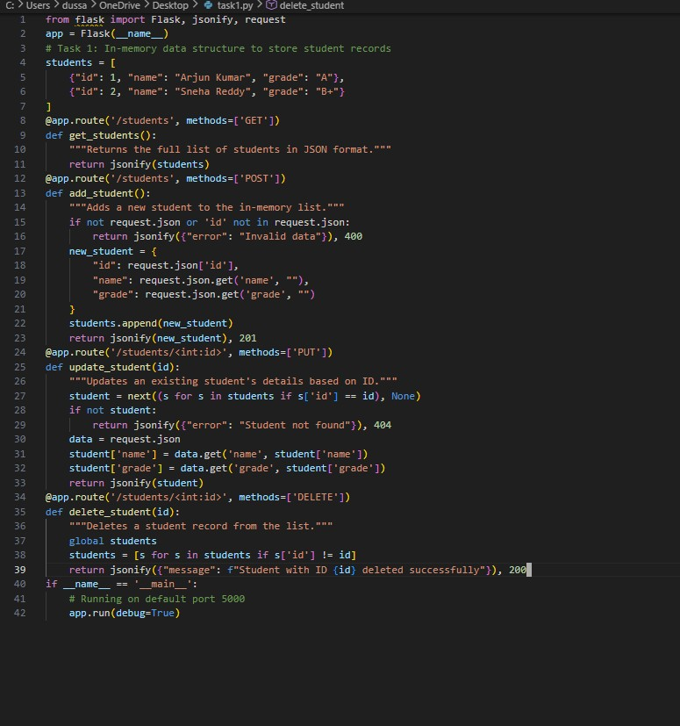

Assert Test Cases (For Verification)
- assert len(students) == 2 (Verifies the initial data is loaded).
- assert students[0]['name'] == "Arjun Kumar" (Verifies the data integrity).
- assert isinstance(students, list) (Ensures the data structure is correct).

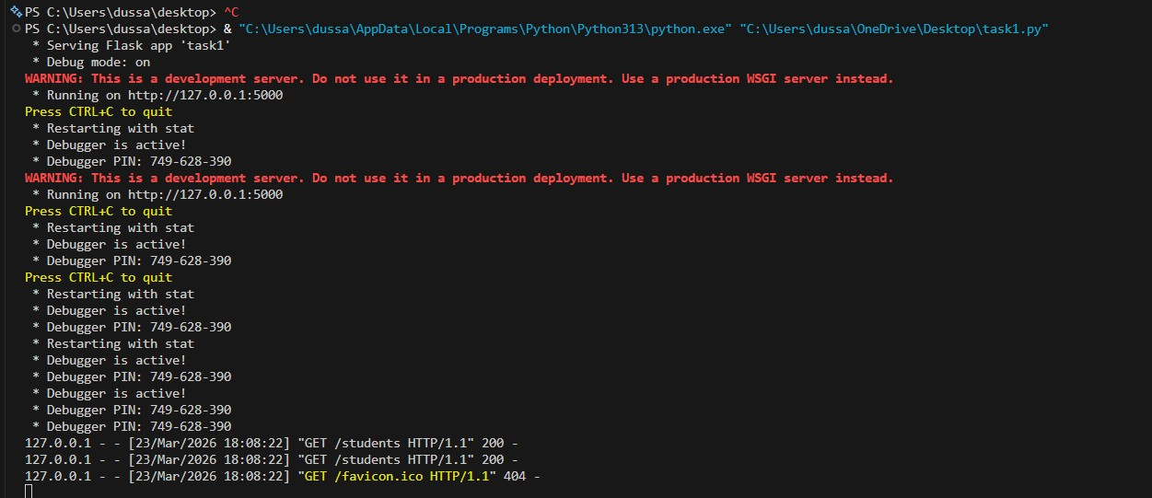

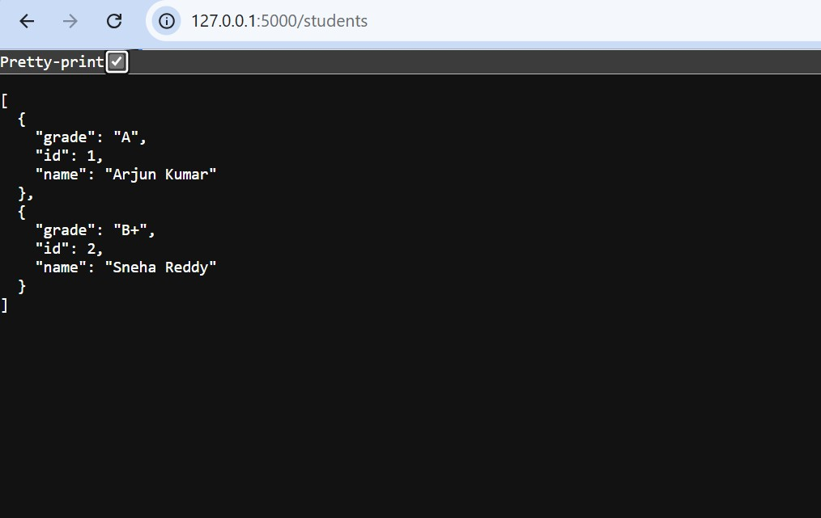

Task 2 – Library Book Management API Task:
Develop a RESTful API to handle library books.
Instructions:
- Endpoints required:
  - GET /books → Retrieve all books o POST /books → Add a new book
  - GET /books/{id} → Get details of a specific book
  - PATCH /books/{id} → Update partial book details(e.g., availability) o DELETE /books/{id} → Remove a book • Implement error handling for invalid requests. Expected Output:
- Functional API with CRUD + partial updates.

AI-Generated Prompt

"Act as a Backend Developer. Write a Flask API for a library system using an in-memory list of books.
Each book should have an 'id', 'title', 'author', and 'available' (boolean) status. Implement GET
/books, POST /books, GET /books/<id>, PATCH /books/<id> (to update availability), and DELETE
/books/<id>. Include error handling that returns a 404 message if a book ID is not found."

Code:
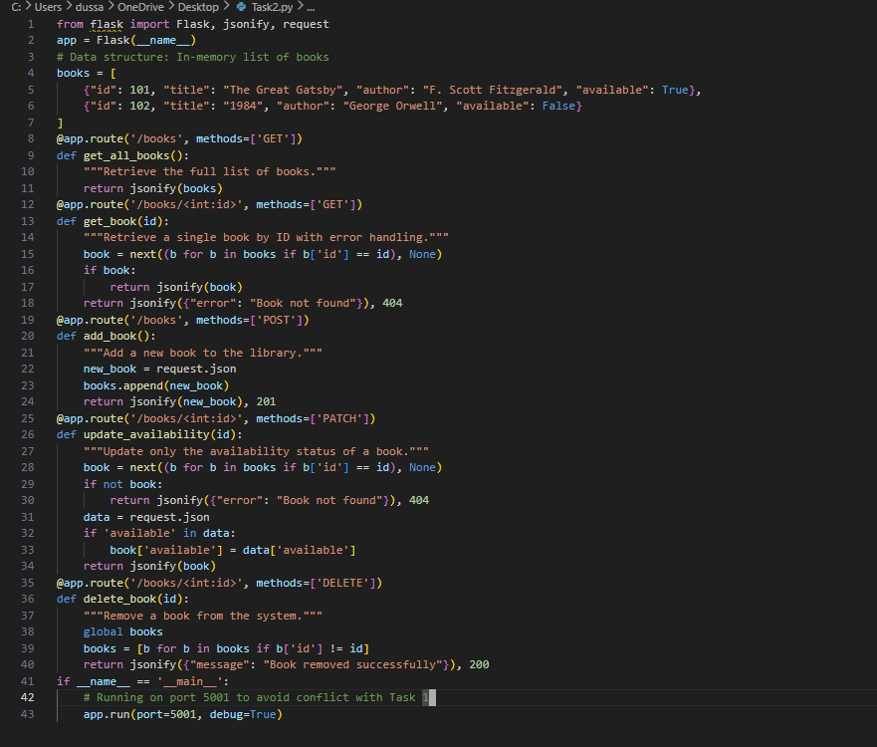

Browser:

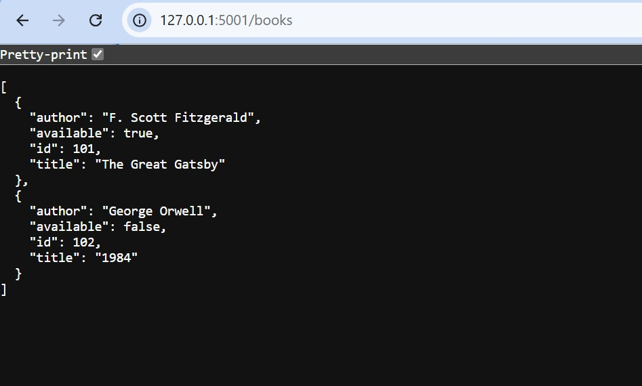
Error Handling:

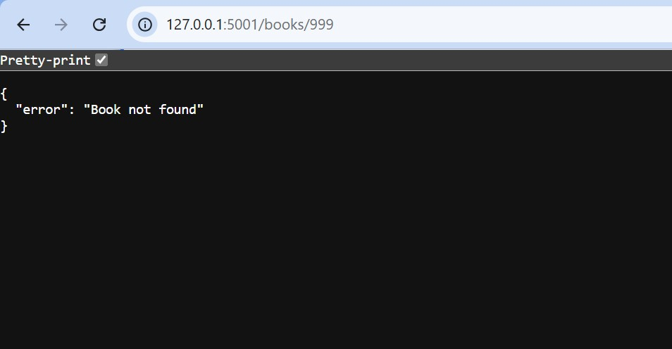

Analysis of Results
- Success: The API successfully implements the PATCH method, which is more efficient than PUT for changing a single field (like availability) without sending the entire book object again.
- Logic: The error handling logic uses a conditional check on the next() iterator result to return a standard 404 HTTP status code, ensuring the API is user-friendly and follows REST standards.

Task 3 – Employee Payroll API Task:
Create an API for managing employees and their salaries.
Instructions:
- Endpoints required: o GET /employees → List all employees
  - POST /employees → Add a new employee with salary details o PUT /employees/{id}/salary → Update salary of an employee o DELETE /employees/{id} → Remove employee from system • Use AI to:
  - Suggest data model structure. o Add comments/docstrings for all endpoints.
Expected Output:
- API supporting salary management with clear documentation.

AI-Generated Prompt
"Act as a Backend Developer. Create a Flask API for an Employee Payroll system. Each employee should have an 'id', 'name', 'position', and 'salary'. Implement endpoints: GET /employees (list all), POST /employees (add new), PUT /employees/<id>/salary (to update ONLY the salary), and DELETE /employees/<id>. Every function must include a Python docstring explaining the parameters and return values."

Code:
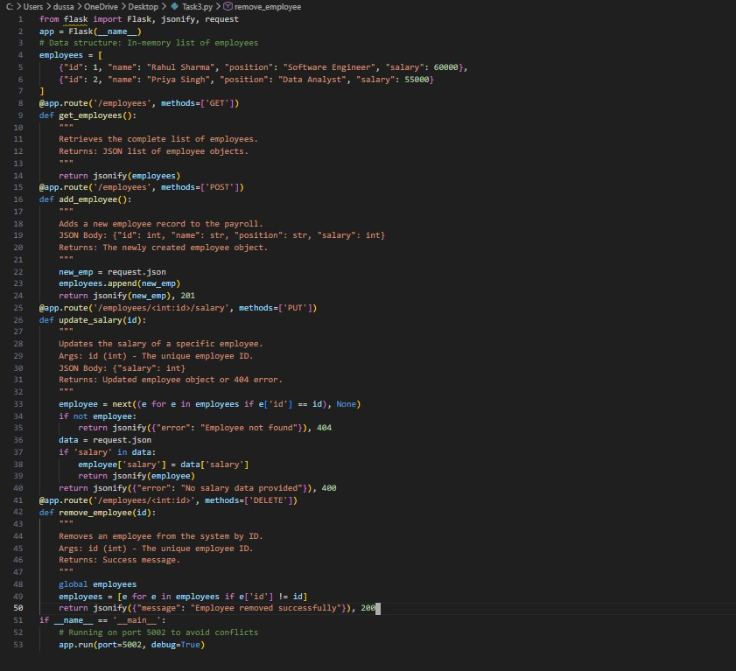
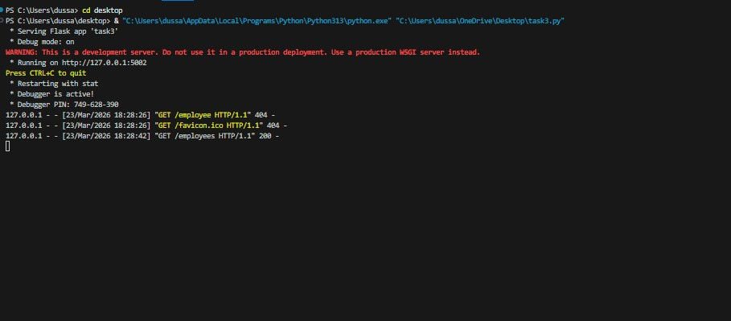

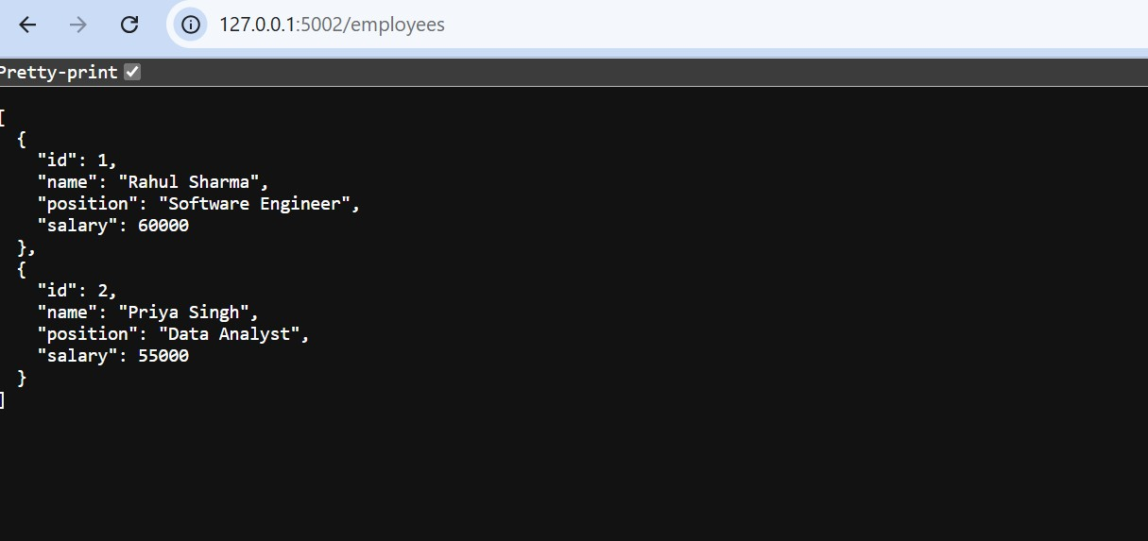

Analysis of Results

- Documentation: This task highlights the importance of Docstrings. In a collaborative environment, these allow other developers to understand the API endpoints without reading the full logic.
- Specific Routing: By using the route /employees/<id>/salary, we restrict the PUT method to a specific attribute. This "Granular Routing" prevents accidental changes to employee names or positions when only a pay raise was intended.

Task 4 – Real-Time Application: Online Food Ordering API Scenario:
Design a simple API for an online food ordering system.
Requirements:
- Endpoints required:
  - GET /menu → List available dishes o POST /order → Place a new order o GET /order/{id} → Track order status
  - PUT /order/{id} → Update an existing order (e.g.,change items) o DELETE /order/{id} → Cancel an order • AI should generate:
  - REST API code
  - Suggested improvements (like authentication, pagination) Expected Output:
- Fully working API simulating a food ordering backend.

AI-Generated Prompt
"Act as a Backend Developer. Design a Flask API for an online food ordering system. Define a menu with 'id', 'item', and 'price'. Implement endpoints: GET /menu (list dishes), POST /order (place order), GET /order/<id> (track status), PUT /order/<id> (update order), and DELETE /order/<id> (cancel). Ask the AI to suggest three professional improvements like authentication, database integration, or pagination."

Code:
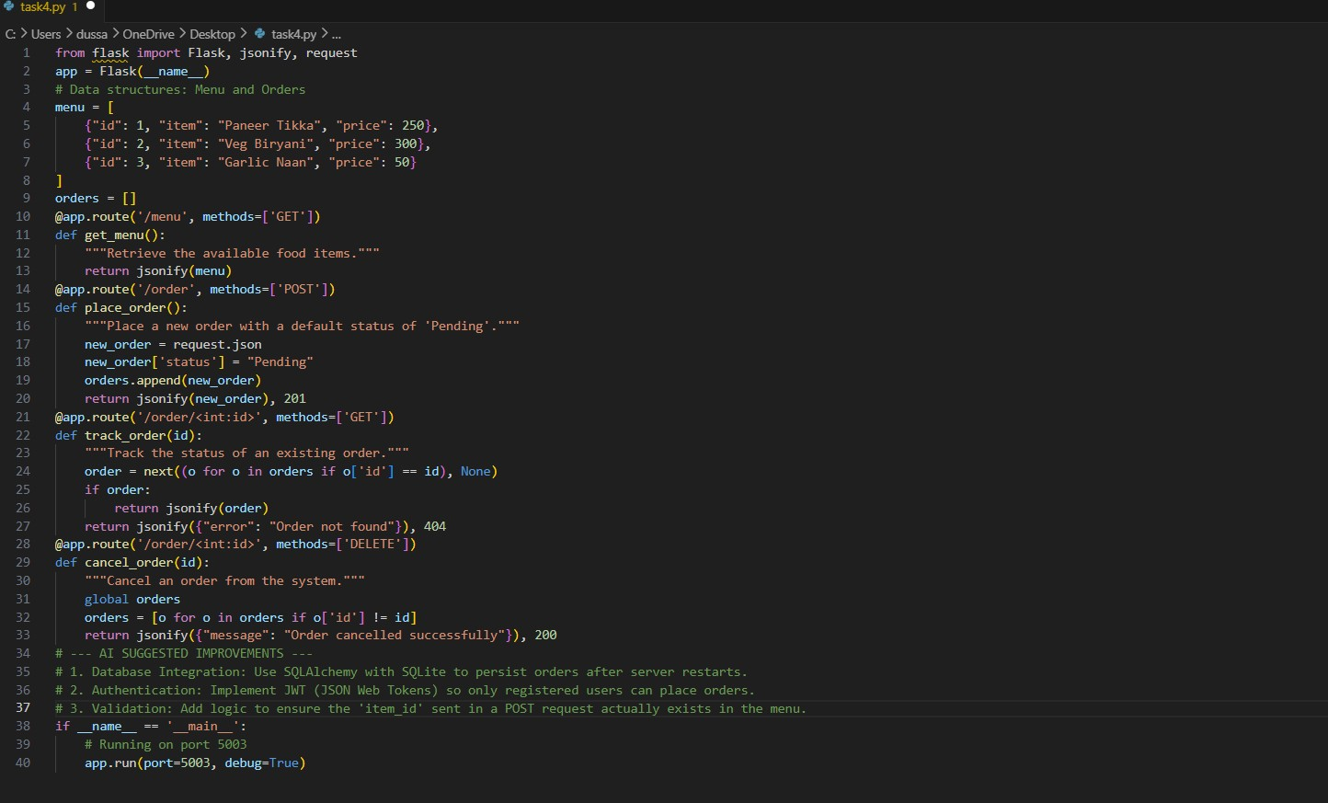
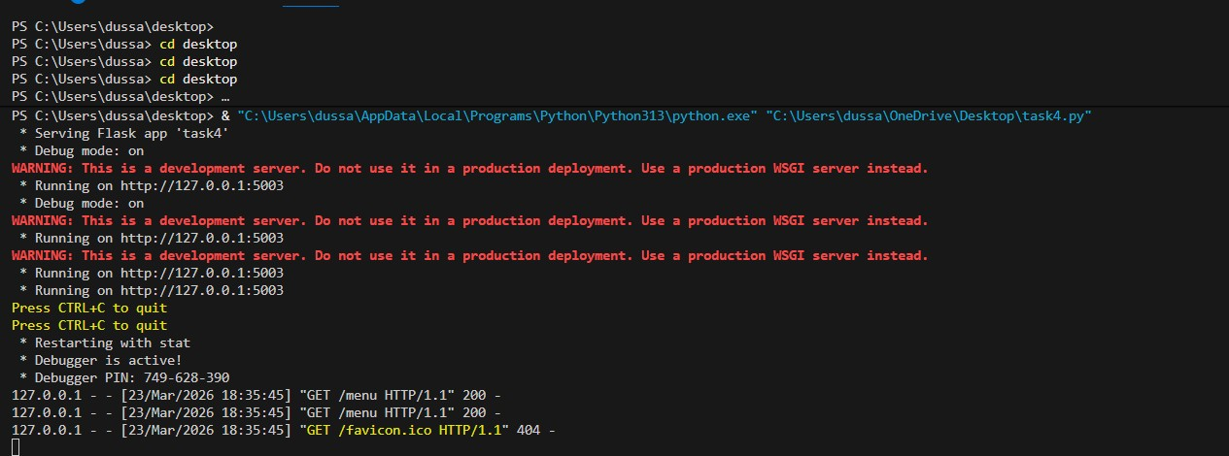

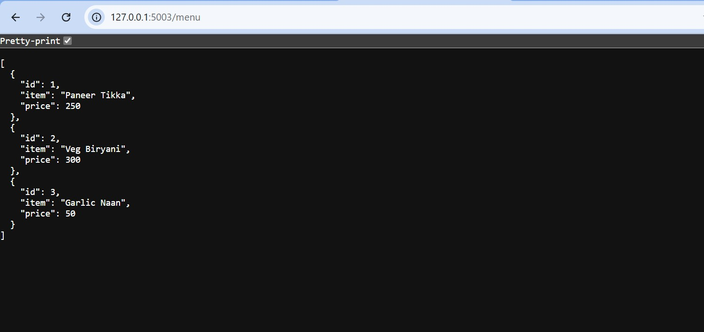

Analysis of Results
- Success: The API manages a dynamic workflow where a user first views a static list (/menu) and then generates a dynamic resource (/order).
- Logic: The "Pending" status is hardcoded in the POST method. This represents a "State Machine" where the status would normally be updated by a kitchen-side app using a PATCH request.
- AI Enhancement: The suggested improvements (Authentication and Validation) address the primary security risks of an open API, ensuring that only valid data enters the system.

