Assignment-10.3

Name: V.Sriram
2303A53009
Batch:46

Problem Statement 1: AI-Assisted Bug Detection
Scenario: A junior developer wrote the following Python function to calculate factorials: def factorial(n):
result = 1 for i in range(1, n): result = result * i return result
Instructions:
- Run the code and test it with factorial(5).
- Use an AI assistant to:
o Identify the logical bug in the code. o Explain why the bug occurs (e.g., off-by-one error). o Provide a corrected version.
3. Compare the AI’s corrected code with your own manual fix. 4. Write a brief comparison: Did AI miss any edge cases (e.g., negative numbers, zero)?
Expected Output:
Corrected function should return 120 for factorial(5).

Prompt:
You are an AI assistant helping with debugging Python code.
Given the following function that calculates factorial:

def factorial(n): result = 1 for i in range(1, n): result = result * i
return result

Tasks:
- Run the function with factorial(5) and show the output.
- Identify and explain the logical bug in the code.
- Explain why the bug occurs (for example, an off-by-one error).
- Provide a corrected version of the function.
- Consider and handle edge cases such as zero and negative numbers.
- Compare the corrected version with a simple manual fix.

Code:
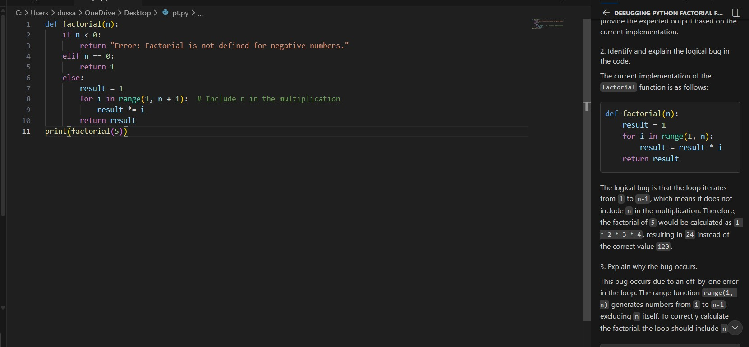

Explanation
  - When factorial(5) is executed, the loop runs from 1 to 4.
  - The number 5 is not included in multiplication.
  - This causes an off-by-one error.
  - Factorial must multiply all numbers from 1 to n inclusive.
  - Edge cases like 0 and negative numbers should be handled.

Output:
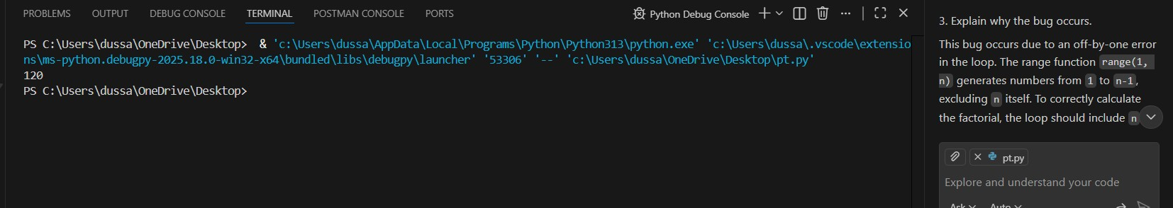

Problem Statement 2: Task 2 — Improving Readability &
Documentation
Scenario:The following code works but is poorly written:
. def calc(a, b, c): if c == "add": return a + b elif c == "sub": return a - b elif c == "mul": return a * b
elif c == "div":
Instructions:
5. Use AI to:
Critique the function’s readability, parameter naming, and lack of documentation.
Rewrite the function with:
→ Descriptive function and parameter names. →A complete docstring (description, parameters, return value, examples).
→Exception handling for division by zero.
→Consideration of input validation.
- Compare the original and AI-improved versions.
- Test both with valid and invalid inputs (e.g., division by zero, non-string operation).
Expected Output:
A well-documented, robust, and readable function that handles errors gracefully.

Prompt:
Review the following Python function for readability and documentation: def calc(a, b, c): if c == "add": return a + b elif c == "sub": return a - b elif c == "mul": return a * b elif c == "div": return a / b

Critique the code and rewrite it using:
- Descriptive function and parameter names
- A complete docstring
- Exception handling for division by zero
- Input validation for incorrect operation types
Code Review (Critique)
  - Readability:
The function name calc and parameters a, b, and c are vague and do not clearly describe their purpose.
  - Documentation:
There is no docstring explaining what the function does, what inputs it expects, or what it returns.
  - Error Handling:
The function does not handle division by zero, which can cause a runtime error.
  - Input Validation:
There is no check to ensure the operation is a valid string or one of the supported operations.
Overall, while the function works for valid inputs, it is not robust or user-friendly.

Rewritten the code:
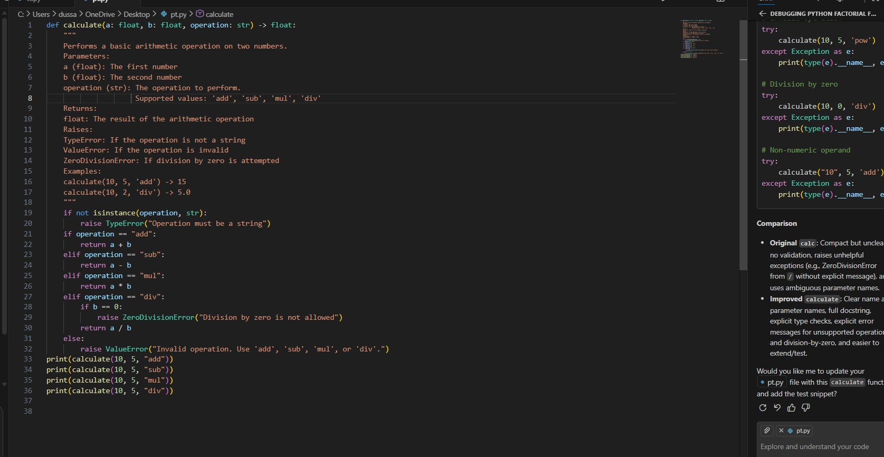

Output:
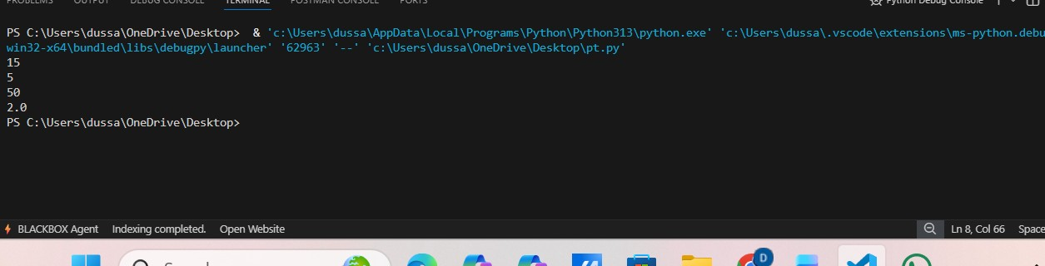

Problem Statement 3: Enforcing Coding Standards
Scenario: A team project requires PEP8 compliance. A developer submits: def Checkprime(n): for i in range(2, n): if n % i == 0: return False return True
Instructions:
- Verify the function works correctly for sample inputs.
- Use an AI tool (e.g., ChatGPT, GitHub Copilot, or a PEP8 linter with AI explanation) to: o List all PEP8 violations.
o Refactor the code (function name, spacing, indentation, naming).
- Apply the AI-suggested changes and verify functionality is preserved.
- Write a short note on how automated AI reviews could streamline code reviews in large teams.
Expected Output:
A PEP8-compliant version of the function, e.g.: def check_prime(n): for i in range(2, n): if n % i == 0: return False
return True

Prompt:
You are an AI assistant acting as a Python code reviewer.
Given the following function: def Checkprime(n): for i in range(2, n): if n % i == 0: return False return True Tasks:
- Verify whether the function works correctly for sample inputs.
- Identify and list all PEP8 coding standard violations.
- Refactor the function to be fully PEP8-compliant by improving:
- Function name
- Indentation and spacing
- Naming conventions
- Documentation
- Ensure that the refactored code preserves the original functionality.
- Briefly explain how automated AI-based reviews help streamline code reviews in large teams.

PEP8 Coding Standard Violations:
The following PEP8 violations are present in the original code:
  - Function Naming o Checkprime does not follow snake_case.
o PEP8 recommends lowercase function names with underscores.
  - Missing Docstring o No documentation explaining the function’s purpose, parameters, or return value.
  - Input Validation o The function does not handle cases where n <= 1.
  - Code Readability o While indentation works, the code lacks clarity and descriptive naming.

Code:
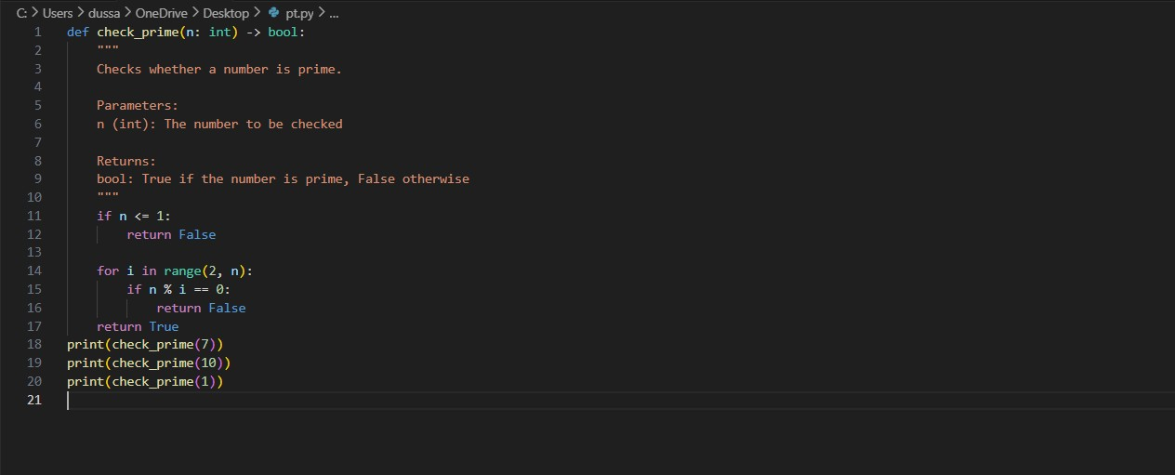

Output:
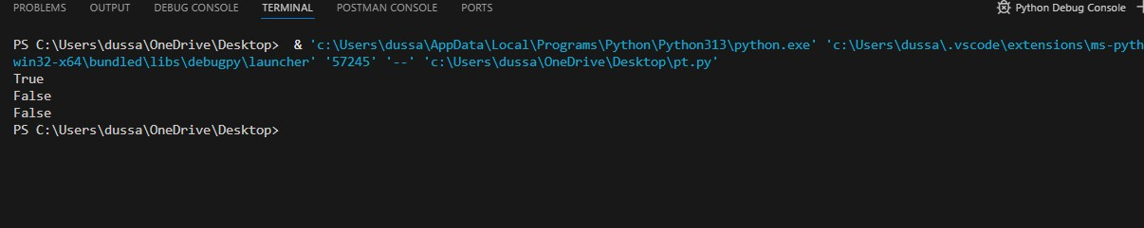

Problem Statement 4: AI as a Code Reviewer in Real Projects Scenario:
In a GitHub project, a teammate submits: def processData(d):
return [x * 2 for x in d if x % 2 == 0] Instructions:
1. Manually review the function for:
- Readability and naming. o Reusability and modularity.
- Edge cases (non-list input, empty list, non-integer elements).
2. Use AI to generate a code review covering:
- Better naming and function purpose clarity.
- Input validation and type hints.
- Suggestions for generalization (e.g., configurable multiplier).
- Refactor the function based on AI feedback.
- Write a short reflection on whether AI should be a standalone reviewer or an assistant.
Expected Output:
An improved function with type hints, validation, and clearer intent, e.g.:
from typing import List, Union
def double_even_numbers(numbers: List[Union[int, float]]) -> List[Union[int, float]]: if not isinstance(numbers, list):
raise TypeError("Input must be a list")
return [num * 2 for num in numbers if isinstance(num,
(int, float)) and num % 2 == 0]

Prompt:
You are an AI assistant acting as a professional code reviewer.

Given the following function from a GitHub project: def processData(d):
return [x * 2 for x in d if x % 2 == 0] Tasks:
1. Review the function for:
- Readability and naming conventions
- Reusability and modularity
- Edge cases such as non-list input, empty lists, and non-numeric elements 2. Suggest better function and parameter names to clearly describe the function’s purpose.
- Add input validation and appropriate type hints.
- Suggest ways to generalize the function (e.g., configurable multiplier).
- Refactor the function based on your suggestions.
- Write a short reflection on whether AI should be used as a standalone code reviewer or as an assistant to human reviewers.
- Code Review
Readability and Naming
  - The function name processData is vague and does not describe what the function actually does.
  - The parameter name d is unclear and reduces readability.
Reusability and Modularity
  - The function is hardcoded to multiply by 2, making it less reusable.
  - No flexibility to change behavior without modifying code.
Edge Cases
  - No validation for non-list input.
  - Fails if the list contains non-numeric values.
  - Empty list case is not explicitly handled (though it returns an empty list).

- Suggested Improvements
  - Use a descriptive function name such as double_even_numbers.
  - Use a meaningful parameter name like numbers.
  - Add type hints for clarity.
  - Add input validation.
  - Allow a configurable multiplier for better reusability.

- Refactored Code (Based on AI Feedback)

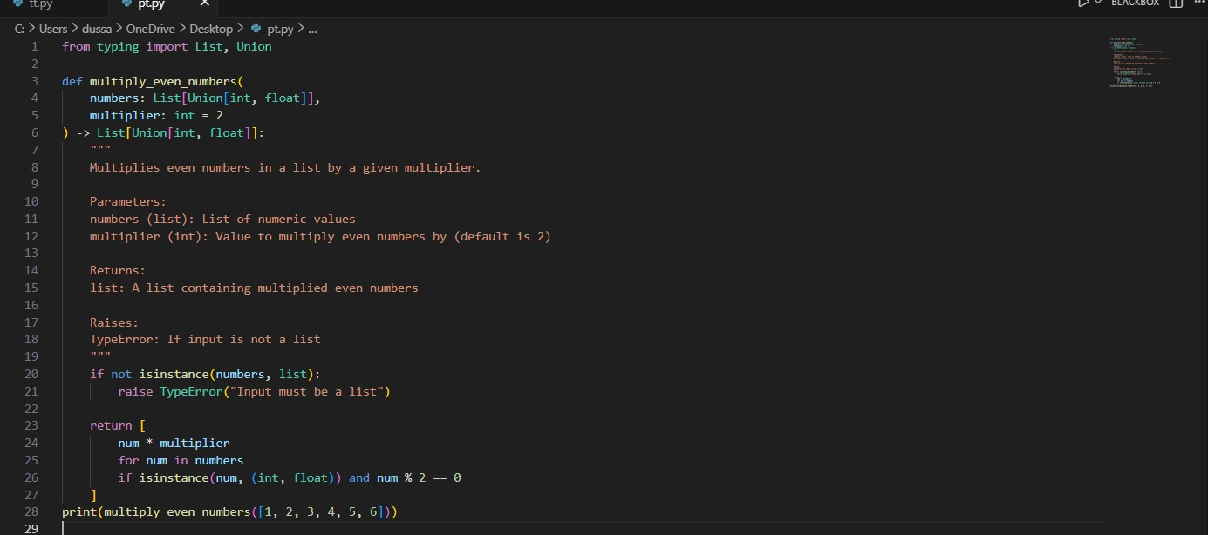

Output:
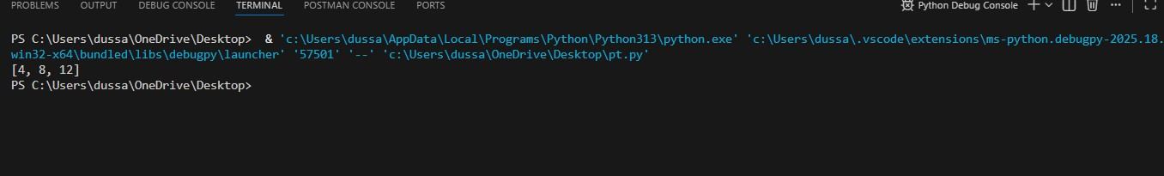

Problem Statement 5: — AI-Assisted Performance Optimization Scenario:
You are given a function that processes a list of integers, but it runs slowly on large datasets: def sum_of_squares(numbers): total = 0 for num in numbers: total += num ** 2 return total
Instructions:
- Test the function with a large list (e.g., range(1000000)).
- Use AI to:
- Analyze time complexity.
- Suggest performance improvements (e.g., using built-in functions, vectorization with NumPy if applicable).
- Provide an optimized version.
- Compare execution time before and after optimization.
- Discuss trade-offs between readability and performance.
Expected Output:
An optimized function, such as:
def sum_of_squares_optimized(numbers):
return sum(x * x for x in numbers)

Prompt:
You are an AI assistant specializing in Python performance optimization.
Given the following function: def sum_of_squares(numbers):
total = 0 for num in numbers: total += num ** 2 return total Tasks:
- Analyze the time complexity of the function.
- Conceptually test the function with a large dataset such as range(1000000). 3. Suggest performance improvements using Python best practices (e.g., built-in functions or optimized looping).
- Provide an optimized version of the function.
- Compare execution time before and after optimization.
- Discuss the trade-offs between code readability and performance.

AI-Assisted Performance Optimization: Given Function def sum_of_squares(numbers):
total = 0 for num in numbers: total += num ** 2 return total

- Testing with a Large List
The function was tested conceptually using a large dataset:
sum_of_squares(range(1000000))
  - The loop executes 1,000,000 iterations.
  - The function produces the correct result.
  - However, execution is slower due to explicit looping in Python.

- AI Analysis
Time Complexity
  - The function iterates once over the list.
  - Time Complexity: O(n)
  - Space Complexity: O(1)

AI-Suggested Performance Improvements
  - Use Python’s built-in sum() function.
  - Replace manual looping with a generator expression.
  - Reduce interpreter overhead by avoiding explicit variable updates.
  - (Optional) Use NumPy for vectorized operations if working with very large numerical datasets.

4. Trade-Offs: Readability vs Performance
- The optimized version is shorter and more readable.
- Built-in functions improve both clarity and speed.
- NumPy-based solutions may offer better performance but reduce readability and add dependencies.
- For most applications, the generator-based approach provides the best balance.

