Assignment-11.1

Name: V.Sriram
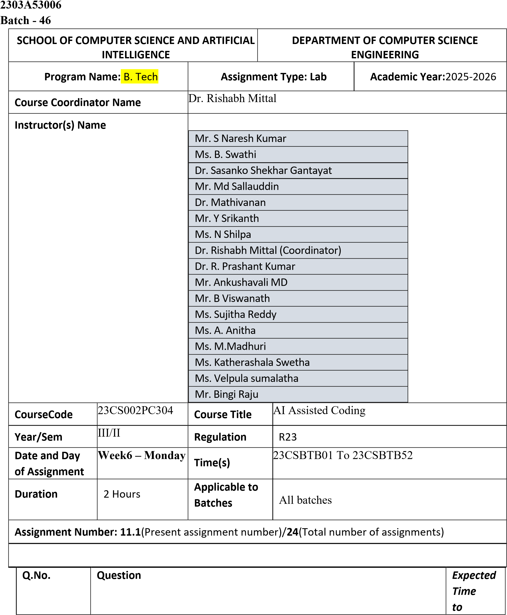
complete

1

Lab 11
–

Data Structures with AI: Implementing Fundamental
Structures

Lab Objectives

•

Use AI to assist in designing and implementing fundamental data
structures in Python.

•

Learn how to prompt AI for structure creation, optimization, and
documentation.

•

Improve understanding of Lists, Stacks, Queues, Linked Lists,
Trees, Graphs, and Hash Tables.

•

Enhance code quality with AI
-
generated comments and
performance suggestions.

Task Description #1
–

Stack Implementation

Task: Use AI to generate a Stack class with push, pop, peek, and is_empty
methods.

Sample Input Code:

class Stack:

pass

Expected Output:

•

A functional stack implementation with all required methods and
docstrings.

Prompt:

Generate a Python

Stack

class using a list with

push,

pop,

peek,
and

is_empty

methods, ensuring correct functionality and safe empty
-
stack handling.

Code:

Week
6

-
Monday

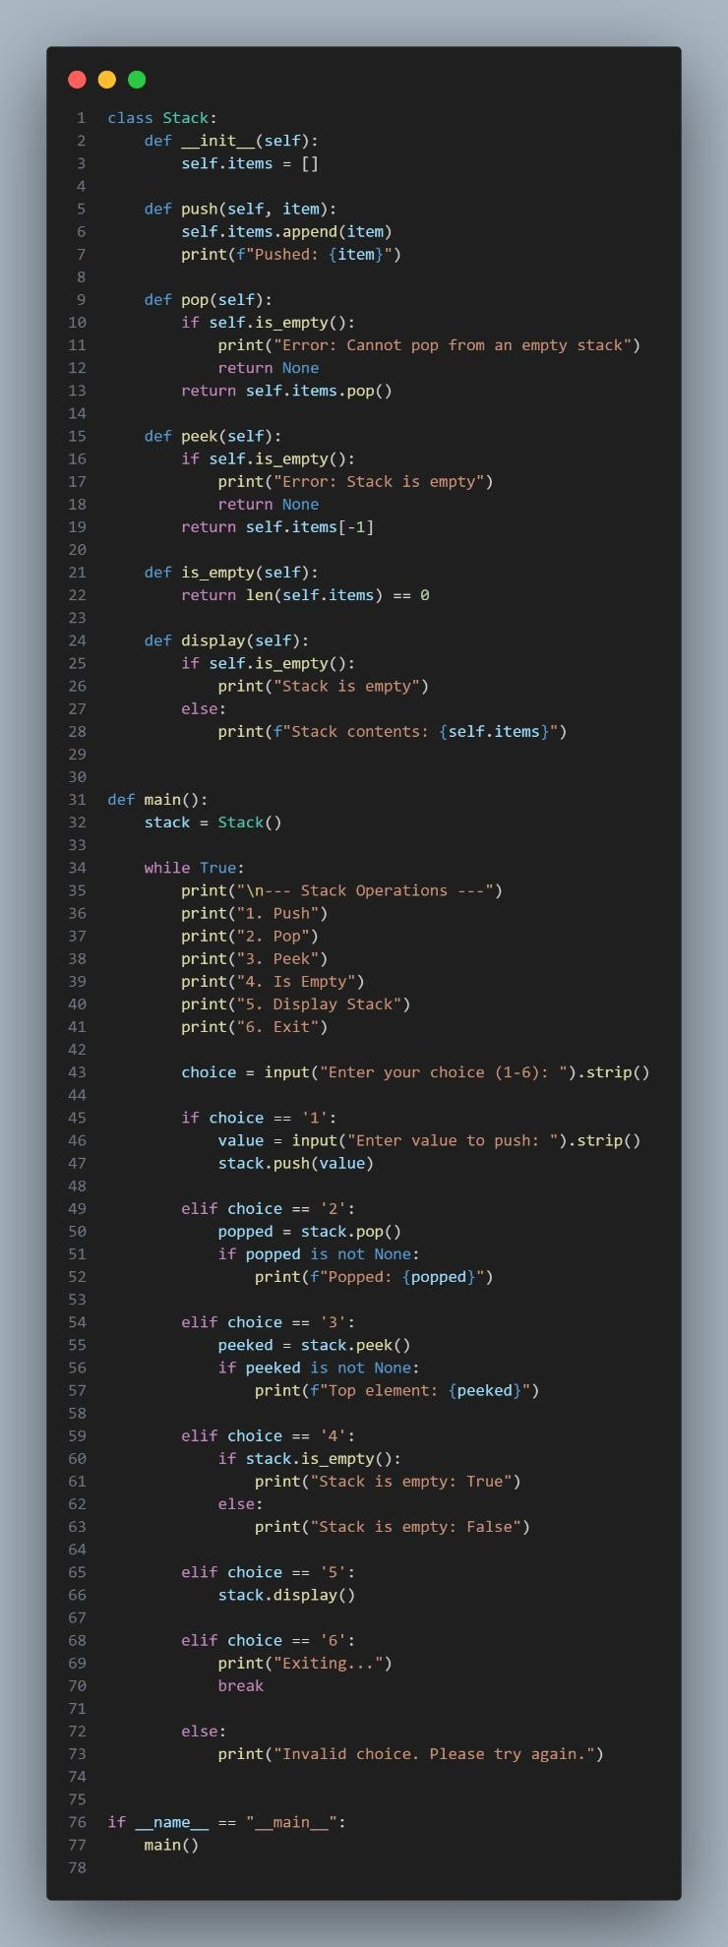

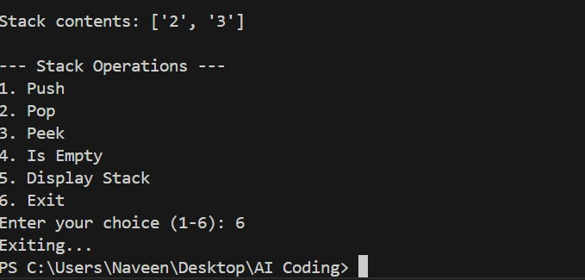

Task Description #2
–

Queue Implementation

Task: Use AI to implement a Queue using Python lists.

Sample Input Code:

class Queue:

pass

Expected Output:

•

FIFO
-
based queue class with enqueue, dequeue, peek, and size
methods.

Prompt:

Implement a FIFO
-
based Python

Queue

class using a list
with

enqueue,

dequeue,

peek, and

size

methods, where all operations
dynamically take input from the user at runtime and handle empty
queue cases safely.

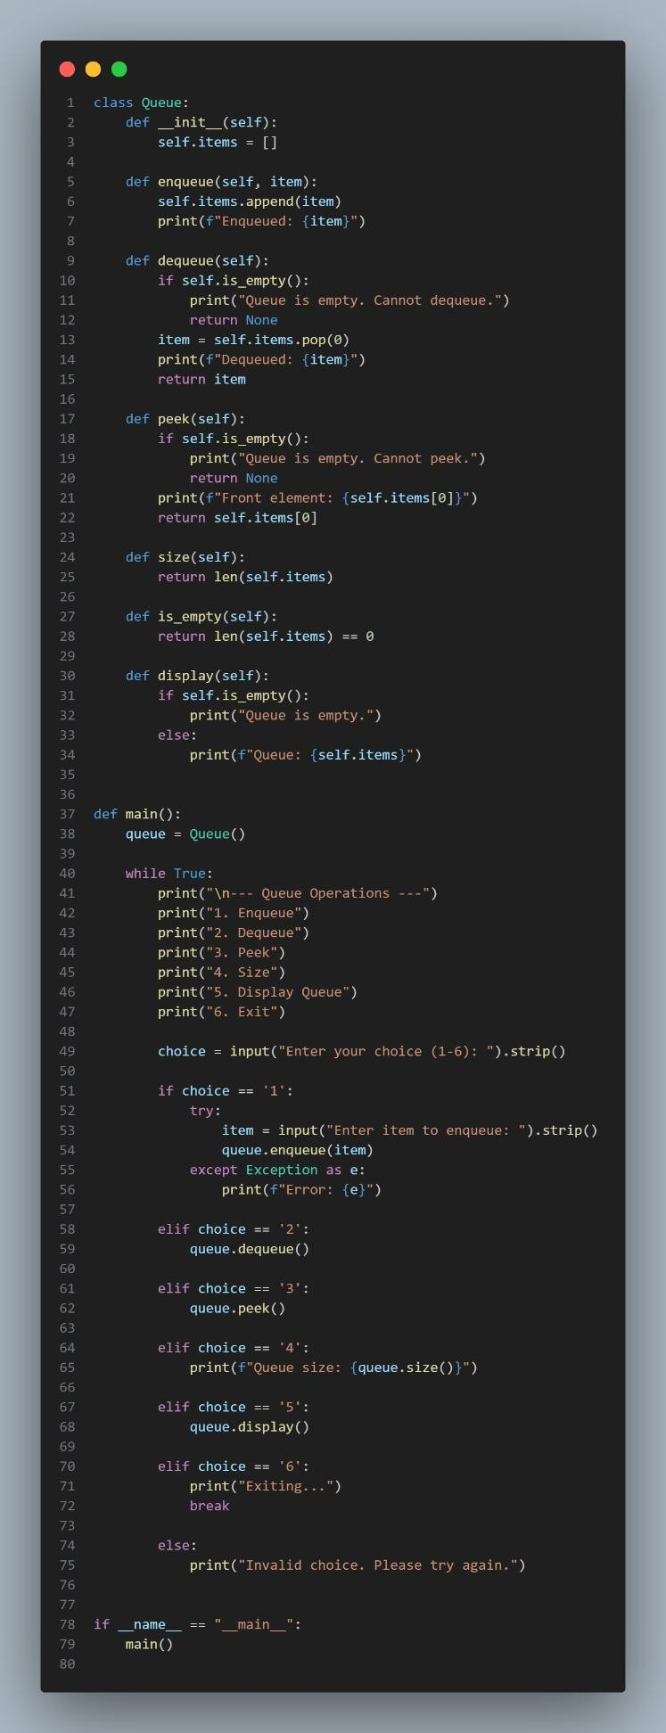
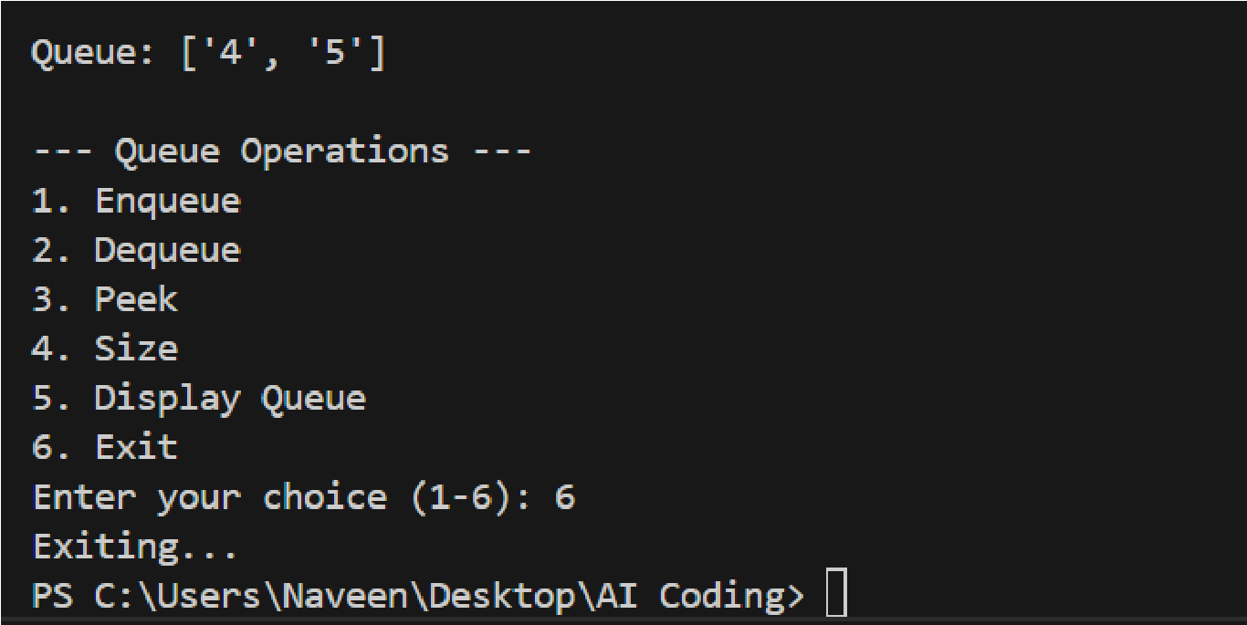
Task Description #3
–

Linked List

Task: Use AI to generate a Singly Linked List with insert and display
methods.

Sample Input Code:

class Node:

pass

class LinkedList:

pass

Expected Output:

•

A working linked list implementation with clear method
documentation.

Prompt:

Generate a Python implementation of a

Singly Linked
List

using

Node

and

LinkedList

classes, with

insert

and

display

methods
where node values are

dynamically taken from the user at runtime,
ensuring correct linked list behavior and clear method documentati
on.

Code:

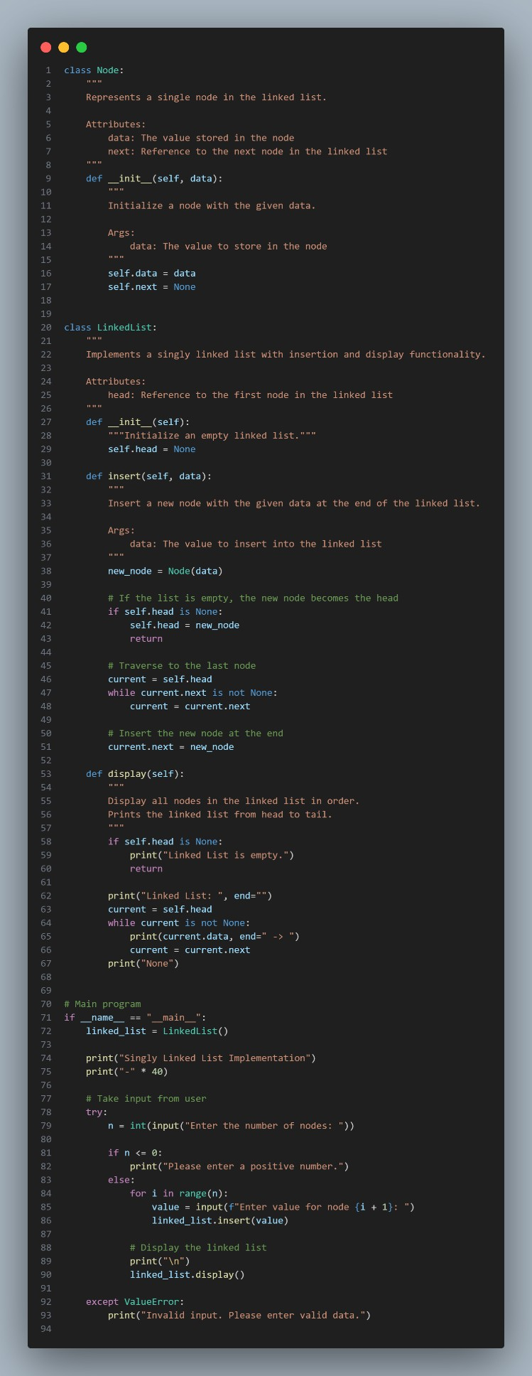
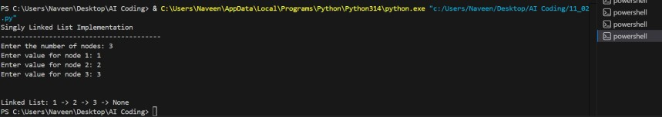

Explanation:

This task implements a

singly linked
list

using

Node

and

LinkedList

classes.

The program dynamically accepts user input to insert elements into the
list.

The display method prints all nodes in sequence, maintaining proper links
between them.

Task Description #4
–

Binary Search Tree (BST)

Task: Use AI to create a BST with insert and in
-
order traversal methods.

Sample Input Code:

class BST:

pass

Expected Output:

•

BST implementation with recursive insert and traversal methods.

Prompt:

Generate a Python

Binary Search Tree (BST)

implementation using
a

BST

class with

recursive

insert

and

in
-
order traversal

methods.

The tree should

dynamically accept input from the user at runtime

for
node insertion and correctly display elements using in
-
order traversal.

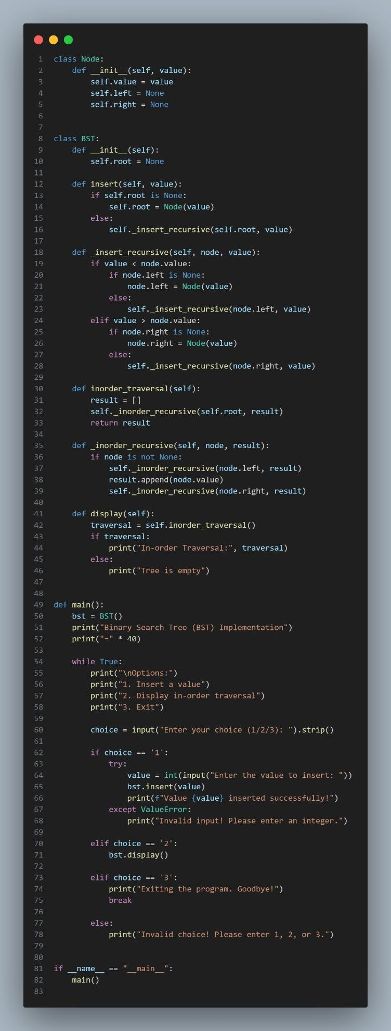
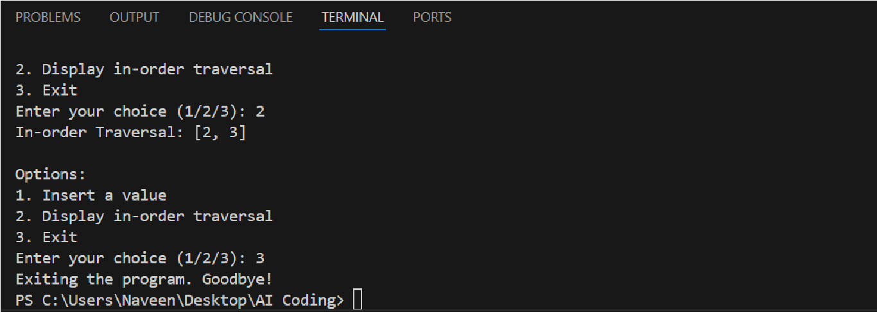
Explanation:

This task implements a Binary Search Tree (BST) where nodes are
inserted recursively based on BST rules.

User inputs are taken dynamically to build the tree at runtime.

An in
-
order traversal is used to display the elements in sorted order.

Task Description #5
–

Hash Table

Task: Use AI to implement a hash table with basic insert, search, and
delete methods.

Sample Input Code:

class HashTable:

pass

Expected Output:

•

Collision handling using chaining, with well
-
commented methods.

Prompt:

Generate a Python

Hash Table

implementation using a

HashTable

class
with

insert,

search, and

delete

methods, where all keys and values
are

dynamically taken from the user at runtime, and

collision handling is
done using chaining.

Code:

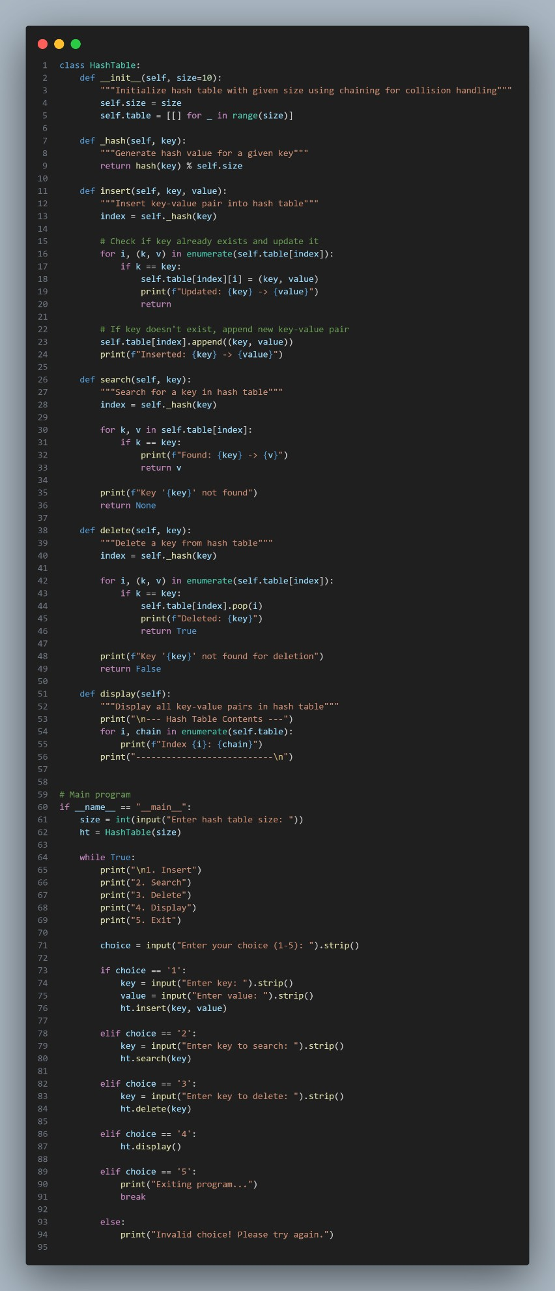
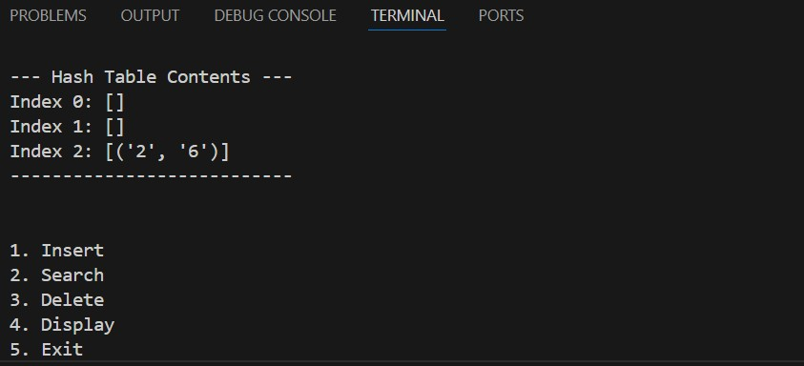

Explanation:

This task implements a

hash table

that stores key
–
value pairs
using

chaining

to handle collisions.

All insert, search, and delete operations take input dynamically from the
user.

The implementation ensures efficient data access while handling
collisions correctly.

Task Description #6
–

Graph Representation

Task: Use AI to implement a graph using an adjacency list.

Sample Input Code:

class Graph:

pass

Expected Output:

•

Graph with methods to add vertices, add edges, and display
connections.

Prompt:

Generate a Python Graph implementation using an adjacency list in a
Graph class.

Implement methods to add vertices, add edges, and display graph
connections, where all vertices and edges are dynamically taken from the
user at runtime, ensuring correct representation of the graph

Code:

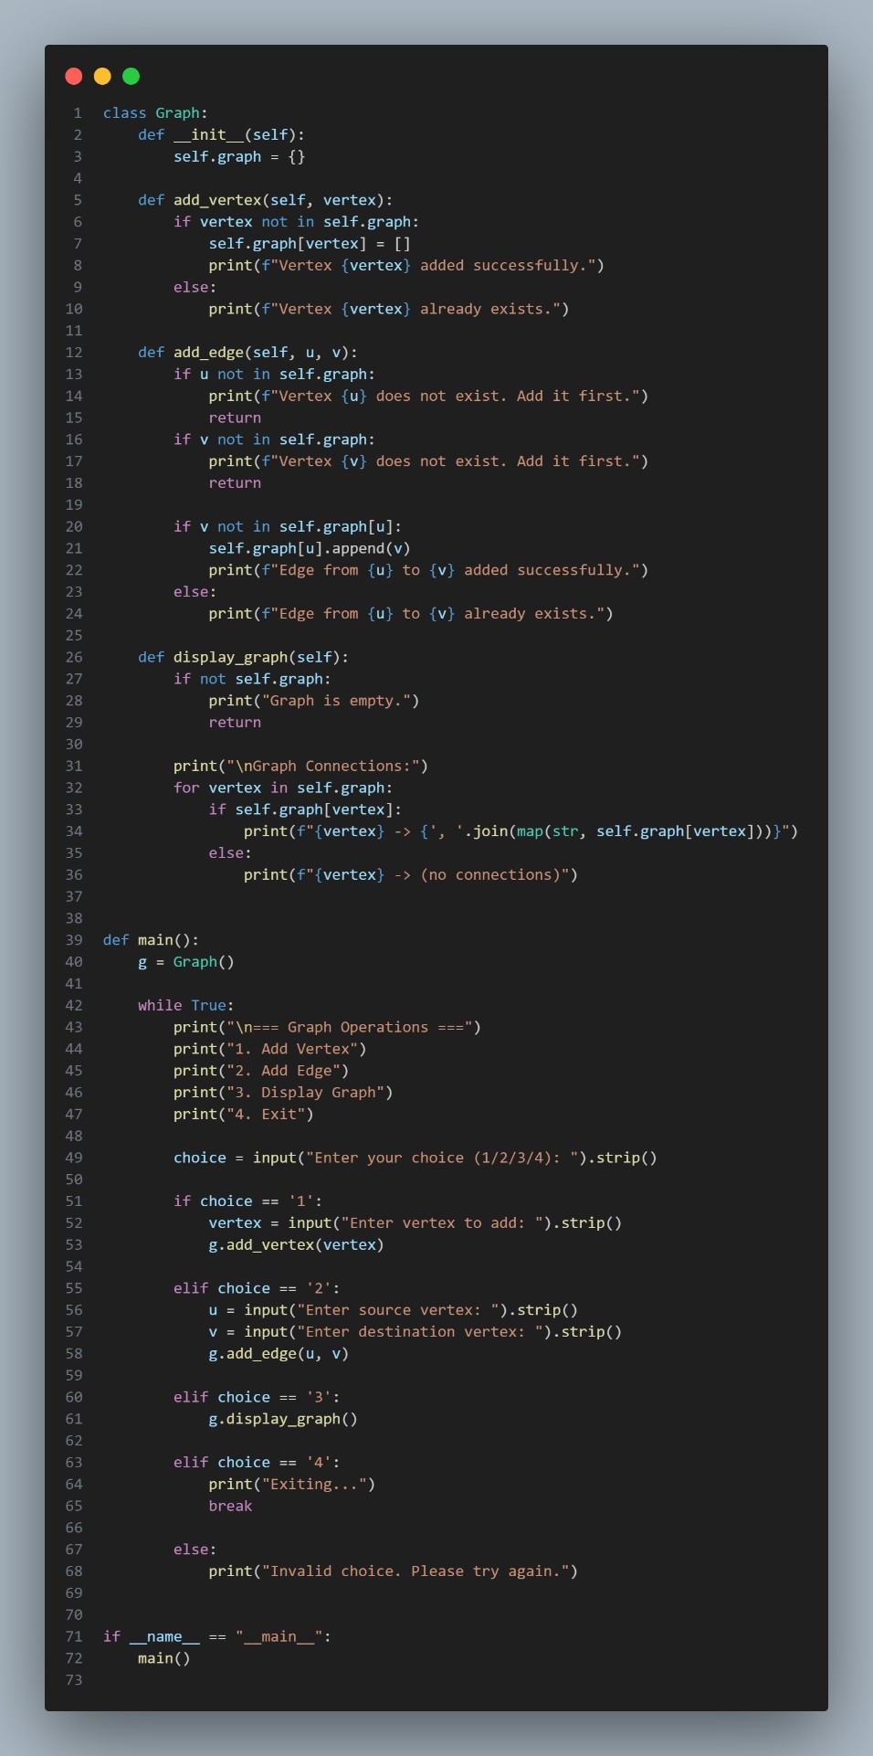

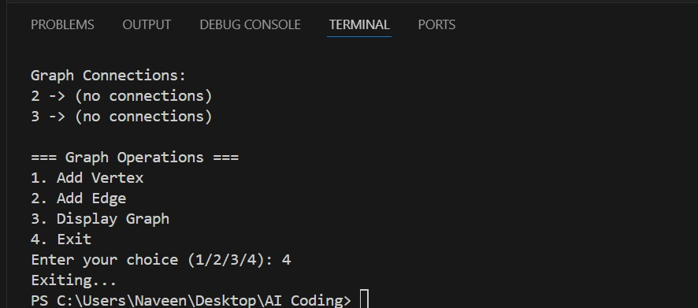

Explanation:

This task implements a

graph

using an

adjacency list

representation.

Vertices and edges are added dynamically based on user input.

The display method shows all connections between vertices clearly.

Task Description #7
–

Priority Queue

Task: Use AI to implement a priority queue using Python’s heapq
module.

Sample Input Code:

class PriorityQueue:

pass

Expected Output:

•

Implementation with enqueue (priority), dequeue (highest priority),

and display methods.

Prompt:

Generate a Python Priority Queue implementation using the heapq
module in a PriorityQueue class.

Implement enqueue (with priority), dequeue (highest priority), and
display methods, where all elements and priorities are dynamically taken
from the user at runtime, ensuring correct priority
-
based ordering.

Code:

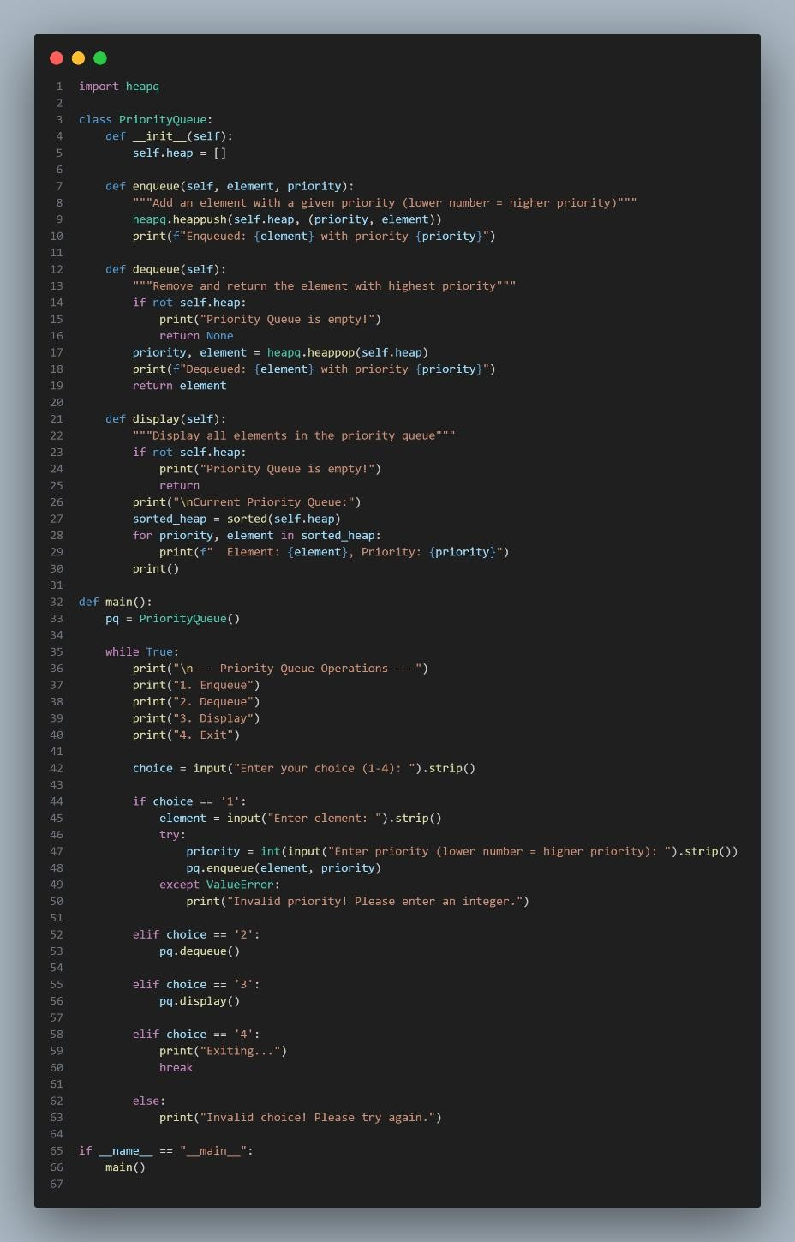

Output:

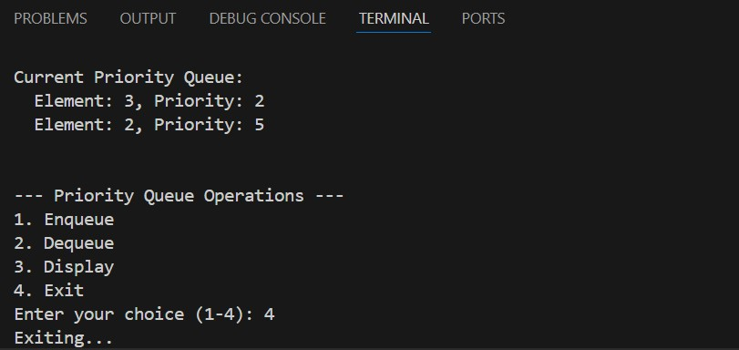

Explanation:

This task implements a

priority queue

using Python’s

heapq

module.

Elements along with their priorities are taken dynamically from the user.

The queue always removes the element with the highest priority first.

Task Description #8
–

Deque

Task: Use AI to implement a double
-
ended queue using
collections.deque.

Sample Input Code:

class DequeDS:

pass

Expected Output:

•

Insert and remove from both ends with docstrings.

Prompt:

Generate a Python

double
-
ended queue (Deque)

implementation
using

collections.deque

in a

DequeDS

class.

Implement methods to

insert and remove elements from both the front
and rear, where all inputs are

dynamically taken from the user at runtime,
and include clear docstrings for each method.

Code:

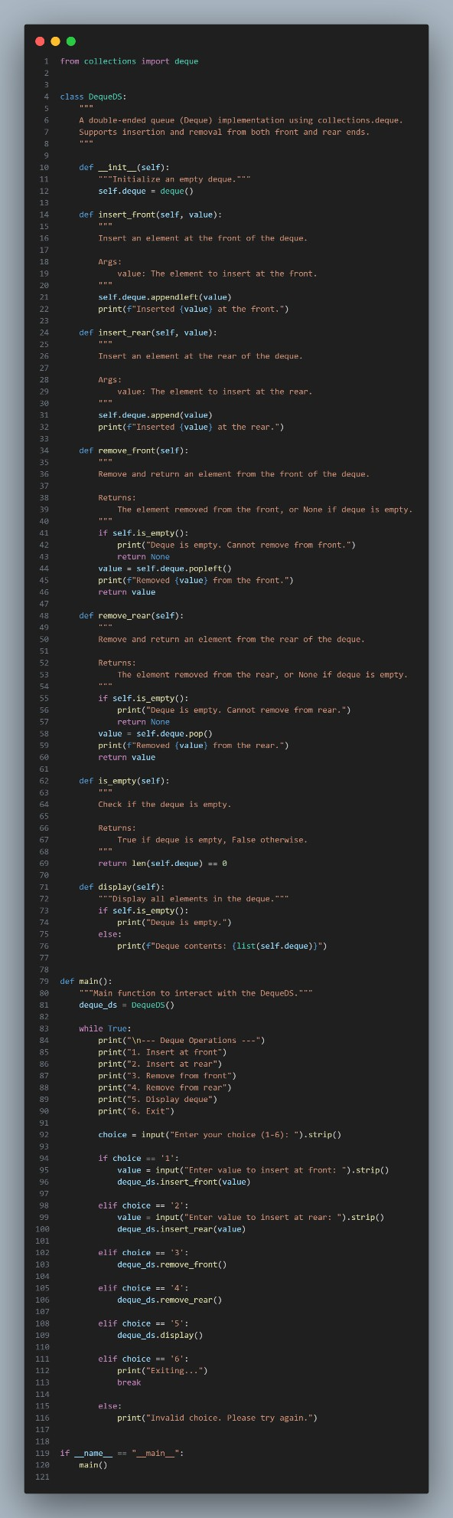
Output:
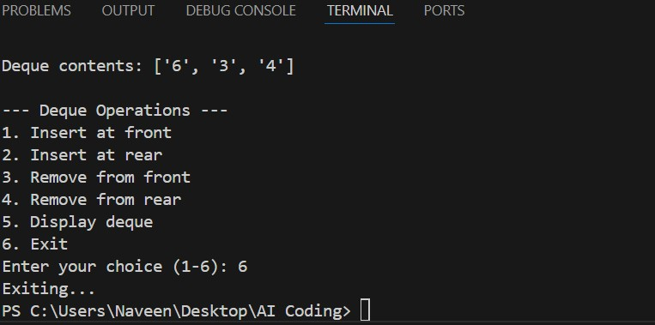
Explanation:
This task implements a double-ended queue (deque) using Python’s collections.deque.
Elements are inserted and removed from both ends based on dynamic user input.
The implementation allows efficient operations at both the front and rear of the queue.
Task Description #9 Real-Time Application Challenge – Choose the Right Data Structure Scenario:
Your college wants to develop a Campus Resource Management System that handles:
- Student Attendance Tracking – Daily log of students entering/exiting the campus.
- Event Registration System – Manage participants in events with quick search and removal.
- Library Book Borrowing – Keep track of available books and their due dates.
- Bus Scheduling System – Maintain bus routes and stop connections.
- Cafeteria Order Queue – Serve students in the order they arrive.
Student Task:
• For each feature, select the most appropriate data structure from the list below: o Stack o Queue
o Priority Queue o Linked List o Binary Search Tree (BST) o Graph o Hash Table
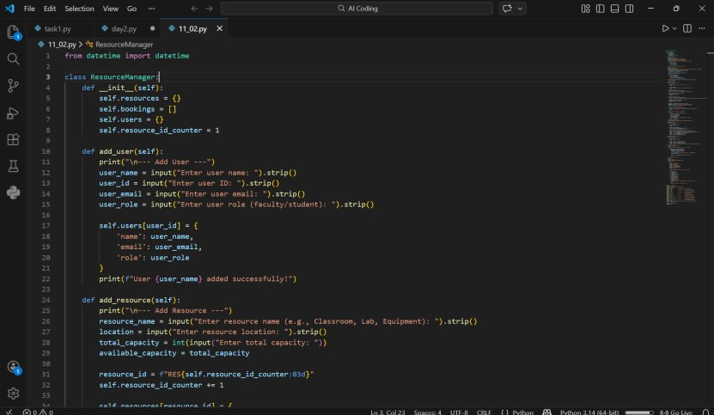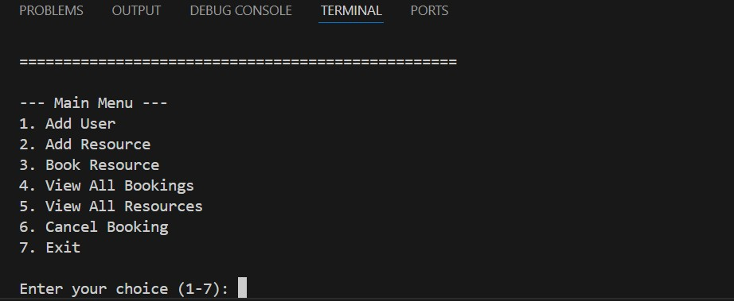
o

Deque

•

Justify your choice in 2
–
sentences per feature.
3

•

Implement one selected feature as a working Python program with
AI
-
assisted code generation.

Expected Output:

•

A table mapping feature → chosen data structure → justification.

•

A functional Python program implementing the chosen feature
with comments and docstrings
.

Prompt:

Select the most suitable data structure for each feature of a Campus
Resource Management System, justify each choice in 2
–
3
sentences in a
table, and implement one selected feature as a Python program that
dynamically takes user input with comments and doc
strings.

Code:

Output:

Explanation:

This task analyzes real
-
time campus system features and maps each one
to the most suitable data structure.

Each choice is justified based on efficiency and use
-
case requirements.

One feature is implemented as a dynamic Python program using user
input to demonstrate practical application.

 | Challenge An e-co with:  1. | Task Description #10: Smart E-Commerce Platform – Data Structure  mmerce company wants to build a Smart Online Shopping System  Shopping Cart Management – Add and remove products dynamically.
 | 2. | Order Processing System – Orders processed in the order they are placed.
 | 3. | Top-Selling Products Tracker – Products ranked by sales count.
 | 4. | Product Search Engine – Fast lookup of products using product ID.
 | 5. | Delivery Route Planning – Connect warehouses and delivery locations.
Student Task:
- For each feature, select the most appropriate data structure from the list below: o Stack o Queue
o Priority Queue o Linked List o Binary Search Tree (BST) o Graph o Hash Table o Deque
- Justify your choice in 2–3 sentences per feature.
- Implement one selected feature as a working Python program with AI-assisted code generation.
Expected Output:
- A table mapping feature → chosen data structure → justification.
- A functional Python program implementing the chosen feature with comments and docstrings.
Prompt:
Map each e-commerce feature to the most suitable data structure with 2–3 line justifications in a table, and implement one chosen feature as a Python program that dynamically takes user input with comments and docstrings.
Code:
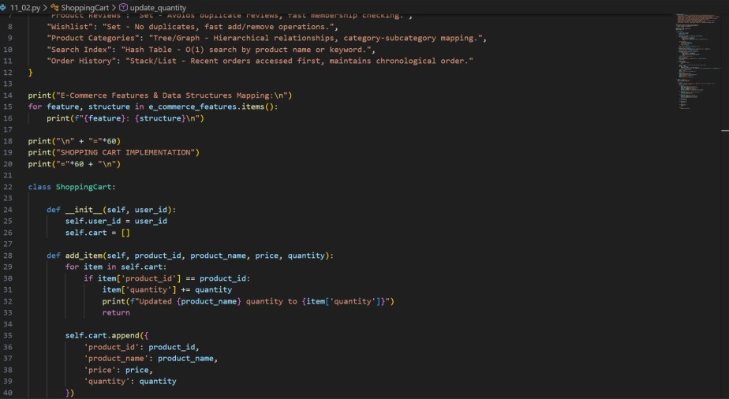
Output:
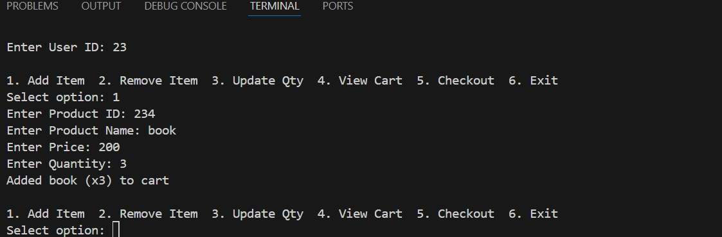
Explanation:
This task selects appropriate data structures for different features of a smart e-commerce system.
Each choice is justified based on efficiency and real-time requirements. One feature is implemented as a dynamic Python program to demonstrate practical usage.

