Lab-8.1

Name: V.Sriram
2303A53009
Batch:46

Lab 8: Test-Driven Development with AI – Generating and Working with Test Cases

Task 1: Password Strength Validator Task
Description

Create a function is_strong_password(password) that returns True if the password meets these rules:
- At least 8 characters
- Contains at least one uppercase letter, one lowercase letter, one digit, and one special character (non-alphanumeric)
- No spaces

Prompt for AI :-

“Generate at least 3 assert test cases for a function is_strong_password(password) that checks password strength according to the rules: minimum length 8, must contain uppercase, lowercase, digit, special character, and no spaces. Include edge cases.”

Code (test cases + implementation)

Python:-
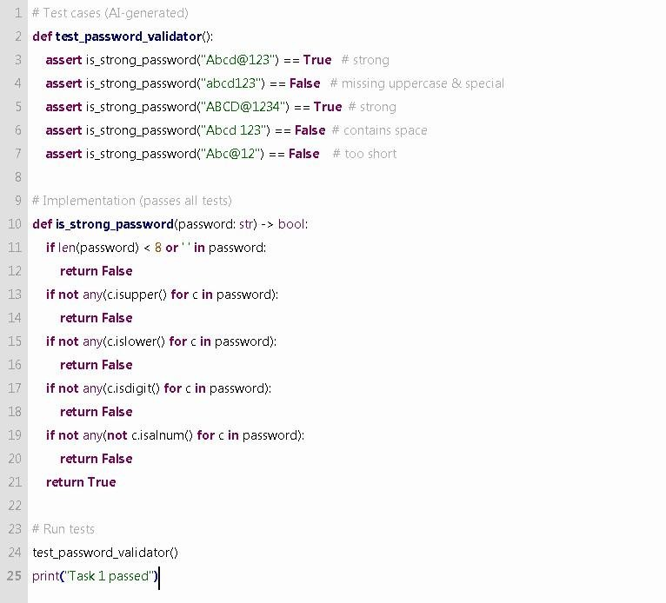

Task 2: Number Classification

Task Description
Write a function classify_number(n) that returns "Positive", "Negative", or "Zero".
- Use loops in the test (e.g., iterate over test cases)
- Handle invalid inputs like strings and None

Prompt for AI (to generate test cases)
“Generate at least 3 assert test cases for a function classify_number(n). The function should return 'Positive', 'Negative', or 'Zero'. Use a loop to test multiple values, including boundary conditions (-1, 0, 1). Also include tests for invalid inputs like strings and None, expecting a TypeError.”

Code (test cases + implementation)
Python:-
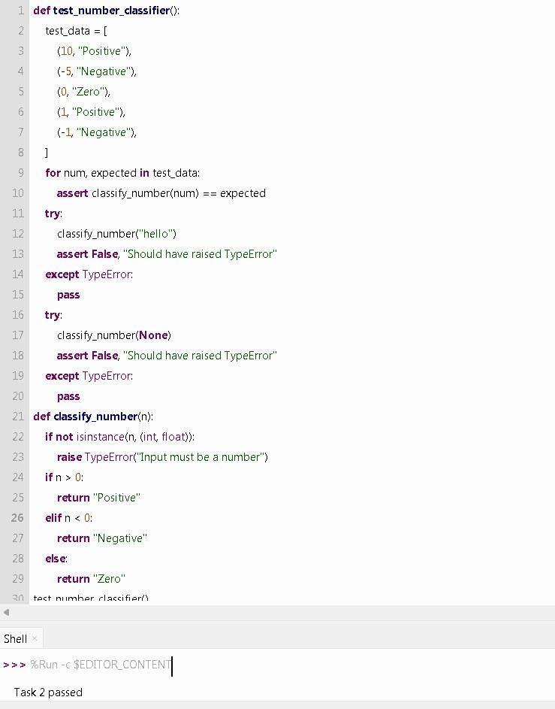

Task 3: Anagram Checker

Task Description
Implement is_anagram(str1, str2) that returns True if the two strings are anagrams.
- Ignore case, spaces, and punctuation
- Handle edge cases like empty strings, identical words
Prompt for AI (to generate test cases)
“Generate at least 3 assert test cases for a function is_anagram(str1, str2). The function should ignore case, spaces, and punctuation. Include edge cases such as empty strings and identical words.”

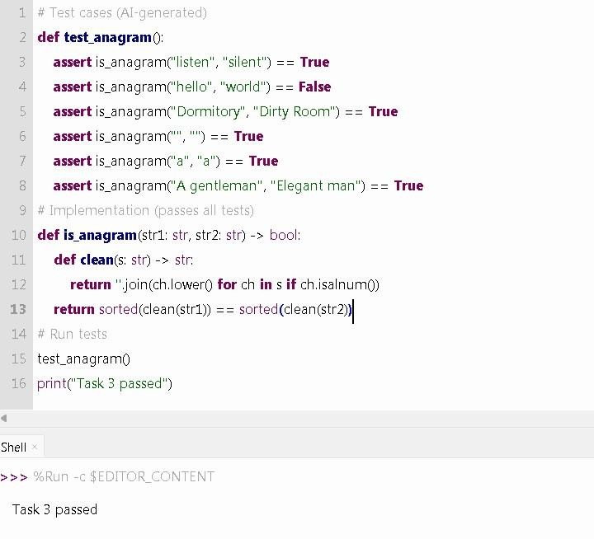

Code

(

test cases + implementation

)

P

ython

:

-

Task 4: Inventory Class

Task Description

Create an Inventory class with methods:
- add_item(name, quantity)
- remove_item(name, quantity)
- get_stock(name)
Prompt for AI (to generate test cases)
“Generate at least 3 assert-based tests for an Inventory class that manages stock. The class should have methods add_item, remove_item, and get_stock. Include tests for adding, removing, and retrieving stock, as well as edge cases like removing more than available or negative quantities.” Code (test cases + implementation)
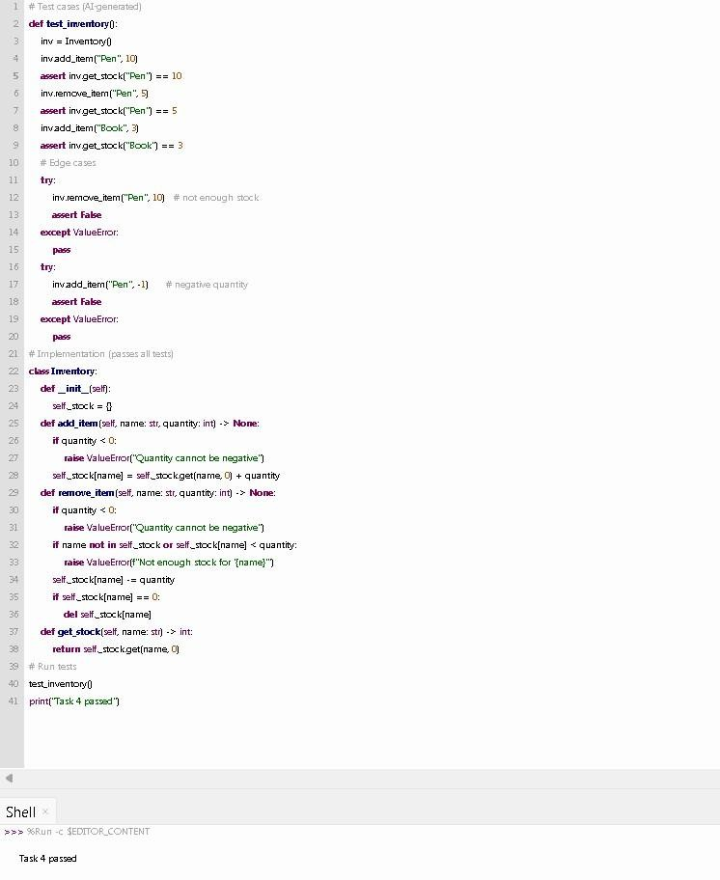
P

ython

:

-

Task 5: Date Validation & Formatting
Task Description:-
Write validate_and_format_date(date_str) that:
- Validates the string in MM/DD/YYYY format
- Returns "Invalid Date" if invalid
- Otherwise returns the date as YYYY-MM-DD
Prompt for AI :-
“Generate at least 3 assert test cases for a function validate_and_format_date(date_str). It should validate dates in MM/DD/YYYY format and convert valid dates to YYYY-MM-DD. Include tests for invalid dates (like Feb 30) and edge cases (leap years, wrong month/day).”

Code (test cases + implementation)
Python:-
