Assignment-13.1

V.Sriram 2303A53009 Batch--46
Suggestions
Lab Objectives:
- Identify code smells and inefficiencies in legacy Python scripts.
- Use AI-assisted coding tools to refactor for readability, maintainability, and performance.
- Apply modern Python best practices while ensuring output correctness.

Task Description #1 (Refactoring – Removing Code Duplication)
- Task: Use AI to refactor a given Python script that contains multiple repeated code blocks.
- Instructions: o Prompt AI to identify duplicate logic and replace it with functions or classes. o Ensure the refactored code maintains the same output.
o Add docstrings to all functions.
- Sample Legacy Code: # Legacy script with repeated logic print("Area of Rectangle:", 5 * 10) print("Perimeter of Rectangle:", 2 * (5 + 10))

print("Area of Rectangle:", 7 * 12) print("Perimeter of Rectangle:", 2 * (7 + 12))

print("Area of Rectangle:", 10 * 15) print("Perimeter of
Rectangle:", 2 * (10 + 15)) ● Expected Output: o
Refactored code with a reusable function and no duplication. PROMPT : Refactor the following Python script to eliminate duplicate logic by creating reusable functions or classes, ensure the output remains unchanged, add proper docstrings to all functions, and return only the final refactored Python code.
SCREENSHOT :

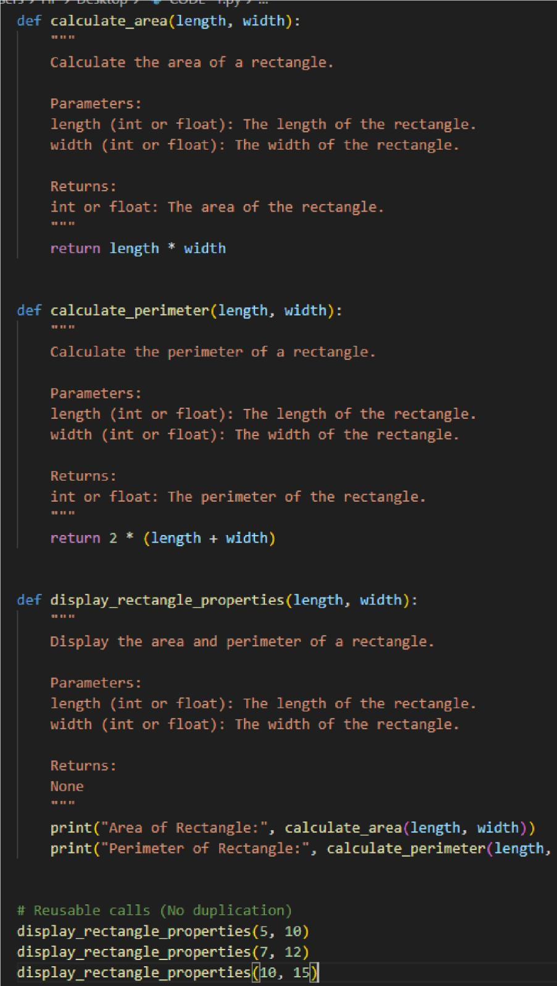
OUTPUT:

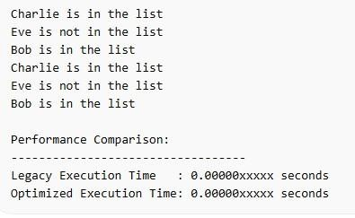

Task Description #2 (Refactoring – Optimizing Loops and
Conditionals)
- Task: Use AI to analyze a Python script with nested loops and complex conditionals.
- Instructions: o Ask AI to suggest algorithmic improvements (e.g., replace nested loops with set lookups or comprehensions).
o Implement changes while keeping logic intact. o Compare execution time before and after refactoring.
- Sample Legacy Code: # Legacy inefficient code names =
["Alice", "Bob", "Charlie", "David"] search_names = ["Charlie", "Eve", "Bob"]

for s in search_names:
found = False for n in names:
if s == n:
found = True if found:
print(f"{s} is in the list") else:
print(f"{s} is not in the list")
● Expected Output:
o Optimized code using set lookups with performance

comparison table.

PROMPT :
Analyze the following Python script containing nested loops and conditionals. Suggest algorithmic improvements (such as replacing nested loops with set lookups or comprehensions), refactor the code while keeping the logic and output unchanged, and compare execution time before and after optimization in a performance table. Return optimized Python code with timing comparison

SCREENSHOT :

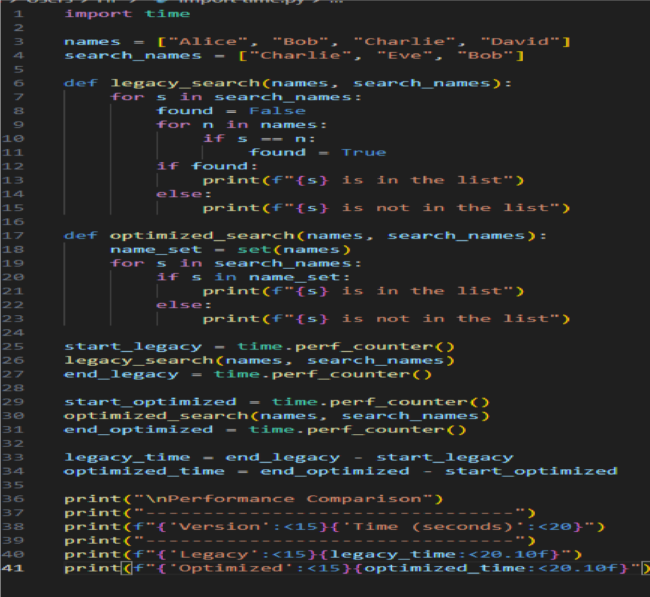
OUTPUT:
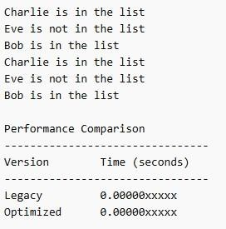

.

Task Description #3 (Refactoring – Extracting Reusable
Functions)
- Task: Use AI to refactor a legacy script where multiple calculations are embedded directly inside the main code block.
- Instructions: o Identify repeated or related logic and extract it into reusable functions.
o Ensure the refactored code is modular, easy to read, and documented with docstrings.
- Sample Legacy Code:
# Legacy script with inline repeated logic price =
250 tax = price * 0.18 total = price + tax print("Total Price:", total)

price = 500 tax = price * 0.18 total = price + tax print("Total Price:", total) ● Expected Output: o Code with a function calculate_total(price) that can be reused for multiple price inputs.
PROMPT : Refactor the following Python script by extracting repeated calculation logic into reusable functions. Ensure the code

is modular, readable, and includes proper docstrings. Maintain the same output and return only the refactored Python code. SCREENSHOT:
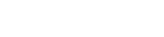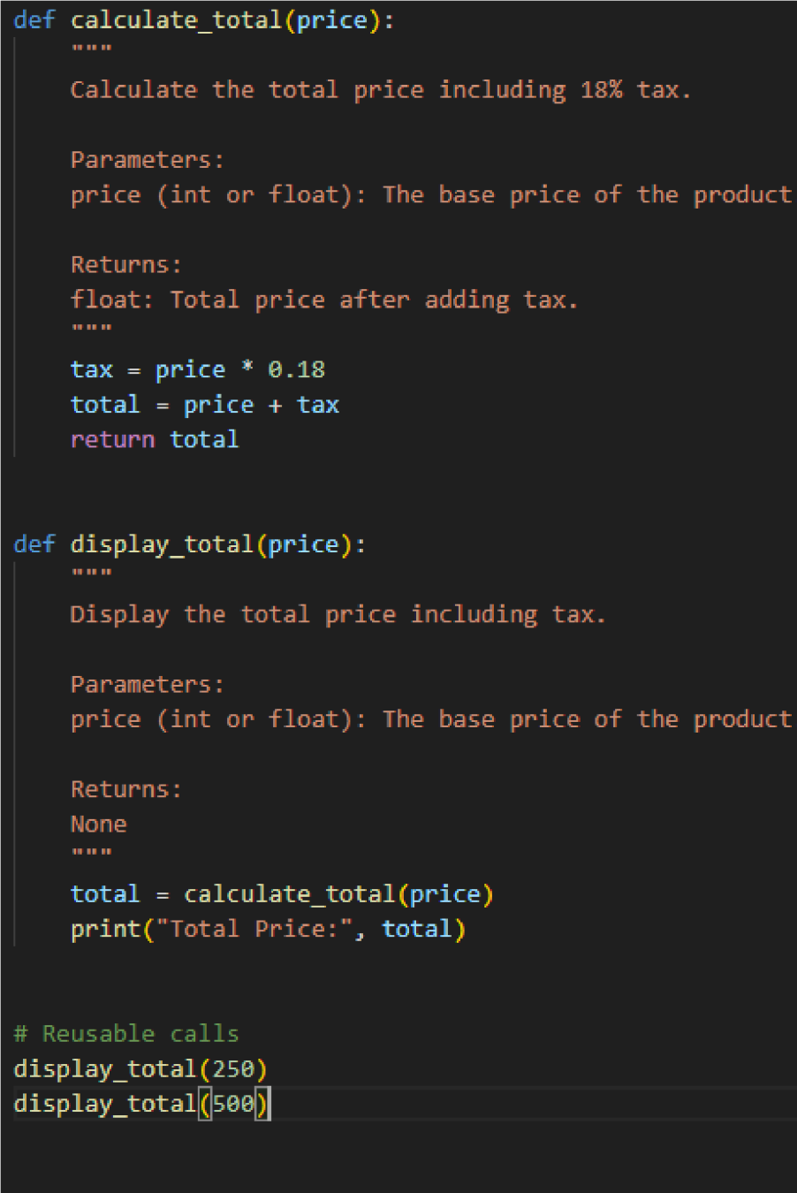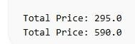
OUTPUT

:

Task Description #4 (Refactoring – Replacing Hardcoded

Values with Constants)
- Task: Use AI to identify and replace all hardcoded “magic numbers” in the code with named constants.
- Instructions: o Create constants at the top of the file.
  - Replace all hardcoded occurrences in calculations with these constants.
  - Ensure the code remains functional and is easier to maintain.
- Sample Legacy Code:
# Legacy script with hardcoded values print("Area of Circle:", 3.14159 * (7 ** 2)) print("Circumference of Circle:", 2 * 3.14159 * 7) ● Expected Output:
  - Code with constants like PI = 3.14159 and RADIUS = 7 used in calculations.
PROMPT : Refactor the following Python script by identifying all hardcoded magic numbers and replacing them with named constants declared at the top of the file. Ensure the code remains functional, readable, and maintainable. Return only the refactored Python code.
SCREENSHOT :

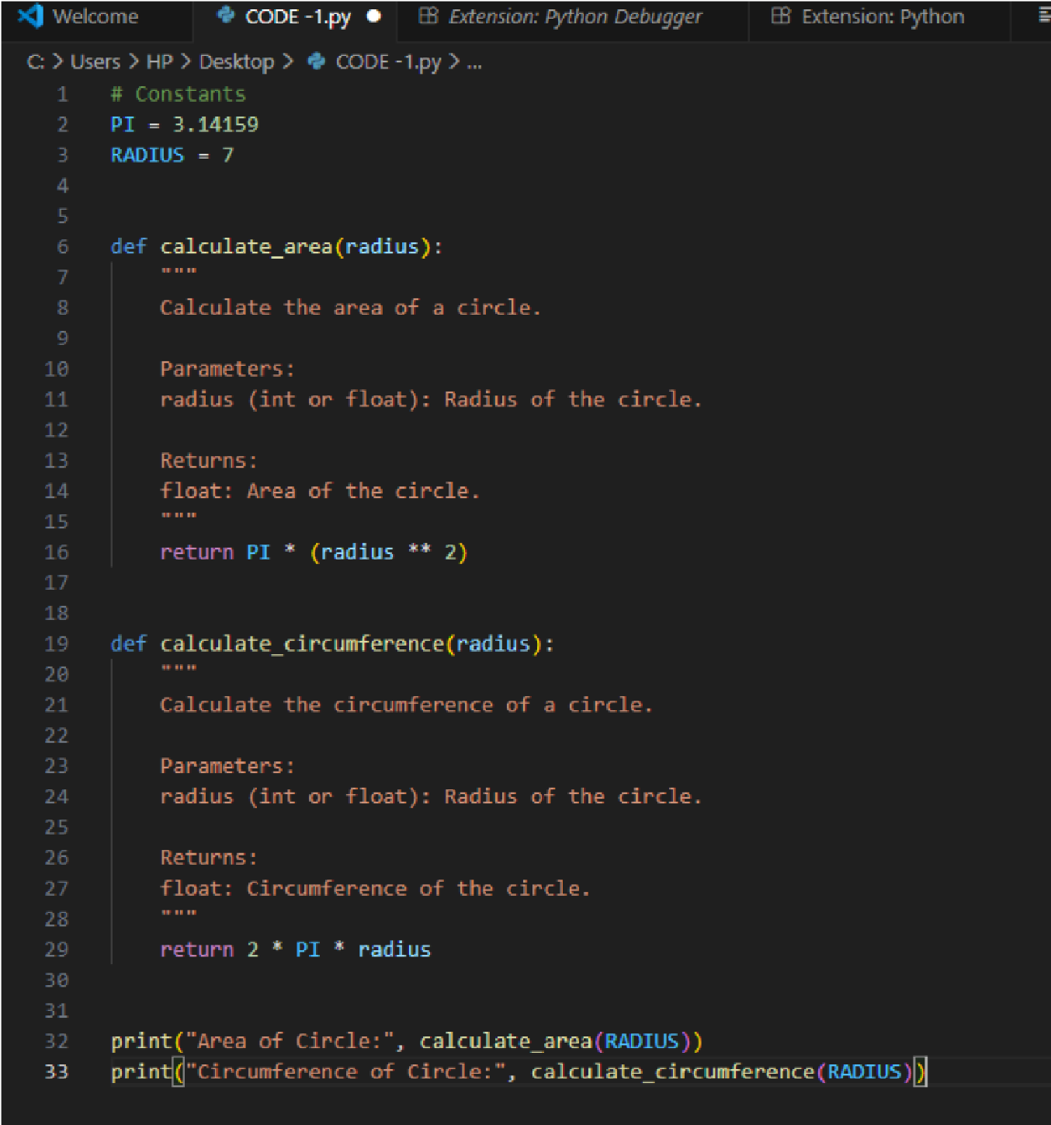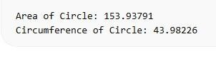

OUTPUT

:

Task Description #5 (Refactoring – Improving Variable Naming and Readability)
- Task: Use AI to improve readability by renaming unclear variables and adding inline comments.
- Instructions: o Replace vague names with meaningful ones. o Add comments where logic is not obvious.
o Keep functionality exactly the same.
- Sample Legacy Code:
# Legacy script with poor variable names a =
10

b = 20 c = a * b / 2 print(c)
● Expected Output: o Code with descriptive variable names like base, height, area_of_triangle, plus explanatory comments.
PROMPT : Refactor the following Python script by renaming unclear variables with meaningful names and adding inline comments to improve readability. Keep the functionality exactly the same and return only the improved Python code. SCREENSHOT :
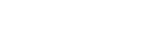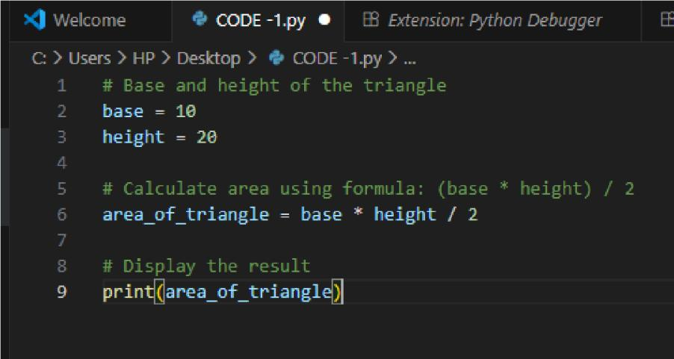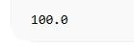
OUTPUT

:

Task Description #6 (Refactoring – Removing Redundant Conditional
Logic)
- Task: Use AI to refactor a Python script that contains repeated if–else logic for grading students.
- Instructions:
o Ask AI to identify redundant conditional checks. o Replace them with a reusable function.

o Ensure grading logic remains unchanged.
• Code:
marks = 85 if marks >= 90:
print("Grade A") elif marks >= 75: print("Grade B") else:
print("Grade C")

marks = 72 if marks >= 90:
print("Grade A") elif marks >= 75: print("Grade B") else:
print("Grade C")
• Expected Output:
o A reusable function like calculate_grade(marks) with clean logic and docstring.
Prompt
Refactor the following Python script by identifying repeated grading conditionals and extracting them into a reusable function. Ensure the grading logic remains unchanged and include a proper docstring.
SCREENSHOT :-

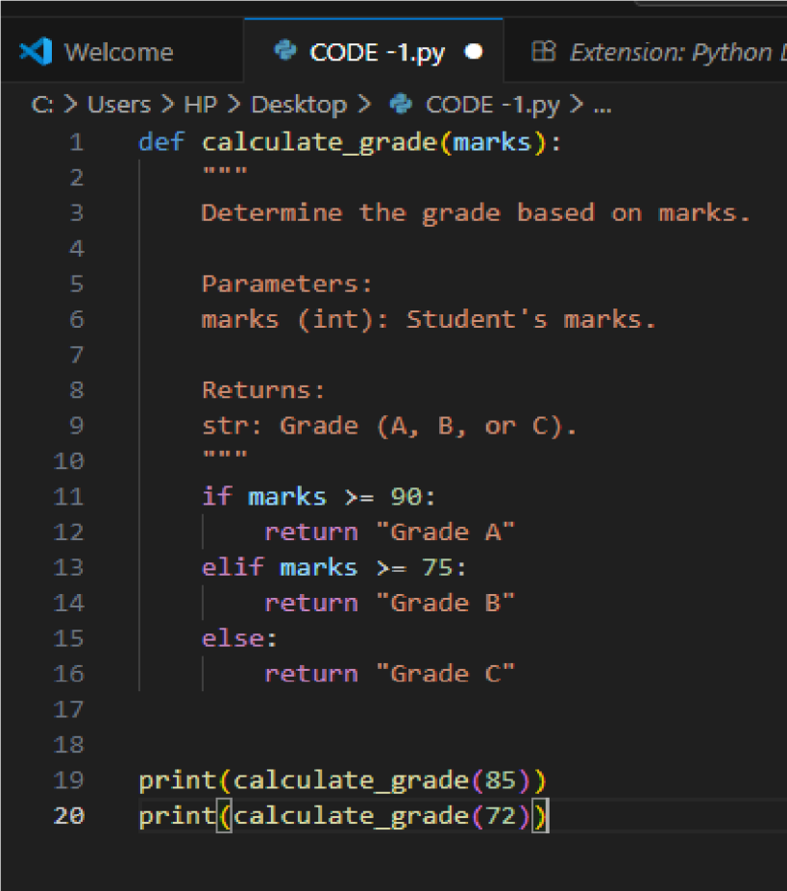
OUTPUT :
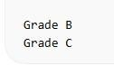

Task Description #7 (Refactoring – Converting Procedural Code to Functions)
• Task: Use AI to refactor procedural input–processing logic into

functions.
- Instructions: o Identify input, processing, and output sections. o Convert each into a separate function. o Improve code readability without changing behavior.
- Sample Legacy Code: num =
int(input("Enter number: ")) square = num * num print("Square:", square)
- Expected Output: o Modular code using
functions like get_input(), calculate_square(), and display_result()
Prompt
Refactor the following procedural Python script by separating input, processing, and output into individual functions. Improve readability while keeping behavior unchanged.
CODE :

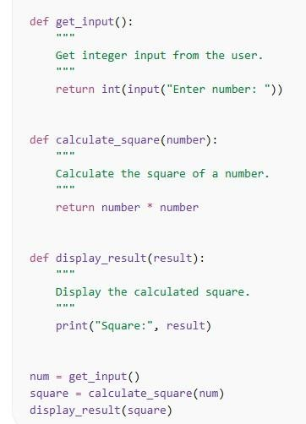
OUTPUT :
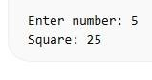

Task Description #8 (Refactoring – Optimizing List Processing)
- Task: Use AI to refactor inefficient list processing logic.
- Instructions:
o Ask AI to replace manual loops with list comprehensions or built-in functions. o Ensure output remains identical.
- Sample Legacy Code: nums = [1, 2, 3, 4, 5] squares = [] for n in nums: squares.append(n * n) print(squares)
- Expected Output: o Optimized version using list comprehension with improved readability
PROMPT :
Refactor the following Python script by replacing manual list processing loops with list comprehensions or built-in functions. Ensure the output remains identical and return only the optimized Python code.
CODE :-
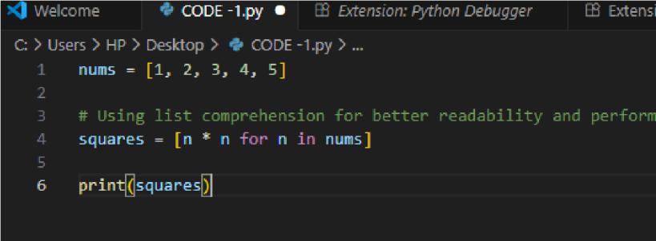
OUTPUT :
