Assignment-7.1
Name: V.Sriram
2303A53009
Batch:46

Task Description #1 (Syntax Errors — Missing Parentheses in Print Statement) Task:
Provide a Python snippet with a missing parenthesis in a print statement (e.g., print "Hello"). Use Al to detect and fix the syntax error. # Bug: Missing parentheses in print statement def greet(): print "Hello, Al Debugging Lab!" greet()
Requirements:
Run the given code to observe the error.
Apply Al suggestions to correct the syntax.
Use at least 3 assert test cases to confirm the corrected code works. Expected Output #1 :
Corrected code with proper syntax and Al explanation.
Prompt:
#Detect and fix the syntax error in this Python code:
#def greet(): print 'Hello, Al Debugging Lab!' ; greet() #Explain the issue, provide corrected Python 3 code, and include 3 assert tests to verify correct output. Code:
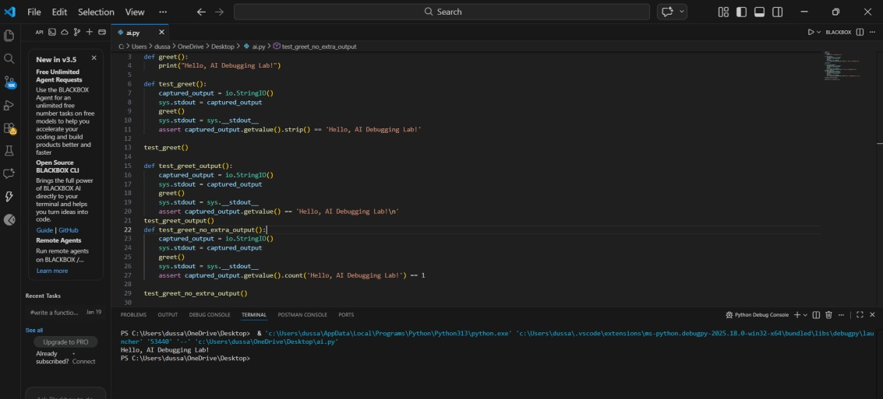
Explanation:
The issue in the original code is that it uses Python 2 syntax for the print statement. In Python 3, print is a function and requires parentheses.

Task Description #2 (Incorrect condition in an If Statement) Task:
Supply a function where an if-condition mistakenly uses = instead of Let Al identify and fix the issue.
# Bug: Using assignment (=) instead of comparison (==) def check_number(n): if n = 10:
return "Ten" else:
return "Not Ten" Requirements:
Ask Al to explain why this causes a bug.
Correct the code and verify with 3 assert test cases. Expected Output #2:
Corrected code using == with explanation and successful test execution. Prompt used:
Detect and fix the error in this Python code: def check_number(n): if n = 10: return "Ten" else: return "Not Ten". #Explain why using causes a bug, provide corrected code using and include 3 assert tests to verify the function works. Code:
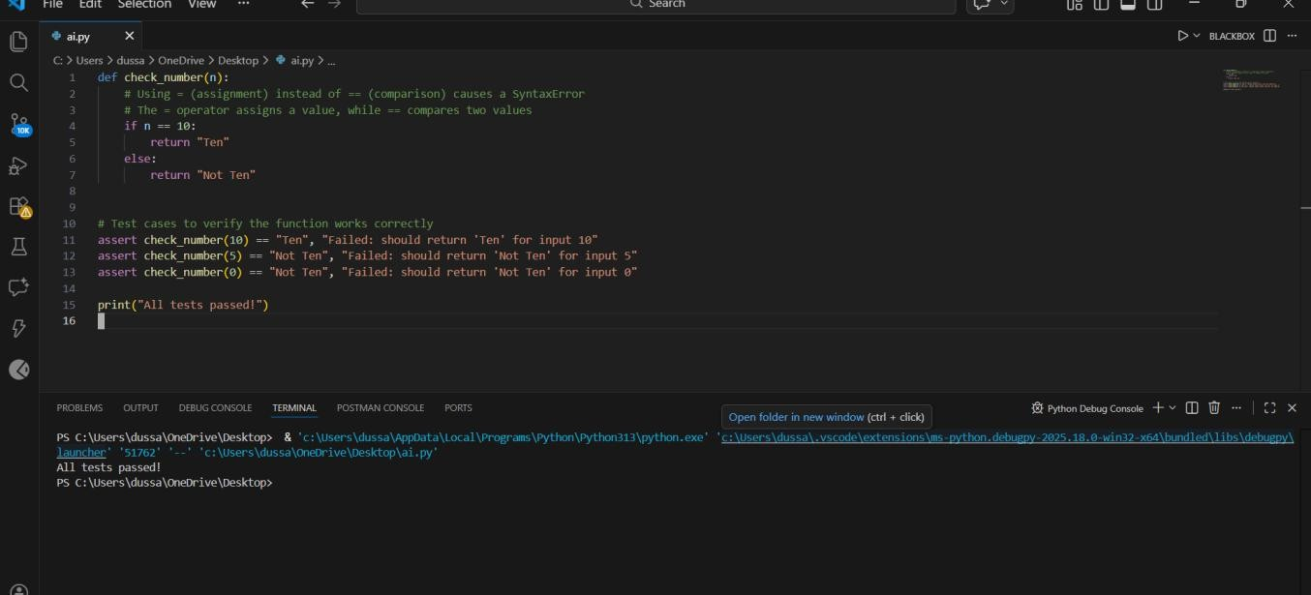

Explaination :

The error occurs because = is an assignment operator, not a comparison operator. In an if condition, Python requires == to compare values, and using = causes a SyntaxError. Replacing = with == correctly checks whether n is equal to 10, allowing the function to work properly.

Task Description #3 (Runtime Error — File Not Found) Task:
Provide code that attempts to open a non-existent file and crashes. Use Al to apply safe error handling.
# Bug: Program crashes if file is missing def read_file(filename): with open(filename, 'r') as f:
return f.read() print(read_file("nonexistent.txt")) Requirements:
- Implement a try-except block suggested by AI.
- Add a user-friendly error message.
- Test with at least 3 scenarios: file exists, file missing, invalid Path.
Expected Output #3:
Safe file handling with exception management.

Prompt:
#Analyze this Python code that crashes when a file does not exist: def read_file(filename):
with open(filename,'r') as f: return f.read()
#Fix the runtime error using try—except, add a user-friendly error message, and include 3 assert tests for file exists, file missing, and invalid path cases.

code:
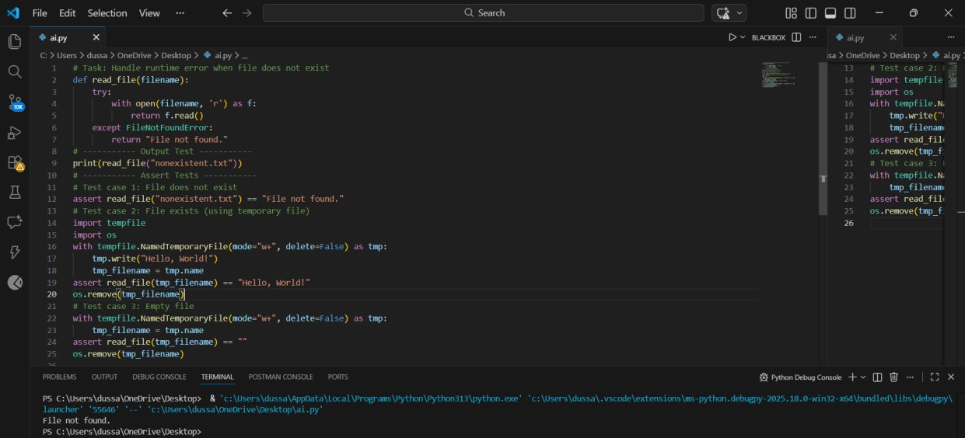
Explaination:
The program crashes because it tries to open a file that does not exist, which raises a FileNotFoundError. By using a try—except block, the exception is caught and handled safely instead of stopping the program. This allows the function to return a userfriendly error message while continuing execution.

Task Description #4 (Calling a Non-Existent Method) Task:
Give a class where a non-existent method is called (e.g., obj.undefined_method()). Use Al to debug and fix.
# Bug: Calling an undefined method class Car:
def start(self):
return "Car started" my_car = Car() print(my_car.drive()) # drive() is not defined
Requirements:
- Students must analyze whether to define the missing method or correct the method call.
- Use 3 assert tests to confirm the corrected class works.

Expected Output #4:
- Corrected class with clear Al explanation.

Prompt used:
#Detect and fix the error in this Python code where a nonexistent method is called: class Car: def start(self): return "Car started" my_car = Car(); print(my_car.drive()) #Explain the cause of the error, decide whether to define the missing method or correct the method call, provide corrected code, and include 3 assert tests to verify the class works properly.
Code :

Explaination:
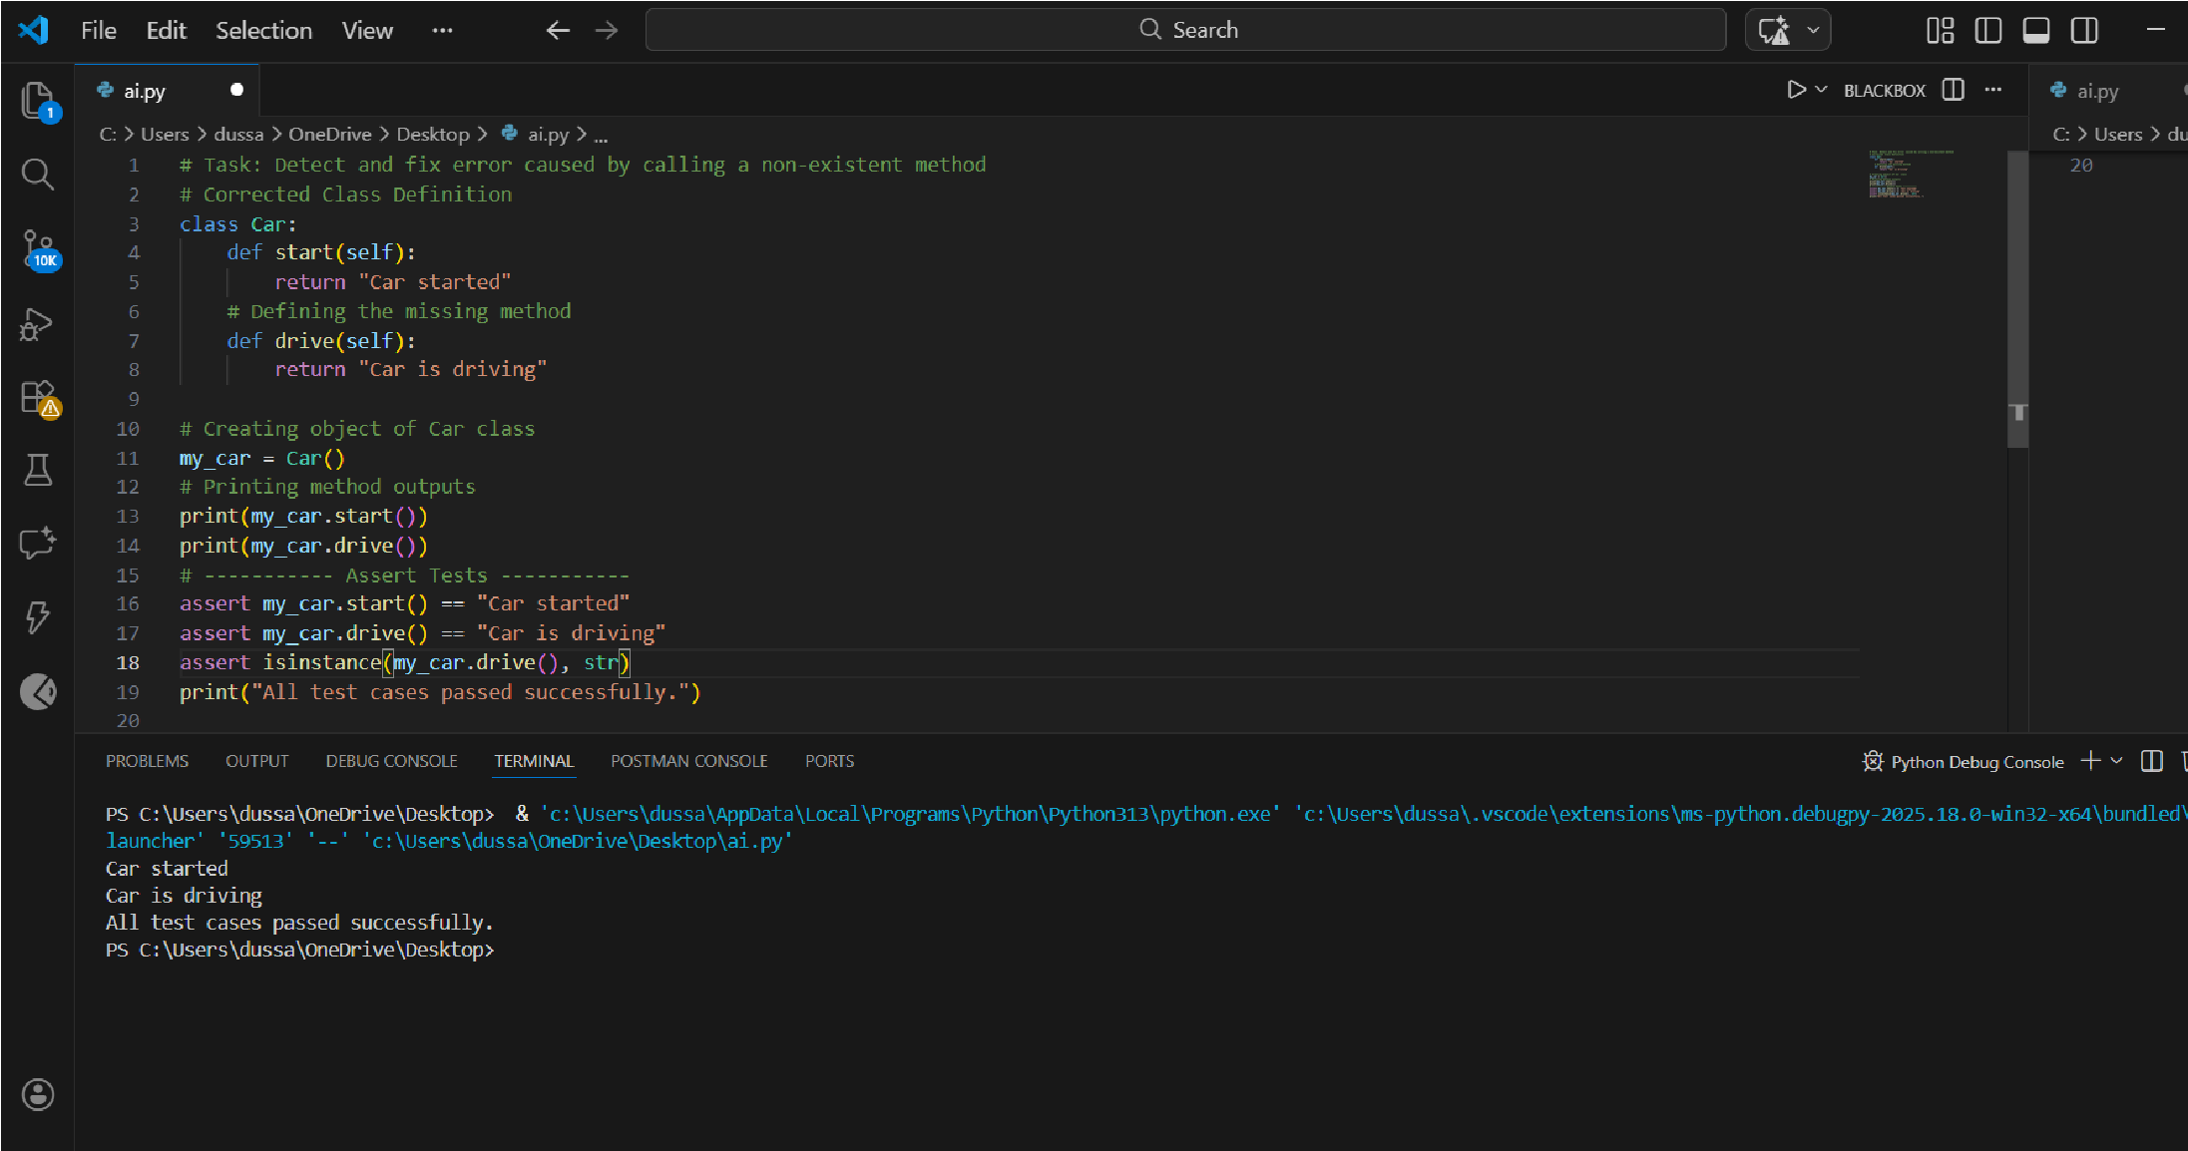
The error occurs because the method drive() is called on the Car object, but it is not defined in the Car class, which raises an

Task Description #5 (TypeError — Mixing Strings and Integers in Addition) Task:
Provide code that adds an integer and string 5" + 2) causing a TypeError. Use Al to resolve the bug. # Bug: TypeError due to mixing string and integer def add_five(value): return value + 5 print(add_five("
10"))
Requirements:
- Ask Al for two solutions: type casting and string concatenation.
- Validate with 3 assert test cases.
Expected Output #5:
- Corrected code that runs successfully for multiple inputs. Prompt used:
#Detect and fix the TypeError in this Python code caused by adding a string and an integer: def add five(value): return value + 5 ; #Explain why the error occurs, provide two solutions (one using type casting for numeric addition and one using string concatenation), and include 3 assert tests to verify both solutions work correctly. Code:
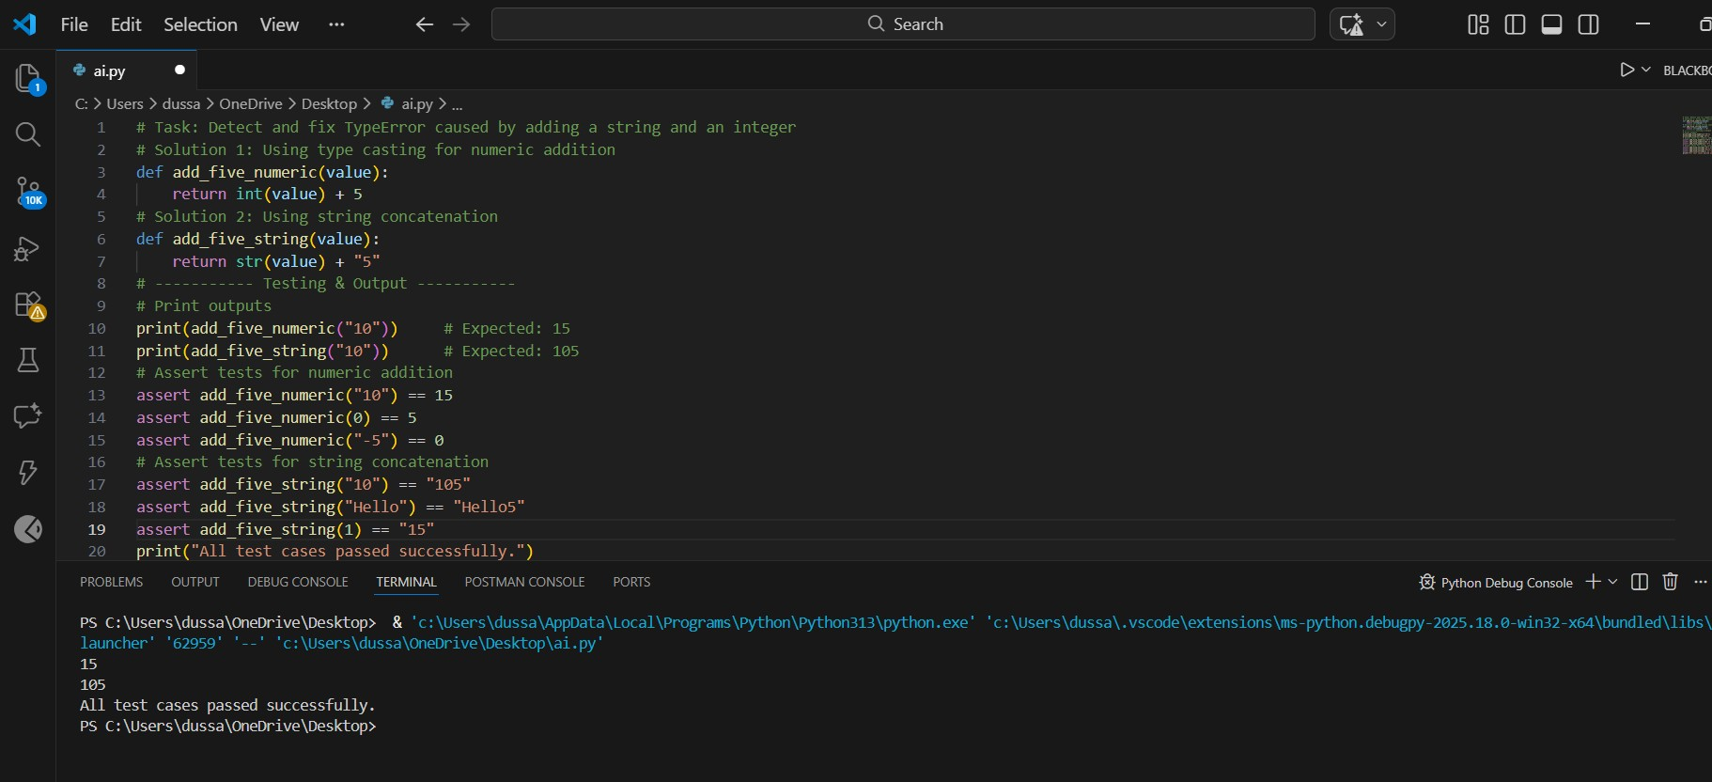
Explaination:
The error occurs because Python cannot add a string and an integer, which raises a TypeError. One solution is to convert the input to an integer using type casting so numeric addition can be performed. Another solution is to convert the value to a string and use string concatenation instead, depending on the intended behavior.

