ASSIGNMENT-7.1
V.Sriram
HNO: 2303A53009
BATCH-46
Task Description #1 (Syntax Errors — Missing Parentheses in Print Statement)
Task: Provide a Python snippet with a missing parenthesis in a print statement (e.g., print "Hello"). Use Al to detect and fix the syntax error.
# Bug: Missing parentheses in print statement def greet():
print "Hello, Al Debugging Lab!"
greet()
Requirements:
Run the given code to observe the error.
Apply Al suggestions to correct the syntax.
Use at least 3 assert test cases to confirm the corrected code works.
Expected Output #1 :
Corrected code with proper syntax and Al explanation.
PROMPT:
#Detect and fix the syntax error in this Python code:
#def greet(): print 'Hello, Al Debugging Lab!' ; greet() #Explain the issue, provide corrected Python 3 code, and include 3 assert tests to verify correct output.
CODE:
def test_greet():
captured_output = io.StringlO() # Create StringIO object sys.stdout = captured_output # Redirect stdout.
greet() # Call the function. sys.stdout = sys._stdout_ # Reset redirect.
assert captured_output.getvalue().strip() == 'Hello, Al Debugging Lab!'
test_greet()
def test_greet_output():
captured_output = io.StringIO() sys.stdout = captured_output greet() sys.stdout = sys._stdout_ assert captured_output.getvalue() 'Hello, Al Debugging
test_greet_output() def test_greet_no_extra_output():
captured_output = io.StringIO() sys.stdout = captured_output greet() sys.stdout = sys._stdout_ assert
captured_output.getvaIue().count('HeIIo, Al Debugging Lab") test_greet_no_extra_output() output:
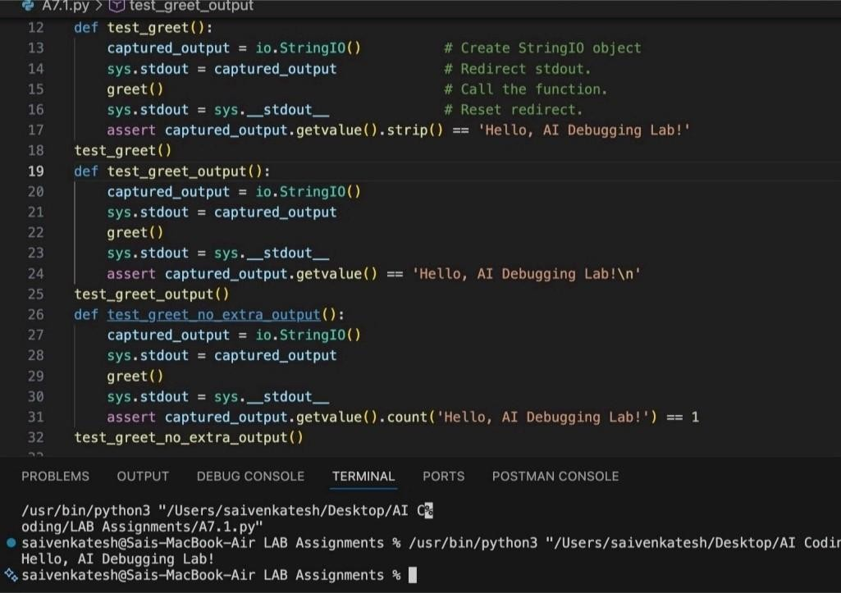
Explanation:
The issue in the original code is that it uses Python 2 syntax for the print statement. In Python 3, print is a function and requires parentheses.
Task Description #2 (Incorrect condition in an If Statement)
Task: Supply a function where an if-condition mistakenly uses = instead of Let Al identify and fix the issue.
# Bug: Using assignment (—) instead of comparison def check_number(n):
(==) if n = 10: return "Ten" ^{else:} return "Not Ten" Requirements:
Ask Al to explain why this causes a bug.
Correct the code and verify with 3 assert test cases.
Expected Output #2:
Corrected code using == with explanation and successful test execution.
Prompt used:
Detect and fix the error in this Python code: def check_number(n): if n = 10: return "Ten" else: return "Not Ten". #Explain why using causes a bug, provide corrected code using and include 3 assert tests to verify the function works. CODE:
def check_number(n): if n == 10. return "Ten" else: return "Not Ten"
# Assert tests
assert check_number(10) == "Ten" assert check_number(5) == "Not Ten" assert check_number(O) == "Not Ten" print("All tests passed! ") output:
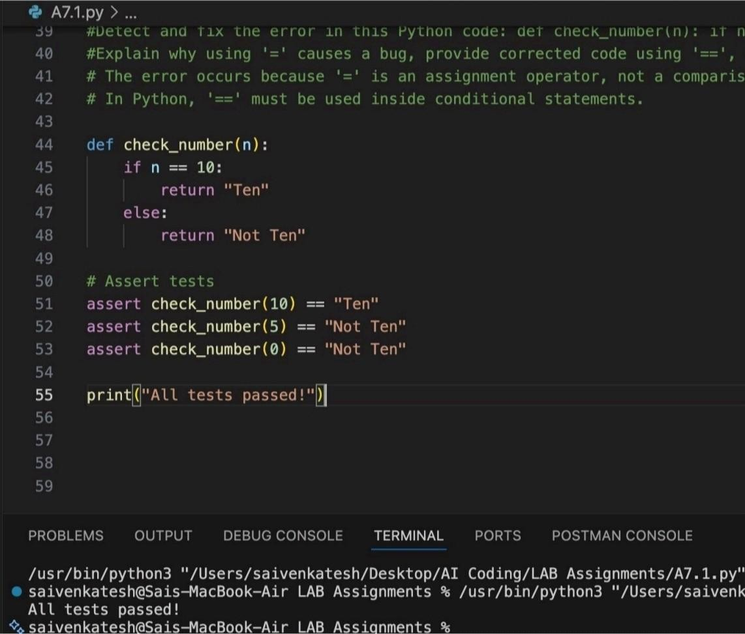
saivenkatesh

Sais
—
MacBook
—
Air

LAB

Assi

nments

Explaination :
The error occurs because = is an assignment operator, not a comparison operator. In an if condition, Python requires == to compare values, and using = causes a SyntaxError. Replacing = with == correctly checks whether n is equal to 10, allowing the function to work properly.
Task Description #3 (Runtime Error — File Not Found)
Task: Provide code that attempts to open a non-existent file and crashes. Use Al to apply safe error handling.
# Bug: Program crashes if file is missing def read_file(filename): with open(filename, as f:
return f.read() print(read_file("nonexistent.txt")) Requirements:
Implement a try-except block suggested by Al.
Add a user-friendly error message.
Test with at least 3 scenarios: file exists, file missing, invalid path.
Expected Output #3:
Safe file handling with exception management.
PROMPT:
#Analyze this Python code that crashes when a file does not exist: def read_file(filename): with open(filename,'r') as f: return f.read()
#Fix the runtime error using try—except, add a user-friendly error message, and include 3 assert tests for file exists, file missing, and invalid path cases.
code:
def read_file(filename):
try:
with open(filename, "r") as file:
return file. read()
except FileNotFoundError:
return "File not found."
print(read_file("nonexistent.txt"))
# Assert tests assert read_file("nonexistent.txt") == "File not found."
# To test the function with an existing file, we can create a temporary file and write to it import tempfile
with tempfile.NamedTemporaryFile(delete=False) as tmp:
tmp.write(b"Hello, World!") tmp_filename = tmp.name
assert read_file(tmp_filename) "Hello, World!"
import os os.remove(tmp_filename)
# Test with an empty file with tempfile.NamedTemporaryFile(delete=False) as tmp: tmp_filename = tmp.name
assert read_file(tmp_filename) " os.remove(tmp_filename) output :
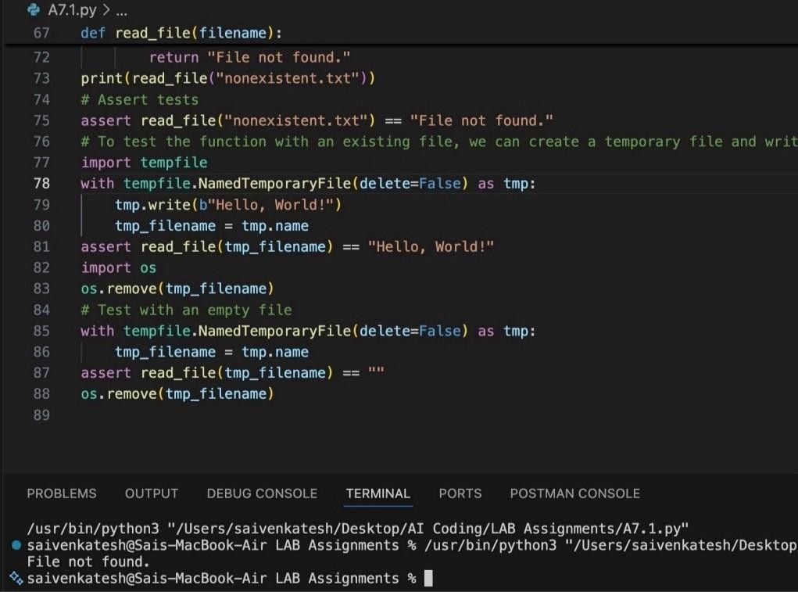
Explaination:
The program crashes because it tries to open a file that does not exist, which raises a FileNotFoundError. By using a try—except block, the exception is caught and handled safely instead of stopping the program. This allows the function to return a userfriendly error message while continuing execution.
Task Description #4 (Calling a Non-Existent Method)
Task: Give a class where a non-existent method is called (e.g., obj.undefined_method()). Use Al to debug and fix.
# Bug: Calling an undefined method class Car: def start(self):
return "Car started" my_car = Car()
print(my_car.drive()) # drive() is not defined
Requirements:
- Students must analyze whether to define the missing method or correct the method call.
- Use 3 assert tests to confirm the corrected class works.
Expected Output #4:
- Corrected class with clear Al explanation.
Prompt used:
#Detect and fix the error in this Python code where a nonexistent method is called: class Car: def start(self): return "Car started" my_car = Car(); print(my_car.drive()) #Explain the cause of the error, decide whether to define the missing method or correct the method call, provide corrected code, and include 3 assert tests to verify the class works properly.
Code : class Car:
def sta rt(self): return "Car started"
def drive(self):
return "Car is driving"
my_car = Car() print(my_car.drive())
# Assert tests assert my_car.start() == "Car started" assert my_car.drive() ==
"Car is driving"
another_car = Car() assert another_car.start() "Car started" assert another_car.drive() "Car is driving" output:
explaination:
The error occurs because the method drive() is called on the Car object, but it is not defined in the Car class, which raises an
Task Description #5 (TypeError — Mixing Strings and Integers in
Addition)
Task: Provide code that adds an integer and string 5" + 2) causing a TypeError. Use Al to resolve the bug.
# Bug: TypeError due to mixing string and integer def add_five(value): return value + 5 print(add_five("
10"))
Requirements:
- Ask Al for two solutions: type casting and string concatenation.
- Validate with 3 assert test cases.
Expected Output #5:
- Corrected code that runs successfully for multiple inputs.
Prompt used:
#Detect and fix the TypeError in this Python code caused by adding a string and an integer: def add five(value): return value + 5 ; #Explain why the error occurs, provide two solutions (one using type casting for numeric addition and one using string concatenation), and include 3 assert tests to verify both solutions work correctly.
Code:
# Detect and fix the TypeError in this Python code caused by adding a string and an integer:
# def add_five(value): return value + 5 ; print(add_five(" 10"))
# The error occurs because the code is trying to add an integer (5) # to a string (" 10"), which is not allowed in Python.
# Solution l : Using type casting for numeric addition
def ue):
return int(value) + 5
print(add_five_numeric(" I O" ))
# Assert tests for numeric addition assert add_five_numeric(" I O") 15
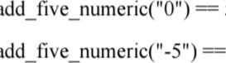
assert 5 assert O
# Solution 2: Using string concatenation def
add_five_string(value):
return value + "5"
# Assert tests for string concatenation assert add five_string(" 10") " 105" assert add five_string(''Hello") "He1105" assert add five_string("") — "5"
output:
Explaination:
The error occurs because Python cannot add a string and an integer, which raises a TypeError. One solution is to convert the input to an integer
using type casting so numeric addition can be performed. Another solution is to convert the value to a
string and use string concatenation instead, depending on the intended behavior.
- #def return value + 5 ; print
- #Explain why the error occurs, provide two solutions (one using type casting for numeric additi0[
- # The error occurs because the code is trying to add an integer (5) to a string which is 118 # Solution 1: Using type casting for numeric addition
- def :
- return int(value) + 5
- print ( add_f ive_numeric 10" ) )
- # Assert tests for numeric addition
- assert add_five_numeric( " 10 " ) --— 15
- assert add_five_numeric( )
- assert add_five_numeric("-5")
- # Solution 2: Using string concatenation 127 def add_five_string(vatue) :
- return value + "5"
- print ( add_f ive_string ( )
- # Assert tests for string concatenation
- assert "105
- assert add_f ive_st ring ("Het ) ''He1105"
- assert add_five_string( 134

PROBLEMS OUTPUT DEBUG CONSOLE TERMINAL PORTS POSTMAN CONSOLE
/usr/bin/python3 "/Users/saivenkatesh/Desktop/AI Coding/LAB Assignments/A7.1.py"
• saivenkatesh@Sais—MacBook—Air LAB Assignments % /usr/bin/python3 "/Users/saivenkatesh/Desktop/AI
Coding/L 15
105

