Lab-14.3
Name V.Sriram
2303A53009
Batch:46

Task 1: AI-Assisted Personal Portfolio Website
Scenario
A student wants to showcase academic projects, technical skills, and contact information through a personal portfolio website. AI tools are used to speed up development while maintaining quality and customization.
Tasks
- Use GitHub Copilot to generate a semantic HTML structure with sections:
Home
About
Projects
Contact
- Ask Copilot to suggest responsive CSS using Flexbox or Grid.
- Customize AI-generated CSS to add:
Hover effects on project cards
Smooth scrolling navigation
Expected Outcome
- Clean and well-structured portfolio website
- Responsive layout for desktop and mobile screens
- Interactive project cards Code:
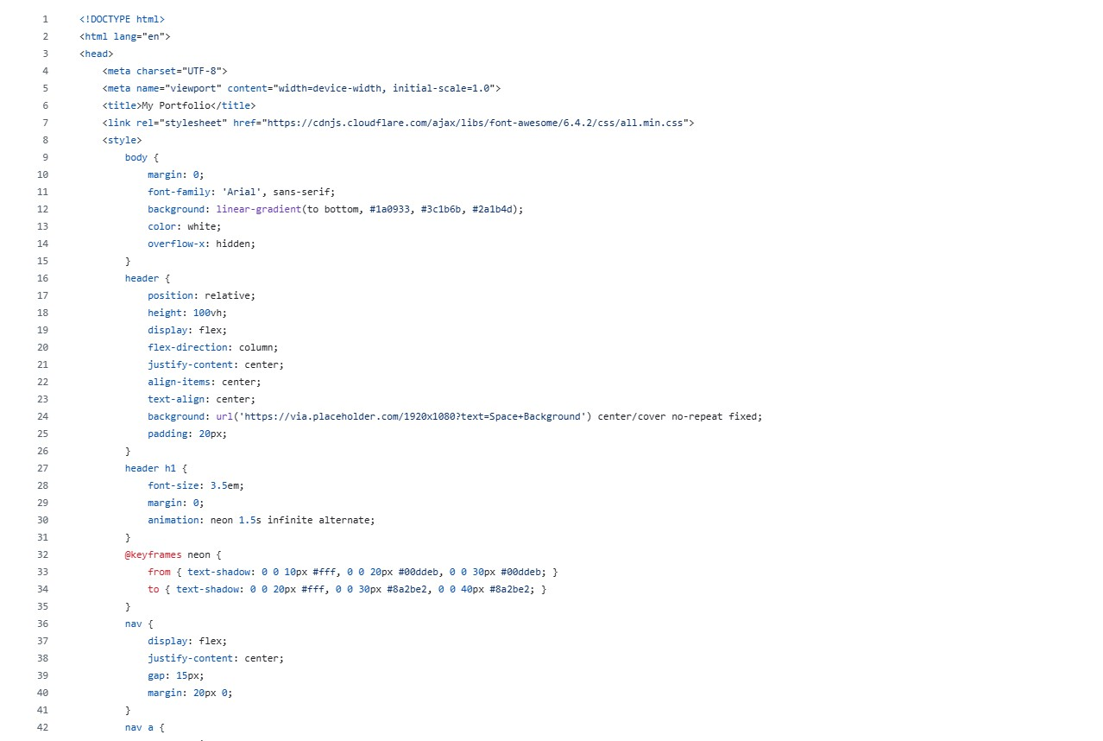
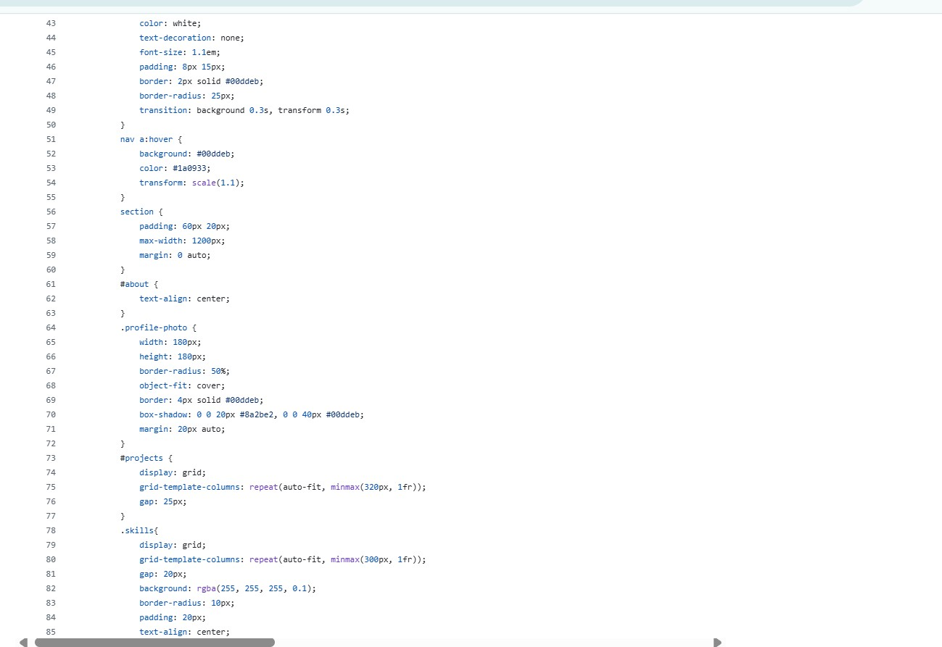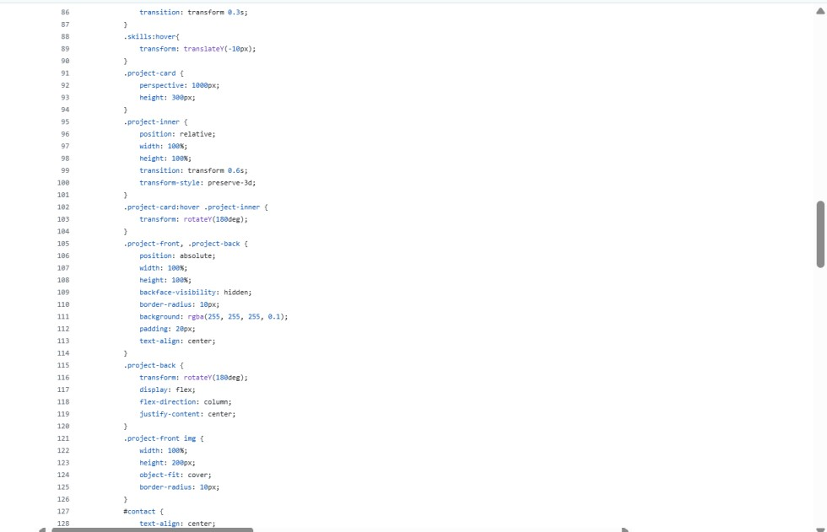

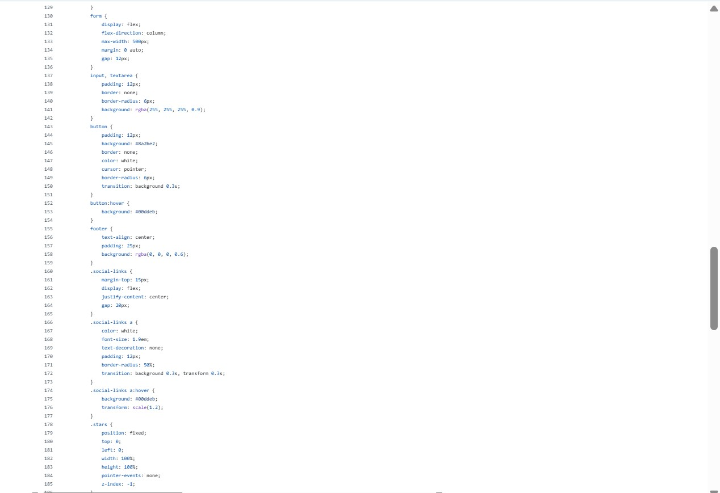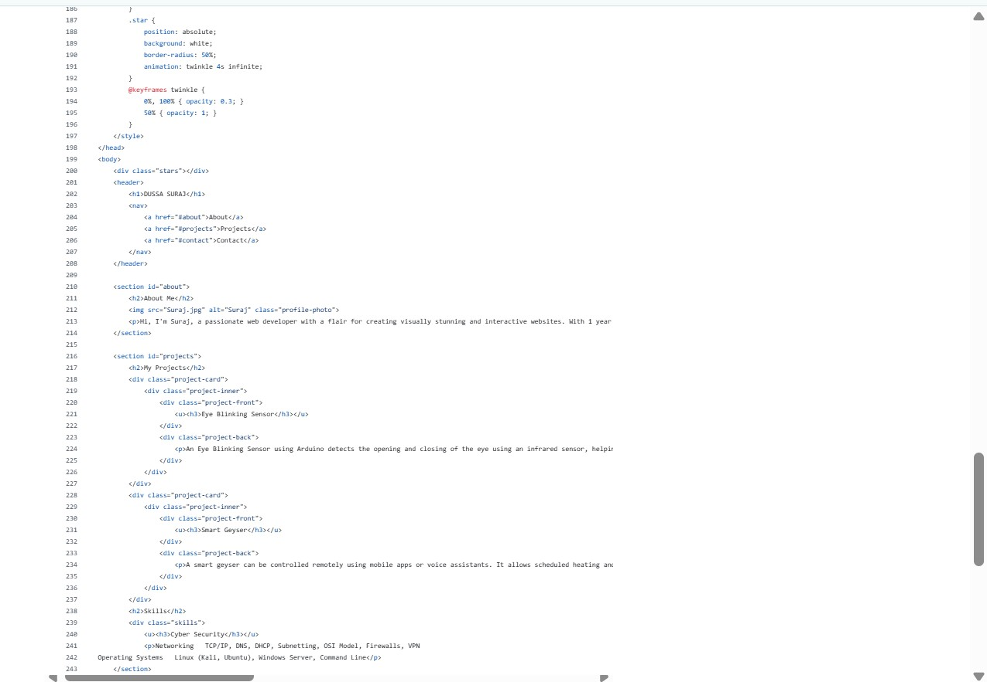
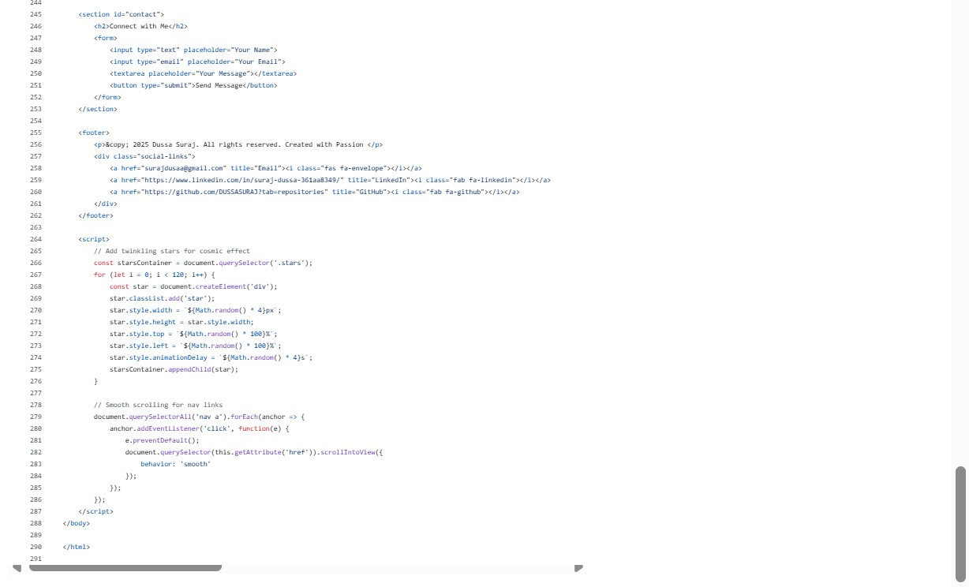

Output:
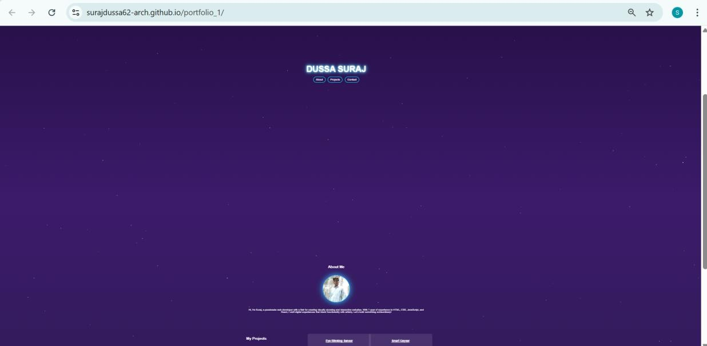
Explanation:
HTML Structure
- create a portfolio website with:
  - Header (Name + Navigation) o About Section o Projects Section o Skills Section
  - Contact Form
  - Footer with Social Links

CSS Design
- Used gradient background for a cosmic look.
- Added neon animation for your name.
- Created hover effects for buttons.
- Used flip card animation for projects.
- Added glowing circular profile photo.
- Designed responsive grid layout.

JavaScript Features
- Created twinkling stars background.
- Added smooth scrolling when clicking navigation links.
Output:
When you open the file in a browser, you see:
- Full-screen header with glowing DUSSA SURAJ
- Navigation buttons (About, Projects, Contact)
- About section with circular photo
- Project cards that flip on hover
- Skills section
- Contact form
- Animated twinkling stars background
- Social media icons in footer

Task 2: AI-Generated Restaurant Landing Page
Scenario
A local restaurant requires a simple yet attractive landing page to display its offerings. The developer uses AI assistance to rapidly generate UI components.
Tasks
- Use Copilot to create a navigation bar with links:
Home
Menu Gallery
Contact
- Generate a menu section styled with CSS cards.
- Implement a JavaScript-based image slider for the gallery using Copilot suggestions.
- Customize animations or transitions for better user experience.
Expected Outcome
- Fully functional restaurant landing page
- Responsive navigation bar
- Working image slider with smooth transitions
Code:
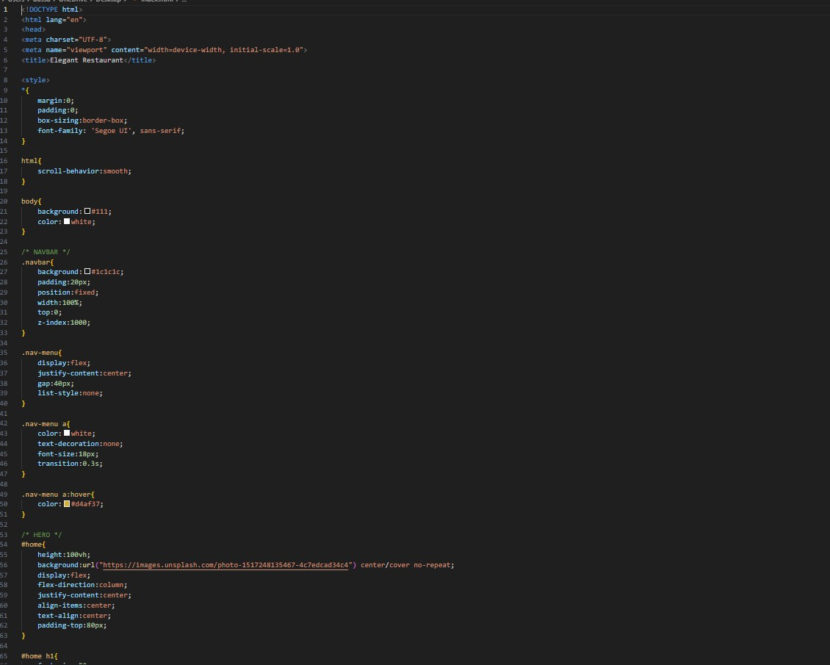
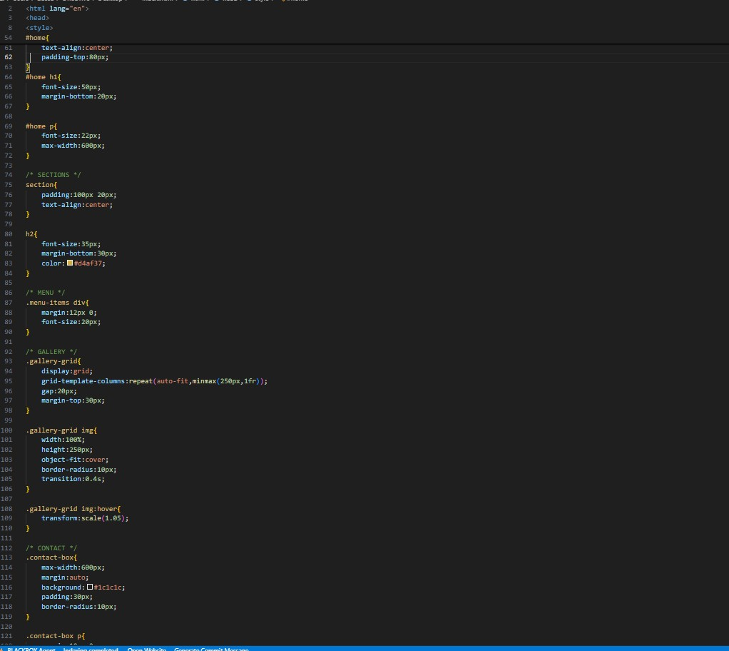
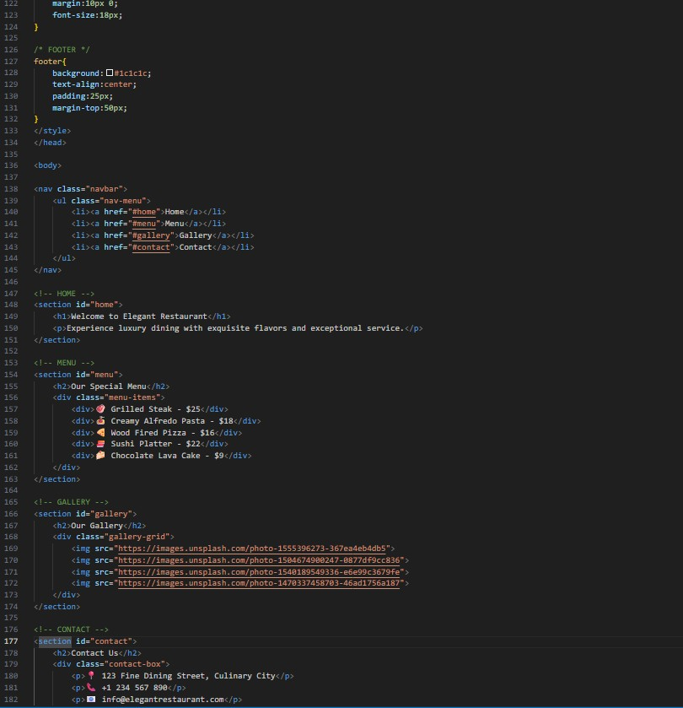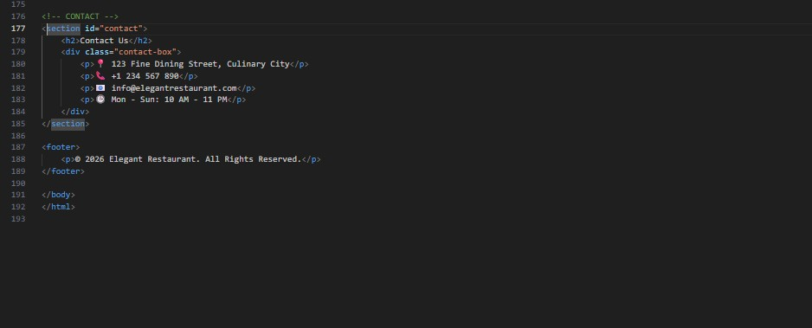

Output:
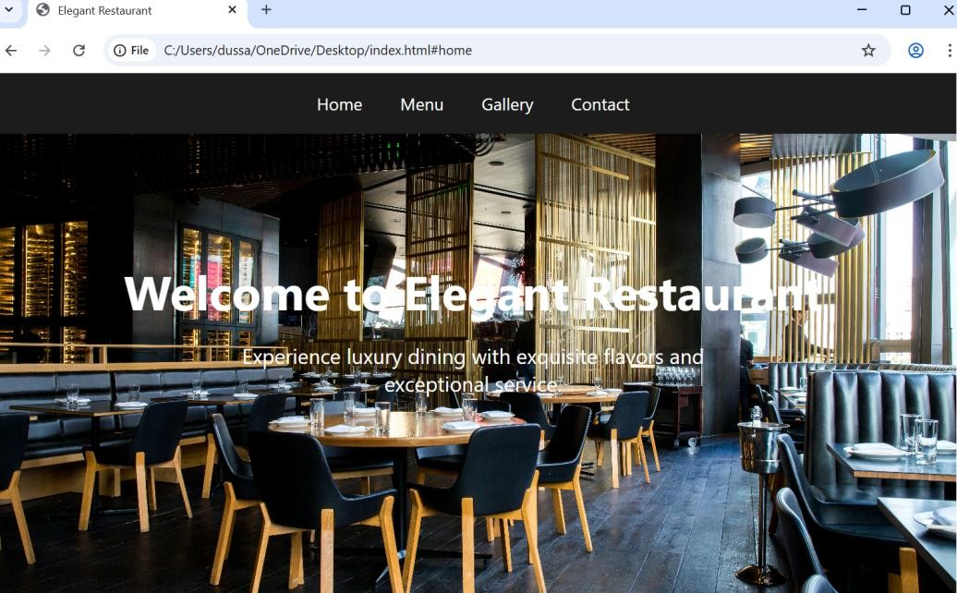
Explanation:
- Navbar → Fixed dark menu bar with smooth scrolling links (Home, Menu, Gallery, Contact).
- Theme → Dark luxury design with gold accent color for a premium look.
- Hero Section → Full-screen background image with welcome text.
- Menu Section → Displays special food items with prices.
- Gallery Section → Food and restaurant images in grid layout with hover zoom effect.
- Contact Section → Shows address, phone number, email, and opening hours inside a styled box.
- Footer → Simple copyright section at bottom.

Task 3: AI-Powered Event Registration Form
Scenario
SR University is hosting a technical fest and requires an online registration form with real-time validation to ensure accurate user input.
Tasks
- Ask Copilot to generate an HTML form with the following fields:
Name
Email
Phone Number Department
Event Selection
- Use AI assistance to style the form using CSS for readability and accessibility.
- Implement JavaScript validation using Copilot:
Email format validation
Phone number length validation
Required field checks
Expected Outcome
- User-friendly and visually appealing form
- Real-time validation messages • Prevention of invalid submissions Code:
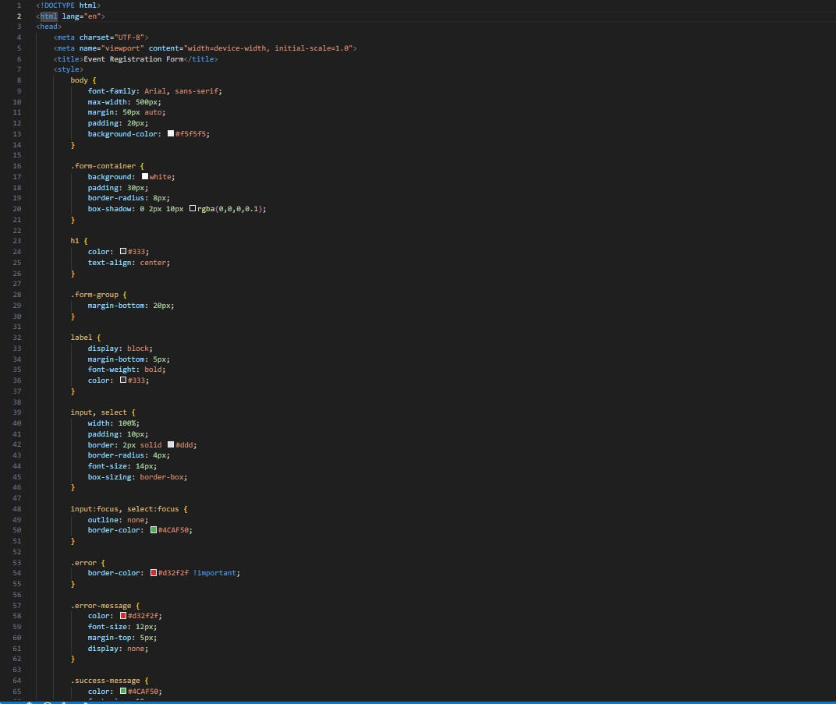
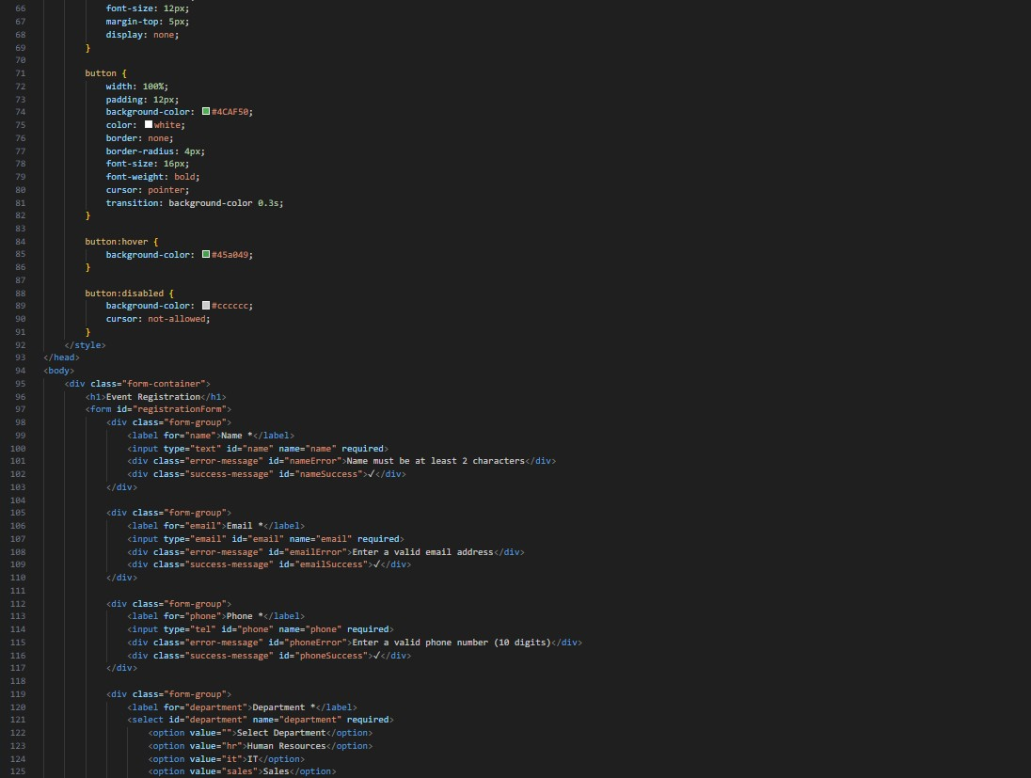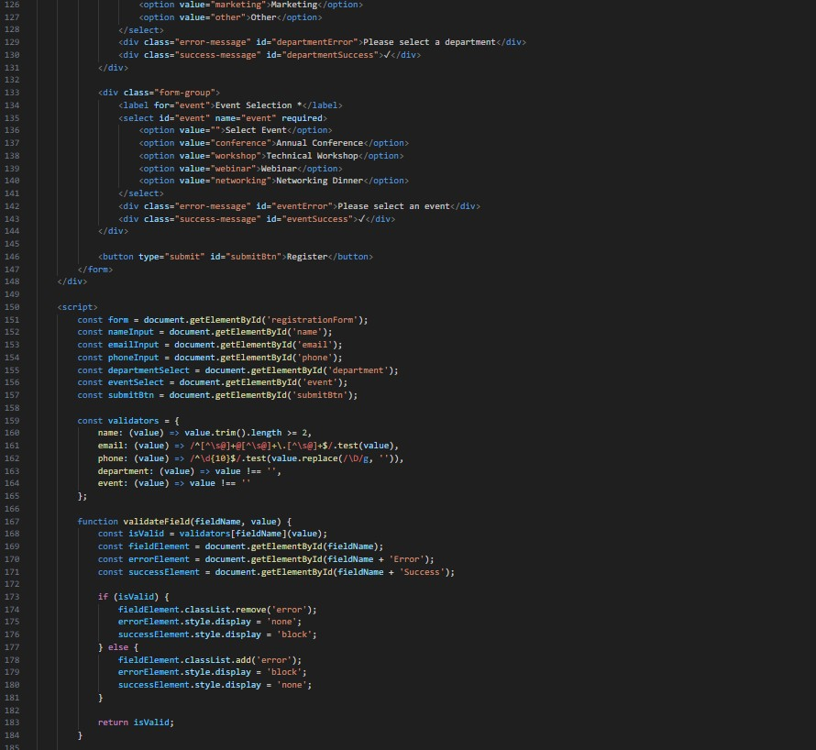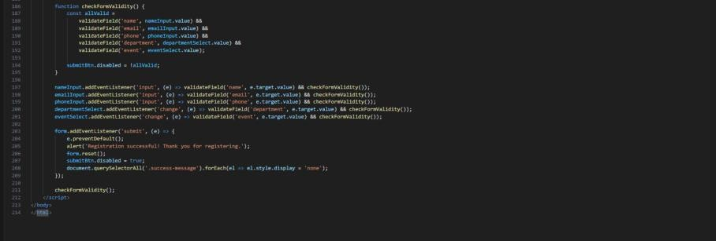

Output:
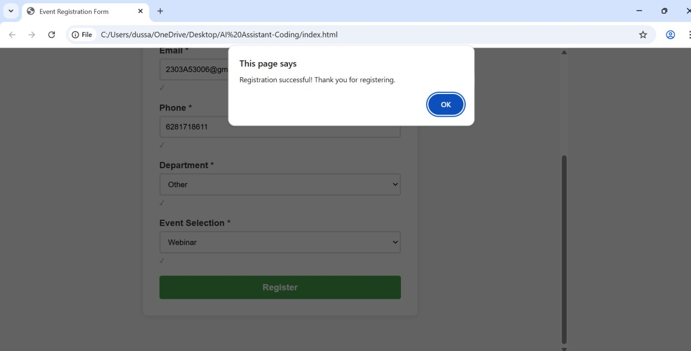
Explanation:
- HTML Structure → Creates an Event Registration Form with Name, Email, Phone, Department, and Event fields.
- CSS Styling → Adds clean white card design, centered layout, rounded corners, shadow, and green theme.
- Required Fields → All inputs are mandatory (required).
- Error Messages → Hidden by default; shown if input is invalid.
- Success Message (✓) → Displays when a field is valid.
- JavaScript Validators →
  - Name → Minimum 2 characters
  - Email → Valid email format using regex o Phone → Exactly 10 digits
  - Department & Event → Must be selected
- Real-time Validation → Checks inputs while typing (input & change events).
- Submit Button → Disabled until all fields are valid.
- Form Submit → Shows success alert, resets form, disables button again.

Task 4: AI-Assisted E-Commerce Product Page
Scenario
A startup is developing a basic e-commerce product page to showcase products and manage simple cart functionality.
Tasks
- Use Copilot to generate a grid-based product catalog using HTML and CSS.
- Implement an “Add to Cart” feature using JavaScript.
- Modify AI-generated code to include:
Cart item counter at the top-right corner
Visual feedback when a product is added
Expected Outcome
- Functional product catalog
- Working cart counter • Interactive user experience Code:
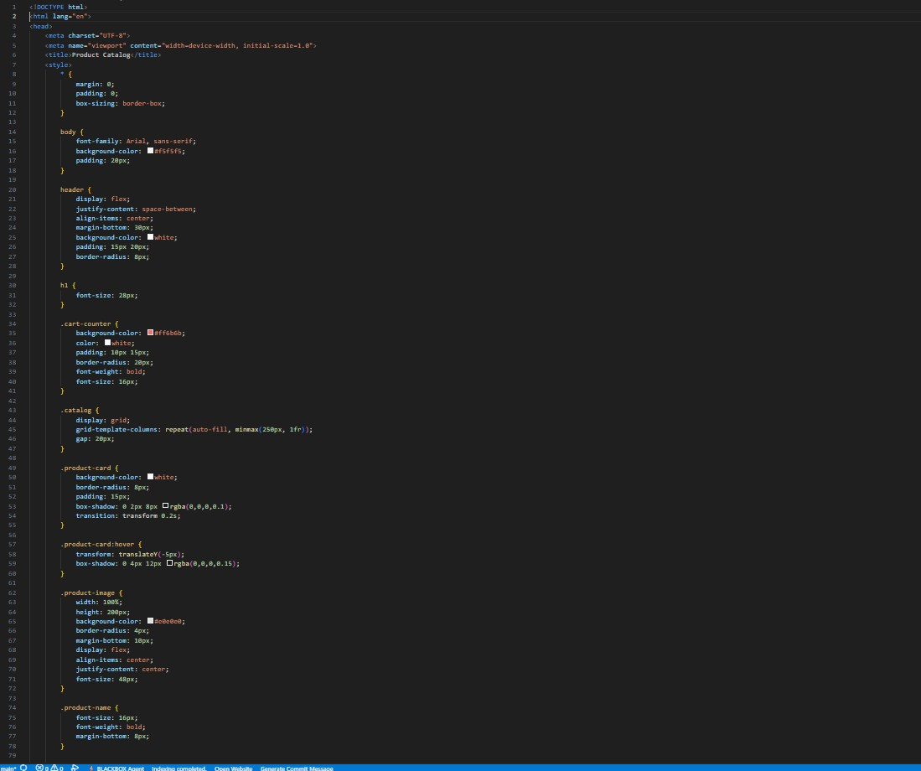
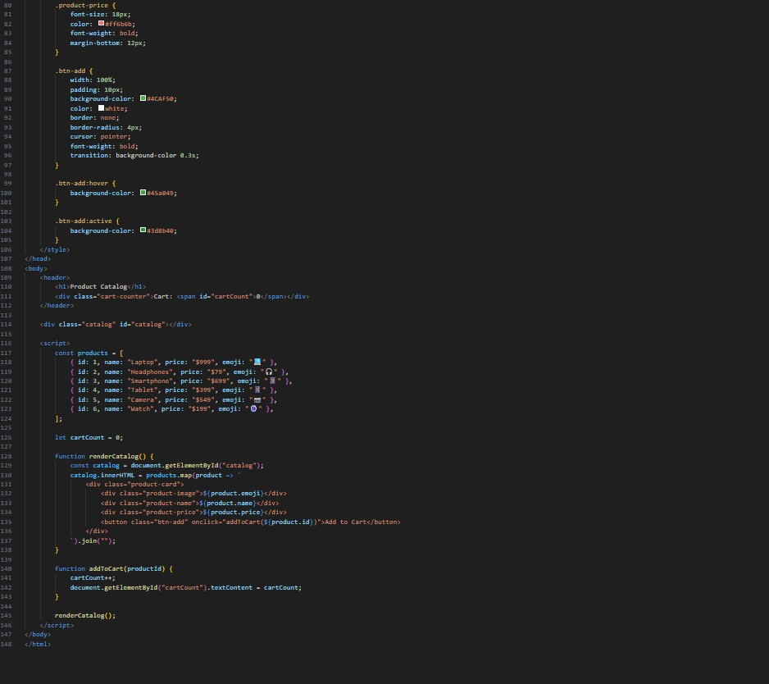
Output:
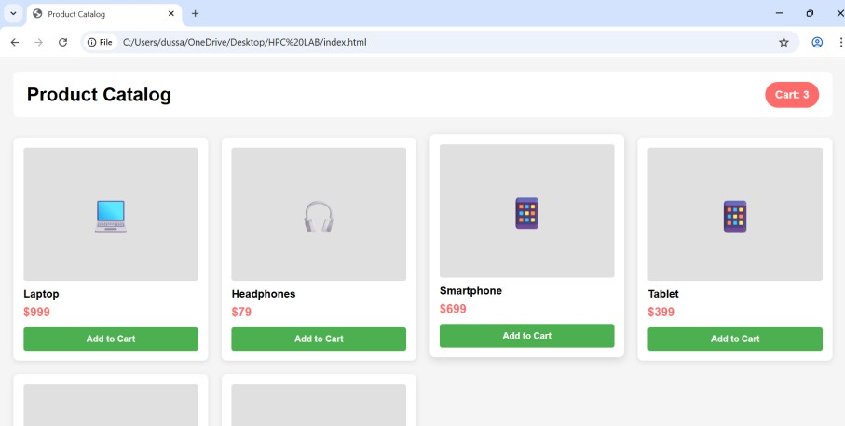
Explanation:
- HTML Structure → Creates a Product Catalog page with header and product grid.
- Header Section → Displays page title and cart counter (Cart: 0).
- CSS Styling → o Grid layout for products o White product cards with shadow
o Hover effect (card lifts up) o Green “Add to Cart” button o Red cart counter badge
- Products Array (JavaScript) → Stores product details (id, name, price, emoji).
- renderCatalog() Function → Dynamically displays all products using map() and innerHTML.
- addToCart() Function → Increases cart count and updates it on the page.
- onclick Event → Adds selected product to cart when button is clicked.
- Initial Call → renderCatalog() loads products when page opens.

Task 5: Create a Responsive Web Page Layout Instructions:
- Design a basic web page layout with a header, main content area, and footer using HTML and CSS.
- Use AI to assist in generating responsive CSS for different screen sizes.
- Ensure the layout is clean and visually organized.
Expected Output:
- A responsive web page with:
- Header with navigation links
- Main section with placeholder text/images
- Footer with copyright or contact info
- Layout adapts correctly to desktop, tablet, and mobile screen sizes.
Code:
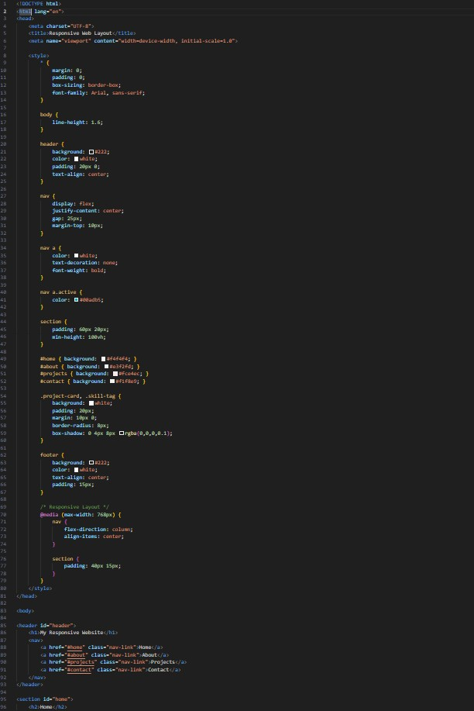
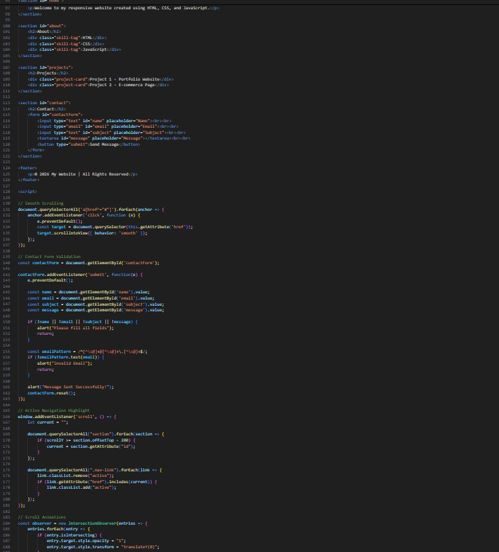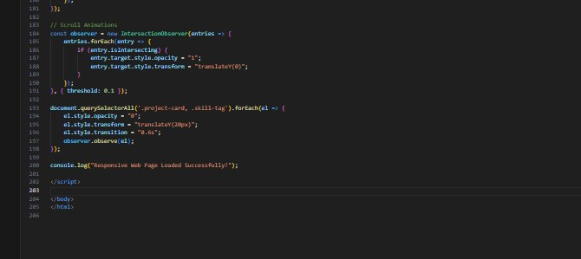
Output:
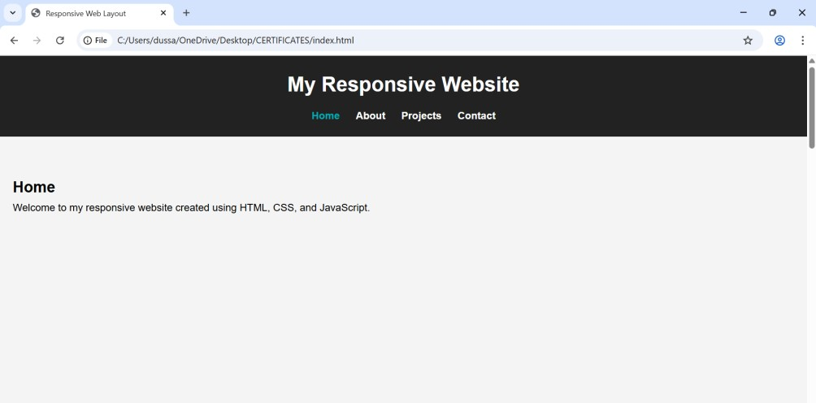
Explanation
- The HTML creates a page with header, navigation, sections, contact form, and footer.
- CSS uses Flexbox for navigation and a media query to make the layout responsive.
- JavaScript enables smooth scrolling when clicking menu links.
- The contact form includes basic validation for empty fields and email format.
- Active navigation links highlight based on scroll position.
- Scroll animations make project cards and skills appear smoothly.

