Assignment 5.1
---------------------------------------------------------------------------------------------------------
Course Title: Ethical Foundations – Responsible AI
Lab Title: Responsible AI Coding Practices
Lab No: 5
Week: 3
Day: Monday

Student Name: V.Sriram
Roll No: 2303A53009

Aim
To understand ethical risks in AI-generated code and apply responsible AI coding practices focusing on privacy, security, transparency, and accountability.

Objectives
- Identify insecure coding patterns generated by AI
- Analyze privacy and security risks
- Ensure transparency and explainability in algorithms
- Understand developer responsibility in AI-assisted programming

Tools Used
• VS Code

Task-Wise Implementation

Task 1: Privacy in API Usage Problem Statement
Generate a Python program to fetch weather data securely without exposing API keys.

AI Prompt Used
Generate a Python program to fetch weather data from a weather API without hardcoding the API key.
Use environment variables to store and access the API key securely.
Include basic error handling.

Observation
- AI-generated code avoided hardcoded API keys
- Environment variables were used for security

Secure Code
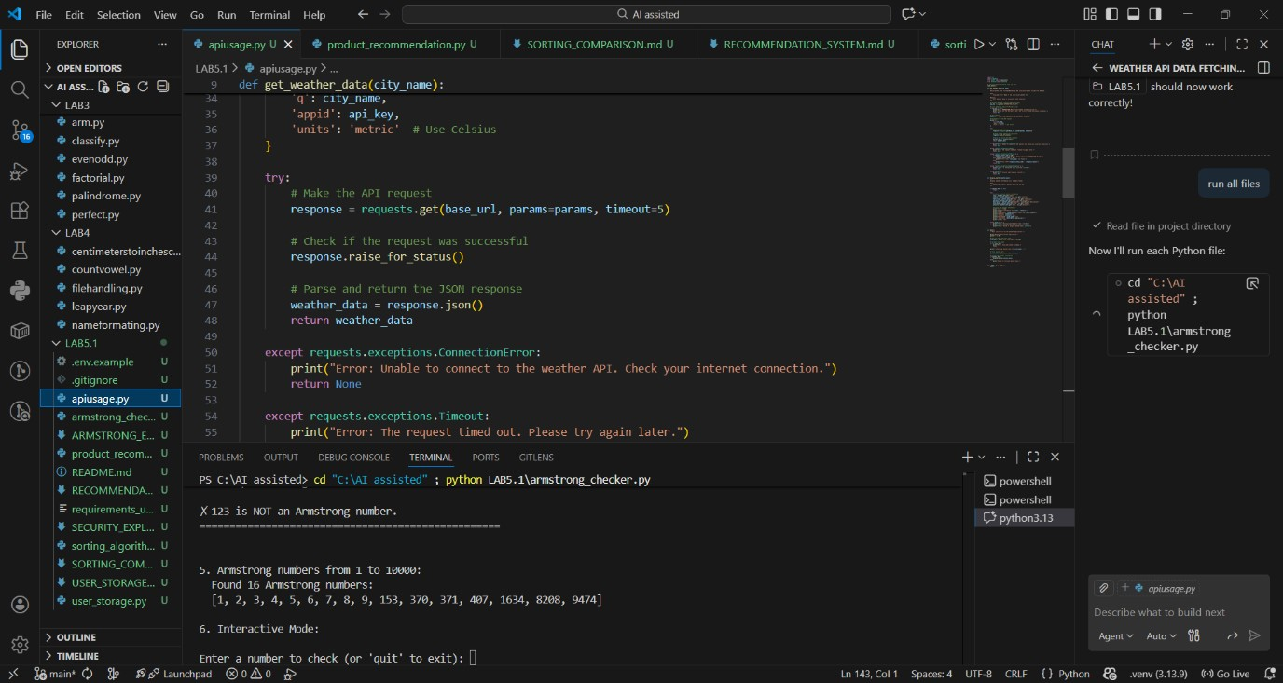

Ethical Analysis
Using environment variables protects sensitive credentials and prevents unauthorized misuse.

Task 2: Privacy & Security in File Handling Problem Statement
Store user data securely without exposing sensitive information.

AI Prompt Used
Generate a Python program to store user details (name, email, password) securely.
Do not store passwords in plain text.
Use hashing for password storage and explain why this approach is secure.
Privacy Risk Identified
• Plain-text password storage is insecure

Secure Code
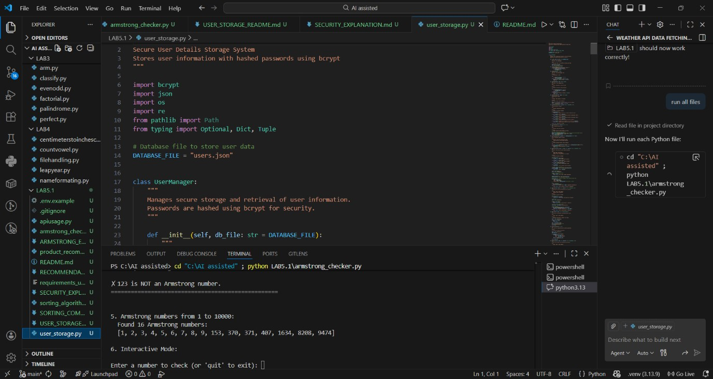

Ethical Analysis
Hashing ensures passwords cannot be recovered even if the file is leaked.

Task 3: Transparency in Algorithm Design
Problem Statement
Design an Armstrong number checking program with clear explanation.

AI Prompt Used
Generate a Python function to check whether a given number is an Armstrong number.
Add clear comments to every important line of code.
Also explain the code line-by-line in simple terms.

Implementation
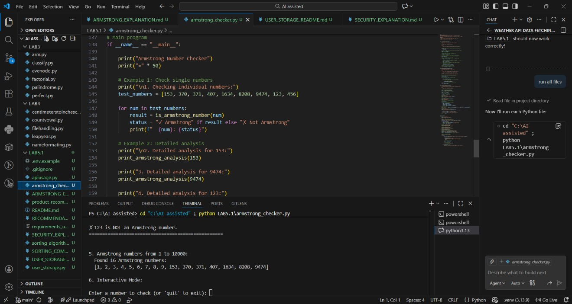

Transparency Evaluation
The explanation clearly matches the program logic, ensuring understandability.

Task 4: Transparency in Algorithm Comparison Problem Statement
Implement and compare two sorting algorithms.

AI Prompt Used
Generate Python code for Bubble Sort and Quick Sort.
Include step-by-step comments explaining how each algorithm works.
Compare both algorithms in terms of logic, time complexity, and efficiency.
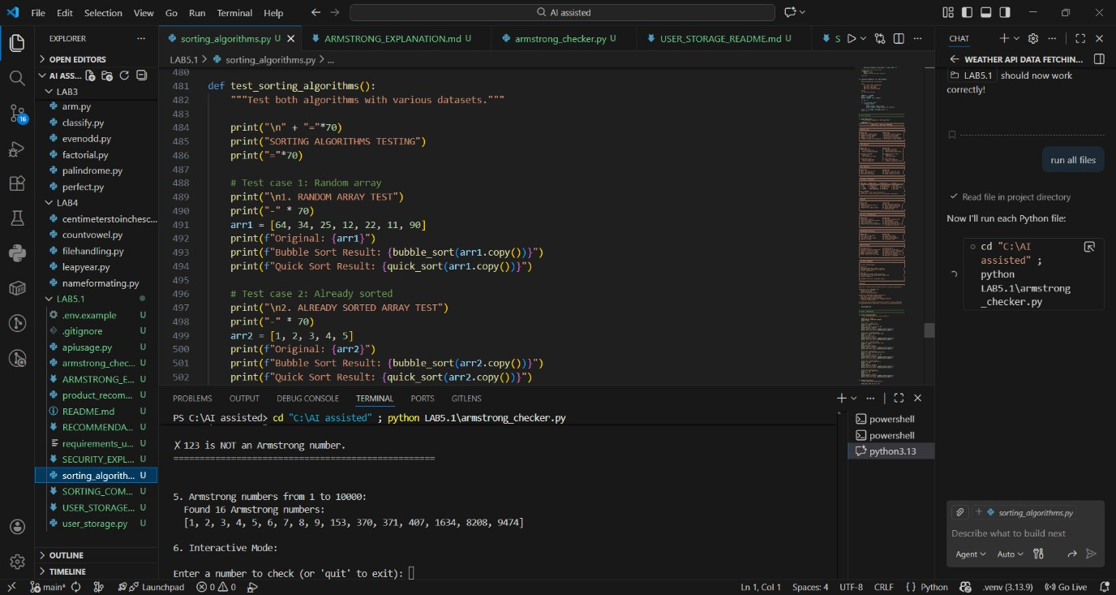
Comparison

Algorithm Time Complexity Efficiency
Bubble Sort O(n²) Low
Quick Sort O(n log n) High

Task 5: Transparency in AI Recommendations Problem Statement
Create an explainable recommendation system.

AI Prompt Used
Generate a simple product recommendation system in Python.
For each recommended product, also provide a clear explanation of why it was recommended.
Ensure the recommendations are explainable and transparent.

Implementation
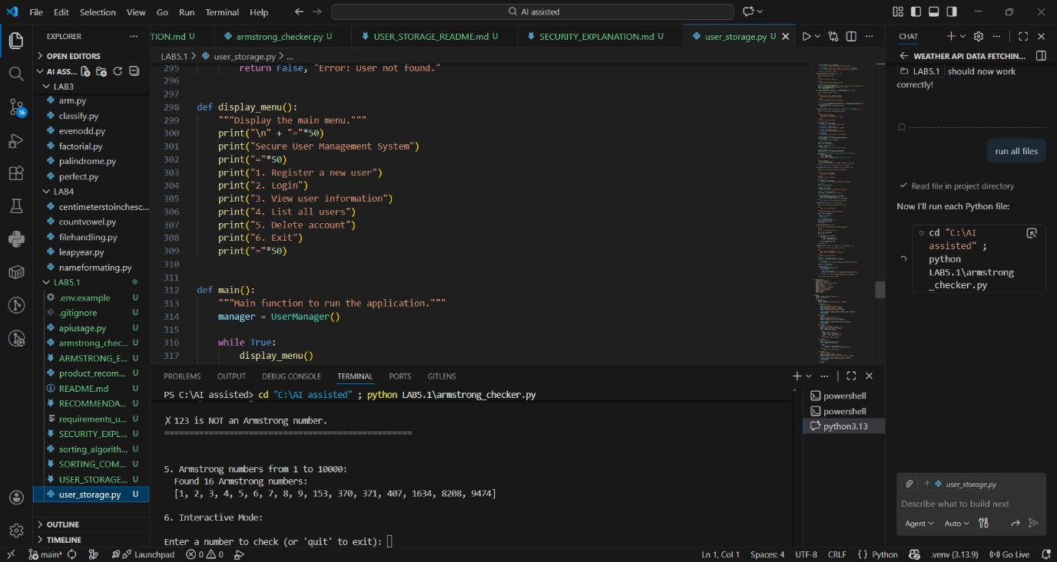

Transparency Evaluation
Each recommendation includes a reason, making the system explainable.

Result
All tasks were implemented successfully using ethical AI coding practices with proper privacy, security, and transparency.

Conclusion
AI-generated code must be reviewed by developers to ensure ethical compliance. Human accountability is essential in responsible AI usage.

