Week-4.3

Name: V.Sriram

2303A53009

Batch:46

Task 1: Zero-Shot Prompting – Leap Year Check Prompt Used (Zero-Shot)
Write a Python function that accepts a year as input and checks whether it is a leap year.

AI-Generated Python Code
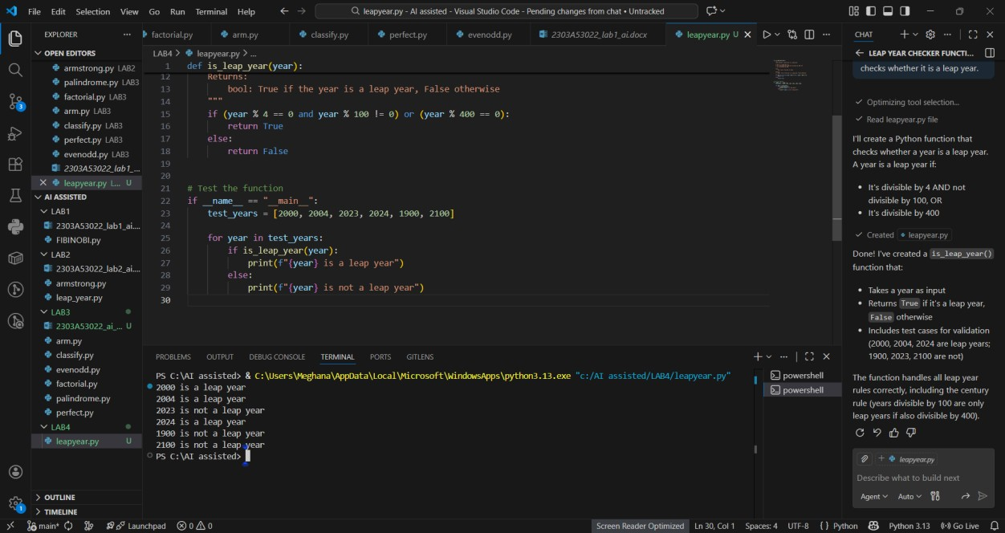

Explanation
- A year divisible by 4 is a leap year
- Years divisible by 100 are not leap years unless divisible by 400
- The logic correctly follows the leap year rules

Task 2: One-Shot Prompting – Centimeters to Inches Conversion Prompt Used (One-Shot)
Write a Python function to convert centimeters to inches.
Example:
Input: 10 cm → Output: 3.94 inches

AI-Generated Python Code
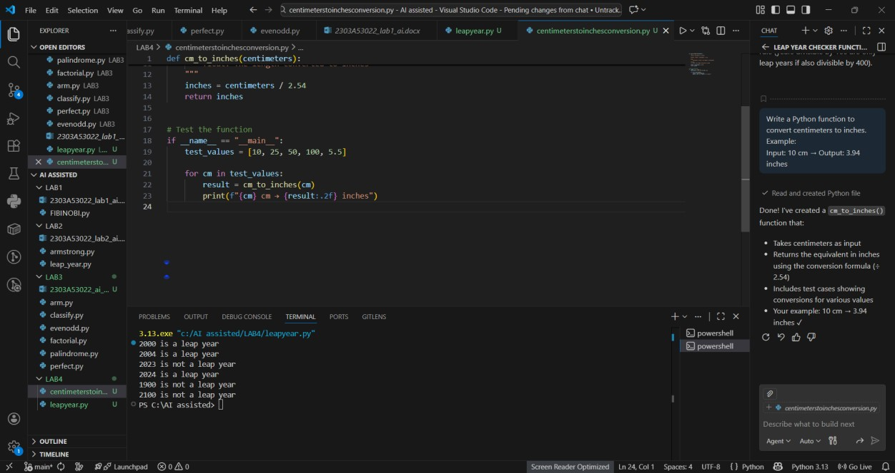

Explanation
- 1 inch = 2.54 cm
- The function divides centimeters by 2.54
- One example was enough to guide correct logic

Task 3: Few-Shot Prompting – Name Formatting Prompt Used (Few-Shot)
Write a Python function that formats a full name as "Last, First".

Examples:
"John Smith" → "Smith, John"
"Anita Rao" → "Rao, Anita"

AI-Generated Python Code
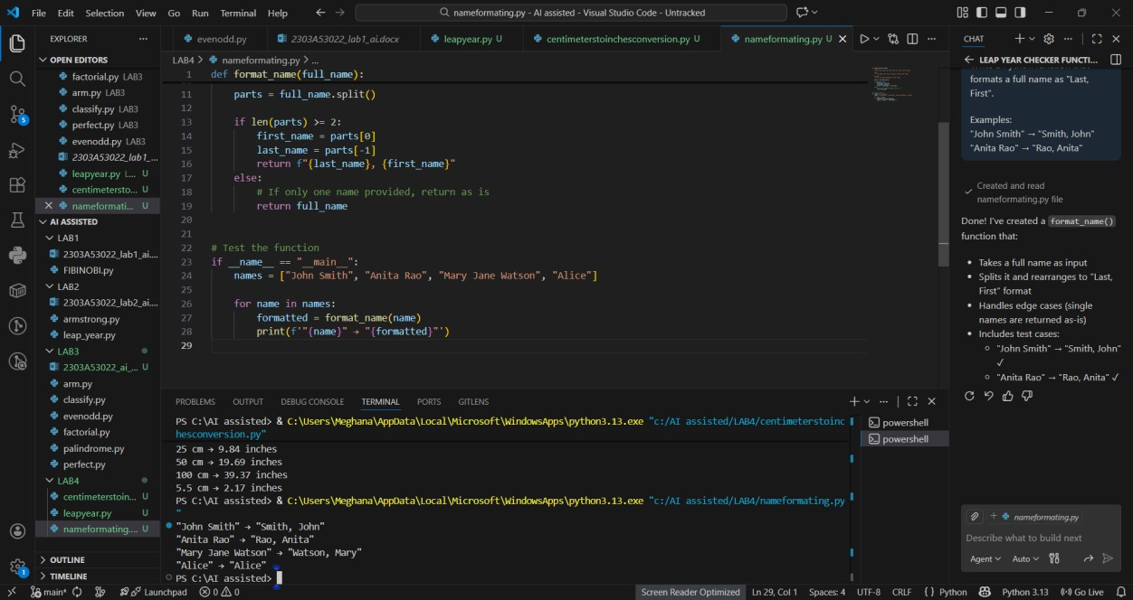

Explanation
- Few-shot examples clarify output format
- Function splits name into first and last
- Output strictly follows given examples

Task 4: Comparative Analysis – Zero-Shot vs Few-Shot Problem: Count Vowels in a String

Zero-Shot Prompt
Write a Python function to count vowels in a string.

Zero-Shot Output
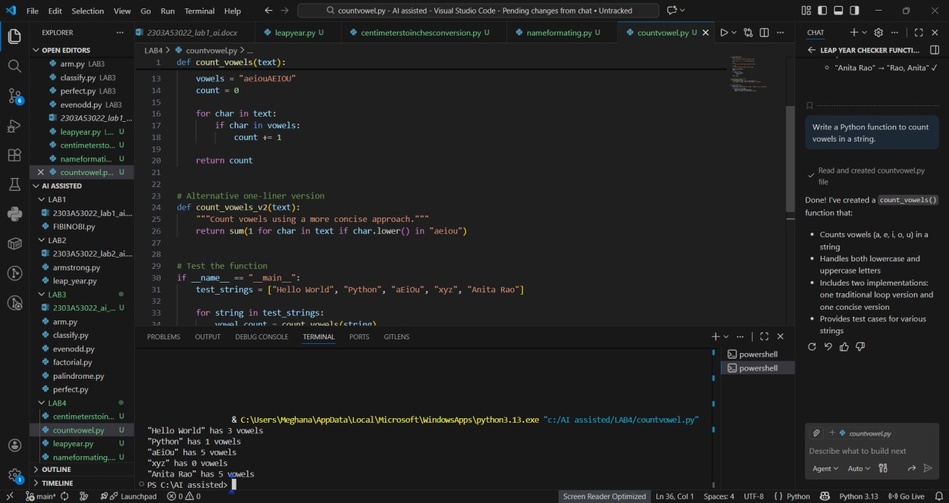

Few-Shot Prompt
Write a Python function to count vowels in a string.

Examples:
"hello" → 2
"AI Tools" → 4
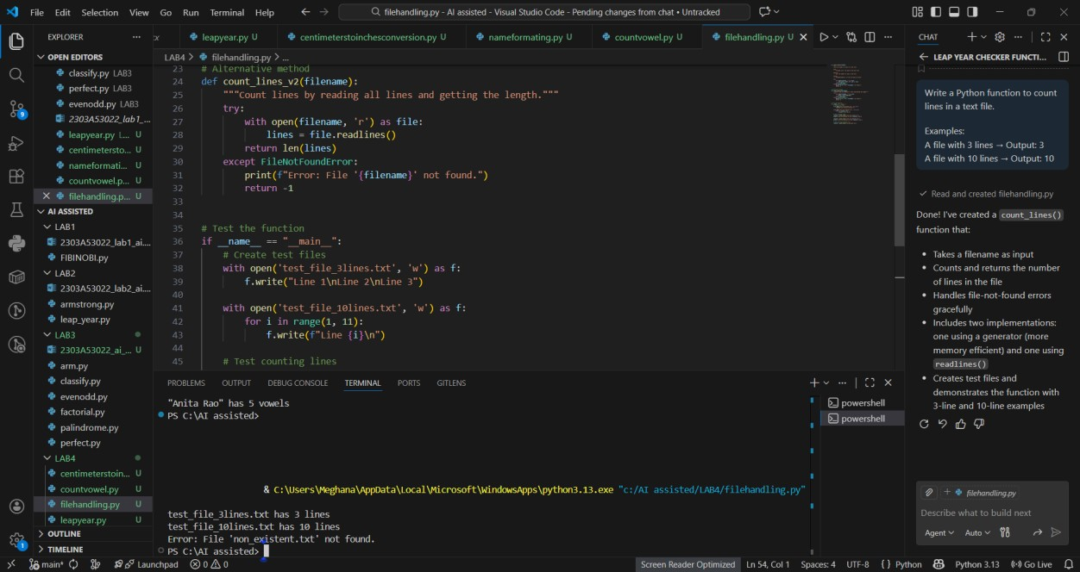
Few
-
Shot Output

Comparison Table

Criteria Zero-Shot Few-Shot
Accuracy Correct Correct
Readability Moderate High
Logical Explicit
Clean & Pythonic
Clarity loop
Efficiency Average Better

Conclusion
Few-shot prompting produced more concise, readable, and optimized code by learning from examples.

Task 5: Few-Shot Prompting – File Handling Prompt Used (Few-Shot)
Write a Python function to count lines in a text file.
Examples:
A file with 3 lines → Output: 3
A file with 10 lines → Output: 10

AI-Generated Python Code Explanation
- File opened in read mode
- readlines() returns list of lines
- Length of list equals number of lines

Overall Conclusion
- Zero-shot works well for simple, well-known problems
- One-shot helps clarify expected behavior
- Few-shot produces the best quality code for formatting and logic-heavy tasks
- Providing examples improves accuracy, readability, and confidence in AI outputs

