Lab-10.1
Name: V.Sriram
2303A53009
Batch:46

Lab 10 – Code Review and Quality: Using AI to Improve Code Quality and
Readability Lab Objectives
- Use AI for automated code review and quality enhancement.
- Identify and fix syntax, logical, performance, and security issues in Python code.
- Improve readability and maintainability through structured refactoring and comments.
- Apply prompt engineering for targeted improvements.
- Evaluate AI-generated suggestions against PEP 8 standards and software engineering best practices

Lab Outcomes:-
- Students will be able to use AI tools to review code.
- Students will be able to improve code quality and readability.
- Students will be able to identify and fix common coding issues.

Task Description #1 – Syntax and Logic Errors
Task: Use AI to identify and fix syntax and logic errors in a faulty Python script.
Sample Input Code:
# Calculate average score of a student def calc_average(marks):
total = 0
for m in marks:
total += m
average = total / len(marks) return
avrage # Typo here marks = [85, 90, 78, 92] print("Average Score is ", calc_average(marks) Expected Output:
• Corrected and runnable Python code with explanations of the fixes.

Prompt:-
Review the following Python code and fix all syntax and logical errors. Explain what was wrong and provide corrected runnable code.

Code(python):-
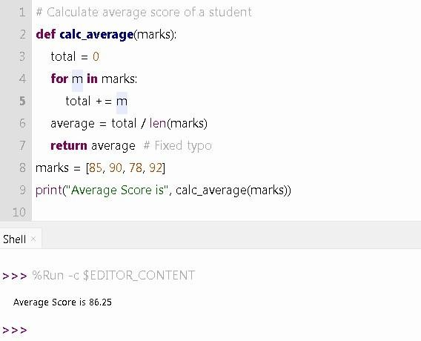

Explanation of Fixes:
- Fixed indentation of average and return.
- Corrected typo: avrage → average.
- Added missing closing parenthesis in print().
- Ensured consistent spacing and formatting.

Task Description #2 – PEP 8 Compliance
Task: Use AI to refactor Python code to follow PEP 8 style guidelines.
Sample Input Code:
def area_of_rect(L,B) : return L*B print(area_of_rect(10,20)) Expected Output:
• Well-formatted PEP 8-compliant Python code.

Prompt:-
Refactor the following Python code to follow PEP 8 style guidelines. Improve formatting, spacing, and naming conventions.

Code(python):-

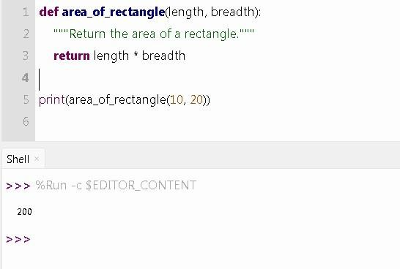

Improvements Made:
- Used descriptive variable names.
- Added docstring.
- Proper spacing.
- Removed one-line function definition.
- Followed PEP 8 naming conventions.

Task Description #3 – Readability Enhancement
Task: Use AI to make code more readable without changing its logic. Sample Input Code: def c(x,y):
return x*y/100 a=200 b=15 print(c(a,b))
Expected Output:
• Python code with descriptive variable names, inline comments, and clear formatting.

Prompt:-
Improve the readability of the following code without changing its logic. Use meaningful variable names and add comments.

Code(python):-
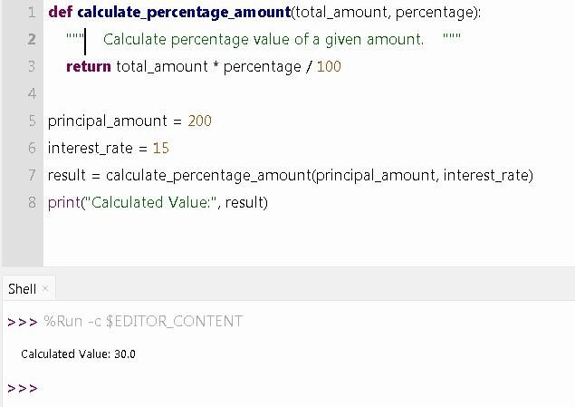

Improvements:
- Function renamed to meaningful name.
- Variables renamed clearly.
- Added comments and spacing.
- Improved output clarity.

Task Description #4 – Refactoring for Maintainability
Task: Use AI to break repetitive or long code into reusable functions.
Sample Input Code:
students = ["Alice", "Bob", "Charlie"]
print("Welcome", students[0]) print("Welcome", students[1]) print("Welcome", students[2]) Expected Output:
• Modular code with reusable functions.

Prompt:-
Refactor the repetitive code into reusable functions to improve maintainability.

Code(python):-
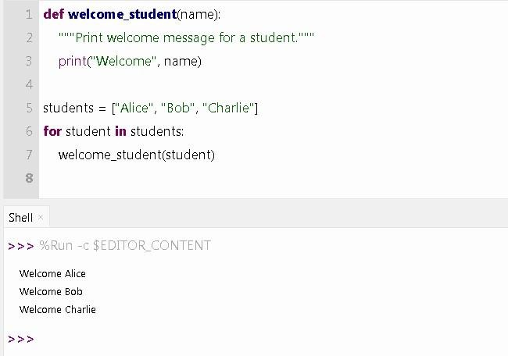
Improvements:
- Removed repetitive print statements.
- Created reusable function.
- Used loop for scalability.
- Code works for any number of students.

Task Description #5 – Performance Optimization
Task: Use AI to make the code run faster. Sample Input Code: # Find squares of numbers nums = [i for i in range(1,1000000)] squares = [] for n in nums:
squares.append(n**2) print(len(squares)) Expected Output:
• Optimized code using list comprehensions or vectorized operations.

Prompt:-
Optimize the following Python code to improve performance using list comprehension.

Code(python):-
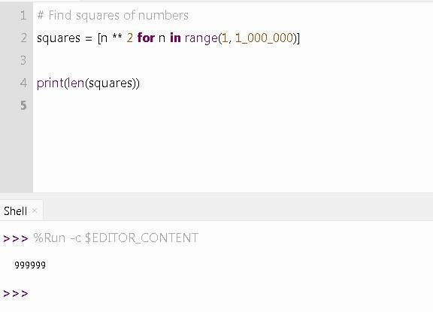
Improvements:
- Removed unnecessary nums list.
- Used direct list comprehension.
- Reduced memory usage.
- Faster execution.

Task Description #6 – Complexity Reduction

Task: Use AI to simplify overly complex logic. Sample Input Code: def grade(score): if
score >= 90: return
"A" else: if score >= 80: return "B" else: if score >= 70: return "C" else: if score >= 60:
return "D" else:
return "F""
Expected Output:
• Cleaner logic using elif or dictionary mapping.

Prompt:-
Simplify the following grading function using cleaner logic such as elif statements.

Code(python):-
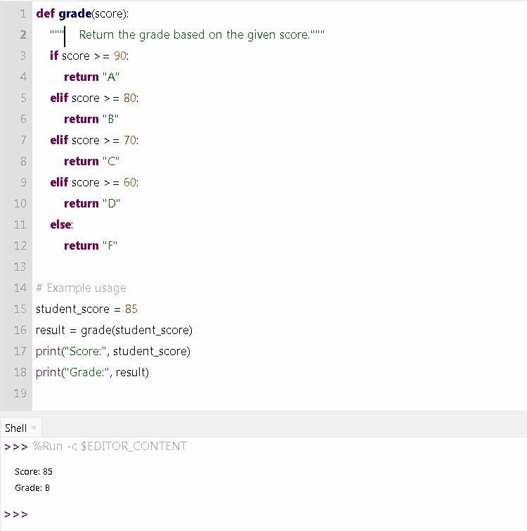

Improvements:
- Replaced nested if-else with elif.
- Fixed syntax error ("F"" → "F").
- Improved readability.
- Reduced indentation complexity

