Lab-16.1

Lab 16 – Database Design and Queries: Schema Design and SQL Generation

Task 1 – Student Information System Schema

Task:
Design a database schema for a Student Information System and generate queries using AI.

Instructions:
- Tables: Students, Courses, Enrollments.
- Define primary keys, foreign keys, and relationships.

- Generate queries:
o Insert a new student record. o Fetch all courses enrolled by a student. o Count number of students in each course.

Expected Output:
- SQL CREATE TABLE statements and queries for student– course relationships.

Prompt:

"Design a normalized SQL database schema for a Student Information System with three tables: Students, Courses, and Enrollments. Define primary keys, foreign keys, and relationships. Generate SQL queries to:

- Insert a new student record.

- Fetch all courses enrolled by a student using an INNER JOIN.

- Count the number of students in each course using GROUP BY. Ensure the syntax is compatible with MySQL 8.0."

Goal:

Create a 3NF schema for Students, Courses, and Enrollments.

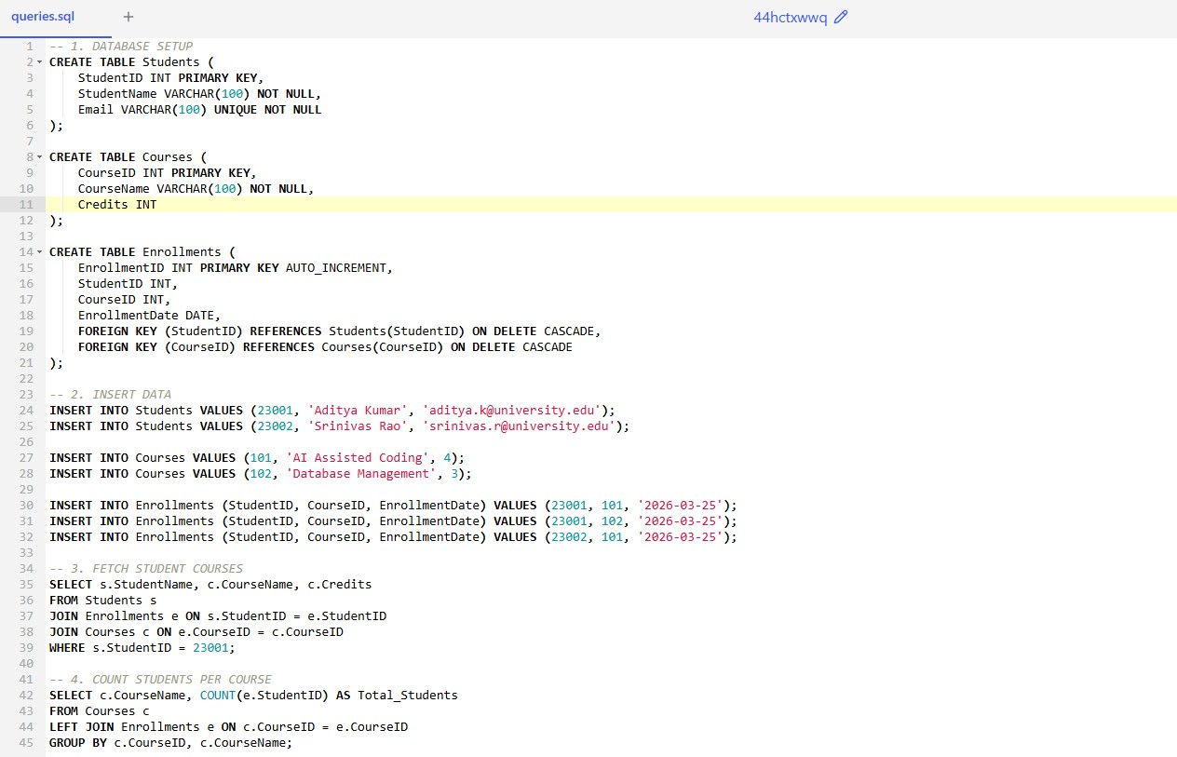

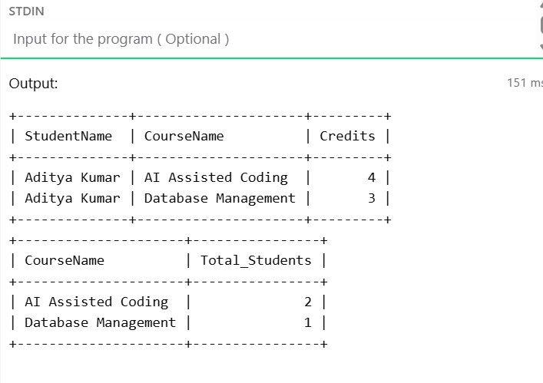

Task 2 – Hospital Management Database

Task:

Create schema and queries for a Hospital Management System.

Instructions:
- Tables: Doctors, Patients, Appointments.
- Use AI to define constraints (unique IDs, valid dates).

- Generate queries:
  - List all appointments for a specific doctor.
  - Retrieve patient history by patient ID. o Count total patients treated by each doctor.

Expected Output:
- Normalized schema and SQL queries with joins.

Prompt:

"Create a SQL schema for a Hospital Management System including Doctors, Patients, and Appointments tables. Use AI to define constraints such as unique IDs and valid dates. Generate queries to:

- List all appointments for a specific doctor.

- Retrieve the complete medical history for a patient by their PatientID.

- Count the total unique patients treated by each doctor using a JOIN and COUNT DISTINCT."

Goal:

Manage appointments with doctor and patient history.

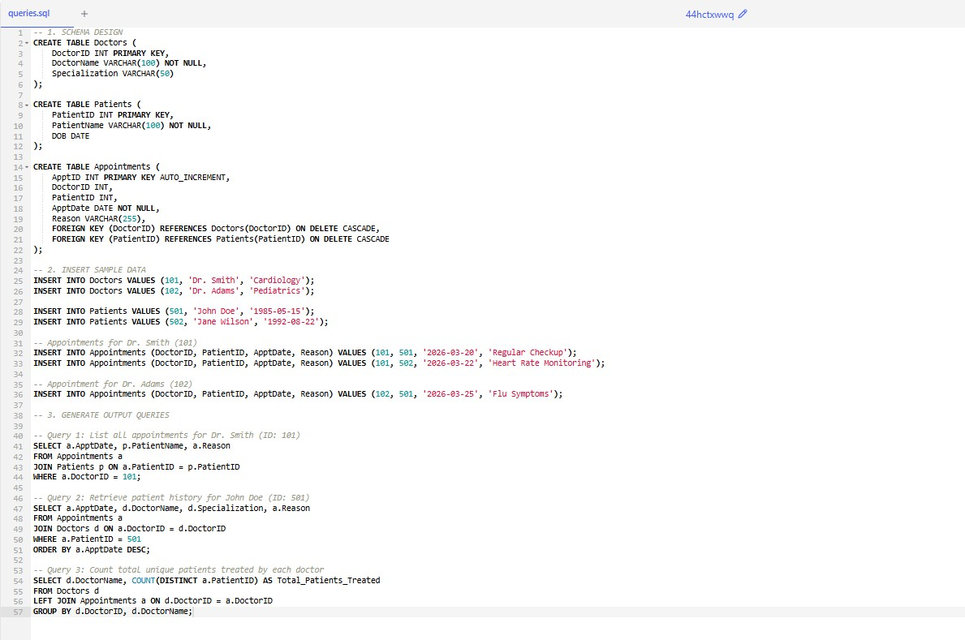

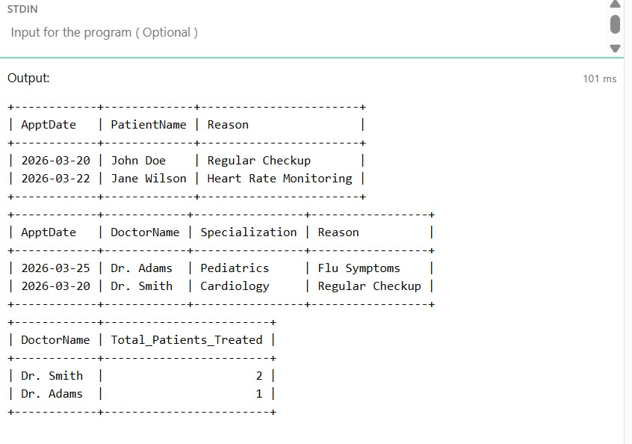

Task 3 – Library Database

Task:
Design schema for a Library Management System.

Instructions:
- Tables: Books, Members, Loans.
- Use AI to suggest indexing strategy for faster queries.

- Generate queries:
o Retrieve all books currently issued. o Find overdue books (loan date > 30 days). o Count number of books loaned by each member.

Expected Output:
- Schema + SQL queries demonstrating joins and conditions.

Prompt:

"Generate a SQL schema for a Library Management System with Books, Members, and Loans tables. Suggest an indexing strategy for faster queries on loan dates. Write queries to:

- Retrieve all books currently issued (where return date is NULL).

- Find overdue books where the loan date is older than 30 days.

- Count the number of books loaned by each member."

Goal:

Track book loans and identify overdue items.
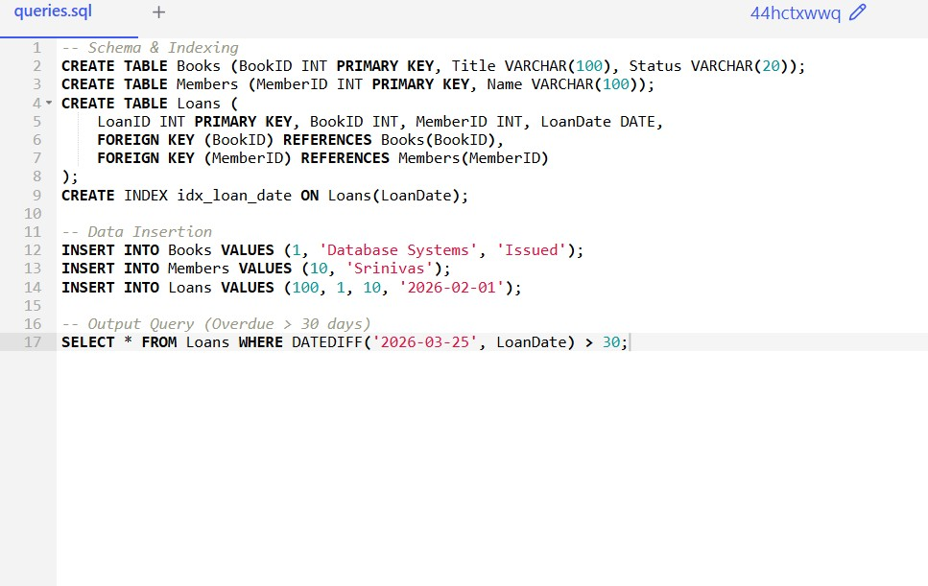

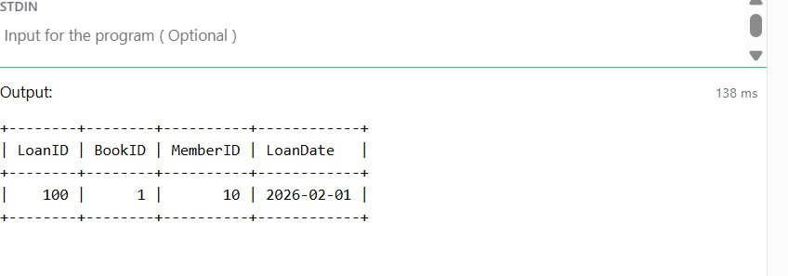

Task 4 – Real-Time Application: Online Shopping Database Scenario:

Design a database for an E-commerce platform.
Requirements:
- Tables: Users, Products, Orders, OrderDetails.

- Generate queries to: o Retrieve all orders by a user. o Find the most purchased product. o Calculate total revenue in a given month.
- AI should also suggest normalization improvements and query optimization.

Expected Output:
- Complete schema with relationships + SQL queries for analytics.

AI Prompt:
Design an E-commerce database (Users, Products, Orders, OrderDetails) in 3NF. Generate queries for user history, most purchased product, and monthly revenue. Suggest query optimization.

Goal: E-commerce analytics and normalization.
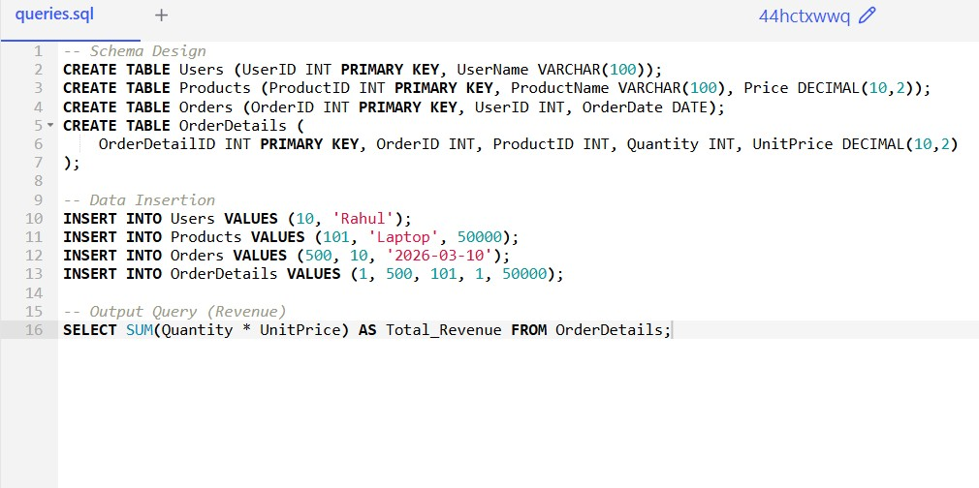

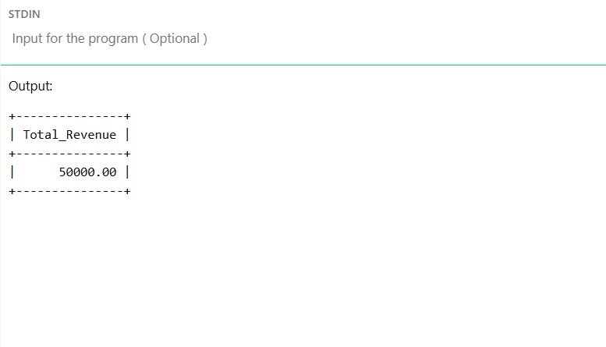
Task 5 – University Examination Database
Design a database schema for a University Examination System and generate SQL queries using AI.
Instructions:
- Tables: Students, Subjects, Exams, Results.
- Define primary keys, foreign keys, and referential integrity constraints.
- Generate queries:
o Insert examination results for a student. o Retrieve subject-wise marks for a student. o Calculate average marks for each subject.
Expected Output:
- Normalized schema and SQL queries involving aggregation and joins.

AI Prompt: Create a schema for a University Exam System with Students, Subjects, Exams, and Results. Define referential integrity. Generate queries for inserting results, student subject marks, and subject averages.
Goal: Referential integrity for exam results.
