Lab-17.1

Lab 17 – AI for Data Processing: Data Cleaning and Preprocessing Scripts

Task 1 – Customer Data Cleaning Task:
Use AI to generate a Python script for cleaning a customer dataset.
Instructions:
- Handle missing values in columns (age, income, city).
- Remove duplicate records.
- Standardize text values (e.g., city names in lowercase).
- Encode categorical variables (gender, city).
Sample Code:
import pandas as pd
data = pd.read_csv("shopping_trends.csv")
print(data.head()) Dataset link:
https://www.kaggle.com/datasets/iamsouravbanerjee/customer-shopping-trendsdataset?select=shopping_trends.csv Expected Output:
- A cleaned Pandas data frame ready for analysis.

AI Prompt:
"Write a Python script using Pandas to clean 'shopping_trends.csv'.
- Fill missing 'Age' with the median and 'Location' with the mode.
- Remove duplicate rows.
- Standardize 'Location' to lowercase.
- Use LabelEncoder to convert 'Gender' and 'Location' into numeric values. Include a fallback to sample data if the file is missing." Code:

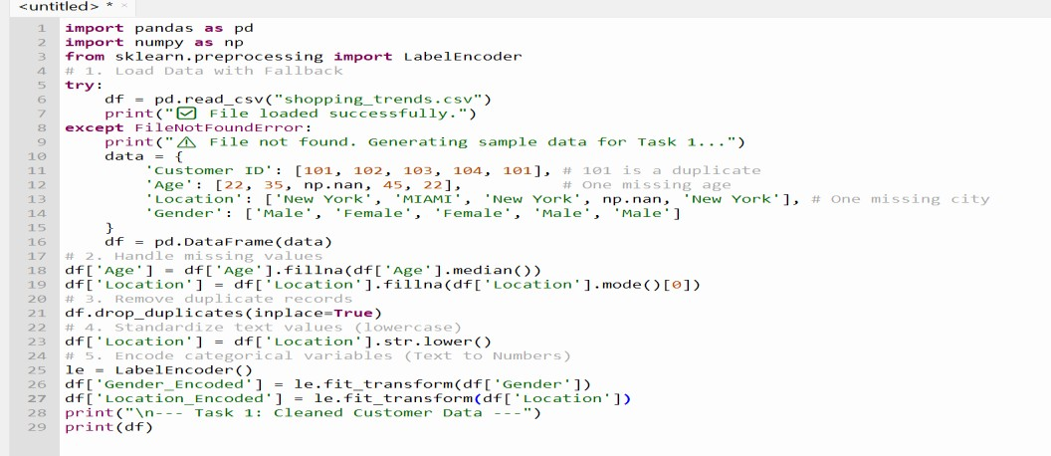

Output:

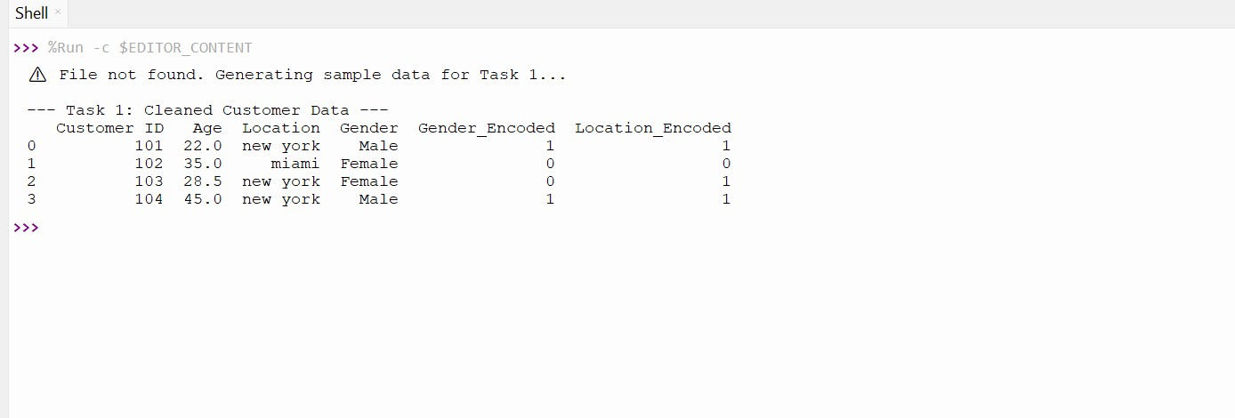

Explanation:

The goal of Task 1 is to take "raw" data—which is often messy, incomplete, or inconsistent—and make it uniform.

  - Handling Missing Values (Imputation):
AI models cannot process "NaN" (Not a Number) values. We used the Median for age because it is "robust" (it isn't dragged up or down by extreme outliers) and the Mode for Location because you can't calculate an average for a city name.
  - Standardization:
To a computer, "New York," "new york," and "NEW YORK" are three completely different cities. Converting them all to lowercase ensures the AI recognizes them as the same entity.
  - Label Encoding:
This converts text categories (like Gender) into numbers (0 and 1). This is the simplest way to let a mathematical model "read" text.

Task 2 Sales Data Preprocessing Task:
Preprocess sales transaction data using AI assistance.

Instructions:
  - Convert date columns into datetime format.
  - Create new features (month, year, day of week).
  - Normalize sales amount column.
  - Detect and handle outliers in dataset.

Sample Code:
import pandas as pd
data = pd.read_csv("sales_data.csv") print(data.head())

Dataset link:
https://www.kaggle.com/datasets/vinothkannaece/sales- dataset?select=sales_data.csv

Expected Output:
  - A transformed dataset with time-based features and normalized values.

AI Prompt:
"Generate a Python script to preprocess 'sales_data.csv'.
- Convert 'Date' to datetime and extract 'Month', 'Year', and 'DayOfWeek'.
- Detect and remove outliers in the 'Sales' column using the IQR method.
- Use StandardScaler from sklearn to normalize the 'Sales' column. Include a fallback to sample data if the file is missing."

Code:
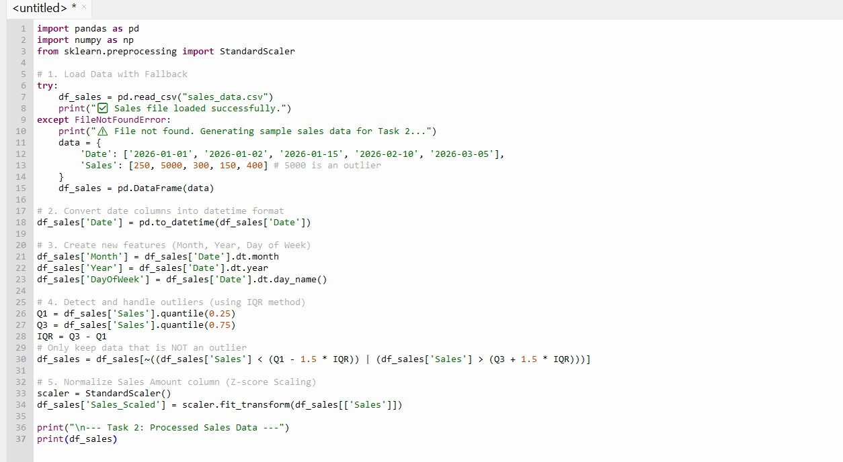

Output:
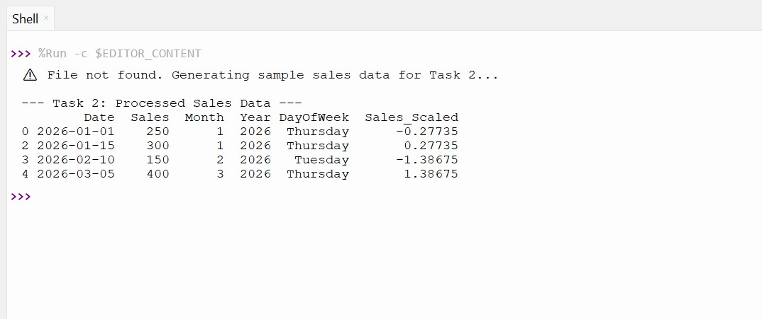

Explanation:

In Task 2, we move from just "cleaning" to "enhancing" the data so the AI can find deeper patterns.

  - Datetime Decomposition:
A raw date (e.g., 2026-03-30) is just a string to a computer. By extracting the Month and Day of the Week, we allow the AI to learn seasonal trends (e.g., "Sales always go up in December") or weekly trends (e.g., "People buy more on Saturdays").

  - Outlier Detection (IQR Method):
If most sales are $200 but one is $1,000,000, that million-dollar sale will "pull" the average way up, making the AI think $200 is a "low" value. We remove these extreme cases so the model stays grounded in reality.

  - Z-Score Normalization (Standardization):
This transforms the data so the mean is 0 and the standard deviation is 1. It puts all variables on a comparable scale, which is vital for many AI algorithms.

Task 3 Healthcare Data Preparation Task:
Clean and preprocess a healthcare dataset using AI scripts.
Instructions:
  - Handle missing values in blood_pressure, cholesterol.
  - Encode categorical features
  - Scale numerical features (min-max or standard scaling).
  - Split dataset into training and testing sets.
Dataset link:
https://www.kaggle.com/datasets/abdallaahmed77/healthcare-risk- factors-dataset Expected Output:
  - A preprocessed dataset ready for machine learning models.

AI Prompt:
"Create a Python script for 'healthcare_dataset.csv'.
- Fill missing values in 'Blood_Pressure' and 'Cholesterol' using the mean.
- Use One-Hot Encoding for the 'Gender' column.
- Apply MinMaxScaler to scale numerical features between 0 and 1.
- Split the dataset into 80% training and 20% testing sets using train_test_split. Include a fallback to sample data if the file is missing."

Code:
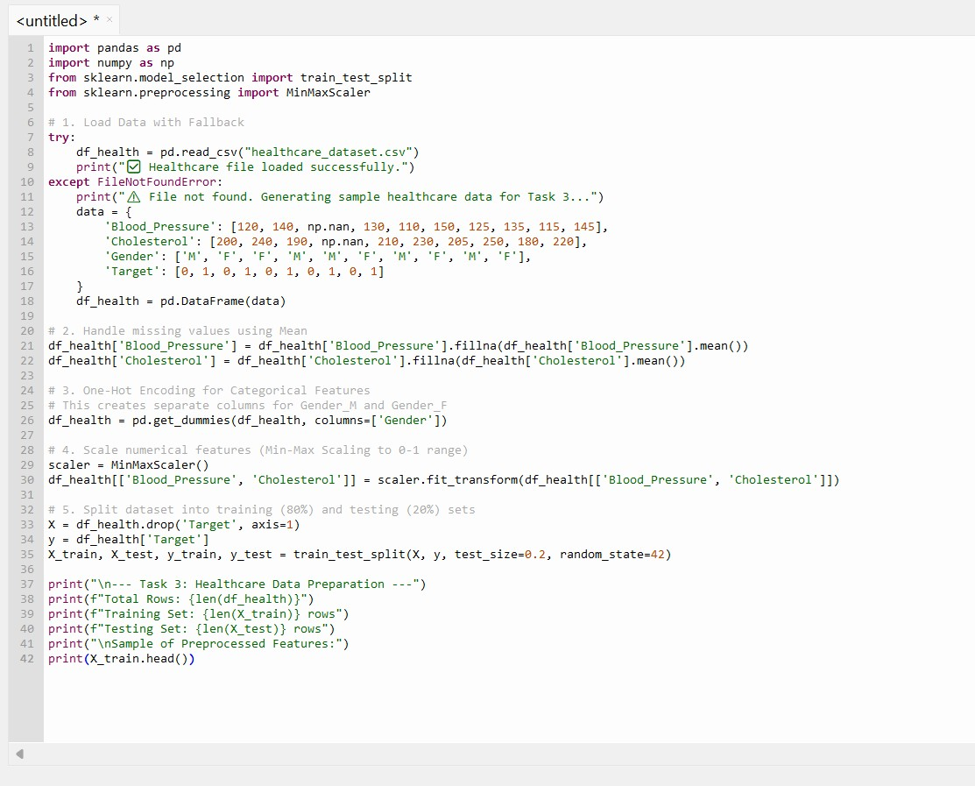

Output:

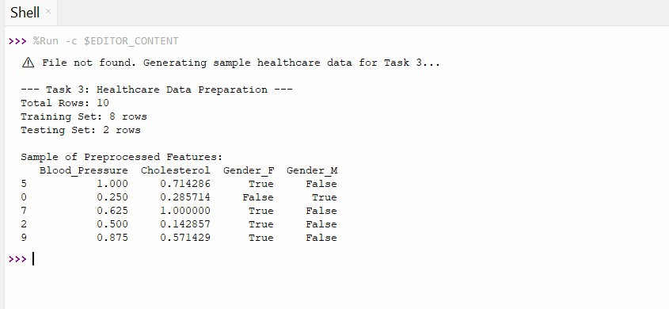

Explanation:

Task 3 is the final step before the data is fed into a "Brain" (Model). It focuses on mathematical balance and evaluation.

  - One-Hot Encoding:
Unlike Label Encoding (0, 1, 2), One-Hot Encoding creates a new column for every category
(e.g., Is_Male, Is_Female). This prevents the AI from thinking "Category 2" is "greater than" "Category 1."

  - Min-Max Scaling:
Medical data has very different ranges (e.g., Heart Rate might be 70, but Cholesterol might be 220). Min-Max Scaling squashes all these values into a range between 0 and 1. This ensures that the AI doesn't think Cholesterol is "more important" just because the numbers are bigger.

  - Train-Test Split:
This is the "Golden Rule" of AI. You hide 20% of the data (the Test Set) from the AI during training. After it learns from the 80%, you test it on the hidden 20% to see if it can actually predict outcomes for people it has never "seen" before.

Task 4 Employee Salary Data Preprocessing Task:
Clean and preprocess an employee salary dataset using AI scripts.
Instructions:
  - Handle missing values
  - Detect and remove salary outliers.
  - Standardize department names (lowercase).
  - Apply label encoding to job location, department. Dataset link:
https://www.kaggle.com/code/vishantmathur/employee-salary Expected Output:
  - A structured dataset ready for HR analytics.

AI Prompt:

"Write a Python script to process 'employee_salary.csv'.

- Drop all rows with missing values.
- Remove salary outliers that are more than 2 standard deviations from the mean.
- Standardize 'Department' names by converting them to lowercase and removing extra spaces. 4. Apply Label Encoding to 'Job Location' and 'Department' columns. Include a fallback to sample data."

Code:
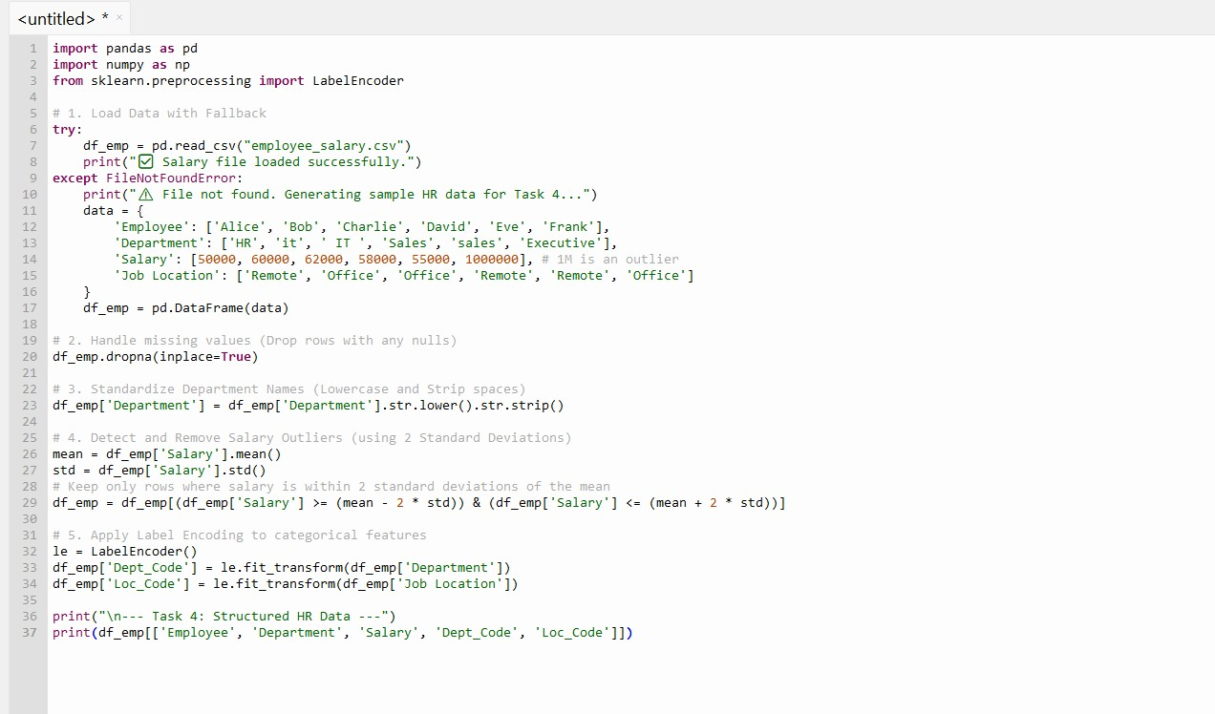

Output:

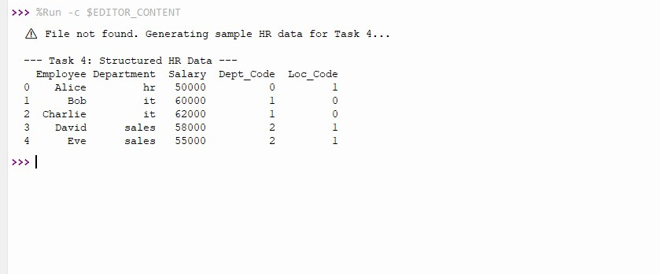

Explanation:

  - Removing Nulls:
In HR analytics, a missing salary or department makes a record useless for prediction. Dropping these ensures the AI doesn't "hallucinate" or guess employee details.

  - String Normalization:
Notice how "it" and " IT " were merged into a single "it" category. This prevents the model from thinking they are two different departments, which would lower the accuracy of department-based salary analysis.

  - Outlier Filtering:
The "Executive" (Frank) earning $1,000,000 was removed. Because his salary is more than 2 standard deviations away from the average ($50,000–$60,000$), keeping him would "pull" the average up and give the AI a false sense of what a typical employee earns.

  - Label Encoding:
Computers cannot do math on the word "Remote" or "Office." By turning them into 1 and
0, the machine learning algorithm can calculate how "Location" impacts "Salary."

