Assignment - 1.3
Name:A.Gouthami
H.NO:2303A53040
BATCH-46

Task 1: AI-Generated Logic Without Modularization (Fibonacci Sequence Without Functions)
INPUT:
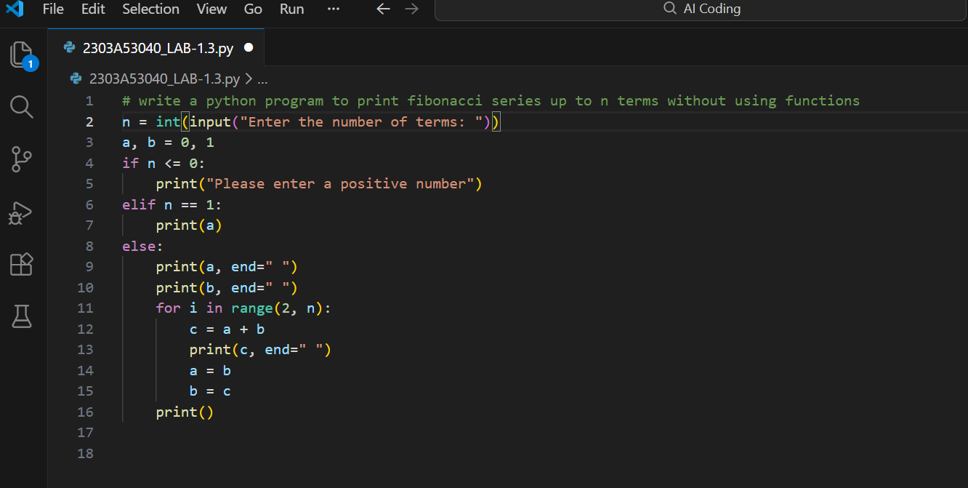
OUTPUT:
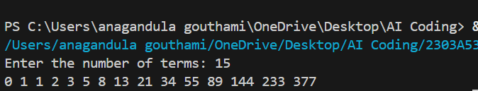
# Program to print Fibonacci series without using any function
# User enters number of terms
# Fibonacci logic is written directly in main code

Task 2: AI Code Optimization & Cleanup (Improving Efficiency)
INPUT:
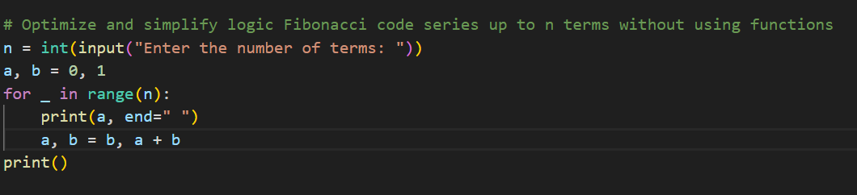
OUTPUT:
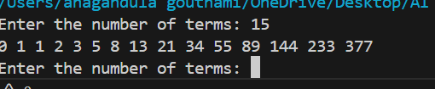
COMMENTS:
# Optimized Fibonacci program
# Redundant variables are removed
# Tuple assignment is used for better readability
# Code is simple and efficient
Task 3: Modular Design Using AI Assistance (Fibonacci Using Functions)
INPUT:
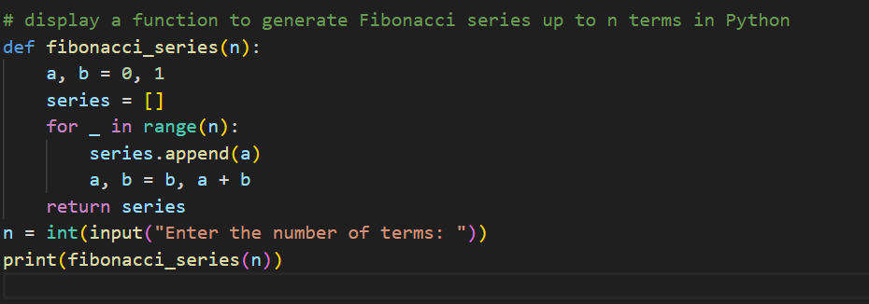
OUTPUT:
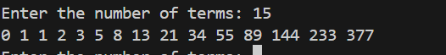
COMMENTS:
# Program to generate Fibonacci series using a function
# Function improves reusability and modularity
# Same logic can be reused in multiple programs

Task 4: Comparative Analysis – Procedural vs Modular Fibonacci Code
INPUT:
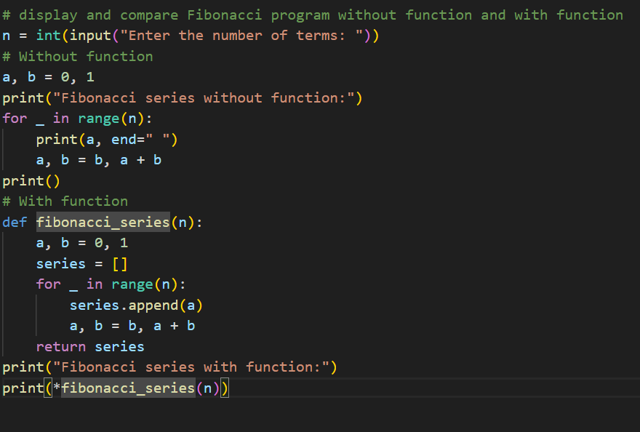
OUTPUT:
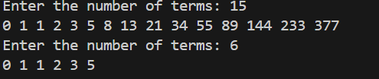
COMMENTS:
# Comparison between Fibonacci program with function and without function
# Function-based code is more reusable and readable
# Procedural code is simple but not suitable for large programs

Task 5: AI-Generated Iterative vs Recursive Fibonacci Approaches (Different Algorithmic Approaches for Fibonacci Series)
INPUT:
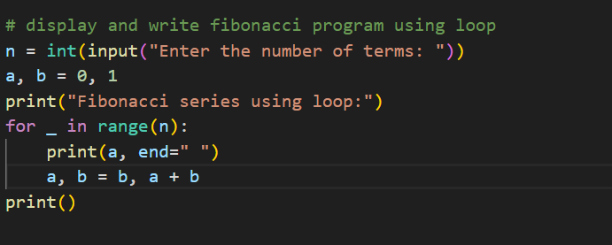
OUTPUT:
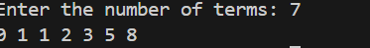
COMMENTS:
# Fibonacci series using iterative approach
# Uses loop to generate Fibonacci numbers
# Faster and memory efficient

