ASSIGNMENT-3

H.NO-2303A53040
BATCH-46

PROBLEM: Develop a basic Solidity smart contract that allows users to:
- Store a message on the blockchain
- Update the message
- Retrieve the stored message
This practical helps understand state variables, functions, constructors, and data types in Solidity.

CODE:
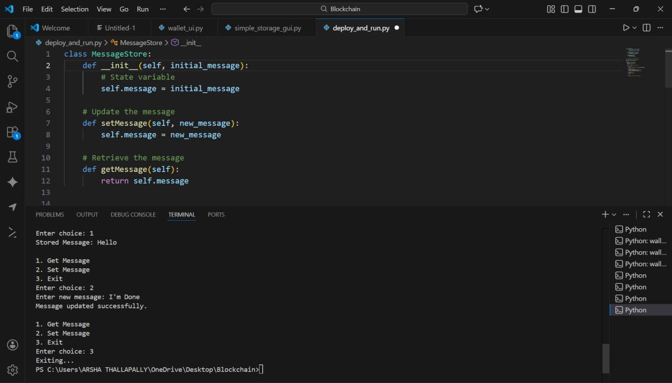

Observation:
state variable =self.message constructor =init
setMessage() =setMessage() getMessage() =getMessage()

