Computer Graphics 2

Test 1

13 March 2024

Shahied Rustin 230500226

Q1.

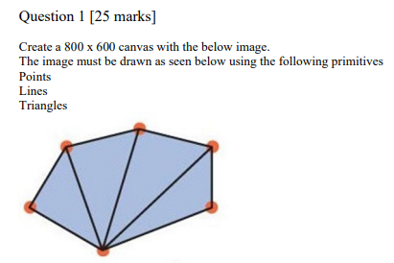

Q2.

Resultant vector = [x`,y`,z`,1`]

= [ (a\*x)+(e\*x)+(i\*x)+(m\*x), (b\*y)+(f\*y)+(j\*y)+(n\*y), z`, 1`]

Q3.

Question 3 [10 marks] Rotate (spin) the object in Question 1 continuously along the Z-axis