Project Documentation
LLM Tutor - Interactive Large Language Model Learning Platform
Prepared from the implemented Streamlit and LangGraph project in the repository.

1. Project Overview
LLM Tutor is an educational AI application designed to help learners understand the foundations and real-world use of large language models through an interactive chatbot experience. The system combines a modern web interface with an agentic workflow, retrieval-augmented generation, and response evaluation so that users receive explanations that are not only conversational, but also grounded in a curated knowledge base.
The project is aimed at students, self-learners, and beginners who often struggle to move from surface-level definitions to practical understanding. Instead of browsing many disconnected articles, the user can ask questions in plain language and receive structured explanations about topics such as transformer architecture, prompt engineering, retrieval augmented generation, LLM evaluation, model comparison, safety, and future trends.

2. Problem Statement
Large language models are now widely discussed, but learning them properly remains difficult. Most beginners encounter scattered tutorials, inconsistent terminology, and highly technical resources that assume prior knowledge of machine learning. At the same time, many general-purpose chatbots answer educational questions with confidence but without clear grounding, which increases the risk of hallucinated or oversimplified explanations.
This project addresses that gap by building a focused tutor for LLM concepts. The goal is to create a learning assistant that can answer topic-specific questions, pull information from a prepared knowledge base, preserve conversation context across turns, and validate its own answers so the user gets a more reliable and guided learning experience.

3. Solution and Features
The proposed solution is a Streamlit-based tutoring platform backed by a LangGraph workflow. When a learner asks a question, the system first stores recent conversation context, then routes the request based on intent. LLM-related questions go through retrieval, date and time questions use a lightweight tool path, and casual or out-of-scope prompts are handled separately. This keeps the application structured and efficient instead of treating every question the same way.

3.1 Key Features
Interactive chat-based learning experience that lets the user ask open-ended questions about LLM concepts in a natural way.
RAG-powered knowledge grounding using a curated 15-topic knowledge base and top-3 semantic retrieval from ChromaDB.
Agentic multi-node design with memory, router, retrieval, answer, evaluation, and save nodes implemented using LangGraph.
Faithfulness scoring and retry logic that helps reduce hallucination by re-generating answers when grounding is weak.
Conversation memory with a sliding window so the tutor can remain coherent across multiple turns without growing context indefinitely.
Premium dark-themed Streamlit interface with quick-start example cards, session information, API key configuration, and topic overview in the sidebar.

3.2 Working Flow
A typical interaction starts with the user entering a question in the chat box. The application appends that question to memory, classifies it into the appropriate route, retrieves the most relevant documents when needed, and then sends the grounded context to the Groq-hosted Llama 3.3 70B model. The generated answer is evaluated for faithfulness, and if the score is too low, the answer node is retried. Once the response is accepted, it is shown to the learner together with sources and the stored conversation state.

4. Screenshots
The following visuals represent the implemented project interface and system behavior. They highlight the main user experience, the quick-start learning flow, and the grounded chat response view that includes sources and evaluation details.
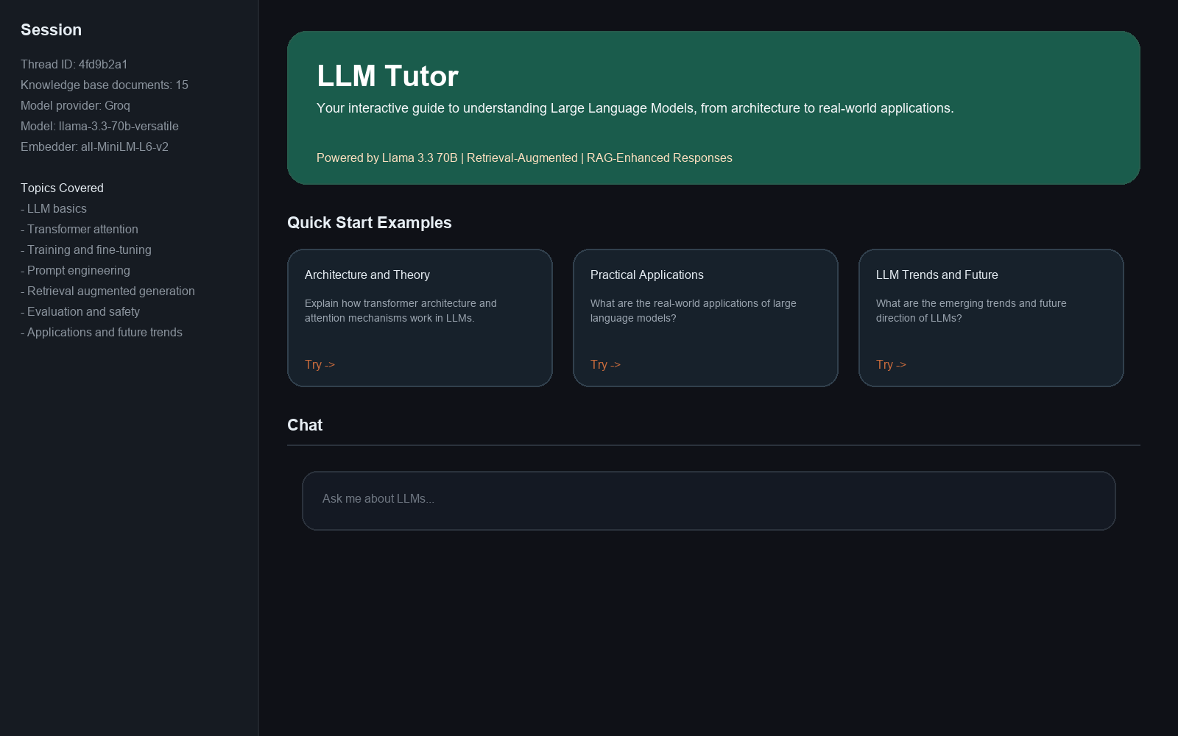
Figure 1. Home screen showing the Streamlit interface, sidebar details, and quick-start prompts.
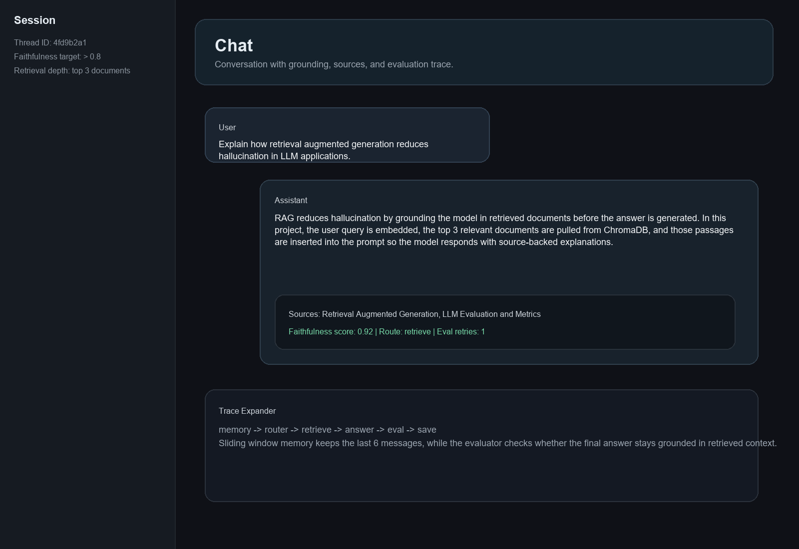
Figure 2. Chat response view showing a grounded answer, sources, and faithfulness trace.

5. Technical Architecture
The architecture is intentionally modular. Streamlit manages the user interface and session state, LangGraph controls the reasoning workflow, ChromaDB stores vectorized knowledge chunks, SentenceTransformer produces embeddings, and Groq provides the high-speed inference layer. This separation makes the system easier to understand, test, and extend.
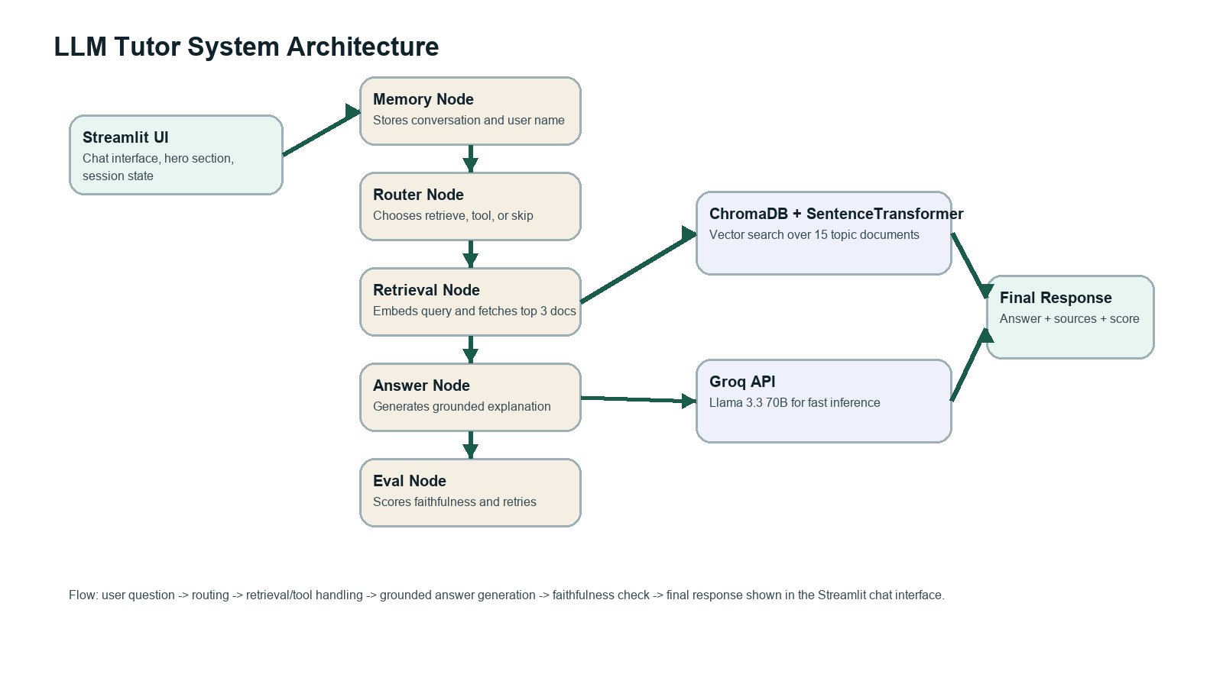
Figure 3. High-level architecture of the LLM Tutor system.

6. Tech Stack
Layer | Technology | Role in Project
Frontend | Streamlit | Provides the chat interface, sidebar controls, and guided prompts.
Agent Workflow | LangGraph | Implements the memory, routing, retrieval, answer, evaluation, and save nodes.
LLM Provider | Groq with Llama 3.3 70B | Generates fast, conversational answers for learning-focused queries.
Retrieval | ChromaDB + SentenceTransformer | Stores embeddings and finds the top 3 relevant knowledge chunks.
Knowledge Base | Python data module | Curates 15 topic documents covering LLM theory, practice, and trends.
Evaluation | LLM-as-judge scoring | Checks faithfulness and retries answers that are not grounded enough.

7. Unique Points
Unlike a simple chatbot wrapper, this project combines retrieval, routing, memory, and evaluation in one educational workflow. The application does not just answer questions; it decides how the question should be handled and checks whether the final answer remains grounded in the retrieved material.
The project is also domain-focused. Instead of covering every possible topic, it concentrates on teaching large language models through a curated knowledge base. This makes the assistant more useful for learning and demonstration because the answers remain aligned with the assignment theme.
Another strong point is the balance between user experience and engineering depth. The interface is simple enough for non-technical users, while the backend shows important AI engineering concepts such as vector retrieval, prompt grounding, conversation memory, answer evaluation, and multi-route agent design.

8. Future Improvements
The first improvement would be persistent storage for conversations and analytics, allowing users to revisit previous sessions, compare question patterns, and track learning progress over time.
The retrieval system could be improved with hybrid search, chunk optimization, or re-ranking so that context selection becomes even more accurate for long and nuanced questions.
The evaluation module can be expanded beyond faithfulness to include answer relevance, context precision, and user feedback scores. This would create a more complete quality-monitoring pipeline for the tutor.
From a product perspective, the platform could later support quizzes, topic-wise lessons, multilingual explanations, downloadable notes, and deployment to a public cloud environment for easier access.

9. Conclusion
LLM Tutor demonstrates how an agentic AI application can be designed for education rather than generic chat. By combining a curated knowledge base, retrieval-augmented generation, routing logic, conversation memory, and answer evaluation, the project delivers a practical and technically sound learning tool for understanding large language models. The implementation is clear, modular, and aligned with current AI application development practices, which makes it suitable both as a capstone submission and as a strong foundation for future enhancement.

