Project Documentation
LLM Tutor - A Retrieval-Grounded Study Assistant for Large Language Models
Original write-up prepared from the implemented Streamlit application and LangGraph pipeline.

1. Project Overview
LLM Tutor is a subject-focused AI learning tool created to explain large language model concepts through a guided chat experience. Instead of behaving like a general chatbot, it is designed as a focused tutor that answers questions about LLM basics, transformer architecture, training, prompting, retrieval, evaluation, and practical use cases with the support of a curated internal knowledge base.
The idea behind the project is simple: many beginners want to study LLMs, but most available resources are either too scattered or too advanced. This application brings the material into one place, lets the learner ask questions in natural language, and returns answers that are easier to follow because the system combines conversation flow, relevant context retrieval, and a basic reliability check.

2. Problem Statement
Learning about large language models is difficult for new students because the topic spans neural networks, transformers, data preparation, prompting, evaluation, and deployment. A learner who searches online usually finds isolated articles, mixed terminology, and explanations with very different depth levels. That makes it hard to build a clear mental model of how LLM systems actually work.
Another problem is reliability. A generic chatbot may reply fluently, but the answer may not stay grounded in the intended learning material. This project solves that issue by building a dedicated tutor that retrieves information from prepared documents, keeps short-term conversation history, and scores the generated answer before returning it. The objective is to make LLM learning more structured, trustworthy, and beginner-friendly.

3. Solution and Features
The solution is implemented as a Streamlit web application connected to a LangGraph-based backend. When the learner submits a question, the system first records recent conversation context, then decides which path should handle the request. Questions about LLMs trigger retrieval from the knowledge base, time-related prompts go through a simple tool route, and irrelevant or casual prompts are handled without unnecessary retrieval. This design keeps the system organized and avoids wasting computation.

3.1 Key Features
Natural question-answer interface that allows the learner to explore LLM concepts in a conversational way instead of reading static notes.
Retrieval-grounded response generation using a custom knowledge base of 15 topic areas and semantic search over the most relevant entries.
Node-based workflow with separate stages for memory update, intent routing, retrieval, answer generation, faithfulness checking, and response saving.
Automatic answer review through a faithfulness score, with retry behavior when the generated response is not grounded strongly enough.
Sliding-window conversation memory that preserves recent context while keeping the prompt size manageable.
Clean Streamlit interface with a sidebar summary, quick-start example buttons, topic list, session identifier, and API key setup area.

3.2 Working Flow
A normal session begins when the user types a question into the chat box. The memory node stores the latest interaction, the router decides the correct processing path, and the retrieval step searches the vector store for the most relevant content when the question is knowledge-based. That retrieved context is added to the prompt sent to the language model. After the answer is produced, the evaluation step checks how well it matches the supporting material. If the score is weak, the answer can be regenerated before the final result is saved and displayed.

4. Screenshots
The following figures present the main user interface and the internal design of the project. They show how the learner enters the system, how the chat experience looks during a real educational query, and how the backend components work together to produce grounded answers.
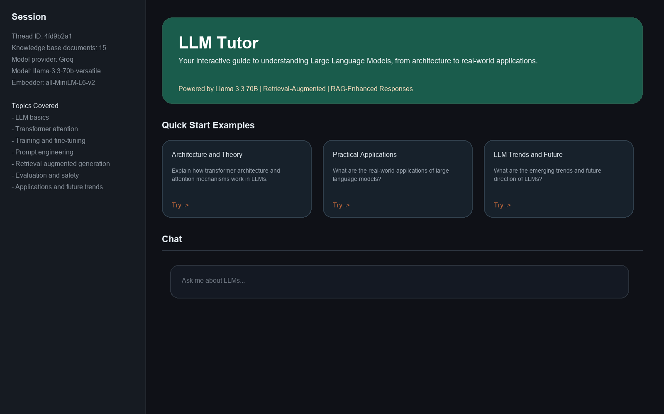
Figure 1. Main application view with sidebar details and guided starter prompts.
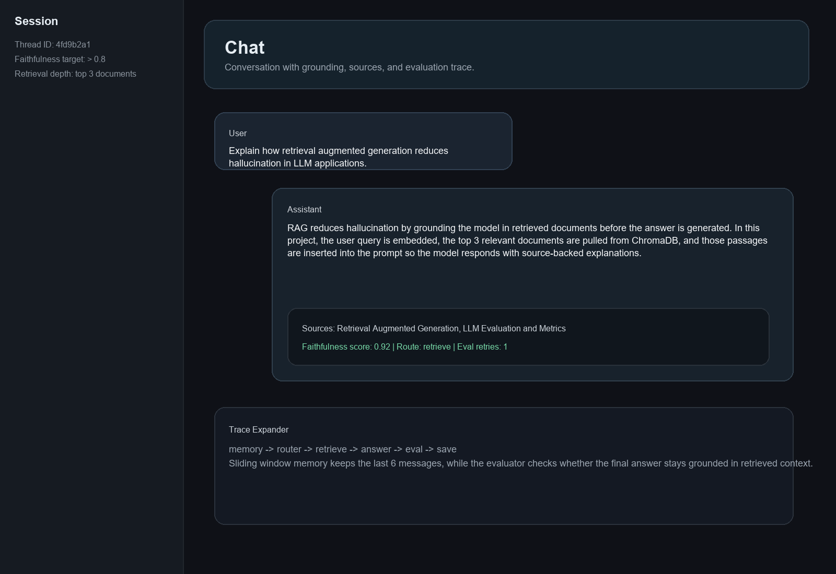
Figure 2. Example chat output with retrieved sources and faithfulness information.

5. Technical Architecture
The project follows a modular architecture so that each layer handles a clear responsibility. Streamlit manages the visible interface and session state. LangGraph controls the backend decision flow. SentenceTransformer converts both user queries and learning documents into embeddings. ChromaDB stores those vectors and returns the closest matching content. Groq provides access to the Llama 3.3 70B model, which generates the final explanation after retrieval has prepared the context. This separation improves readability, maintainability, and future scalability.
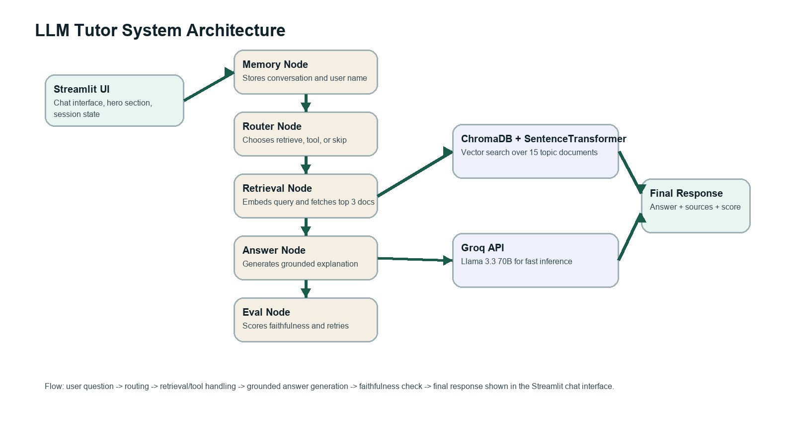
Figure 3. High-level component flow used by the LLM Tutor system.

6. Tech Stack
Layer | Technology | Role in Project
Frontend | Streamlit | Used to build the chat page, sidebar, session controls, and guided example prompts.
Workflow Engine | LangGraph | Runs the node-based flow for memory handling, routing, retrieval, response generation, and saving state.
Model Layer | Groq with Llama 3.3 70B | Produces fast answers for student questions inside the tutoring workflow.
Retrieval Layer | ChromaDB + SentenceTransformer | Converts topics into embeddings and returns the closest knowledge chunks for each query.
Content Layer | Python knowledge base module | Stores curated learning material on transformers, training, RAG, evaluation, safety, and applications.
Quality Check | Faithfulness scoring | Measures whether the answer stays tied to the retrieved context before it is shown to the user.

7. Unique Points
A key strength of this project is that it is not built as a plain prompt-to-response chatbot. It makes a routing decision, retrieves supporting information, and runs a post-generation faithfulness check before the answer becomes part of the user experience.
The project is also strongly aligned with one learning domain. Because the knowledge base is dedicated to LLM topics, the tutor remains focused and educational rather than drifting into unrelated areas.
Another unique aspect is the balance between simplicity and engineering value. The interface is approachable for students, while the backend demonstrates modern AI application patterns such as retrieval augmentation, graph-based orchestration, conversational memory, and lightweight answer validation.

8. Future Improvements
An important next step would be permanent conversation storage so that users can resume previous study sessions and review earlier questions.
The retrieval layer can be improved further with hybrid search, re-ranking, or better chunk design so that document matching becomes stronger for long and detailed questions.
The current answer check focuses mainly on faithfulness. In a future version, the project could also track answer relevance, context precision, and direct user feedback to build a broader evaluation pipeline.
The product can also grow beyond chat by adding quizzes, topic-based study modules, downloadable summaries, multilingual support, and cloud deployment for easier classroom access.

9. Conclusion
LLM Tutor shows how an educational AI system can be built with more structure than a standard chatbot. By combining domain-focused content, retrieval-grounded generation, graph-based orchestration, short-term memory, and answer checking, the project creates a practical tool for learning about large language models. The final result is both a useful student-facing application and a solid demonstration of current AI engineering practices.

