EXPERIMENT – 11

Performing IP Spoofing Using a GitHub Tool in Kali Linux

Aim:
To demonstrate IP spoofing techniques using an open-source GitHub tool in Kali Linux for understanding network-level attack concepts and security vulnerabilities.

Software Requirements
- Host Operating System: Windows / Linux / macOS
- Virtualization Software: Oracle VirtualBox
- Guest Operating System: Kali Linux
- Tool Source: GitHub (IP Spoofing Tool – Educational Use)
- Programming Language: Python / Bash (as per tool)
- System Requirements:
- RAM: Minimum 4 GB (8 GB recommended)
- Disk Space: Minimum 30 GB
- Processor: Intel/AMD with Virtualization support

Procedure:

Step 1: Start Kali Linux Virtual Machine
- Open Oracle VirtualBox.
- Start Kali Linux.
- Log in using Kali credentials.

Step 2: Open Terminal
- Launch Terminal in Kali Linux.
- Update system packages:
sudo apt update

Step 3: Clone IP Spoofing Tool from GitHub
- Clone the repository:
git clone https://github.com/<username>/<ip-spoofing-tool>
- Navigate to the tool directory:
cd ip-spoofing-tool

Step 4: Install Dependencies
- Install required dependencies:
sudo apt install python3
pip3 install -r requirements.txt

Step 5: Configure the Tool
- Open the script file:
nano spoof.py
- Configure:
  - Target IP address
  - Spoofed source IP address
  - Network interface

Step 6: Execute IP Spoofing
- Run the tool with root privileges:
sudo python3 spoof.py
- Observe packet transmission with spoofed IP addresses.

Step 7: Monitor Network Traffic (Optional)
- Use Wireshark or tcpdump:
sudo tcpdump
- Verify spoofed source IP packets.

Output:

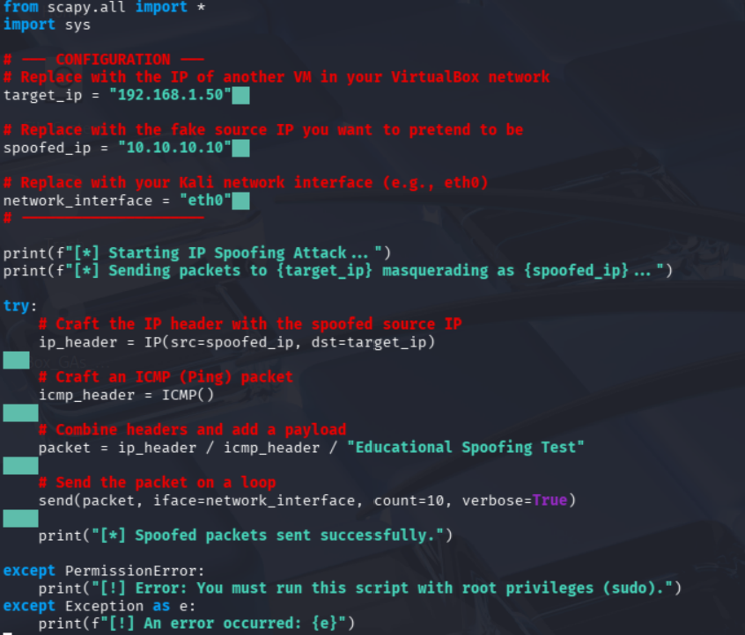

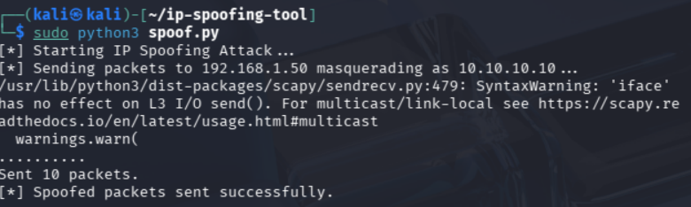

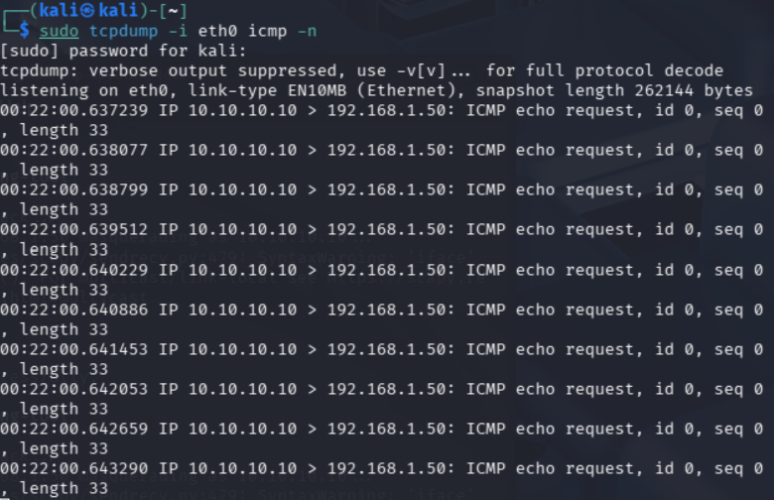

Result:
IP spoofing was successfully demonstrated using a GitHub-based tool in Kali Linux.
The experiment illustrates how attackers can manipulate IP headers and highlights the need for robust network security mechanisms.

