EXPERIMENT – 12

Study of Camera Phishing Using an Open-Source GitHub Tool in Kali Linux (Educational Demonstration)

Aim:
To study the concept of camera phishing attacks using an open-source GitHub tool in Kali Linux in order to understand privacy threats and the importance of secure user awareness.

Software Requirements:
- Host Operating System: Windows / Linux / macOS
- Virtualization Software: Oracle VirtualBox
- Guest Operating System: Kali Linux
- Study Tool: Open-source GitHub camera phishing framework
- System Requirements:
- RAM: Minimum 4 GB (8 GB recommended)
- Disk Space: Minimum 30 GB
- Processor: Intel/AMD with Virtualization support

Procedure:

Step 1: Start Kali Linux Virtual Machine
- Open Oracle VirtualBox.
- Start Kali Linux.
- Log in using Kali credentials.

Step 2: Study the Open-Source Tool
- Access an open-source GitHub repository related to camera phishing (educational purpose).
- Review the documentation to understand:
  - How fake permission prompts are created
  - How user interaction is exploited
  - Ethical limitations of such tools

Step 3: Understand the Attack Workflow
- Analyze how phishing pages request camera permissions.
- Observe how browsers handle camera access requests.
- Study how attackers misuse user trust.

Step 4: Simulated Demonstration
- Perform a local, consent-based simulation using test accounts.
- Observe how camera permission prompts appear.
- Analyze user response behavior.

Step 5: Analyze Security Implications
- Identify risks related to:
  - Unauthorized camera access
  - Privacy leakage
  - Social engineering
- Discuss how modern browsers and OS security attempt to mitigate such attacks.

Step 6: Study Prevention Techniques
- Browser permission management
- User awareness and training
- HTTPS and trusted domains
- OS-level camera access controls

Output:

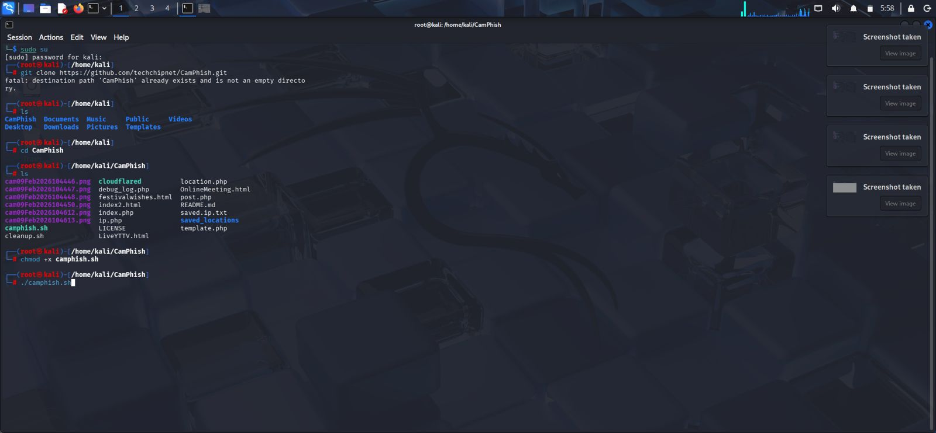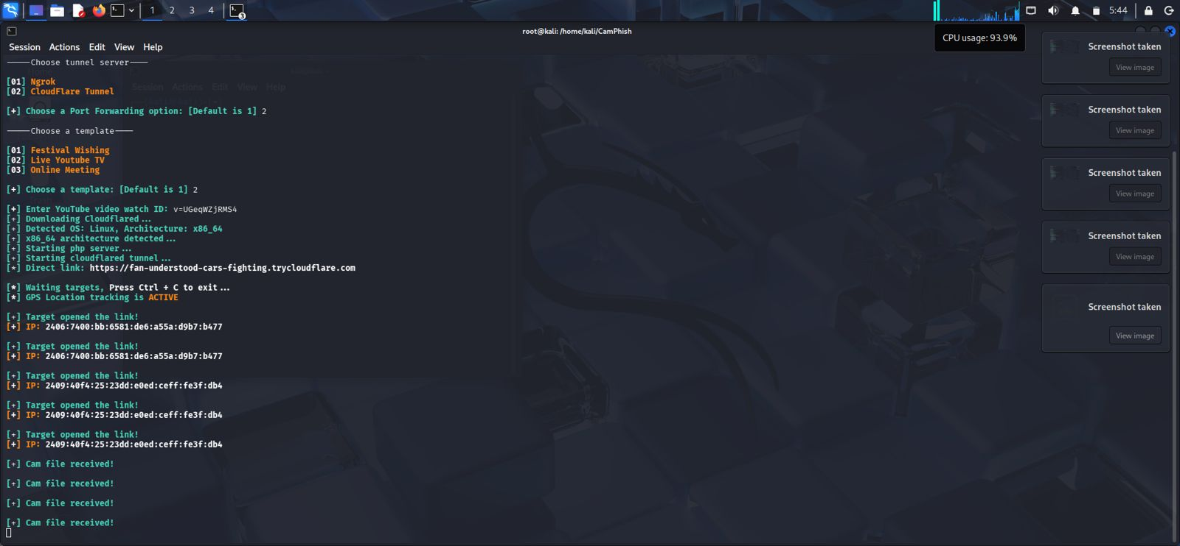

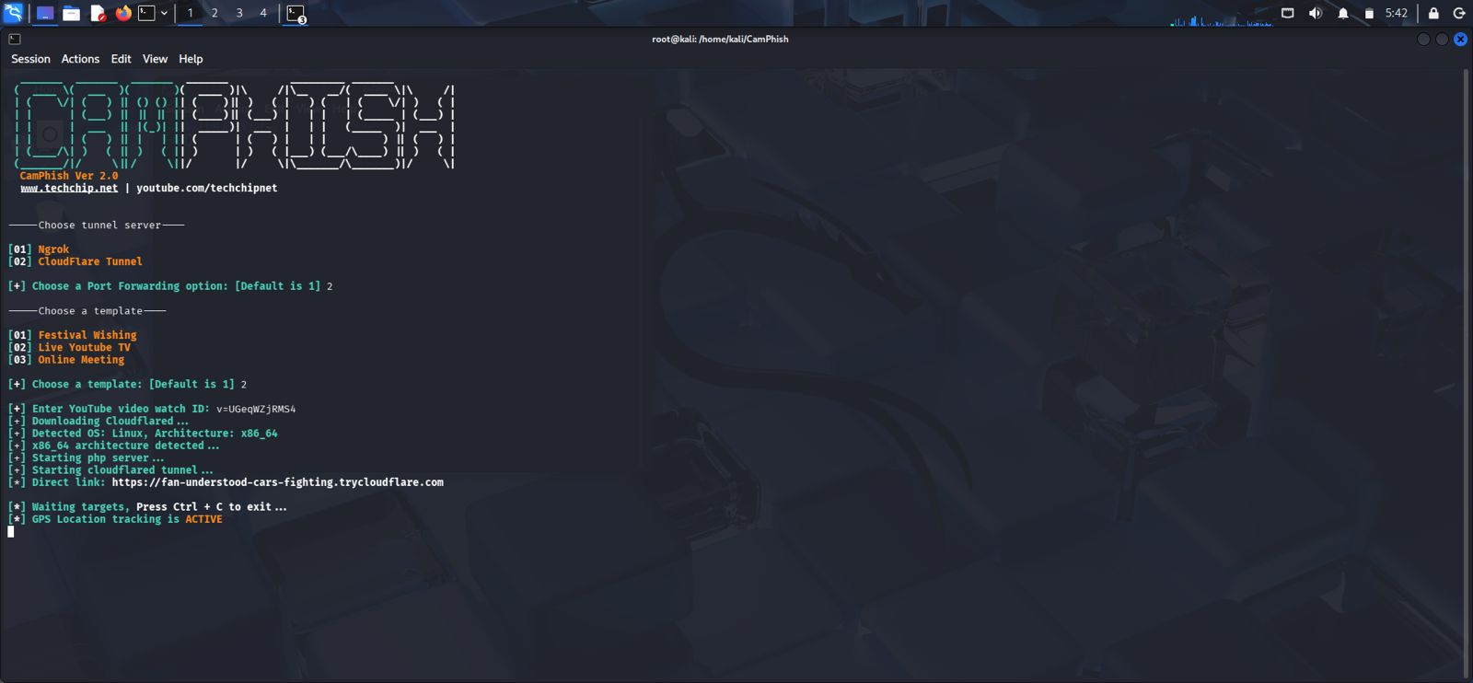

Result:
The study of camera phishing using an open-source GitHub tool was successfully completed in Kali Linux.
The experiment enhanced understanding of social-engineering attacks and emphasized the importance of user awareness and privacy protection.

