EXPERIMENT – 14

Study and Demonstration of Brute Force Password Attack in a Controlled Kali Linux Environment

Aim:
To study and demonstrate the concept of brute force password attacks in a controlled Kali Linux environment to understand password vulnerabilities and the importance of strong authentication mechanisms.

Software Requirements:
- Host Operating System: Windows / Linux / macOS
- Virtualization Software: Oracle VirtualBox
- Guest Operating System: Kali Linux
- Study Tools: Open-source password auditing utilities (educational use only)
- System Requirements:
  - RAM: Minimum 4 GB (8 GB recommended)
  - Disk Space: Minimum 30 GB
  - Processor: Intel/AMD with Virtualization support

Procedure:

Step 1: Start Kali Linux Virtual Machine
- Open Oracle VirtualBox.
- Start Kali Linux.
- Log in using Kali credentials.

Step 2: Set Up a Controlled Test Environment
- Use a locally created test account or dummy authentication service.
- Ensure no real systems or credentials are involved.
- Confirm the environment is isolated from external networks.

Step 3: Study Brute Force Attack Workflow
- Understand how login mechanisms validate credentials.
- Analyze how attackers automate repeated login attempts.
- Observe how password complexity affects attack feasibility.

Step 4: Educational Demonstration (Simulation Only)
- Simulate repeated authentication attempts using dummy data.
- Observe system responses such as delays or access denial.
- Record observations without executing real attacks.

Step 5: Analyze Security Weaknesses
- Weak or short passwords
- No rate limiting
- Missing account lockout policies
- Lack of multi-factor authentication

Step 6: Study Prevention and Mitigation Techniques
- Strong password policies
- Account lockout and rate limiting
- CAPTCHA mechanisms
- Multi-factor authentication (MFA)
- Monitoring and alerting

Output:

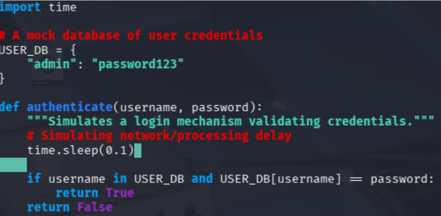

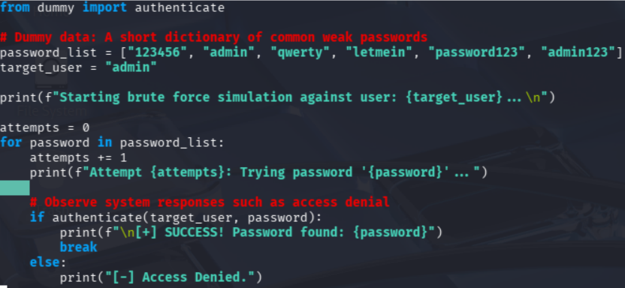

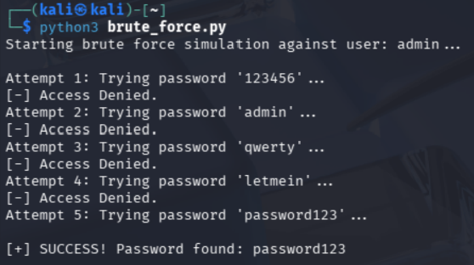

Result:
The study and demonstration of brute force password attacks were successfully completed in a controlled Kali Linux environment.

