EXPERIMENT – 3

Performing Man-in-the-Middle (MITM) Attacks Using Ettercap in Kali Linux

Aim:
To perform and analyze a Man-in-the-Middle (MITM) attack using the Ettercap tool in Kali Linux for educational and ethical hacking purposes.

Software Requirements:
- Host Operating System: Windows / Linux / macOS
- Virtualization Software: Oracle VirtualBox
- Guest Operating System: Kali Linux
- Security Tool: Ettercap
- System Requirements:
  - RAM: Minimum 4 GB (8 GB recommended)
  - Disk Space: Minimum 30 GB
  - Processor: Intel/AMD with Virtualization support

Procedure:

Step 1: Start Kali Linux Virtual Machine
- Launch Oracle VirtualBox.
- Start the Kali Linux virtual machine.
- Log in using Kali credentials.

Step 2: Verify Network Connectivity
- Ensure Kali Linux is connected to the same network as the target system.
- Check IP address using:
ifconfig

Step 3: Launch Ettercap
- Open Terminal in Kali Linux.
- Start Ettercap with graphical interface:
ettercap -G

Step 4: Select Network Interface
- In Ettercap GUI, click Sniff → Unified Sniffing.
- Select the active network interface (e.g., eth0 or wlan0).
- Click OK.

Step 5: Scan for Hosts
- Click Hosts → Scan for Hosts.
- After scanning, select Hosts → Hosts List.
- Identify the target system and gateway.

Step 6: Configure MITM Attack
- Add the target system as Target 1.
- Add the gateway/router as Target 2.
- Click MITM → ARP Poisoning.
- Enable Sniff remote connections.
- Click OK.

Step 7: Start Sniffing
- Click Start → Start Sniffing.
- Observe intercepted traffic in real time.

Output:

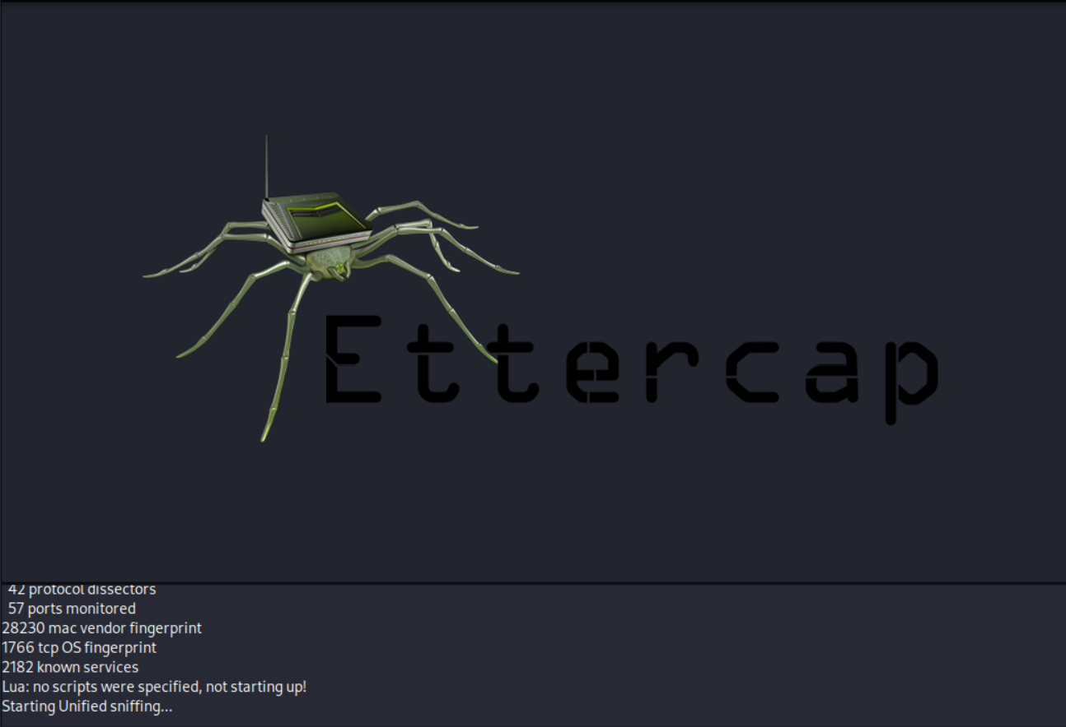

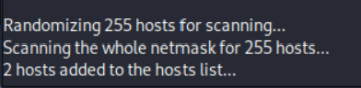

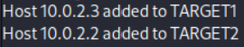

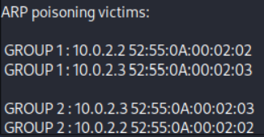

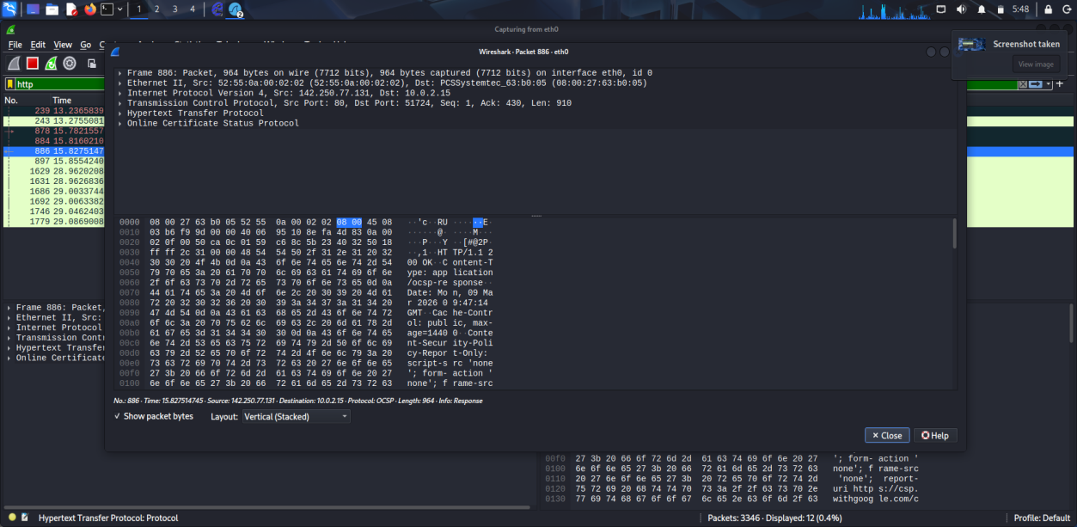

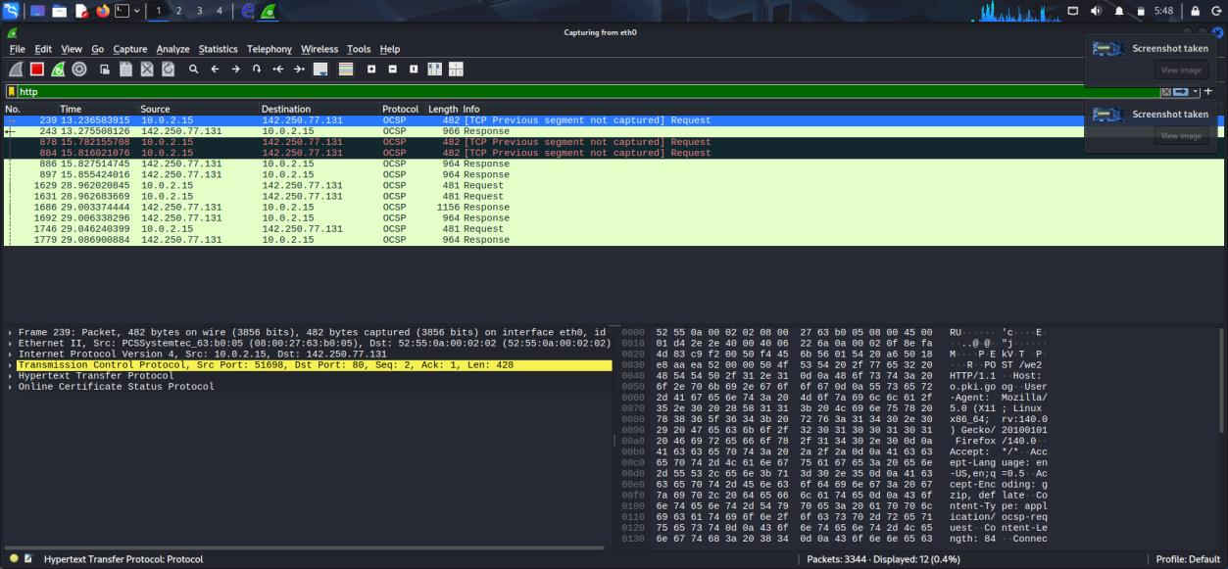

Result:
The MITM attack was successfully performed using Ettercap in Kali Linux.
The experiment demonstrated how insecure network communication can be intercepted, highlighting the importance of encryption and secure network protocols.

