EXPERIMENT – 4

Demonstration of Hash Cracking Using John the Ripper Tool in Kali Linux

Aim:
To demonstrate password hash cracking using the John the Ripper tool in Kali Linux for understanding password vulnerabilities and security analysis.

Software Requirements:
- Host Operating System: Windows / Linux / macOS
- Virtualization Software: Oracle VirtualBox
- Guest Operating System: Kali Linux
- Security Tool: John the Ripper
- System Requirements:
  - RAM: Minimum 4 GB (8 GB recommended)
  - Disk Space: Minimum 30 GB
  - Processor: Intel/AMD with Virtualization support

Introduction:
Password hashes are commonly used to store user credentials securely. However, weak passwords and outdated hashing techniques can be exploited using password-cracking tools.
John the Ripper is a popular open-source password auditing and cracking tool used to identify weak passwords by performing dictionary, brute-force, and hybrid attacks.
Using Kali Linux in a virtualized environment allows safe and ethical experimentation without affecting real systems.

Procedure:

Step 1: Start Kali Linux Virtual Machine
- Open Oracle VirtualBox.
- Start the Kali Linux virtual machine.
- Log in using Kali credentials.

Step 2: Open Terminal
- Click on Terminal from the Kali Linux menu.
- Ensure John the Ripper is installed:
john --version

Step 3: Prepare the Hash File
- Create a text file containing password hashes (example: hash.txt).
- Store the hash inside the file:
nano hash.txt
- Save and exit the file.

Step 4: Run John the Ripper
- Execute the John the Ripper command:
john hash.txt
- The tool starts cracking the hash using default wordlists.

Step 5: View Cracked Passwords
- To display cracked passwords:
john --show hash.txt

Output:

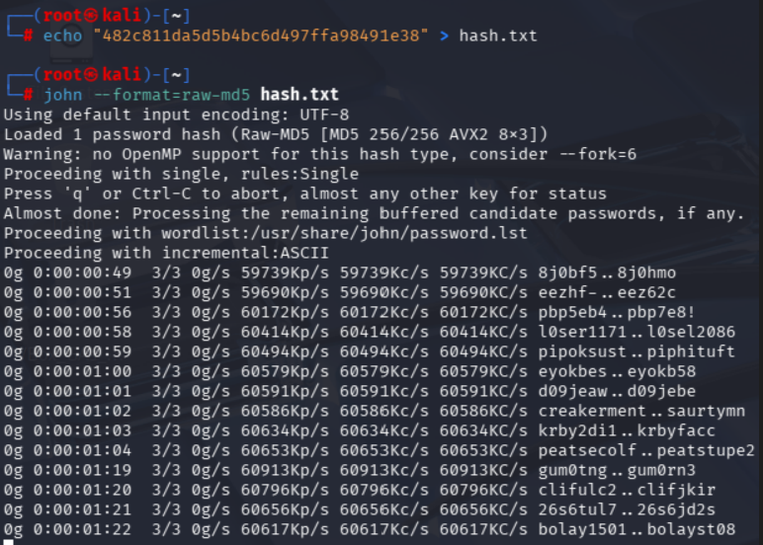

Result:
Hash cracking was successfully demonstrated using the John the Ripper tool in Kali Linux.

