EXPERIMENT – 5

Performing Various Configurations of IPTables Firewall in Kali Linux

Aim:
To perform and analyze various firewall configurations using IPTables in Kali Linux to control network traffic and enhance system security.

Software Requirements:
- Host Operating System: Windows / Linux / macOS
- Virtualization Software: Oracle VirtualBox
- Guest Operating System: Kali Linux
- Firewall Tool: IPTables
- System Requirements:
  - RAM: Minimum 4 GB (8 GB recommended)
  - Disk Space: Minimum 30 GB
  - Processor: Intel/AMD with Virtualization support

Procedure:

Step 1: Start Kali Linux Virtual Machine
- Open Oracle VirtualBox.
- Start the Kali Linux virtual machine.
- Log in using Kali credentials.

Step 2: Open Terminal and Check IPTables
- Open Terminal in Kali Linux.
- Check IPTables version:
iptables --version

Step 3: View Existing Firewall Rules
- Display current IPTables rules:
sudo iptables -L

Step 4: Set Default Policies
- Set default policy to drop incoming traffic:
sudo iptables -P INPUT DROP
- Allow outgoing traffic:
sudo iptables -P OUTPUT ACCEPT

Step 5: Allow Localhost Traffic
- Allow loopback interface traffic:
sudo iptables -A INPUT -i lo -j ACCEPT

Step 6: Allow SSH Access
- Allow SSH connections on port 22:
sudo iptables -A INPUT -p tcp --dport 22 -j ACCEPT

Step 7: Allow HTTP and HTTPS Traffic
- Allow HTTP traffic:
sudo iptables -A INPUT -p tcp --dport 80 -j ACCEPT
- Allow HTTPS traffic:
sudo iptables -A INPUT -p tcp --dport 443 -j ACCEPT

Step 8: Block a Specific IP Address
- Block traffic from a specific IP:
sudo iptables -A INPUT -s 192.168.1.100 -j DROP

Step 9: Save IPTables Rules
- Save the configured rules:
sudo iptables-save > firewall_rules.txt

Output:
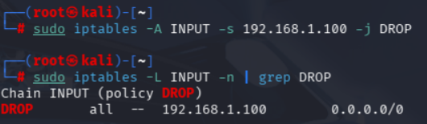
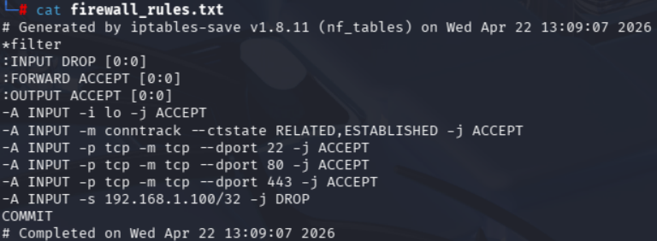

Result:
Various firewall configurations were successfully implemented using IPTables in Kali Linux.

